NORTH COUNTRY CHARTER ACADEMY
BOARD OF TRUSTEES’ MEETING
Thursday, November 20, 2025
LITTLETON ART STUDIO & WHITE MOUNTAINS SCIENCE, INC.
23 AMMONOOSUC STREET, LITTLETON, NH
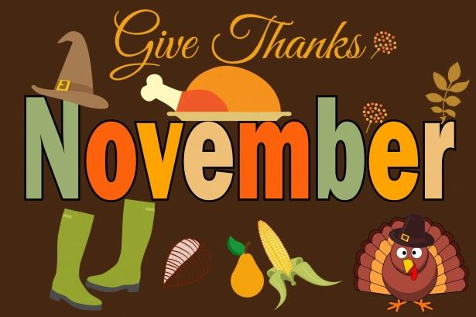
Meeting Agenda
8:00am to 10:00am

- Welcome/Call to Order – Kate Cassady, Chair

- Board Membership & Business Manager Introductions – Kate Cassady, Chair

- Approval of Minutes, October 16, 2025 – Kate Cassady, Chair

- NCCA Charter School Renewal - Lisa Lavoie, Superintendent
  - New Schedule & Times
  - Proposed Changes to the Charter Application

- Legislative Meet & Greet - Lisa Lavoie, Superintendent
  - Tuesday, December 16, 2025

- FY 25 Policies – Lisa Lavoie, Superintendent
  - New Policies: BBAB, IHBH
  - 2nd Readings: ACA, ACN, ACD
  - Amended Policies: BEDG, JICG, AC, BBA, BCA
  - Review Only: CBI, CLA, IJ, IMAH, JI, JRA, AA, ABA, ACE, AD, AE, BA, BB, BBB, BCB, BDB, BDE, BEA, BEB, BEC, BEDA, BEDC, BFE

- Financials – Lisa Lavoie, Superintendent
  - Personnel Policy & Procedure Manual: Employee incentive: Bonus for grant writer
  - FY27 Draft Budget
  - FY 26 Budget & Fund Balance

- 9:20am to 10:00am- Special Presentation: Littleton Art Studio & White Mountains Science, Inc.-Tour & Meet Students/Teachers – Alex Greene, Center Director & Rich Larcom, Teacher

- Non-Public Session RSA 91-A311: (A)
Nonpublic Session RSA 91-A:311
- The dismissal, promotion or compensation of any public employee or the disciplining of such employee, or the investigation of any charges against him, unless the employee affected requests that the meting be open, in which case the request shall be granted.
- The hiring of any person as a public employee.
- Matters which if discussed in public would likely affect adversely the reputation of any person other than a member of the body or agency itself.
- Consideration of the acquisition, sale, or lease of real or personal property which if discussed in public would likely benefit a party or parties whose interests are adverse to those of the general community.
- Consideration or negotiations of pending claims or litigation against the body or against any member of the body because of his membership in such body.

- Superintendent’s Report – Lisa Lavoie, Superintendent
Attachments:
  - October 16, 2025 Minutes
  - Policies: New: BBAB, IHBH 2nd Reading: ACA, ACD, ACN Amended: BEDG, JICG, AC, BBA, BCA Review Only: CBI, CLA, IJ, IMAH, JI, JRA, AA, ABA, ACE, AD, AE, BA, BB, BBB, BCB, BDB, BDE, BEA, BEB, BEC, BEDA, BEDC, BFE
  - Fund Balance

