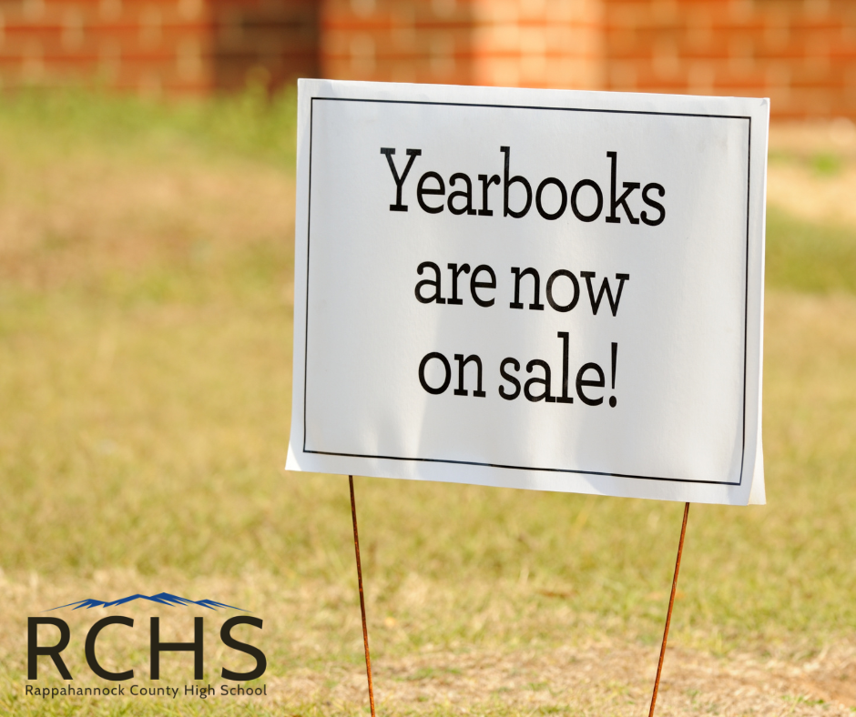

RCHS Family--Preorder your RCHS yearbook before febore they are sold out. Yearbooks are on sale now for $65.00. Click on the link below or contact LJones@rappahannockschools.us if you have any questions or prefer to pay by cash or check.
https://www.balfour.com/student-info?smi=76864

