

districts to exceed the aggregate expenditure limit.
Thank you TVUSD Schooll Counsellors!
Governiing Board Meetiing Summary February 9, 2022Sttudentt Board Member ReporttStudent Board Member, Lainie Radomsky, presented the Student Board Report for TVES and EGJH. Student Board Report - February 2022Superiinttendentt ReporttDr. Scott Hagerman's reports included theSuperintendent Report, February 9, 2022 and the AEL Projected Budget Cuts, where the following information was outlined in detail:Coviid Updatte - Pima County remains in high transmission, however the numbers are currently decreasing.Consttructtiion Updatte - Construction is proceeding well, and progress on buildings can be seen throughout the district.Aggregatte Expendiitture Liimiitt (AEL)Information was provided on the history of the AEL, including the historic context of the current issue. Please see the presentation for more detailed information.Main Points:District schools across Arizona would have to cut $1.2 billion beginning in April 2022 if a resolution is not passed before March 1, 2022.The Tanque Verde Unified School District will lose $2.6 million in current year funding if the Arizona Legislature does not pass a resolution allowing school

These are funds that have already been allocated to districts, it is not new money. It does not allow school districts to overspend their budget

Dr. Hagerman explained we do not anticipate having to close our schools, as some other districts may have to do. However, we may have curriculum materials and other resources we would not be able to purchase as planned. We have just had our capital budget restored, and to have the funding pulled away again will have serious ramifications.

The two big impacts for TVUSD will be the curriculum items, and our careful financial preparations for the anticipated recession will be negated and will have long term effects. The Board Members discussed communicating their concern to our legislative representatives. Information will be made available on the website.

Saffe Retturn tto IIn-Person Learniing Pllan

The Safe Return to In-Person Learning Plan3rd Revision was approved by the board. The revision was approved to reflect the updated Pima County Mask Ordinance dated December 21, 2021, which is to remain in effect through February 28, 2022. The district will then follow County or State requirements.

Sttudentt Learniing Updatte

Dr. Amy Cislak, TVHS Principal, Greg Miller, EGJH Principal, Chris Rietz, ACES Principal, and Emma Batty, TVES Principal, presented information about their recent Professional Development work with Janel Keating. Key Takeaways, Action Steps and Team Celebrations were addressed in the presentation.

IImporttantt Dattes & IInfformattiion

Wed., February 23rd - Governing Board Meeting 6:00-7:30 PM

Wed., February 24th - Thursday, February 25th - Rodeo Break NO SCHOOL Thu. March 3rd - Fri. March 4th K-6 Parent Teacher Conferences K-6 EARLY RELEASE
Wed., March 9th - Governing Board Meeting 6PM

Fri., March 11th - End of 3rd Quarter/Grading Day K-8 EARLY RELEASE Mon., March 14th - Fri. March 18th Spring Break NO SCHOOL

District Events Calendar -February (Updated 2-9-2022)

Nextt Governiing Board Meettiing Datte::

The next Regular Meeting of the TVUSD Governing Board will be held on Wednesday, February 23rd at 6:00 p.m. (May be held virtually - TBD).

Board Meeting Agendas and Minutes

TVUSD Board Meeting Livestream Link

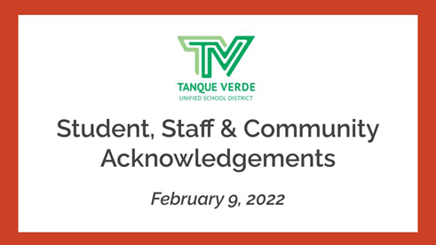

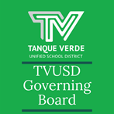
Student, Staff & Communiity Acknowlledgments

TVUSD students and staff members were recognized for their individual accomplishments. The Open Enrollment period has concluded, and the many individuals who were involved in the process were recognized for their contributions. In recognition of National School Counseling Week, February 7-11, 2022, we would like to thank our TVUSD School Counselors for the caring, compassionate, and expert support and guidance they provide our students.
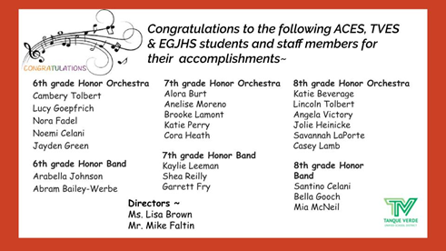
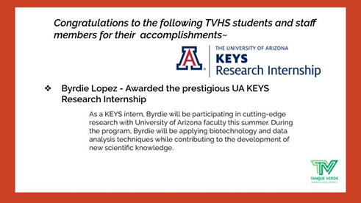
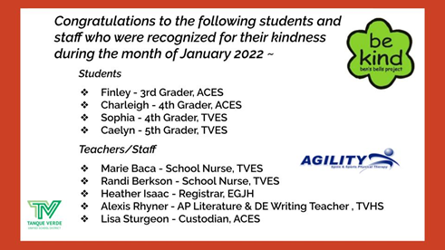
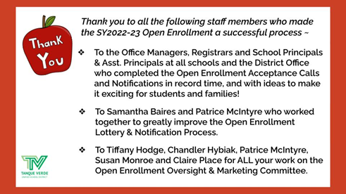
Connect wiith us
Visit our website

