Letter to Households, Community Eligibility Provision (CEP)
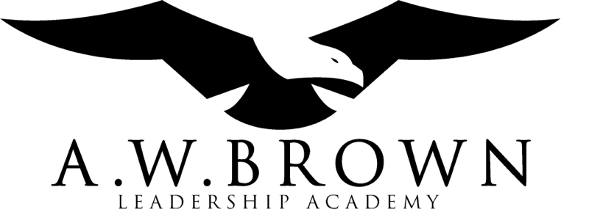

September 29, 2022

Dear AWBLA Families,

We are pleased to inform you that A.W. Brown Leadership Academy will be implementing the Community Eligibility Provision (CEP) under the National School Lunch and School Breakfast Programs for School Year 2022-2023. In CEP schools, applications are no longer required.

Schools that participate in CEP provide healthy breakfasts and lunches each day at no charge for ALL students enrolled in that CEP school during the 2022-2023 School Year.

If you need more information, please contact us at
Vickie Holmes Child Nutrition Coordinator
A.W. Brown Leadership Academy – Quest Campus
5701 Red Bird Center Drive
Dallas, Texas 75237
972-709-4700 Ext 1025

Sincerely,

Vickie Holmes

In accordance with federal civil rights law and U.S. Department of Agriculture (USDA) civil rights regulations and policies, this institution is prohibited from discriminating on the basis of race, color, national origin, sex (including gender identity and sexual orientation), disability, age, or reprisal or retaliation for prior civil rights activity. Program information may be made available in languages other than English. Persons with disabilities who require alternative means of communication to obtain program information (e.g., Braille, large print, audiotape, American Sign Language), should contact the responsible state or local agency that administers the program or USDA’s TARGET Center at (202) 720-2600 (voice and TTY) or contact USDA through the Federal Relay Service at (800) 877-8339. To file a program discrimination complaint, a Complainant should complete a Form AD-3027, USDA Program Discrimination Complaint Form which can be obtained online at: https://www.usda.gov/sites/default/files/documents/USDA-OASCR%20P-Complaint-Form-0508-0002-508-11-28-17Fax2Mail.pdf, from any USDA office, by calling (866) 632-9992, or by writing a letter addressed to USDA. The letter must contain the complainant’s name, address, telephone number, and a written description of the alleged discriminatory action in sufficient detail to inform the Assistant Secretary for Civil Rights (ASCR) about the nature and date of an alleged civil rights violation. The completed AD-3027 form or letter must be submitted to USDA by: (1) mail: U.S. Department of Agriculture, Office of the Assistant Secretary for Civil Rights, 1400 Independence Avenue, SW, Washington, D.C. 20250-9410; (2) fax: (833) 256-1665 or (202) 690-7442; or (3) email: program.intake@usda.gov. This institution is an equal opportunity provider.

