PBIS at Miller Elementary School
Dear Student,
Welcome to Miller Elementary School. We are so excited that you are here.
Our school is participating in a state initiative. It is called Positive Behavior Interventions and Supports (PBIS).
What is PBIS?
It is a systems approach to enhancing the capacity of schools to educate all children by developing research based, school-wide, and classroom behavior support systems. The process focuses on improving a schools ability to teach and support positive behavior for all students.
What is PBIS at our school?
We have created a behavior matrix that defines our expectations for behavior. You will see the matrix posted throughout the school and your child will be learning them throughout the day.
Our matrix is as follows:
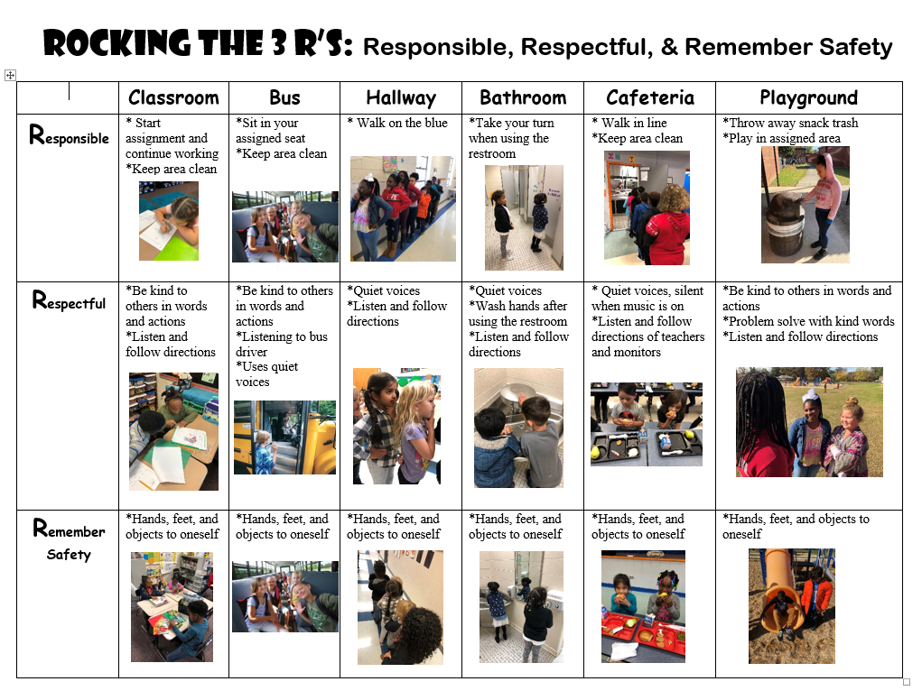
As part of our PBIS process, teachers and other staff members use evidence-based practices to increase student learning and decrease classroom disruptions. Each day teachers are utilizing the Class Dojo to communicate with parents and to reward positive behavior.
How are students acknowledged?
Students earn points according to their behavior throughout the day. Students earn points for positive behavior and loose points for negative behavior. If a student loses a point, the teacher uses this opportunity as a teachable moment and reteaches the desired behavior. Each month there is a goal set to determine how many points a student must earn to attend the good behavior celebration. If students do not earn enough points to attend the celebration, they will have an opportunity to improve specific behaviors.
Another way our students are acknowledged is through our student of the week program. Students that display good character are celebrated as a student of the week. We also acknowledge students with rocket bucks. When students go above and beyond, they receive school money called rocket bucks. The rocket bucks are used to purchase items at the school store.
We are excited to implement PBIS in our school! Our goal is to create a safe and positive learning environment for all students. We appreciate your support, and we look forward to the positive things to come.

Sincerely,
MES PBIS Team

