
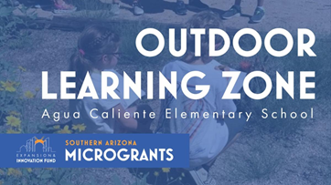

Governiing Board Meetiing Summary September 22, 2021At the September 22, 2021 Governing Board meeting, presentations to the Board included a student presentation about the ACES Nature Trail Project, the SY 2021-22 Governing Board Goals, and a student learning update focusing on Student Achievement.The Governing Board expressed their excitement about being able to welcome students back as presenters to the board for this school year, and thanked them and their parents for their participation.
ACES Natture Traiill Presenttattiion -Agua Caliente Elementary School (ACES) won an A for Arizona Innovation micro-grant in the amount of $25,000 to revitalize their 32-year-old Nature Trail and create a stimulating, safe outdoor learning zone with two classroom-like areas and small collaboration stations to experience curriculum integration and space to learn in a motivating outdoor setting.ACES Principal, Mrs. Chris Rietz and ACES STUCO Co-Presidents/Vice Presidents, Legacy Committee President, and Kindness Ambassadors shared a presentation with the Governing Board which included the history of the nature trail, the school’s goals, ideas, and plans for future use.

Partnering with Agua Caliente on this project are: A for Arizona (Innovation Grant), Tanque Verde High School CTE departments, Eagle Scout Devin Dessey of Troop 186, TV Foundation, ACES PTG, and landscape architect Eric Barrett, of ARC Stuidos, Inc. Their involvement and support are very much appreciated.

Outdoor seating in the one acre area will help with Covid by providing space and an outdoor learning space. One goal of the project is to preserve the history of the nature trail, and maintain an ecosystem which utilizes native vegetation and encourages natural habitats for desert dwelling animals. There is a specific goal to encourage community involvement and use of the nature trail. Enhancements will include: a new outdoor classroom, renovation of the existing classroom space, new storage and learning areas, including a weather station, and an interactive nature trail open to the whole community. Other enhancements include: Implementing water harvesting, improving the entrance, and creating a kindness area.

Eagle Scout Devin Dessey, of Troop 186, described the bridge project he will lead. The project includes taking out the old bridge, packing in dirt and creating culverts to pass the water through, and building a new bridge.

Eric Barrett, of ARC Studios, Inc., the landscape architect who designed the EGJH inner courtyard landscape design, presented ideas about the architectural landscape design proposals. Some areas will be left natural. Other areas have been impacted by weather over time which need to be repaired and enhanced. A series of photos in the presentation show the concepts which were presented. A terraced wall, and other hardscaping will enhance the outdoor learning experience, as well as informal cluster-type seating, all of which will allow the use of nature as an educational component.

ACES Nature Trail Revitalization Board student Presentation 9/22/21

ACES Conceptual Landscape Plan

ARC ACES Plant Selection Proposal

Board Goalls SY 2021-22

Dr. Scott Hagerman presented information about the Governing Board Goals, including the current status of last year's goals around student achievement, teacher coaching, and the status of the new curriculum implementation. Implementation occurred during the pandemic, therefore, Dr. Hagerman’s recommendation was to evaluate the curriculum in year two, after a more normal school year’s utilization of new materials. Benchmark testing will facilitate assessment of the new curriculum implementation.

Board Goals Presentation

Draft Board TVUSD Governing Board Goals School Year 2021-2022

Sttudentt Learniing Updatte

Dr. Scott Hagerman presented information about the AZM2 scores in the context of other Pima County districts and Arizona district rankings.
ELA scores have improved over time. There is a challenge in presenting comparative data because of score changes implemented by the state over the past few years. The high school subgroup is a case in point. In Math scores, we saw a decrease in scores as a trend across the district, which was true across Pima County.

Opportunities for improvement include:
Increasing Math Proficiency (This is an issue all districts face in the next few years).



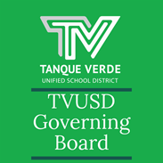
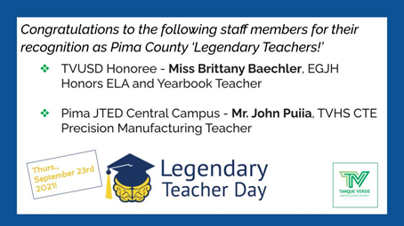
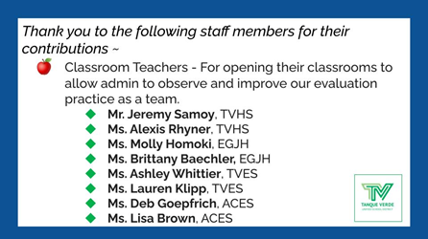
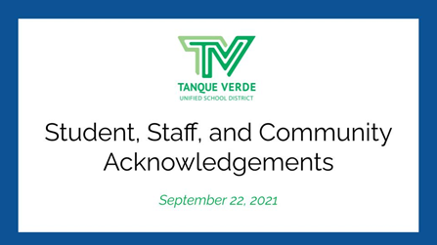
Establishing Year to Year Consistency.TVUSD has moved up significantly in comparison to other districts in both Pima County and Arizona, in our placement in the standings/rankings. Items to celebrate include:We are the only district in Pima County to increase proficiency during the pandemic. We had the second highest ELA proficiency scores of K-12 districts in the state.We would like to acknowledge and celebrate the work of our teachers, administrators and students who have facilitated these notable improvements.Student Achievement Presentation 9/22/2021
IImporttantt Dattes & IInfformattiionOctober Events Calendar - October 2021Fall Break - October 11-15, 2021 NO SCHOOLThe Tanque Verrde Foundattiion is hosting the Tinker Verde Nerdy Derby on November 20, 2021 at the Forty Niner Country Club. This family oriented event replaces the Tech Trek and our TVUSD schools will benefit from technology investment.For more information click on the event logo, or visit: https://tanqueverde.org/2021/08/30/2nd-annual-tinker-verde-nerdy-derby/The 21-22 SCHOOL YEAR CALENDAR may be found here: TVUSD School Year Calendar 2021-22 K-12th.
Nextt Governiing Board Meettiing Datte::The next Regular Meeting of the TVUSD Governing Board will be held on Wednesday, *October 6th.*The October meetings will be held on the first and third Wednesday of the month due to Fall Break. A Call to the Public will be held at the first meeting of each month.Board Meeting Agendas and MinutesTVUSD Board Meeting Livestream LinkTVUSD Virtual Call to the Public Form
Board Acknowlledgementts - Septtember 22,, 2021

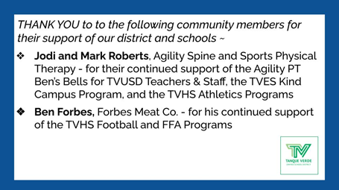
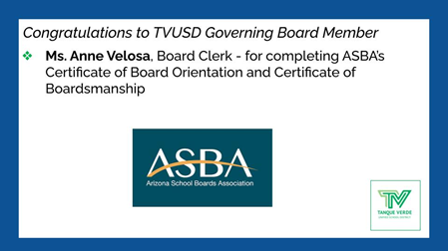
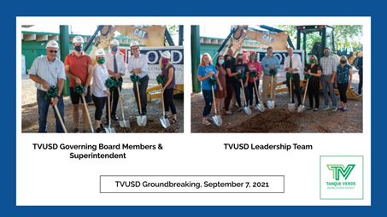
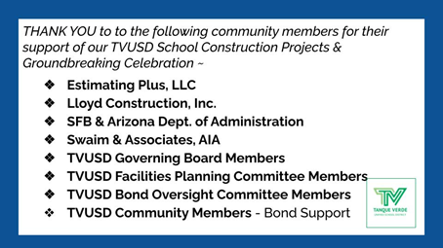
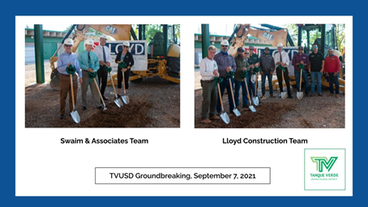
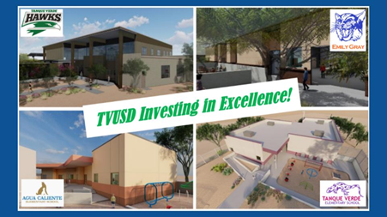
Connect wiith us
Visit our website

