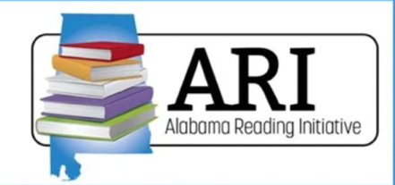
SoR Spotlight School: Learning Walk Targets

Coaching
Support

Comprehensive
Core Reading
Dyslexia Specific Interventions
Plans to Address Deficiencies
Student Reading Improvement Plans
Assessments
Families
& Community
Professional Development

Instruction is focused on the  big 5+2 components of literacy  and are visible on visits. | Teachers use  explicit and systematic framework  (model, guide, practice). | Instruction is  multi-sensory. | Students are  actively engaged  and motivated to learn; pacing is appropriate.
Independent practice  is aligned to  students’ needs. | Independent practice includes  applied phonics  (decodable readers, writing). | Small group instruction is differentiated.  Differentiated instruction  is a regular, daily activity. | The literacy leadership can reflect on their SoR journey.

