
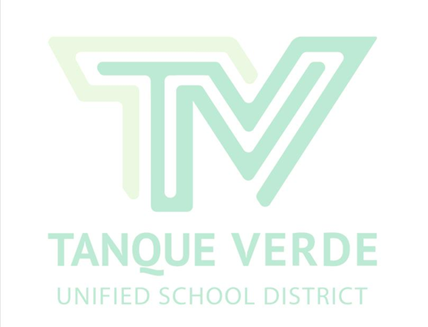
Tanque Verde Unified School District Governing Board/District Goals School Year 2016/2017

1. Ensure the fiscal sustainability of the District.
1.1 Review salary issues and competitive benefits for the recruitment and retention of all employees.
1.2 Pursue new significant revenue sources, including grants and gifts. 1.3 Improve operational efficiency district-wide.

2. Maintain and enhance a rigorous and relevant curriculum.
2.1 Evaluate and administer an appropriately aligned assessment tool which will allow the analysis and delivery of assessment data to inform instruction and support student academic achievement.
2.2 Evaluate and develop district-wide curriculum options that prepare students for 21st

Century learning and employment aligned with the current Arizona Standards.
2.3 Support continuous academic growth with an integrated curriculum and project-based learning, which emphasizes writing skills and a STEAM oriented science program.

3. Promote professional development and instructional improvement. 3.1 Continue to evaluate and refine the state-mandated, performance-based evaluation
system, considering the effective evaluation of and the requirements for evaluating all teachers in the district.
3.2 Encourage employee wellness and personal health awareness. 3.3 Investigate the development of a district pre-school program.

4. Involve and engage community in District pursuits.
4.1 Encourage and support partnerships and collaborations with business and community groups.
4.2 Involve the community in defining the priorities and qualifications for the successful recruitment of the permanent TVUSD superintendent.

5. Sustain modern, safe and efficient facilities for students, staff and community.
5.1 Continue to investigate and implement strategic safety and security improvements at each school site.
5.2 Continue to provide ongoing emergency preparedness training and practice at all district facilities to ensure the safety and security of students and staff.
5.3 Assess the implementation of the district technology program, and ensure adequate infrastructure is in place and well-functioning to support the needs of students and staff.

