Agenda – Regular Board Meeting
Florence County School District Five Board of Trustees
District Office – 156 East Marion Street
Monday, August 23, 2021, 7:00 p.m.

- Call to Order, Welcome, and Pledge of Allegiance

2. Approval of Agenda

3. Confirmation of Notice to Media

4. Public Forum

5. Consent Agenda
A. Minutes – June 28, 2021 and July 12, 2021 – pp. 1-3
B. Monthly Financial Statements – June and July 2021 – pp. 4-7

6. Special Presentation – Presentation of Adult Education Diplomas

7. Regular Agenda
A. Staff Report Updates:
1. JES – Mrs. Mirandi Squires
2. JMS – Mr. Brian Goins
3. JHS – Mr. Sam Tuten
B. Superintendent’s Report
1. Trustee Election (November 2, 2021)
2. Operational Updates
3. Instructional Updates
4. Legislative Updates
5. Recognitions

8. For Action Agenda
A. Request(s) for Student Release from Florence Five
B. Textbook Adoptions – Mrs. Beth Snowden – p. 8
C. First Reading of Policy IKAA (Tests and Examinations) – p. 9
D. Board Member Resignation – p. 10

9. Executive Session Agenda
A. Personnel for Hire and Resignations

10. Reconvene in Open Session with Action if Necessary from Executive Session

11. Adjournment
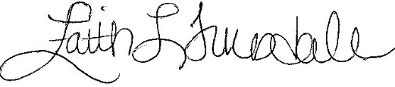 __________________________
Faith L. Truesdale, Vice Chair
Board of Trustees
The Morning News/NPO
WMBF-TV
WPDE-TV
WBTW News
www.fsd5.org

