FACULTY HANDBOOK
2023 - 2024

PRINCIPAL
Lytrice Washington-Murray

ASSISTANT PRINCIPAL
Suanketha Bates-Anderson

“Empowering students through challenging curriculum. Committed teachers, led by skilled administrators who will support student achievement, prepare students socially, emotionally, and academically.”

Department Chairs

Leadership Team Representatives/Charge: Teaching and Learning
English | Ms. Michelle Merriweather
Math | Mr. Jay Smith
Science | Ms. Paula Stewart
Social Studies | Mrs. Hailey Tarver
Special Education | Ms. Miranda Artis
Physical Education | Mrs. Joeva Bryant-Thomas

Leadership/PST Team

Dr. Kimberly Wilson
Ms. Michelle Merriweather
Mrs. Joeva Bryant-Thomas
Mrs. LaTonia Johnson
Ms. Miranda Artis
Mrs. Hailey Tarver
Mrs. Felicia Harris-Yates
Mr. Erik Witherspoon
Mr. Jay Smith
Ms. Paula Stewart

SCHS High School
Administrative Duties/Responsibilities
2023-2024

Mrs. Washington-Murray

All Administrative duties

TBA

SCHS High School
Counselor Duties and Responsibilities
2023-2024

Ms. McVay
- Everything to do with 9th -12th grade students.
- 504 Team Member for 9-12
- Testing Coordinator (ACAP, Pre-ACT, ACT, WorkKeys)
- Rising 9th grade registration of students with Mrs. Washington-Murray visiting 8th grade
- 8th Grade Orientation Coordinator w/Mrs. Washington-Murray for February 2024
- Registration process for master schedule 9-12
- 9-12 registration of students’ w/classroom visitations and individual conferences with students
- College and Career Ready (CCR) Compliance and tracking for progress.
- Supervise students during class change in the guidance hallway.
- Acquiring/keeping track of scholarships/awards related to Senior Honors Day (Work with Senior Sponsor)
- All other duties assigned by Mrs. Washington-Murray

Mrs. Perry (College and Career Coach)

- ASVAB Testing Coordinator
- FAFSA
- YouScience
- Mandatory Parent Meetings w/Seniors
- Military Visits to SCHS
- College & Career Awareness Initiative
- Junior Achievement
- Alabama College Application Week
- College and Career Ready (CCR) Compliance and tracking for progress.
- All other duties assigned by Mrs. Washington-Murray

CRISIS MANAGEMENT PROCEDURES

The 2023-2024 Emergency Operation Plan will be shared to all staff via a word document. You are to save this on your desktop as well as read and make yourselves familiar with all Crisis Management protocols and Procedures.

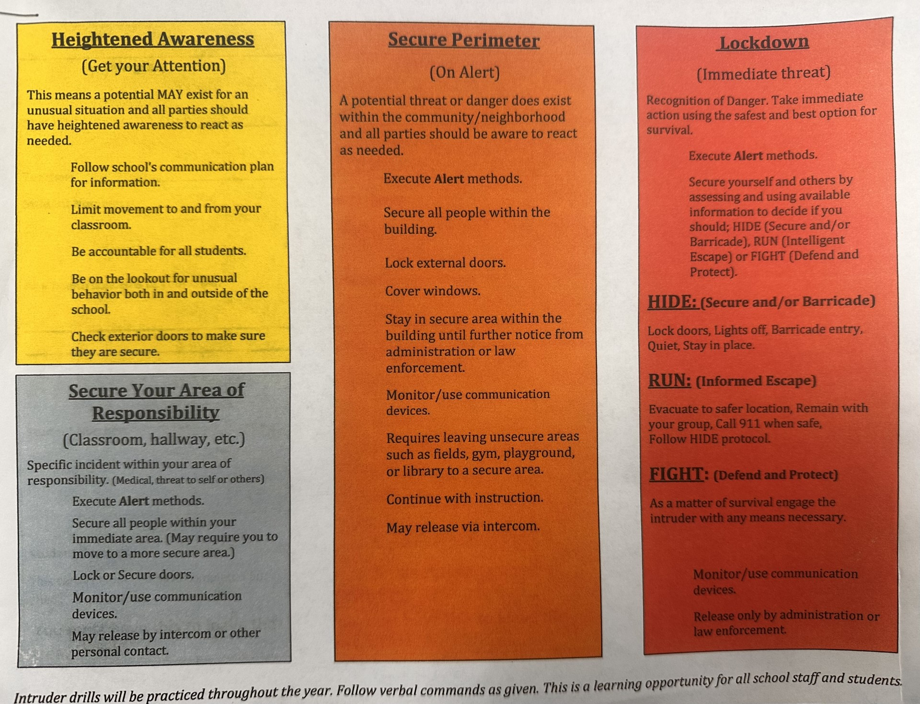
Front Office Professional Decorum

It is imperative that if you are in the front office, you maintain a level of professional decorum at all times. There are no exceptions to this.

Anyone in the office should NEVER:
- Discuss a student aloud in the front office,
- Use unprofessional voice(s) (volume) in the front office.
- Speak and say things violating student privacy especially when student assistants are present.
- Use profanity.

BELL SCHEDULES 2023 - 2024

2023-2024 SCHS Bell Schedule

Morning Duty : 7:30
Breakfast 7:35 - 7:55

Bell Schedule
1st Period | 8:00 - 8:50
2nd Period | 8:55 - 9:45
3rd Period | 9:50 -10:40
4th Period | 10:45 - 11:35
5th Period | 11:40 - 1:00
6th Period | 1:05 - 1:55
7th Period | 2:00 - 3:00

Bell Brown Schedule

1st Period | 2nd Period | 3rd Period | 4th Period | 5th Period | 6th Period | 7th Period
Main C (8 students) | Main C | Main A  (20 students) | Main A |  | Main B  (17 students) | Main B
Natural Hair  (10 students) | Natural Hair |  | State Board  (20 students) | State Board | Intro. Cos  (15 students) | Intro Cos
Welding 2  (12 students) | Welding 2 | Welding 1  (9 students) | Welding 1 |  | NCCER Core (7 students) | NCCER Core
Fund Agri  (9 students) | Fund Agri |  | Intermediate Agri  (8 Students) | Inter Agri | Coop 1-4 (2 students) | Coop 1-4
Found of Health  (8 students) | Foundations of Health | Health Intern (12 students) | Health Intern |  | Pt Care  (10 students) | Pt Care

1st and 2nd Period (5 classes) | 3rd-4th Period.  (3 classes) | 4th-5th Period.  (2 classes) | 6th-7th Period.  (5 classes)
8:00-9:45 | 9:50 - 11:35 | 10:45 - 1:00 | 1:05 - 3:00

Teacher Absences/Substitute Teachers

EMERGENCY ABSENCES: If you must leave during school hours 8:00 am – 3:00 pm please do the following:
- If your absence is more than 3 hours, notify admin and call Frontline to report the absence.
- If your absence is less than 3 hours make Ms. Williams and Mrs. Washington-Murray aware. The teacher is responsible for finding coverage for their classroom.
- Sign in and out in the front office if there is a need to leave during your prep.
ABSENCE EARLY AM THE DAY OF: Please follow these steps.
- You cannot enter your absence online within an hour of your start time. You will need to Call Frontline at 800-528-0049. No Excuses Accepted – CALL FRONTLINE! Text Mrs. Washington-Murray as well as Mrs. Williams.
- Make sure you leave lesson plans in your room where the sub can find them or notify your department head of class work.

ADVANCED ABSENCES: Please follow these steps.
Log into Frontline with your ID# and enter your absence. Be sure to always check the “sub needed” option.

SUB FOLDERS

- Subfolders for emergency absences should be prepared and placed on your desk, cart, closet, etc.
- Subfolders should include class rosters.
- Please let your Department Chairperson know where to locate these materials in case of emergency absences.
- No one will be able to make copies for your classes (students' worksheets, etc.). Please notify your Department Head so that arrangements can be made within the department for any copying needs.

LESSON PLANS
- Lesson plans are due each Friday by 3:00 pm. These will be reviewed on Sundays before the beginning of each week by admin.

Alabama Educator Code of Ethics

Introduction: The primary goal of every educator in the state of Alabama must, always, be to provide an environment in which all students can learn. To accomplish that goal, educators must value the worth and dignity of every person, must have a devotion to excellence in all matters, must actively support the pursuit of knowledge, and must fully participate in the nurturance of a democratic citizenry. To do so requires an adherence to a high ethical standard.

The Alabama Educator Code of Ethics defines the professional behavior of educators in Alabama and serves as a guide to ethical conduct. The code protects the health, safety, and general welfare of students and educators; outlines objective standards of conduct for professional educators; and clearly defines actions of an unethical nature for which disciplinary sanctions are justified.

Code of Ethics Standards Standard 1: Professional Conduct An educator should demonstrate conduct that follows generally recognized professional standards.

Ethical conduct includes, but is not limited to, the following: • Encouraging and supporting colleagues in the development and maintenance of high standards. • Respecting fellow educators and participating in the development of a professional and supportive teaching environment. • Engaging in a variety of individual and collaborative learning experiences essential to developing professionally to promote student learning.

Unethical conduct is any conduct that impairs the certificate holder’s ability to function in his or her employment position or a pattern of behavior that is detrimental to the health, welfare, discipline, or morals of students. Unethical conduct includes, but is not limited to, the following: • Harassment of colleagues. • Misuse or mismanagement of tests or test materials. • Inappropriate language on school grounds. • Physical altercations. • Failure to provide appropriate supervision of students.

Standard 2: Trustworthiness An educator should exemplify honesty and integrity during professional practice.

Ethical conduct includes, but is not limited to, the following:
• Properly representing facts concerning an educational matter in direct or indirect public expression. • Advocating for fair and equitable opportunities for all children. • Embodying for students the characteristics of intellectual honesty, diplomacy, tact, and fairness.

Unethical conduct includes, but is not limited to, the following: • Falsifying, misrepresenting, omitting, or erroneously reporting professional qualifications, criminal record, or employment history when applying for employment or certification. • Falsifying, misrepresenting, omitting, or erroneously reporting information submitted to federal, state, and/or other governmental agencies. • Falsifying, misrepresenting, omitting, or erroneously reporting information regarding the evaluation of students and/or personnel. • Falsifying, misrepresenting, omitting, or erroneously reporting reasons for absences or leaves. • Falsifying, misrepresenting, omitting, or erroneously reporting information submitted during an official inquiry or investigation.

Standard 3: Unlawful Acts An educator should abide by federal, state, and local laws and statutes.

Unethical conduct includes, but is not limited to, the commission or conviction of a felony or any crime involving moral turpitude. As used herein, conviction includes a finding or verdict of guilty, or a plea of nolo contendere, regardless of whether an appeal of the conviction has been sought or a situation where first offender treatment without adjudication of guilt under the charge was granted.

Standard 4: Teacher/Student Relationship An educator should always maintain a professional relationship with all students, both in and outside the classroom.

Ethical conduct includes, but is not limited to, the following: • Fulfilling the roles of trusted confidante, mentor, and advocate for students’ growth. • Nurturing the intellectual, physical, emotional, social, and civic potential of all students. • Providing an environment that does not needlessly expose students to unnecessary embarrassment or disparagement. • Creating, supporting, and maintaining a challenging learning environment for all students.

Unethical conduct includes, but is not limited to, the following: • Committing any act of child abuse, including physical or verbal abuse. • Committing any act of cruelty to children or any act of child endangerment. • Committing or soliciting any unlawful sexual act.
• Engaging in harassing behavior based on race, gender, national origin, religion, or disability. • Soliciting, encouraging, or consummating an inappropriate written, verbal, or physical relationship with a student. • Furnishing tobacco, alcohol, or illegal/unauthorized drugs to any student or allowing a student to consume alcohol or illegal/unauthorized drugs.

Standard 5: Alcohol, Drug, and Tobacco Use or Possession An educator should refrain from the use of alcohol and/or tobacco during professional practice and should never use illegal or unauthorized drugs.

Ethical conduct includes, but is not limited to, the following: • Factually representing the dangers of alcohol, tobacco, and illegal drug use and abuse to students during professional practice.

Unethical conduct includes, but is not limited to, the following: • Being under the influence of, possessing, using, or consuming illegal or unauthorized drugs. • Being on school premises or at a school-related activity involving students while documented as being under the influence of, possessing, or consuming alcoholic beverages or using tobacco. A school-related activity includes but is not limited to, any activity that is sponsored by a school or a school system or any activity designed to enhance the school curriculum such as club trips, etc., where students are involved.

Standard 6: Public Funds and Property An educator entrusted with public funds and property should honor that trust with a high level of honesty, accuracy, and responsibility.

Ethical conduct includes, but is not limited to, the following: • Maximizing the positive effect of school funds through judicious use of said funds. • Modeling for students and colleagues the responsible use of public property.

Unethical conduct includes, but is not limited to, the following: • Misusing public or school-related funds. • Failing to account for funds collected from students or parents. • Submitting fraudulent requests for reimbursement of expenses or for pay. • Co-mingling public or school-related funds with personal funds or checking accounts. • Using school property without the approval of the local board of education/governing body.

Standard 7: Remunerative Conduct An educator should maintain integrity with students, colleagues, parents, patrons, or businesses when accepting gifts, gratuities, favors, and additional compensation.

Ethical conduct includes, but is not limited to, the following: • Ensuring that institutional privileges are not used for personal gain. • Ensure that school policies or procedures are not impacted by gifts or gratuities from any person or organization.

Unethical conduct includes, but is not limited to, the following: • Soliciting students or parents of students to purchase equipment, supplies, or services from the educator or to participate in activities that financially benefit the educator unless approved by the local governing body. • Accept gifts from vendors or potential vendors for personal use or gain where there appears to be a conflict of interest. • Tutoring students assigned to the educator for remuneration unless approved by the local board of education.

Standard 8: Maintenance of Confidentiality An educator should comply with state and federal laws and local school board policies relating to the confidentiality of student and personnel records, standardized test material, and other information covered by confidentiality agreements.

Ethical conduct includes, but is not limited to, the following: • Keeping in confidence information about students that has been obtained in the course of professional service unless disclosure serves professional purposes or is required by law. • Maintaining diligently the security of standardized test supplies and resources.

Unethical conduct includes, but is not limited to, the following: • Sharing confidential information concerning student academic and disciplinary records, health and medical information, family status/income, and assessment/testing results unless disclosure is required or permitted by law. • Violating confidentiality agreements related to standardized testing including copying or teaching identified test items, publishing, or distributing test items or answers, discussing test items, and violating local school system or state directions for the use of tests or test items. • Violating other confidentiality agreements required by state or local policy.

Standard 9: Abandonment of Contract An educator should fulfill all of the terms and obligations detailed in the contract with the local board of education or educational agency for the duration of the contract.

Unethical conduct includes, but is not limited to, the following: • Abandoning the contract for professional services without prior release from the contract by the employer; • Refusing to perform services required by the contract.

Reporting

Educators are required to report a breach of one or more of the Standards in the Alabama Educator Code of Ethics as soon as possible, but no later than sixty (60) days from the date the educator became aware of the alleged breach unless the law or local procedures require reporting sooner. Educators should be aware of their local school board policies and procedures and/or chain of command for reporting unethical conduct. Complaints filed with the local or state school boards, or with the State Department of Education Teacher Certification Section, must be filed in writing and must include the original signature of the complainant.

Alabama Administrative Code 290-3-2-.05 (1)-5-c Each Superintendent shall submit to the State Superintendent of Education within ten calendar days of the decision, the name and social security number of each employee holding an Alabama certificate or license who is terminated, or nonrenewed, resigns, or is placed on administrative leave for cause, and shall indicate the reason for such action.

Disciplinary Action Disciplinary action shall be defined as the issuance of a reprimand or warning or the suspension, revocation, or denial of certificates. “Certificate” refers to any teaching, service, or leadership certificate issued by the authority of the Alabama State Department of Education.

Alabama Administrative Code 290-3-2-.05 (1) Authority of the State Superintendent of Education (a) The Superintendent shall have the authority under existing legal standards to: 1. Revoke any certificate held by a person who has been proven guilty of immoral conduct or unbecoming or indecent behavior in Alabama or any other state or nation in accordance with Ala. Code §16−23−5 (1975). 2. Refuse to issue a certificate to an applicant whose certificate has been subject to adverse action by another state until after the adverse action has been resolved by that state. 3. Suspend or revoke an individual’s certificate issued by the Superintendent when a certificate or license issued by another state is subject to adverse action. 4. Refuse to issue, suspend, or recall a certificate for just cause.

Any of the following grounds shall also be considered cause for disciplinary action: • Unethical conduct as outlined in the Alabama Educator Code of Ethics, Standards 1-9. • Order from a court of competent jurisdiction. • Violation of any other laws or rules applicable to the profession. • Any other good and sufficient cause.

An individual whose certificate has been revoked, denied, or suspended may not be employed as an educator, paraprofessional, aide, or substitute teacher during the period of his or her revocation, suspension, or denial.

PROFESSIONALISM

Dress
- All staff members are expected to dress professionally. Everyone that walks into our campus should be able to tell the teachers apart from the students.
- Employees may wear blue jeans that are clean and in very good condition, free of any tears, fades, or flashy embellishments as part of their daily professional attire up to twice a week, not including Fridays. Jeans must be paired with dressier pieces such as blouses, blazers, or collared shirts when worn. On Fridays only, blue jeans may be paired with an SCHS or school-based T-shirt.

Professional Behavior
- Do not “back a student into a corner” with aggressive speech or actions. You leave them with little option when you do. If the student is misbehaving, use the referral, not aggressive mannerisms of speech or actions.
- Always keep the doors to your office and classroom open when meeting with students. Try to schedule appointments when other teachers are nearby.
- Avoid being alone with a single student. If tutoring or supervising students after school or during lunch, have someone else present or find an open public area to use. Try scheduling two or more students for the same tutorial session.
- Don’t socialize with students outside of school-related events; don’t leave school grounds with a student or offer to take one home.
- Should circumstances require you to use physical restraint with a student, use the minimum force necessary.

TEACHING AND LEARNING PROCESSES

LESSON PLANS
- All teachers are to keep daily lesson plans and have them ready to go by 3:00 pm on Fridays for the upcoming week. Lesson plans will need to be submitted to the designated Google Folder as well as placed outside/inside the door of your classrooms. These will be reviewed on Sundays before the beginning of each week by admin.

GRADES

- Course outlines/Syllabus should reflect a grading system that can be easily understood by both students and parents.
- If 45% of one of your classes fails a test you MUST reteach and provide another test on those standards before moving on with new material.
- Teachers should have a minimum of two grades per week recorded for grades for every student in every class they teach.
- Group Work: Students cannot be required to meet outside of school hours to complete group work/projects. Grades assigned to individual students for their role in group work must be fair and equitable and reflective solely of their contribution to the project.
- Your procedure/policy for dealing with late work/deadlines should be addressed in the course outline/syllabus.

REPORT CARDS
- Students receive report cards at the end of each nine-week grading period.
- Each teacher will keep a parent log to document contacts with parents throughout the school year. No student can fail a class without proper repeated contact documentation to parents can be shown through the parent log.
- Progress reports are issued to students at the midpoint of each nine weeks.
- Grades given at the end of each marking period should reflect the cumulative average for all work done to that point.

EXAMINATIONS
- Examinations should be an indication of the work that has been done.
- You are expected to take different types of exams each semester.
- Students should NEVER help prepare for the test or examination.
- Final exams will be cumulative and count 10- 20 percent of the semester grade.

USE OF CLASS TIME
- All classes should start when students enter your class with a “bell ringer” of some sort.
- You can expect class disruptions and behavior issues if you are not teaching bell-to-bell.
- Everyone must use an agenda on the board every day, for every class.
- You must use a tardy sign-in book for each class. Tardy students will sign in. Please follow the tardy policy when addressing tardy issues.
- Planning and preparation are the keys to good teaching.
- You should over-plan.
- NEVER LEAVE STUDENTS UNSUPERVISED.

CLASS ATTENDANCE

- Attendance must be taken each block of the school day.

TEXTBOOKS
- Textbooks will be checked in and out by the teacher.

GUEST SPEAKERS
- Administration MUST approve all guest speakers before they are scheduled.

Instructional Model

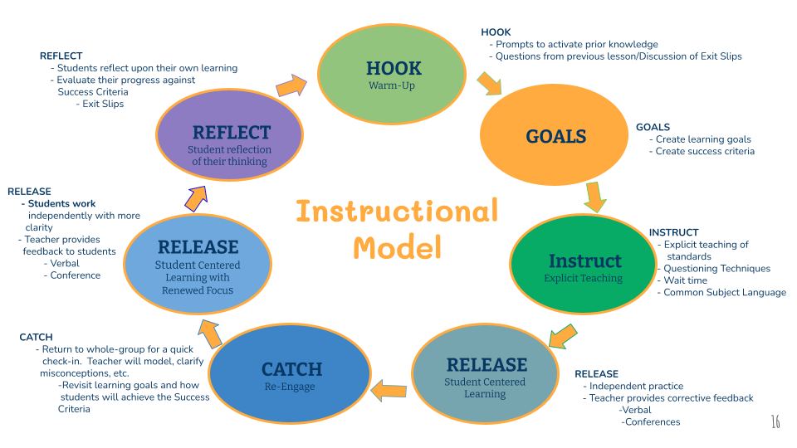

Teaching Formula

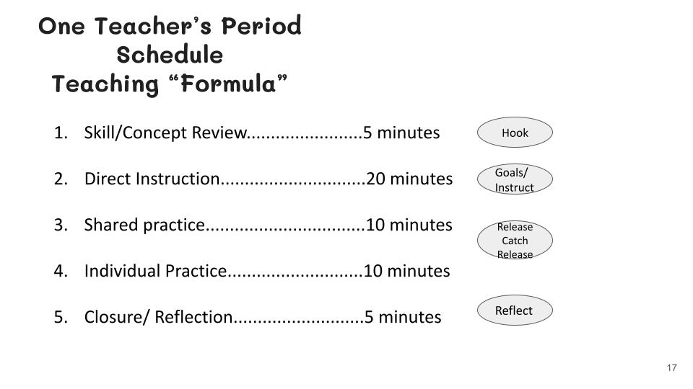

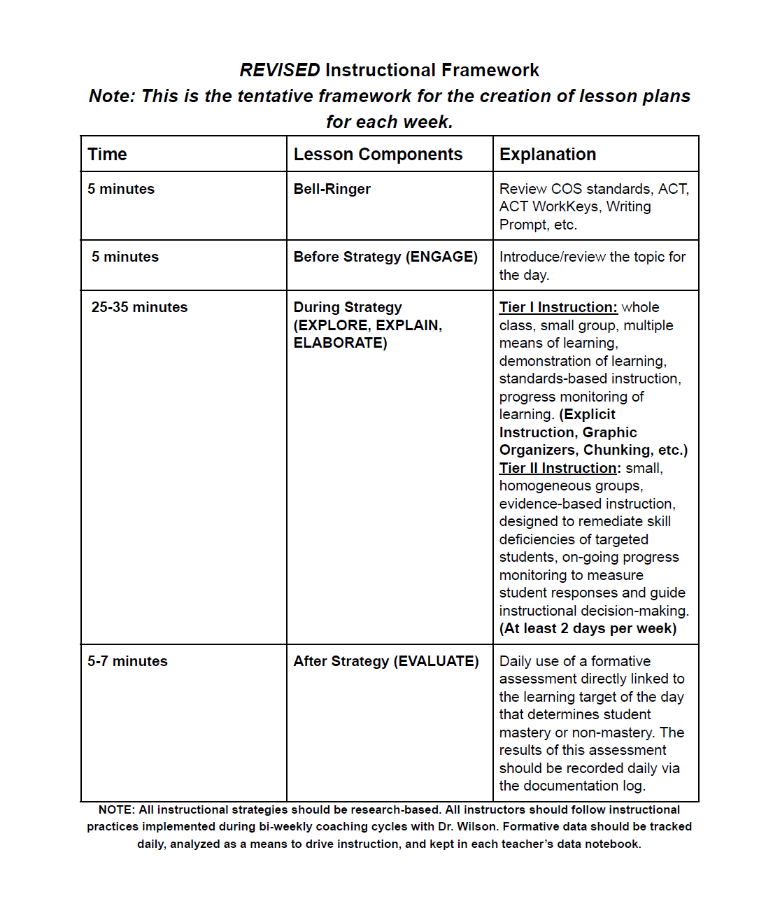
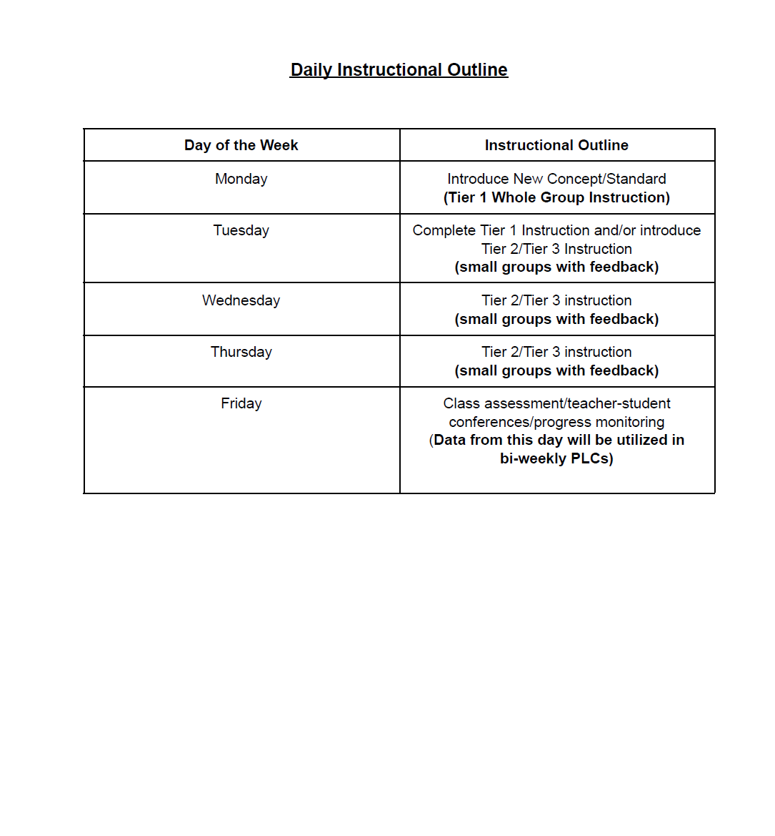

DISCIPLINE PROCEDURES

Non-Negotiables 23-24
CELL PHONES
Students are not to use cell phones in the classroom unless it is for an activity associated with your lesson plans.

The process will be discussed during preplanning with staff and the first week with students.

TARDIES TO CLASS
There is a one-week ‘grace period’ for them to get acclimated to the process. After the first week, the tardy policy will be followed.

SUGGESTIONS FOR AVOIDING DISCIPLINE PROBLEMS
- Be prepared and be enthusiastic!!
- Know your students as soon as possible.
- Classrooms should be attractive, clean, and orderly.
- Give clear, specific directions.
- The use of seating charts is highly recommended; make changes when needed.
- Stay with your students. NEVER LEAVE STUDENTS WITHOUT ADULT SUPERVISION!!!
- BE MOBILE AT ALL TIMES (if you are not feeling well, let an admin know beforehand).
- Allow and encourage “student discourse” in your lessons to involve students more.
- Use positive feedback.
- Use a variety of teaching techniques and materials.
- Check students’ work often.
- It is easier to loosen up than to tighten up.
- Be firm, fair, and consistent – at all times.

HOW TO HANDLE DISCIPLINE PROBLEMS IN YOUR CLASSROOM

- Make sure the students know your processes and expectations of your classroom. And, make sure you carry them out consistently with every student. Do not “show up” a student in front of his/her peers. You are asking for problems if you do. .
- Use the following with disruptive students: (1) Warning, (2) Student conference (Teacher addresses the inappropriate behavior/action as well as the replacement behavior/action) , (3) Parent contact/conference (4) Admin referral
- Use our counselors to help with persistent and consistent “frequent flyers” related to behavior issues.
- If unacceptable behavior persists and you followed steps above, then you should make a disciplinary referral to the appropriate administrator.
- Once a student has been referred to the office, all decisions of the administrators are final. Admin will inform you of the results.
- We have NO corporal/physical punishment of any type.
- Teachers are not authorized to conduct student searches - call an administrator.
- Discuss rules and expectations with your students on the 1st day of class so students know what to expect. Be consistent in enforcement.
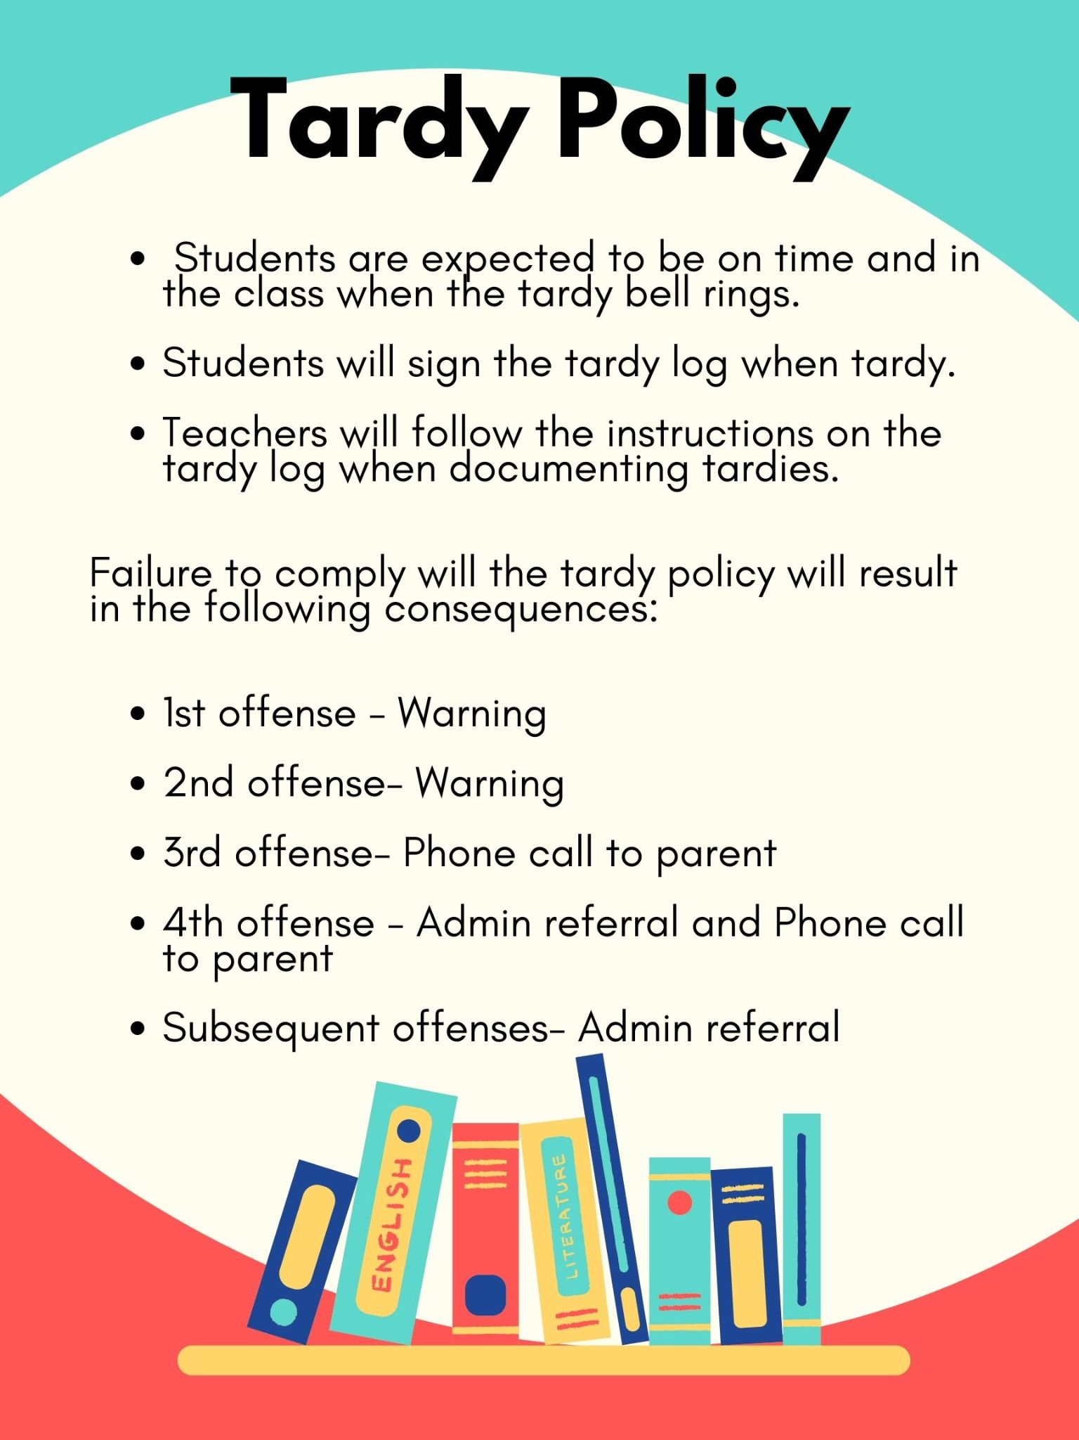
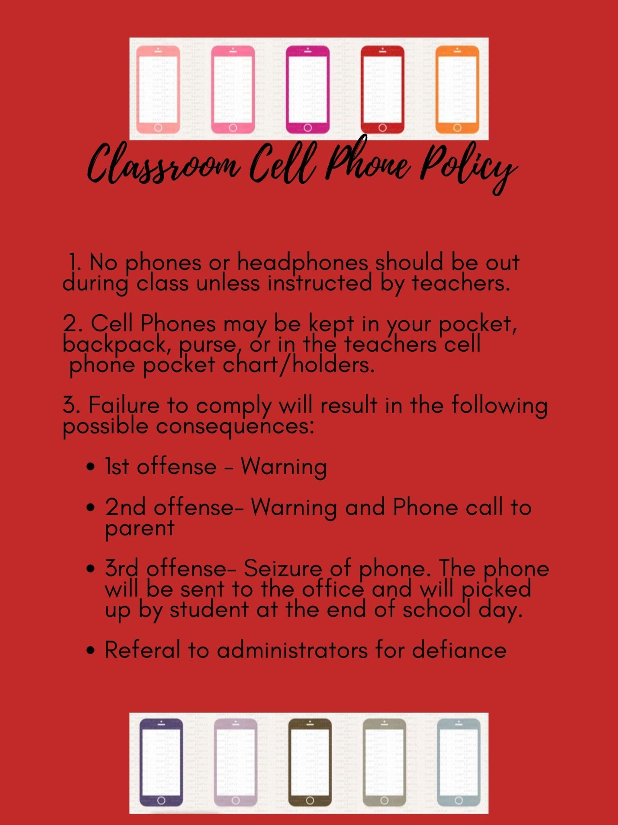DAILY DUTIES/RESPONSIBILITIES
HOURS
- Teachers are to report at 7:40 am and leave at 3:10 pm.
- Supervision Duty Week - You are to report to campus at your morning duty station by 7:30 am; you may leave when the morning bell rings and students begin leaving your designated area.
- Every morning, teachers are at their front door to meet their students. First-period class instruction begins immediately after the bell rings for the period to begin.
- All staff members are to sign out if leaving campus for any reason during the school day. The sign-out sheet will be in the front office.

DAILY PROCEDURES

- TEACHERS are to monitor the hallway right outside of your classroom by your class door.
- Teachers are expected to correct any students who exhibit inappropriate behavior. All students are your responsibility.
- Do not take or detain students from other classes unless approved by the administration.
- No teacher is to divide class by race, color, national origin, sex, or handicap for any reason (competitive skills, etc.) per Title IX.
- You are the role models for students. You must set an example.
- All teachers have a mailbox located in the main office. Teachers should check their mailboxes and e-mail at least twice each day.

- NO STUDENT SHOULD BE IN THE HALL DURING CLASS TIME without a hall pass signed by the teacher. If a student is found without a pass, that student will be brought back to your room.

Hall Passes
- Hall passes should only be allowed for emergencies. Hall passes should not be given out to the first 10 or the last 10 of class. Student passes to other teachers' classrooms are not allowed unless approved by the administration.

CLASSROOM CARE

- Each teacher is encouraged to stress the importance of pride for our building, grounds, etc., and require students to help clean up their mess daily!
- Lock up all your personal belongings in your room at all times.
- Teachers are required to do the following each day before leaving rooms:
- Close all windows. Keep all windows closed during the heating and cooling seasons.
- Keep the room in good order with desks and materials organized.
- Require students to clean their work area each period/block.
- Turn off lights.
- Close and lock doors; do not allow students to use your keys for any reason.

GENERAL INFORMATION

ACTIVITY CALENDAR
Admin and a designated person will monitor our SCHS High School calendar. You need to be certain you provide either person with athletic or curricular activities. The calendar should be all-inclusive for everyone to follow.

ANNOUNCEMENTS
Mrs. Washington-Murray, or her designee, will make morning announcements at the beginning of 2nd period. She will begin with the Pledge of Allegiance and Moment of Silence.

If you desire for Mrs. Washington-Murray to make an announcement, please place your announcement in the box outside her office. She will need all daily announcements by 7:45 am.

The only announcements made in the afternoon will only relate to any other information Mrs. Washington-Murray deems appropriate for the closing of the school.

ASSEMBLY PROGRAMS (PEP RALLIES)
We will use Pep Rallies as PBIS opportunities. (Designated teachers will accompany students to and from all assembly meetings and sit with their assigned classes, or gym areas for pep rallies).

Ticket Sales
- All school-sponsored events will use the online ticketing platform GoFan. Tickets may be purchased in advance using the app or at the gate using the GoFan card reader and tablet.
- It is the policy to have an admission fee at all sporting events. The person collecting money for admission must be board-certified.

Other Reminders:

Faculty Attendance
- All employees must sign in at the front office.
- Absences are either full-day or half-day (AM or PM) increments. You cannot enter an absence online within an hour of the absence time. The office staff will not report your absences. You are required to report your absence by calling 1(800) 528-0049.
- You should make every attempt to enter your absences in advance and secure a sub. Do NOT assign a sub to your job if you have not confirmed their availability in advance.

CELL PHONES
Faculty and staff at Sumter Central High School are not to have their cell phones visible to students. You must model the same expectations we have on students. Dr. Williams understands that there may be exceptions.

CONTINUED CERTIFICATION
Sumter County Schools works with teachers in maintaining your certificate on what it is to be updated, etc. for continued certification.

EXTRACURRICULAR ACTIVITIES
Each school organization should have at least one faculty advisor. All meetings during the school day and all activities held outside of school hours shall be attended by the teacher/sponsor of the activity.

Mrs. Washington-Murray will assign administrators supervision duties for all school activities related to athletics, fine arts, and curricular. She will email these to the entire faculty and staff. All school rules apply to all students during all extracurricular activities.

If your club or activity wishes to place posters in the building, these posters must be checked for correct grammar, spelling, punctuation, good taste, etc. These are to be placed ONLY on the bulletin board already in the hallways. Any poster, paper, etc. not on these bulletin boards will be taken off the walls.

FREE ADMISSION TO SCHOOL ACTIVITIES
All full-time personnel are encouraged to attend school activities and are eligible for free admission to all Sumter Central High School regular season athletic contests and other student activities sponsored by the school. This does NOT go for playoff Alabama High School Athletic Association-sanctioned events.

INVENTORIES
Departments complete room and textbook inventories each May. No equipment, furniture, supplies, etc. should be moved from classrooms, storage areas, or offices without the approval of the administration and/or department chairperson. INVENTORY MUST BE ACCURATE.
MARQUEE
The SCHS Marquee is available to inform parents about special events at Sumter Central High School. Inform Mrs. Washington-Murray if you desire an announcement to be placed on the marquee.

MEDIA CENTER

The media center should be the center of our school and learning. The media center is an important part of the school and is a place for serious work. The following procedures will apply:
- Students going to the media center to check out books should have individual passes.
- Teachers needing to send students to the media center should plan with the media specialist as to periods and materials needed.
- Teachers must sign up in advance to take your classes to the media center and the teacher must be present.
- No food or drinks are allowed in the media center.

MEETING SCHEDULE

Keep your Monday mornings and afternoons free of appointments for that is the day that we will have faculty, leadership, departmental, and other meetings at Sumter Central High. The meeting on Monday schedule begins at 3:15. pm and is as follows:

1st and 3rd Monday of every month - PST/Leadership Team Meeting
Wednesdays of each week- PLC Meeting via Departments
2nd and 4th Monday of every month - Faculty Meeting 3:15 pm
5th Monday of every month - Leadership Team, or Faculty meeting as Needed by Principal to coaching responsibilities, club meetings, etc.

PARENT CONTACT LOGS
Every teacher needs to be consistent in formulating and completing a Parent Contact Log. This will be for your protection in matters related to discipline, academic grading, and other items of note. Please use the following document for your log. You can see the sample log below. Please feel free to use whatever process works best for you.

PUBLICITY OR NEWS ITEMS
Please update Mrs. Johnson or Mrs. Washington-Murray on all public relations items, notes for the marquee, or social media. We will use Principal Pages, Twitter, Instagram, and Facebook. Designated personnel will also run our school website.

REQUESTS TO THE SUPERINTENDENT
All requests of the central office staff concerning Sumter Central High School will be made by the principal. The principal will make decisions relating to the SCHS.

STUDENT RECORDS
Certain information in a student’s permanent record should be confidential; therefore, it is the policy of the Sumter County Schools that the following information be classified as confidential without the written consent of the students and/or parent:
- Student’s name and address d. Standardized test scores
- Character and/or personality rating e. Personal and family information
- Academic rank and grades f. Medical conditions

STUDENT WELFARE – CHILD ABUSE/NEGLECT
The State of Alabama requires by law that any employee is to report suspected child abuse or neglect of children less than eighteen years of age. The law requires the reporting of injuries or neglect of minors, provides immunity for those reporting in good faith, and provides a penalty for violation of the law.

Personnel

5.1 Employee Qualifications and Duties

5.1.1 General Requirements - Employees must perform their jobs responsibly and conscientiously. In addition to any specific job requirements outlined in job descriptions or elsewhere, employees are expected to meet the following general performance and service standards:

A. Employees are required to be punctual and to attend work regularly.

B. Employees are required to perform the duties and responsibilities that are assigned to them by the Board, the Superintendent, or their supervisor(s). Such duties and assignments may extend beyond or outside the instructional day and may include off-campus 31 functions, events, and activities.

C. Employees are expected to treat all students, co-employees, visitors, and guests of the Board with respect. Employees are expected to demonstrate moderation, restraint, and civility in their dealings with others and, in general, to serve as appropriate role models for students in their behavior and demeanor.

D. Employees are required to obey all laws, ordinances, Board policies, supervisory directives, and other pertinent authority while carrying out duties for the Board.

E. Employees whose duties include the instruction or supervision of students must provide effective supervision, discipline, organization, and instruction of the students.

F. Employees must complete and submit required reports accurately and in a timely fashion.

G. Employees must respect, protect, and exercise due care in the handling, use, and operation of Board property and equipment.

H. Employees shall always maintain appropriate, “professional” demeanor from students and shall not engage in conduct including communication of any kind that constitutes, solicits, or suggests sexual, romantic, or inappropriately familiar interaction with students.

I. Employees are required to report to work or to school functions in attire that is appropriate to their position and the nature of the function and that is in keeping with generally accepted standards of decorum and professionalism. Service and other employees who are issued uniforms shall wear uniforms when required.

J. Employees shall promptly disclose to the Board any fact that would disqualify them from employment or that renders them unable to perform their essential job functions.
Employees shall promptly disclose to the Board any fact that would disqualify them from employment or that renders them unable to perform their essential job functions.

K. The Board of Education shall not prohibit outside employment by an employee. Under no condition, however, will the Board permit outside work by an employee to interfere with his efficiency in carrying out his responsibilities. The Board reserves the authority to deny any employee the privilege of working at another job if such employment lessens or interferes with the employee’s 32 efficiency and work in his assigned duties.

5.1.2 Special Requirements

A. Work Schedules (Teachers) - Supervisory and instructional duties of teachers commence a minimum of fifteen (15) minutes before the actual arrival and conclude ten (10) minutes after the departure of students. Except as may otherwise be provided by the Board or required, the minimum instructional day for teachers is seven (7) hours. Assignments and duties may extend beyond the instructional day and may include off-campus functions, events, and activities; conferences and meetings with parents; supervision of student arrival and departure; and preparation for the following instructional day. Teachers will be provided with a minimum of thirty (30) minutes free of instructional and supervisory responsibilities each instructional day.

B. Work Schedules (Support Personnel, Central Office Staff, and Administrators) - The Superintendent is authorized to establish work schedules, including minimum work times, for support personnel, central office staff, and administrators.

C. Professional Certification - In addition to requirements established by testate Board of Education and the pertinent job description, professional employees must hold a degree from an accredited college or university and hold a current, valid, and properly endorsed Alabama Teacher’s Certificate, which will be maintained in the Superintendent’s office. A teacher who has completed the certification process but has not received the certificate may be employed on tentative or temporary compensation pending verification of certification from the State Department of Education. Upon receipt of such verification, appropriate adjustments will be made to the teacher’s salary. If teacher earns a higher certificate that merits increased compensation under the approved salary schedule, any salary increase will become effective upon Board approval following receipt of documentation of the new certification from the State Department of Education.

D. Substitute Teachers - Substitute teachers must, at a minimum, possess a high school diploma and a valid and current Alabama Substitute Teacher’s Certificate or Alabama Teacher’s Certificate.

E. Teacher Aides - Teacher assistants must, at a minimum, possess (i) a high school diploma or its equivalent; (ii) a two-year diploma 33 from a college or university (or the equivalent hours) or pass the Work Keys Assessment; and (iii) a certificate from the State Department of Education verifying a “clear” status resulting from a background check.

F. Bus Drivers - In addition to the requirements established by the State Board of Education, a bus driver must: (i) hold a valid commercial driver’s license, (ii) complete a minimum of twelve (12) hours of approved instruction in school bus driving, (iii) satisfactorily complete a written examination driver’s performance test approved or administered by the State Department of Education or State Superintendent, (iv) complete additional Board requirements as required by the Superintendent or his designee. A bus driver must also meet any requirements of the entity providing the Board’s automobile liability coverage.

[Reference: Ala. Code §16-27-4(1975)]

VISITORS AT SCHOOL
All visitors must report to the front office. Please report to the office any person you see on the campus without official permission. Visitors are not to be in your classroom during class time unless otherwise approved by the principal.

SCHS SCHOOLS MANDATED REPORTER CHECKLIST
- Alleged Victim(s)
Name(s) of Victim(s)
Birthdate(s) of victim(s) or approximate age
Address
Parent/Guardian name and contact information

- Alleged Perpetrator(s)
Name(s)
Birthdate(s) or Age(s) or some approximation for DHR
Relationship to Victim(s)
Address or approximate location
Contact information if known.
- Harm to Victim(s)
Physical Abuse
Sexual Abuse
Emotional Abuse
Risk of Harm
Neglect
- Description of Incident(s)
Be prepared to give a brief description of the incident(s) of abuse. This description should include:
- As much detail as you have about the actual incident
- Indication of intention (especially in physical abuse)
- Description of the time and place of the incident
- Information, if any, about possible witnesses to the abuse
- Evidence of abuse (physical evidence, behavioral indicators, disclosure by the victim, etc.)
Please remember it is NOT your role to interview the child about the abuse. Only ask the child for information that you NEED to know, such as the information above to complete a report. Try to use the child’s exact words whenever possible in describing the incident.

You have reason to believe child abuse or neglect occurred.
You are individually responsible for reporting it.

Organize your information and call Tuscaloosa Co. DHR by phone in a timely manner.
Make repeated calls if necessary

Tuscaloosa DHR Intake:
205-554-1116 or 205-554-1117
The penalty for not reporting is a Class B
misdemeanor for failing to comply with the law.

DHR intake worker or officer will take your information (required) as well as the information regarding the child, incident/concerns, and the family

Submit a written report to DHR-1593 to DHR regardless of who you spoke with on the phone. A DHR intake worker will determine if it will be accepted and who it will be assigned .

If your report is accepted for investigation or assessment, DHR intake worker will notify you and the assigned worker may follow-up. You will be notified of the disposition.
If it is not accepted, you will be notified. But you can continue to document on-going concerns.

FIELD TRIPS

Criteria for planning field trips and extra-curricular activities for students must adhere to individual school guidelines and to the following procedures:
- When requesting a field trip/activity, a Field Trip Activity Request form must be submitted for approval to the principal and his/her designee. A rationale explaining the instructional purpose of the field trip must be included on the form. In addition, the request should include a lesson plan noting the course of study objectives, a plan of supervision for students, the cost and fund source, transportation arrangements, commercial carrier safety documentation, and any need for medical assistance for students participating in the trip.
- Out-of-state field trips and overnight field trips must be approved by the board. Requests for out-of-state and overnight travel must be submitted to the superintendent at least thirty (30) days prior to anticipated travel.
- Overnight field trips should be connected to a weekend whenever possible to minimize the number of days out of class.
- All parents will be informed of the specific details of the field trips, such as the time, place, travel arrangements, cost, supervision, and purpose of the trip.
- Written permission from parents or guardians must be secured for all students.
- The cost of the field trip is to be paid by each participant unless special circumstances prevail.
- School rules and regulations as stated in the Code of Student Conduct and bus safety rules will prevail at all times.
- Private transportation is permitted only with the approval of the superintendent/his or her designee. Private vehicles should be driven by an adult with a valid Alabama driver’s license. No student drivers may transport other students. The owner of the vehicle must show proof of liability insurance.
- Commercial carriers may be used for field trips extending beyond the normal school day. Documentation of safety inspections must be submitted to the principal and superintendent/his or her designee with request for approval documents.
- Provisions should be made prior to the trip to ensure students can make up work for missed classes due to field trips.
- Prior to field trip travel plans, each school shall develop a safety/emergency plan for all field trips to include the following:
  - Each bus/vehicle should have a list of students on trip with emergency contact information,
  - Permission forms signed by parents/guardian,
  - Medical information,
  - List of chaperones,
  - Detailed trip itinerary,
  - Current emergency telephone numbers,
  - Carrier information,
  - For overnight or out-of-state trips, a calling tree, and
- Only students enrolled in the class or group scheduling the trip may participate. Preschool children and/or other siblings or guests are not allowed to accompany teachers, parents, or other chaperones.
- Student accommodation information for overnight trips.

Medical Assistance
A nurse must sign off on all Field Trip/Activity Request forms before submission for final approval from the assistant superintendent.
- Submission of the final student roster must be submitted to the nurse a minimum of two weeks before the field trip.

The procedure the nurse will follow to sign off on the Field Trip/Activity Request form is indicated below:
- Review the final student roster.
- Indicate if a nurse(s) will be required to attend the field trip, along with the number of nurses needed.

Accommodations
Certain behaviors and physical handicaps may necessitate special accommodations for some students participating in field trips. Arrangements must be made by the general education teacher if special accommodation is needed. These arrangements must be made at least 10 days in advance as prescribed in the 504 Plan or the Individual Education Plan (IEP). Students requiring significant accommodations (interpreter, nurse, etc.) must have documented accommodations/modifications included in a 504 Plan or IEP and additional staff will be provided. Staff added to accommodate a special needs student will be considered chaperones and required to supervise students during times when special needs are not being served.

Teacher/Field Trip Leader’s Responsibilities
The teacher planning/organizing the field trip must complete the following:
- Complete and submit Field Trip Permission/Activity Request at least two weeks before the trip.
- Always ensure proper appropriate supervision of students for the entire trip (including an adequate number of chaperones and names).
- Arrange for procurement of the financial resources to pay all costs associated with the trip.
- Communicate with parents to provide details of the trip and secure a Parental Permission Form for each student attending.
- Secure student medical information for all students attending.
- Secure adequate nurse for field trips (if needed).
Field Trip Transportation – School System Owned Buses
When school system buses are used, the following provisions will apply:
- Field trip buses, when available, shall be operated according to terms and conditions that apply specifically to such buses. Reservations must be made through the Director of Transportation by the principal or designee with the teacher/sponsor preparing the Field Trip Request for approval by the principal.
- At least one certified employee must ride the bus and accept responsibility for seeing that all rules and regulations governing school buses are carried out.
- All field trip bus passengers must be enrolled in the school(s) approved for the field trip, be an employee of the School System, or be designated as chaperones by the field trip sponsor and approved by the school principal.
- The principal of each school is responsible for handling the scheduling of such trips.
- Mileage and other applicable cost factors (driver, substitute driver, etc.) for each field trip will be computed by the Director of Transportation based on the current procedures and costs.
- Only adult drivers with state-approved school bus driver’s licenses will be permitted to drive field trip buses with the cost of paying the driver to be borne by the school or class making the trip(s). If a substitute driver must be employed to complete the field trip driver’s regular bus route, the cost of paying the substitute driver must also be borne by the school or class making the trip(s).
- The Director of Transportation is responsible for arranging for field trip buses based on contact with the school principal, assigning a permit number, employing the driver, and planning for fuel.
- The field trip sponsor should return the school system-owned bus in a clean condition as determined by the Director of Transportation.
- Due to energy regulations, allocations, proration, and other financial problems, the Board may cancel trips, increase prices, or curtail the use of buses. Principals will be notified if changes occur.

