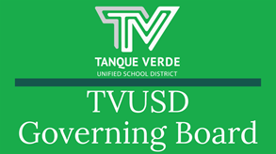
Governiing Board Speciiall Meetiing Summary August 19, 2021

August 20, 2021

A Special Governing Board Meeting was held on Thursday, August 19, 2021 to discuss whether to revise the Safe Return to In-Person Learning Plan to include a mask mandate.

Public Comment

An extended public comment was allowed by the board for the first 90 minutes of the meeting in order to hear from all constituents who addressed the board via the virtual call to the public. Comments were heard both in favor and against mandating masks in schools.

Superiintendent’’s Presentatiion

Dr. Hagerman presented information to support the board’s discussion of revising the Safe Return to In-Person Learning Plan for 2021-22 School Year. Please see link below.

Information included:

Recent interpretation of State Law - House Bill 2898. Fester vs. Phoenix Union - Maricopa Superior Court ruling. Universities vs. K-12 differences in restrictions.
ASBA Case challenging the ban on mask mandates.

Governor Ducey’s discussion of gap funding and district compliance. Federal response to new Arizona requirements for Gap Funding.
Active Cases in schools - TVUSD had seven cases(now eight as of 8/20/21). TVUSD School COVID-19 Dashboard
Pima County Health DepartmentOrder 2021-01 - Slowing the Spread of COVID-19 in Schools and Memo - Close Contact Definition
Tanque Verde PediatricsRecommendations to TVUSD - 8-16-2021 TVUSD enrollment, positive cases, attendance data, current quarantine numbers, and exposure information.
Data on current mask usage in schools by both students and staff - data as of August 18th.


Mitigation measures -The number 1 mitigation step is not sending a sick

student to school!

Remote Learning - Students may move to remote learning at any time if needed. Contact your principal for more information.
Pima County Feedback on mitigation measures/masks - Any increase in mask usage would reduce the rate of transmission.

Please review thepresentation for more detailed information.

Actiion Item -

The board considered an item to mandate universal mask usage in all district schools and facilities. The board voted four to one against implementing a mask mandate. Their main concern voiced was the inability to enforce a mandate at this point, with a large number of students/some staff not wearing them, and a large number of families not in favor as expressed in the public comment. Members stated that circumstances could occur that could have them reconsider their decision in the future.

Vollunttary Mask Usage

Although a mask mandate was not passed, Board Members asked that communications continue to encourage increased mask usage and other mitigation steps in schools. In keeping with CDC guidelines, the district continues to strongly recommend and encourage students and staff to wear masks while on campus, regardless of their vaccination status.

Pllease do nott send sttudentts tto schooll siick!!

The number one mitigation step is not sending a sick student to school. The board reiterated the schools’ request not to send children to school if they are sick, or exhibiting any signs of illness. They emphasized the need for continued communication of the actions that can be taken to keep schools safe and open, and to keep children in school. Schools will resume communicating weekly reminders to all families to continue symptom checking.

Please be Considerate

The board members also focused on the challenges our nurses are having of communicating the Pima County Health Department’s recommendations to families and asked that people be considerate of the difficulty the nurses and school leaders are experiencing in managing the continuing health crisis.

A little kindness goes a long way!

Keepiing Schoolls Safe and Open

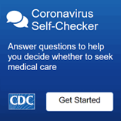
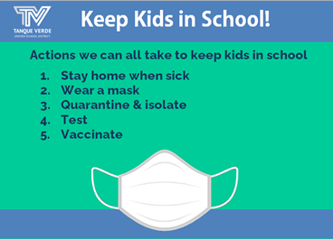
If your child/children exhibit any symptoms of illness, please keep them home and contact the school nurse. If, during the school day, any symptoms of illness appear, your child/children will be separated from the class and you will be called to pick up your child/children within one hour.

IItt iis sttronglly recommended by tthe CDC and Piima Countty Healltth Departtmentt tthatt sttudentts and sttaffff wear masks when on campus iin K-12 schoolls,, regardlless off ttheiir vacciinattiion sttattus..

Stay Home When Siick!

All attendance policies have been put on hold for the 2021-22 school year. Please continue to report your child’s absences so they receive the support needed.
Launch tthe CDC Sympttom Sellff Checker Here::

Symptoms may appear 2-14 days after exposure to the virus. People with these symptoms may have
COVID-19: Symptoms of COVID-19 CDC

Important Dates & Informatiion ACES Open House - August 23, 2021

Regular Governing Board Meeting - August 25, 2021 Labor Day Holiday - September 6, 2021 NO SCHOOL

See more school event dates and information here:August District Events Calendar

The 21-22 SCHOOL YEAR CALENDAR may be found here:TVUSD School Year



Calendar 2021-22 K-12th.Next Governiing Board Meetiing Date:The next Regular Governing Board Meetingwill be held on Wednesday, August 25th, at 6:00 p.m. at the Tanque Verde Elementary School Library. Seating is limited. The meeting will be livestreamed.Board Meeting Agendas and MinutesTVUSD Board Meeting Livestream Link
Connect wiith us
Visit our website

