

TITLE 1 HANDBOOK
Revision Date: 10/1/2025
A Parent’s Guide to Title I
What is Title I?
Title I, Part A is a federally funded program under the Every Student Succeeds Act (ESSA). The purpose of Title I under ESSA is to ensure that all children have a fair, equal, and significant opportunity to obtain a high-quality education and reach, at a minimum, proficiency on challenging state academic achievement standards and state academic assessments.
Which Houston County schools are Title I schools?

CB Watson Primary Northside High Thomson Middle
Centerville Elementary Northside Middle Tucker Elementary
Eagle Springs Elementary Parkwood Elementary Warner Robins High
Huntington Middle Pearl Stephens Elementary Warner Robins Middle
Westside Elementary David A. Perdue Primary Northside Elementary
Miller Elementary Quail Run Elementary Shirley Hills Elementary
Morningside Elementary Russell Elementary Langston Road Primary

What supports are provided through Title I?
The Title I Program offers a variety of supports which may include, but are not limited to, additional teachers, support staff, instructional materials and supplies, technology to support student learning, tutoring, professional development for school staff and capacity building events for families.

What role does family engagement play in Title I?
Family engagement is an integral part of the ESSA law. Districts and schools receiving Title I funding must:
- Ensure that high-quality academic assessments, accountability systems, teacher preparation and training, curriculum, and instructional materials are aligned with challenging State academic standards so that students, teachers, parents, and administrators can measure progress against common expectations for student academic achievement.
- Afford parents substantial and meaningful opportunities to participate in the education of their children.

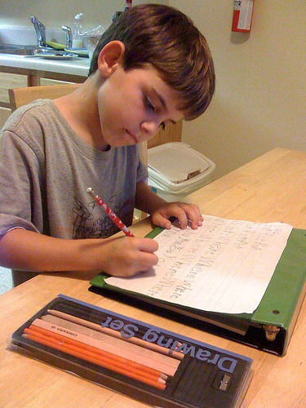
Families,
You can have a tremendous influence on your child’s success in school. By partnering with the school and participating in the Title I program, you will:
- show your child that you support and value his/her education.
- be able to closely monitor your student’s progress.
- build stronger relationships between home and school.
- provide valuable input about schoolwide programs.
Research shows that students whose families are engaged perform better academically, socially and behaviorally. Be sure to become involved in your child’s school by:
- communicating regularly with your child’s teacher.
- attending academic-based family events and parent-teacher conferences.
- volunteering at the school.
- joining the Parent Action Team or School Council.
- Provide input concerning the Title I program at the school.

David A. Perdue Primary

The Connection
Family-School Engagement Plan and Compact
2025-2026



Kathy Gibbs, Principal
150 Jerry Barker Dr.
Warner Robins, GA 31088

www.hcbe.net

Revision Date: 10/01/2025

What is Title I?
David A. Perdue Primary is identified as a Title I school as a part of the Every Student Succeeds Act (ESSA). Title I is designed to support State and local school reform efforts tied to the challenging State academic standards to improve teaching and learning for students. Title I programs must be based on effective means of improving student achievement and include strategies to support family engagement. All Title I schools must jointly develop with parents and family members a written parent and family engagement plan and compact.

The Connection
What is it?
The Connection is a comprehensive document joining our School-Family Engagement Plan and Compact together with the purpose of strengthening the bond between school and home. The Engagement Plan describes how our school will provide opportunities to improve family engagement that will support student learning at school and at home. All students and their families are invited and encouraged to fully participate in the opportunities described in this plan. The school will provide information and as many opportunities as possible for the participation of all family members. The Compact explains what teachers, parents and students each will do in an effort to work together to make sure that our students reach grade level standards. The Compact is discussed with families during parent-teacher conferences throughout the school year.
How is it revised?
The Connection is jointly developed and revised by our school’s stakeholders. All families are invited to attend our annual Shared Decision-Making Meeting (SDM) held each spring. Families are asked to review and give feedback on the Engagement Plan, Compact, and budget including the 1% set aside. All feedback forms from the SDM Meetings are collected, reviewed, and used to revise this document and to improve program planning for the next school year. Families who are not able to attend the SDM Meeting have the opportunity to provide input by completing an online feedback form and completing the Title I Parent Satisfaction Survey that seeks suggestions regarding the plan, compact and budget.

Who is it for?
The Connection is for all students attending a Title I school and their families. We encourage and invite families to fully participate in the opportunities described in this document. Our school will provide full opportunity for the participation of parents and family members with limited English, with disabilities, of migratory children and caretakers of students served in Neglected and Delinquent Centers.

Where is it available?
The Connection is included in our Title I Handbook that is provided to all parents and families at the beginning of the year or whenever a new student enrolls. The Connection is also available on our school website and in our Parent Resource Center. Families can request a copy at any time during the school year.

Let’s Stay Connected

David A. Perdue Primary believes that family engagement means the participation of parents and family members in regular two-way, and meaningful communication involving student academic learning and other school activities. Here are the ways to stay connected and informed.

- Progress Reports and Report Cards
- HCSD App
- School Website
- Social Media
- Callouts
- Emails
- Parent-Teacher Conferences
- Monthly Newsletters

Access to Staff

- Our school has an open-door policy.
- All teachers and staff are available through email. See the school webpage for contact information.
- Conferences may be scheduled directly with your child’s teacher or through the Main office at (478) 218-7500.


Activities to Build partnerships

David A. Perdue plans the following events to build the capacity for strong parent and family engagement and to support a partnership among the school, parents, and the community to improve student academic achievement. Meetings and events are scheduled at various times and in different formats to accommodate the needs of our families. These events may be held in person or virtually.

Event | Focus | Date
Meet and Greet | Welcoming | July 31, 2025
Open House | Curriculum Standard | August 26, 2025
Annual Title I Meeting | Informational | October 30, 2025
Parent-Teacher Conferences | Monitoring Progress | October 13, 2025
Parent University | Literacy & Testing | November 18, 2025
Parent University | Technology | December 4, 2025
Parent Action Team Meeting | SDM | January 12, 2026
Parent University | Curriculum -Math | January 22, 2026
Title I Parent Satisfaction Survey | SDM | January 2026
Parent University | ESOL | February 13, 2026
Parent University | Curriculum-STEM | March 12, 2026
Voices for the Vision | SDM | April 2026
Parent University | Transition- K & 3rd | May 2026

David A. Perdue Primary wants to help all our families participate in our family engagement activities. If you need assistance with childcare or transportation to attend the events listed in this plan, contact our Family Engagement Liaison for more information and assistance.
Juanita Larson
(478) 218-7500
juanita.larson@hcbe.net

Family Engagement Liaison
Our FEL is Juanita Larson. She is available to assist families in a variety of ways from finding resources, connecting with teachers and administrators, navigating Infinite Campus and providing opportunities for you to learn how to help your student at home.

478-218-7500
juanita.larson@hcbe.net

Parent Resource Center
Visit the Parent Resource Center to get pamphlets, brochures, and other resource materials to use at home with your child.

Room 224
Monday – Friday, 8 AM -2:30 PM


- PTO
- Special School Events
- We will host volunteer training several times throughout the year.

Our Pledge to our Parents and Families

David A. Perdue Primary will take the following measures to promote and support parents as equal partners in their child’s education. In order to reach our goal of the highest quality of student achievement, David A. Perdue Primary pledges to support our students and their families as the foundation of the school. We will:

- Ensure that all information related to school and parent programs, meetings and other activities is published in both English and Spanish and posted on the website or on social media.
- Provide training for staff on the value and contribution of parents, on ways to improve communication, on ideas to build strong partnerships with families, on providing information in a friendly format and on responding to parent requests four times during the school year.
- Partner with organizations and early learning centers to provide resources to help prepare families and their students for successful school transitioning.
- Share information/materials related to school and parent engagement activities, meetings and workshops in English and Spanish.
- Communicate with all families and the community on a regular basis regarding schoolwide events through school messenger, social media, school website, newsletters and flyers.
- Work with parents to develop relevant trainings and helpful presentations to educate our staff on the importance of parent and family engagement and how to support student learning.
- Provide information for parents to better understand Georgia Standards of Excellence and assessments for all grade levels.
- Collaborate with stakeholders and community/business leaders to increase awareness of family and community engagement programs.
- Connect families to classes or support groups to help further enhance our parent’s various educational levels.
- Collect feedback from parents and family members after academic events in order to respond to parents’ request for additional support for engagement activities.

2025-2026 District Goals

Increase by at least 2 percentage points the number of students performing at or above proficiency in core content areas in grades 3-11 as measured by Milestones assessment scores.

Increase the percentage of parents who feel their child’s school provides various opportunities for engagement.

2025-2026 School Goals

Increase achievement percentile on MAP Reading Growth Assessment by 3% from Spring 2025 to Spring 2026.

Increase achievement percentile on MAP Math Growth Assessment by 3% from Spring 2025 to Spring 2026.

Grade Levels: K-2

Focus Areas for K
- Letter and Letter Sounds
- Decoding and Encoding CVC Words
- Phonemic Awareness
- Facts to 5
- Counting to 100
Focus Areas for 1
- Decoding skills
- Fluency skills
- Comprehension strategies
- Counting to 120
- Facts to 10
- Place value strategies

Focus Areas for 2
- Decoding skills
- Reading Comprehension strategies
- Facts to 20
- Place value skills
- Reading a clock

Our Compact: Teachers, Families and Students –Together for Success

David A. Perdue Primary will

- Provide families with a monthly newsletter that features literacy and math activities covered in the classroom.
- Provide a weekly UFLI Learning at Home Activity sheet.
- Provide families with a bag of leveled books to help support and improve reading fluency, decoding skills and comprehension.
- Offer family events focused on academic supports in the areas of literacy, curriculum standards, ESOL, testing and technology.
- Provide families with a “Reading and Math Tool Kit” to help aid in student learning at home.

Family will

- Practice literacy and math skills with your child using the newsletters provided by the teachers.
- Complete the UFLI activity sheet weekly with your child.
- Listen to your child read from his/her bag of books nightly.
- Attend family events at school to learn strategies that can help your child in various academic areas.
- Help your child use his/her “Reading and Math Tool Kit” at home.

Student will

- Practice literacy and math skills nightly by using skills covered in the newsletters.

- Complete UFLI activity sheet with family each week.

- Read nightly for at least 20 minutes from their bag of books.

- Attend academic events at the school with their families.

- Utilize their “Reading and Math Tool Kit” at home.

- Practice your skills using Google Classroom and Literacy Footprints.

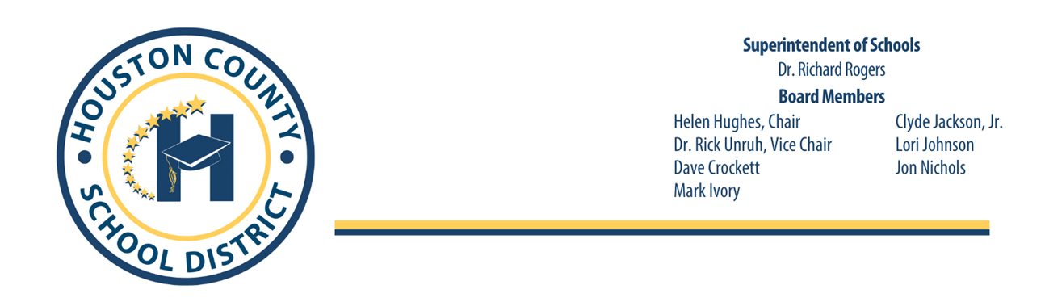
July 31, 2025
Right to Know Professional Qualifications of Teachers and Paraprofessionals

Dear Parent(s) or Legal Guardian(s),

In compliance with the requirements of the Every Student Succeeds Act, the Houston County School System would like to inform you that you may request information about the professional qualifications of your student’s teacher(s) and/ or paraprofessional(s). The following information may be requested:

• Whether the student’s teacher—
- has met State qualification and licensing criteria for the grade levels and subject areas in which the teacher provides instruction.
- is teaching under emergency or another provisional status through which State qualification or licensing criteria have been waived; and
- is teaching in the field of discipline of the certification of the teacher.

• Whether the child is provided services by paraprofessionals and, if so, their qualifications.

If you wish to request information concerning your child’s teacher’s and/ or paraprofessional’s qualifications, please contact your child’s school or you may contact Dana Morris, Director of Federal Programs, at the Houston County Board of Education at (478) 988-6200 ext. 3449 or at email dana.h.morris@hcbe.net.

Thank you for your interest and involvement in your child’s education.

Sincerely,
Dana Morris, Director of Federal Programs
Copyright Piracy Awareness Notification

Title I, Part A, Section 1116 of Every Student Succeeds Act (ESSA) state that Title I schools shall provide information and resources to help parents and families work with their children to understand the harms of copyright piracy. In keeping with this requirement, definitions of relevant terms, as well as links to websites that may be helpful in educating children concerning copyright piracy regulations, are included below.

Copyright-a form of protection given to creators and authors of literary, dramatic, musical, and artistic works. A copyright means that the author has the right to do or let others do any of the following things:
- Make copies
- Distribute copies
- Perform work publicly
- Display work publicly
- Make modifications or adaptations
Generally, it is illegal for anyone to do any of the things listed above without the creator’s permission. However, there are some exceptions and limitations to this right. One major limitation is the Doctrine of Fair Use.

Copyright Piracy-Unauthorized reproduction for sale or use of copyrighted work such as a book, lyric or software.

Online Resources:
https://www.commonsensemedia.org/videos/teaching-kids-about-copyright-piracy
http://www.copyrightkids.org/

If additional assistance or more information is needed, the media specialist at your child’s school can help.
Title I Complaint Procedures

Although the below steps are recommended for the most efficient resolution at the lowest level, the parent/student has the right to bypass these steps at any time and request an impartial due process hearing related to decisions or actions regarding your child’s identification, evaluation, educational program, or placement. The parent and the student may take part in the hearing and have an attorney represent you at your own expense. The impartial Hearing Officer will be selected by the district. Hearing requests must be made to the Title Coordinator identified in Step II below.

Step I
The complaint shall be presented orally or in writing to the school principal within ten (10) calendar days after the most recent incident upon which the complaint is based. Any witness or other evidence should be provided at this time. The administrator will investigate and render a written decision within ten (10) calendar days of the filing of the complaint.

Step II
A complainant dissatisfied with the decision of the school principal may appeal to the System Title I/Title II Coordinator by submitting a written statement of complaint to the System Title I/Title II Coordinator. This statement must be filed within ten (10) calendar days after the complainant receives the decision from the school principal. The complaint should be mailed to:

Mrs. Dana Morris, Federal Programs Director
Houston County Board of Education
Post Office Box 1850
Perry, GA 31069
Phone: (478) 988-6200
dana.h.morris@hcbe.net

Upon receipt of the written statement, the Title I/Title II Coordinator will schedule a meeting to attempt resolution of the concerns. The System Title I/Title II Coordinator will render a written decision within ten (10) calendar days after the meeting.

Step III
A complainant dissatisfied with the decision of the System Title I/Title II Coordinator may appeal to the Houston County Board of Education by filing a written request to the Office of the Superintendent. The complaint should be mailed to:

Dr. Richard Rogers
Office of the Superintendent
Houston County Board of Education
Post Office Box 1850
Perry, GA 31069

The appeal must be filed within ten (10) calendar days after the complainant receives the decision from the System Title I/Title II Coordinator. The Board of Education will act on the complaint at the next scheduled BOE meeting.
PBIS

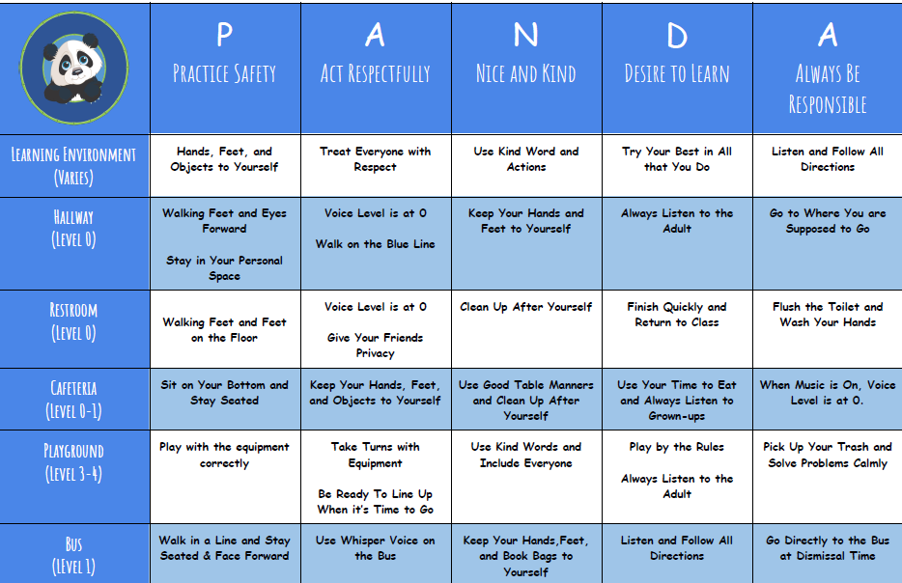

Title I Handbook Acknowledgement Form

David A. Perdue Primary School
Dear Families and Students,
For the 2025-2026 school year, our Title I Handbook is/will be available for your viewing on our school website at https://dpps.hcbe.net under the family engagement tab.
The purpose of the Title I Handbook is to provide our families with detailed information regarding what it means to be a part of a Title I school. The handbook is also a critical component in helping to build a strong relationship between home and school. The documents included in the handbook are the Parent’s Guide to Title I, The Connection (Family Engagement Plan and Grade Level Compact), Right to Know Teacher and Paraprofessional Qualifications, Copyright Piracy Awareness, and Complaint Procedure.
If you prefer a printed copy of the handbook, please indicate in the space provided and we will gladly provide one for you.
To be completed by school personnel only
Hard copy of Title I Handbook given to _____________________________________________________________________
Student Name

Date_____________________________________ By: ________________________________________________________
School Personnel

Additionally, we ask that you sign and date acknowledging access and agreement to the school-Family Compact then return the form to your child’s school.
Please choose one of the following options:
_______ I will access the Title I Handbook on the school’s webpage. I do not wish to receive a printed copy.
_______ I would like to receive a printed, hard copy of the Title I Handbook. Please send one home with my child.
School-Parent Compact Signatures:
School Representative Signature: __________________________________________________ Date: _________________________________________________________________________

Parent/Guardian Signature: ________________________________________________________ Date: __________________________________________________________________________

Student Name (print): _____________________________________________________________
Student Signature: ________________________________________________________________
Date: ____________________________________________ Grade: _________________________

