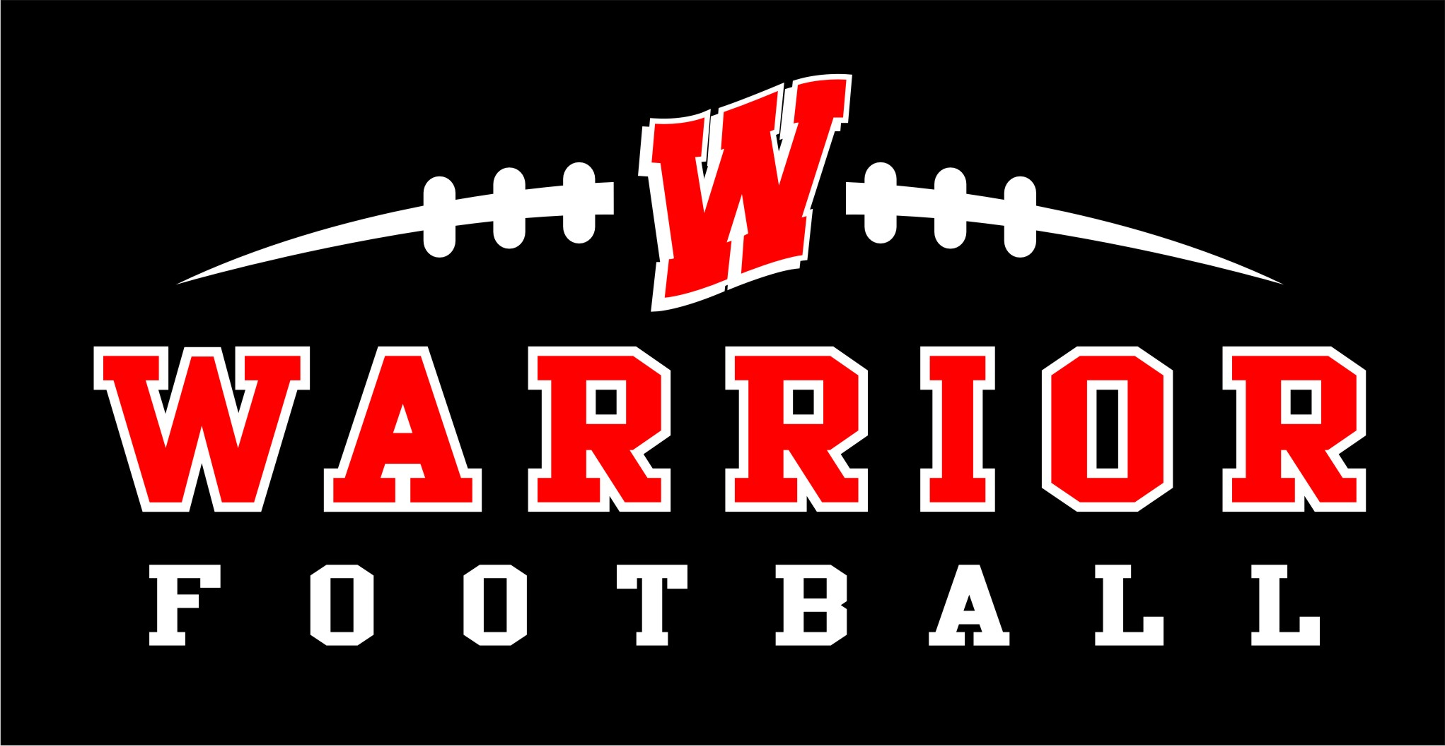

**Warriors Summer Football Camp**

**In preparation for the 2023 football season, Wheatmore Middle will offer a 3 day Mini camp August 2nd - 4th. The camp will be open to rising 7th and 8th Grade students.**

**To help prepare our student athletes for the upcoming football season, athletes will train and be coached at their skill positions by current WHS athletes and coaches as well as their WMS coaches. This will be a great opportunity for our players to work with the High School staff and also meet players. The cost for the camp will be $40 per athlete. T-shirts will be handed out to each player attending the camp.**

**If your student athlete will be participating in this camp please fill out this form and return it with $40 to Coach Peterson.**

**Students Name: ____________________________________________________**

**Grade Level:___________________________________**

**Shirt Size:_____________________________________**