**Villa Rica High School Math Department**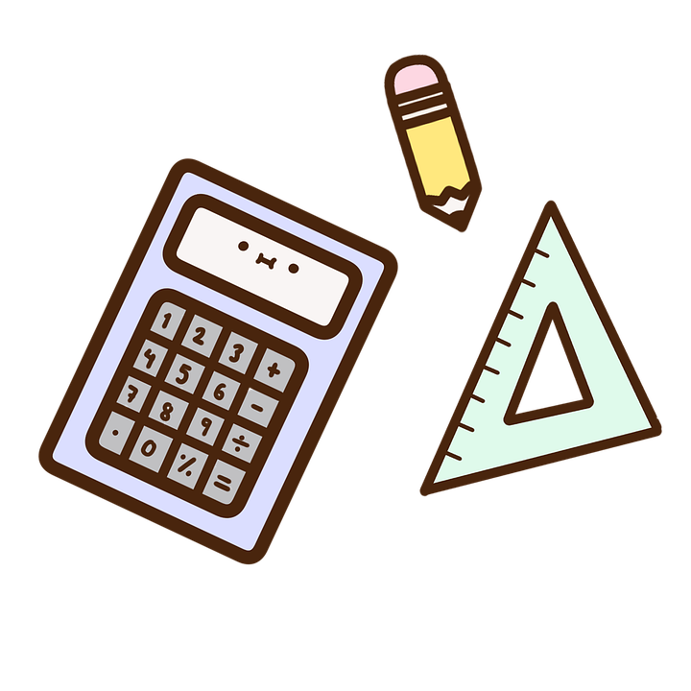

**Honors Geometry**

**TEACHER**: Mrs. Arnold **ROOM:** 801

**E-MAIL**: jenniferm.arnold@carrollcountyschools.com

**Welcome to Honors Geometry!**

In this high school Geometry course, students explore more complex geometric situations and deepen their explanations of geometric relationships by presenting and hearing formal mathematical arguments. The course is organized into the following eight units: Polynomial Expressions, Geometric Foundations, Constructions & Proof, Congruence, Similarity, Right Triangle Trigonometry, Circles, Equations & Measurement, and Probability & Statistics.

**About Mrs. Arnold**

* This is my 9th year teaching at VRHS!
* I am married to Greg and together we have two daughters Addison 8 and Blakely 5
* I graduated from the University of West Georgia ~ GO WOLVES!
* I am a, born and raised, HUGE University of Alabama fan ~ ROLL TIDE ROLL!
* I have two Greyhounds, Blaze and Rev
* I desperately need off the Universal Cat Distribution list as we also have 7 yard cats- Boo, Asher, Vanta, Misty, Josie, Brasso, and Patch
* I love pretty much anything Disney and go to Walt Disney World yearly
* I am here to help YOU and I want YOU to be successful! If you ever have any questions, please talk to me and let me know what I can do to make this your best year of math ever!

**Grading**

* Formative (40%) - classwork, homework (may be assigned if you don’t finish something in class), quick checks
* Summative (60%) – quizzes, unit tests, projects

If you ever have any questions about your grade, please email me or come talk to me! Students are allowed **one test retake per semester**. Students are required to attend two tutoring sessions prior to retaking a test.

**Required Materials**

* You should have either a separate Geometry 1 ½ inch 3-ring binder, OR a section for Geometry in a larger 3-ring binder.
* You should always bring your **notebook, a pencil, your calculator, and your Chromebook/charger** every day.
* Chromebooks will be needed to complete some classwork assignments and nearly all assessments (tests/quizzes). **Failure to bring your fully charged Chromebook to class may result in a missing or failing assignment, quiz, or test!**
* We will be using the [**TI-30XS Multiview**](https://www.amazon.com/dp/B000PDFQ6K/ref=cm_sw_r_cp_dp_T2_t.aDzbKJ9F06N) calculator. Although we have a class set, it is strongly suggested that students purchase their own calculator to reduce sharing of materials. It is also helpful to have your own calculator when practicing skills at home.

**Cell phones and headphones/AirPods are NOT ALLOWED in class. This is a school-wide policy. In Mrs. Arnold’s class, you will put your phone in the phone caddy in your assigned pocket number or your phone must remain in your bag for the duration of the class.**

**Failure to do so will result in an office referral**

**Online Resources/Apps**

Google Classroom will frequently be used to post notes, assignments and helpful resources. You should also have access to Infinite Campus and Gmail (your student account). There are cell phone apps for Google Classroom, Infinite Campus, and Gmail that I recommend you download to receive important notifications for class!

**Missed/Absent Work**

It will be the responsibility of the student to check Google Classroom and/or communicate with your teacher to get the missed notes/assignments. If you are absent, you are expected to make arrangements for work within three days upon return. **Be mindful that the gradebook closes after each 9-week period. All missing work will be marked with an “M” which is calculated as a 0 (zero) in the grade book. Late work will be accepted one week from the initial deadline of the assignment** (I understand there may be special cases when this isn’t possible, just come talk to me and we will work something out!)

**Semester Exams**

There is no Georgia Milestones Test for Geometry. However, there will be a cumulative exam or project at the end of each semester (December and May). The weight of the exam will be communicated as we progress through the course!

**Extra Help**

I am happy to stay after school for tutoring as needed for you throughout this course on **Tuesday afternoon from 3:40 until 4:30,** and mornings by request only. If you need another day, speak with me and we will see if we can work out another day. **Please either let me know in class or send me an email if you plan on coming before or staying after school for tutoring,** in case a meeting falls during this time.

**Academic Honesty**

Students are expected to be honest in all academic work and not to tolerate academic dishonesty of others. This includes **copying the answers of others**, **passing others’ work off as your own**, **providing answers to others**, **dishonestly obtaining and/or distributing answers** and any other dishonest acts. These are **serious offenses** and will result in severe consequences and a grade of a zero in the grade book for the assignment!

**Google Classroom Codes:** Be sure that you have joined the Google Classroom for your class!

1st Period Honors Geometry:

4th Period Honors Geometry:

5th Period Honors Geometry:

6th Period Honors Geometry:

7th Period Honors Geometry:

**We are a One Rule Classroom: Respect each other! *If what you are doing interferes with learning, hurts someone else either physically or emotionally, or prevents you from being your best self, it is not showing respect.***

Let’s have a great year!!! We are VR!