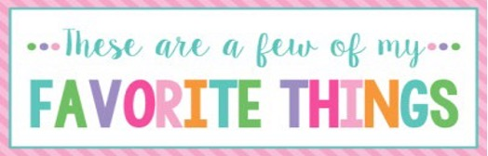

Name: | Elizabeth Dearing | T-Shirt Size: | XL
Birthday: | August 19th | Monogram: | EDA
Favorite Color: | Green | Favorite Flower: | Hydrangea
Favorite Scent: | Jasmine | Favorite Candy: | Twix
Favorite Drink: | Barq’s Root Beer | Favorite Food: | Any dessert
Favorite Snack: | Chex Mix | Favorite Fruit: | Bananas
Favorite Restaurant: | The Parish | Favorite Fast Food: | Chick-fila
Favorite Places to Shop: |  | Tanger Outlets  Target
Favorite Bath & Body Works Scent: |  | Honeysuckle
Things I Collect: |  | Colored Pens
Favorite Author/Book Series for Personal Reading: |  | Liane Moriarty  Taylor Jenkins Reid
Wish List for Classroom: |  | Laminating sheets  Colored copy paper

