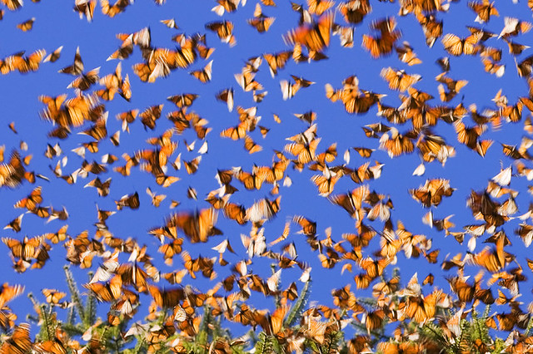

**Reading News**

**Mrs. Williams’ Second Grade**

**October 20, 2025**

**Reading:** Great Migration - Butterflies

**Word Study:** words spelled with -igh

**Vocabulary:**

**migration:** is a type of travel where animals move great distances to avoid winter weather

**generation:** a period of time between when parents are born and their children are born

**protection:** something that prevents harm or injury to something else

**transforming:** making dramatic changes in appearance or form

**chemicals:** substances that have been created (usually by people in a lab) for different purposes