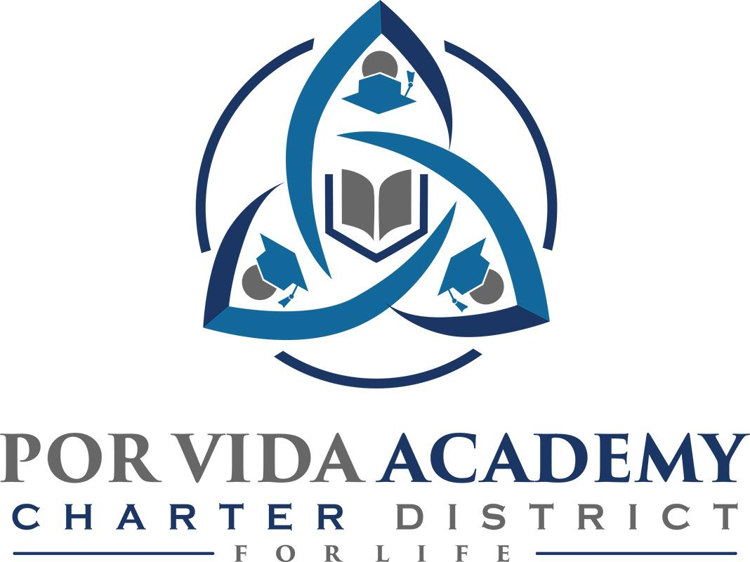

Wednesday, October 14, 2020 at 12:00pm 1135 Mission Road, SA TX 78210

Agenda of Regular Called Board Meeting

- Call to Order and Establishment of Quorum
  - Roll Call & Recording of Board Members Present - Declaration of Quorum Present
  - Recording of the Executive Director/Superintendent and Staff Members Present.

- Closed Session: None

- Pledge of Allegiance

- Salute to the Texas Flag- “Honor the Texas Flag; I pledge allegiance to thee, Texas, one state under God, one and indivisible.”

- Public Testimony

- Approval of Minutes: September 8

- Superintendent Items:

  - Campus Reports – Student Progress & Teacher Expectations
  - Dr. Davidson Report
  - Charter School Performance Framework Training
  - Special ED Operating Procedures Approval

- Financials
  - Current – thru October 6, 2020

- Board Items: None

- Adjournment

