HOW TO REGISTER ON EDISON

- Link Below:
Guest (tn.gov) or https://hub.edison.tn.gov/psp/paprd/EMPLOYEE/EMPL/h/?tan=PAPP_GUEST
- Click “First Time Login/New Hire”
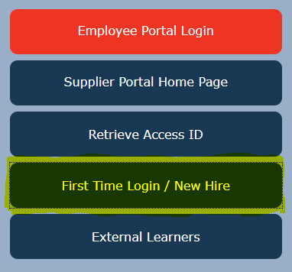

- Retrieve 8-digit Edison Employee ID code from employer
- Complete following fields
- Hit submit
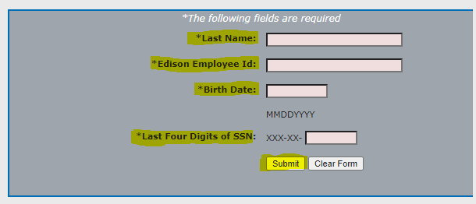

- Reset Password
- Save Access ID and Password

