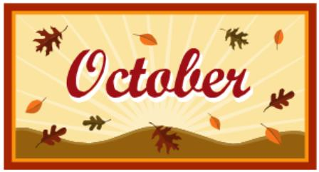

**Mrs. Way’s Class News**

**Week of 10-2-23**

**\*PARENT-TEACHER CONFERENCES – THURS., OCT. 5TH. Sign up forms were sent home on Wed., Sept. 27th. Please indicate if you want to see the reading teacher as well as homeroom teacher. NO SCHOOL FOR STUDENTS ON THURS. 5TH OR FRI., OCT. 6TH.**

**\*NO SCHOOL ON MON., OCT. 9TH – COLUMBUS DAY/INDIGENOUS PEOPLE’S DAY – Students learn about Christopher Columbus**

**Math – Find sums of 2 digit numbers with regrouping**

**Science – Magnets**

**Social Studies – Learn about Christopher Columbus**