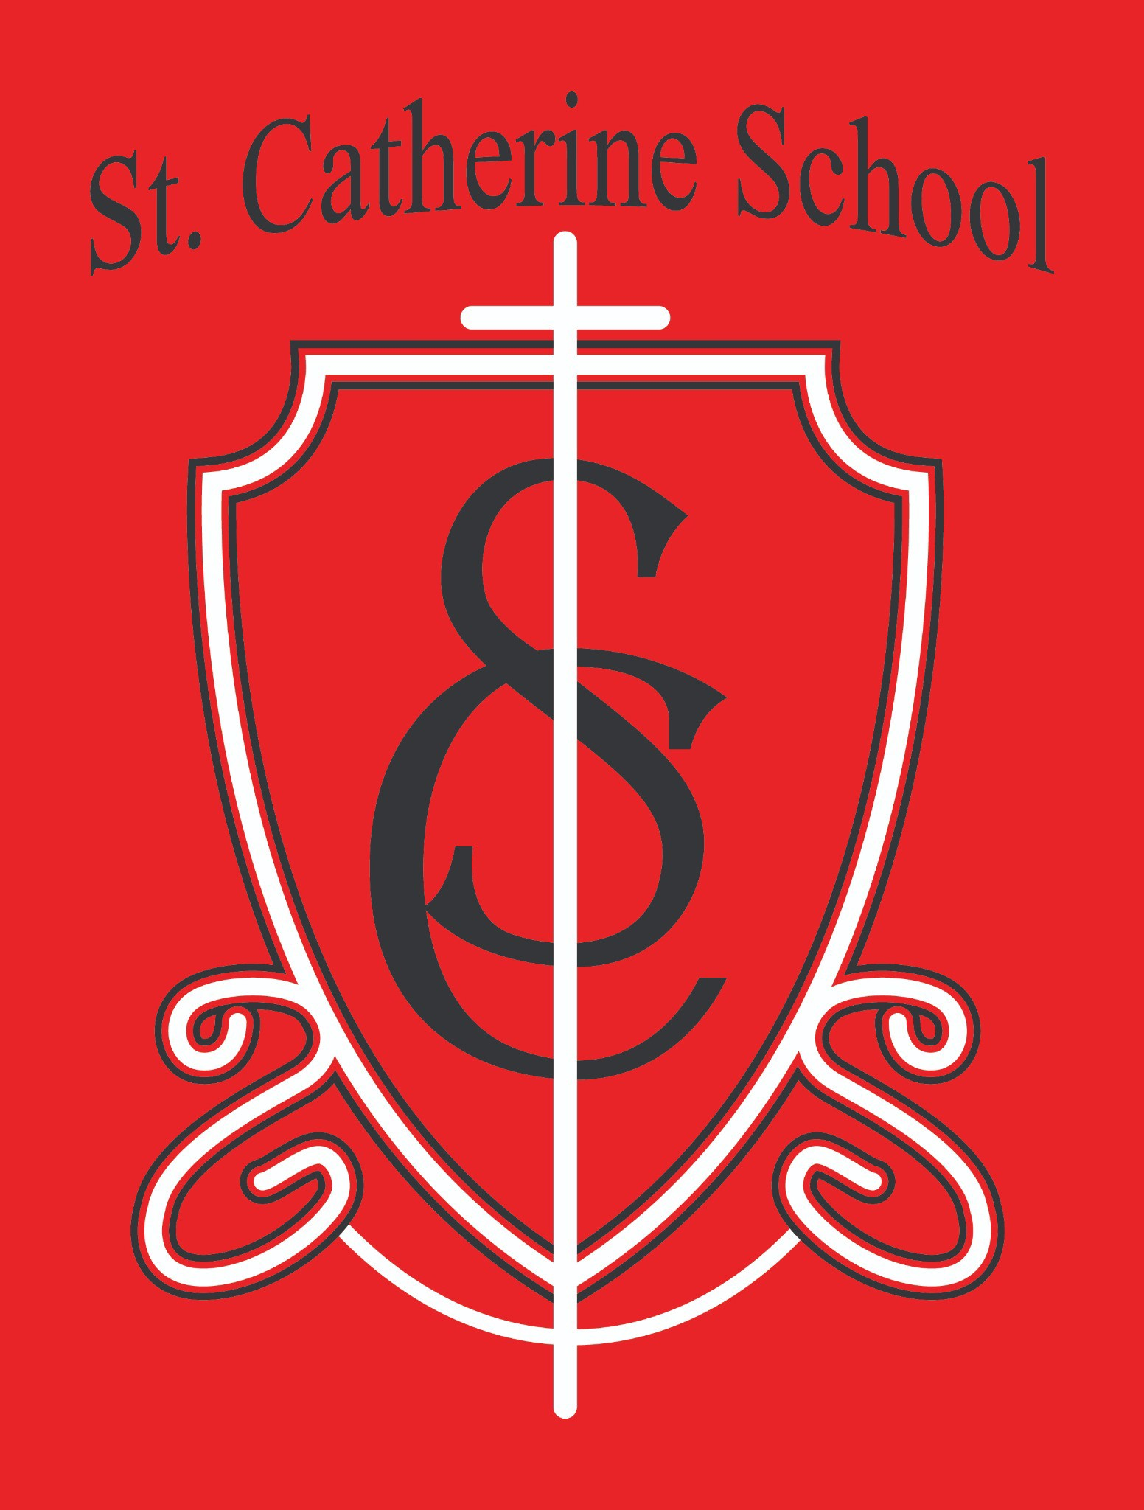

**St. Catherine School Weekly Newsletter (Week of January 13-17)**

[**https://www.stcatherine.k12.nd.us/parents**](https://nam02.safelinks.protection.outlook.com/?url=https%3A%2F%2Fwww.stcatherine.k12.nd.us%2Fparents&amp;data=05%7C02%7CTerra.Giesen%40k12.nd.us%7C195510a171d94d69ae0708dd375879d5%7Cdbbf782acef14af186c81f9201061db6%7C0%7C0%7C638727575341802107%7CUnknown%7CTWFpbGZsb3d8eyJFbXB0eU1hcGkiOnRydWUsIlYiOiIwLjAuMDAwMCIsIlAiOiJXaW4zMiIsIkFOIjoiTWFpbCIsIldUIjoyfQ%3D%3D%7C0%7C%7C%7C&amp;sdata=46YrhLPQ3sbkPHTB%2FsUGwz9s1hiSOzORe%2FxYzmRXzE4%3D&amp;reserved=0)

# Principal's Message

Dear St. Catherine Families,

I am thrilled to share that **Alex Benner** will be joining our team as the new **Custodian**. He starts full-time on January 27th, but you may see him around the school this coming week. A native of Billings, Montana, Alex has previously worked as a custodian and maintenance staff member in a Catholic school setting. We are incredibly thankful for the strong pool of applicants we received and are grateful to have found someone who already values Catholic education. Please join me in welcoming Alex to the St. Catherine School community!

# Reminders

## No School – Monday, January 20th (Martin Luther King Jr. Day)

#### There will be **no school** on Monday, January 20th in observance of Martin Luther King Jr. Day.

Classes resume as usual on Tuesday, January 21st.

Winter Weather Gear

We’ve been having indoor recess when conditions are extremely cold or unsafe, but students do go outside when weather allows.

**Snow pants, snow boots, a coat, hat, and gloves** are required **every day**.

We decide on indoor vs. outdoor recess each morning, so please ensure your child is prepared for either option.

Quarter 2 Report Cards

Report cards for Quarter 2 were sent home during Christmas break.

Please **sign and return** your child’s report card, or contact Ms. Giesen at **701-845- 1453** if you need a new copy.

#### Having the signed report card ensures you’ve reviewed your child’s progress.

Catholic Schools Week 2025 (January 26 – February 1)

We are excited to celebrate **Catholic Schools Week** from **Sunday, January 26th** through **Saturday, February 1st**. This year’s theme is **“Catholic Schools United in Faith and Community.”**

**Sunday, January 26 – PTO Breakfast (9 AM to Noon)**

Open to all parishioners and non-parishioners.

Menu: scrambled eggs, pancakes, sausage, bacon, juice, and coffee. Freewill offering goes to St. Catherine School PTO.

Volunteers needed for 8:30–10:30 AM or 10:30 AM–12:30 PM (also Saturday prep after 5 PM Mass).

Contact: **PTO President, Kaitlen Lee** at [kaitlen.uecker@gmail.com](mailto:kaitlen.uecker@gmail.com) or call the school at **701-845-1453**.

**Monday, January 27 – Veterans Program (11 AM)**

We invite veterans and active-duty military to a special program.

Submit photos of veterans (with name, branch, and years of service if known) to **Ms. Busch** at [alexis.a.busch@k12.nd.us](mailto:alexis.a.busch@k12.nd.us).

Veterans and active-duty members are welcome to stay for lunch—RSVP to

**701-845-1453**.

**Thursday, January 30 – Catholic Schools Week Bingo (2 PM)**

Families and parishioners are welcome to join us in the church hall for bingo.

**Friday, January 31 – All School Mass (11 AM) & Early Dismissal**

Mass at **11 AM**.

#### Students return to the school for belongings before early dismissal.

If not attending Mass, please pick up students **12:10–12:15 PM** (usual early dismissal process).

**Other Special Events**

Watch for a **digital permission form** via email for additional activities and a top-secret event!

**St. Catherine Spotlight**

* **First Grade Success**

Our 1st graders did a fantastic job on their first spelling test, and many are making great strides in reading. Keep it up!

* **Ms. Busch’s Flexibility**



While I was touring a Catholic daycare in Wahpeton, Ms. Busch graciously stepped into several extra roles around the school. We appreciate her willingness to support our staff and students. Another staff member noted it to me and I thought it was worth sharing.

* **Band Kids’ New Space**

Our band students have been using a new (though temporary) space for rehearsals. They’re excited about this setup and enjoy having a dedicated area to practice.

* **Chess Club Leadership**

A big shoutout to our older chess club members who took time to mentor younger students, teaching them the basics of the game. This leadership and mentorship truly embodies the spirit of our St. Catherine community.

Stay Connected with St. Catherine School

📍 **Address:** 540 3rd Ave. NE, Valley City, ND 58072

**Email:** [nicholas.lee1@k12.nd.us](mailto:nicholas.lee1@k12.nd.us)

📧

**Phone:** 1-701-845-1453

📞

**Website:** [www.stcatherine.k12.nd.us](https://nam02.safelinks.protection.outlook.com/?url=https%3A%2F%2Fwww.stcatherine.k12.nd.us%2F&amp;data=05%7C02%7CTerra.Giesen%40k12.nd.us%7C195510a171d94d69ae0708dd375879d5%7Cdbbf782acef14af186c81f9201061db6%7C0%7C0%7C638727575341821719%7CUnknown%7CTWFpbGZsb3d8eyJFbXB0eU1hcGkiOnRydWUsIlYiOiIwLjAuMDAwMCIsIlAiOiJXaW4zMiIsIkFOIjoiTWFpbCIsIldUIjoyfQ%3D%3D%7C0%7C%7C%7C&amp;sdata=dwMVsoEFiyRd7Ke9N9MYNGiYrO%2BkCdufYbyFaVbPwvE%3D&amp;reserved=0)

##### 🌐

📘 **Follow Us on Facebook:** [St. Catherine School on Facebook](https://nam02.safelinks.protection.outlook.com/?url=https%3A%2F%2Fwww.facebook.com%2Fst.catherineschoolvc%2F&amp;data=05%7C02%7CTerra.Giesen%40k12.nd.us%7C195510a171d94d69ae0708dd375879d5%7Cdbbf782acef14af186c81f9201061db6%7C0%7C0%7C638727575341837386%7CUnknown%7CTWFpbGZsb3d8eyJFbXB0eU1hcGkiOnRydWUsIlYiOiIwLjAuMDAwMCIsIlAiOiJXaW4zMiIsIkFOIjoiTWFpbCIsIldUIjoyfQ%3D%3D%7C0%7C%7C%7C&amp;sdata=Actk8ET1eRDWplXVGA%2BmZU6LeVSxPGWnXv077yhvojY%3D&amp;reserved=0)

*“Inspiring excellence through faith, learning, and service.”*