**2024-2025 Travel Log Form Directions**

1. Enter employee name
2. Enter name of conference/meeting
3. Enter name of destination
4. Enter dates and actual time of departure/arrival. This must be entered in the following format: 1:00 PM (with a space after the minute, before the AM/PM). If this is entered incorrectly, you will see an error.

# Incorrect Time Format:

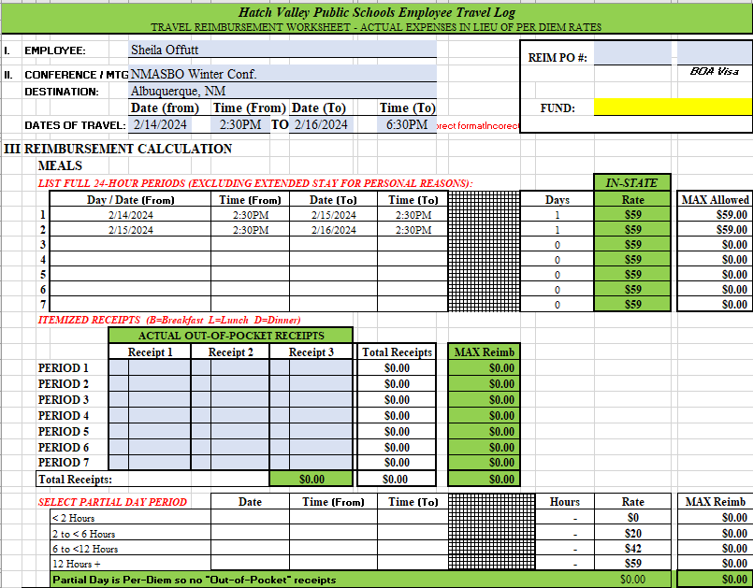

2 times entered incorrectly result in incorrect format error note.

Partial Day reimbursement will not populate

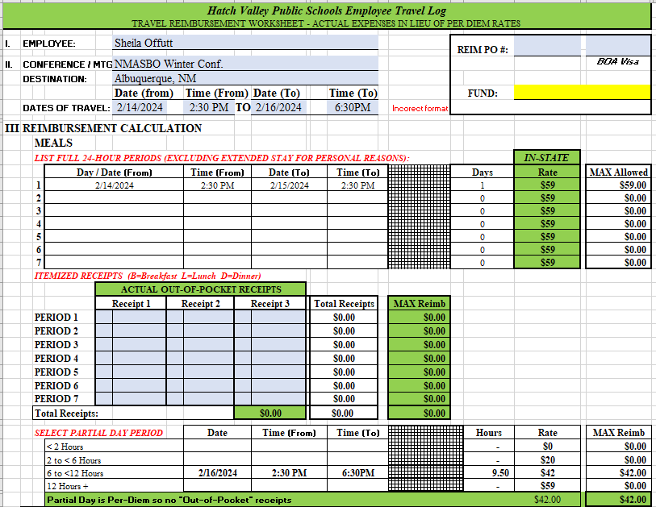

1 time entered incorrectly result in incorrect format error note.

Daily reimbursement periods are incorrect

# Correct Time Format:

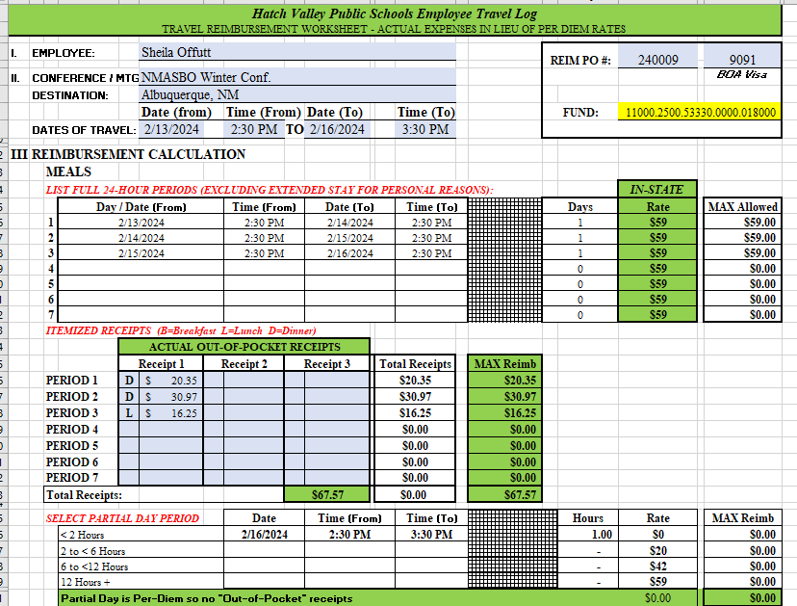

The error is gone!

1. Enter Reimbursement PO # and last 4 digits of the credit card used for the hotel, and the fund code from the File Copy of your PO. The school site secretary should have this information.

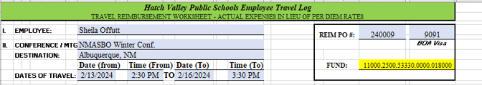

1. Enter your meal receipts (incl. 15% tip unless large group rate applies) in the correct Period as calculated on the form:

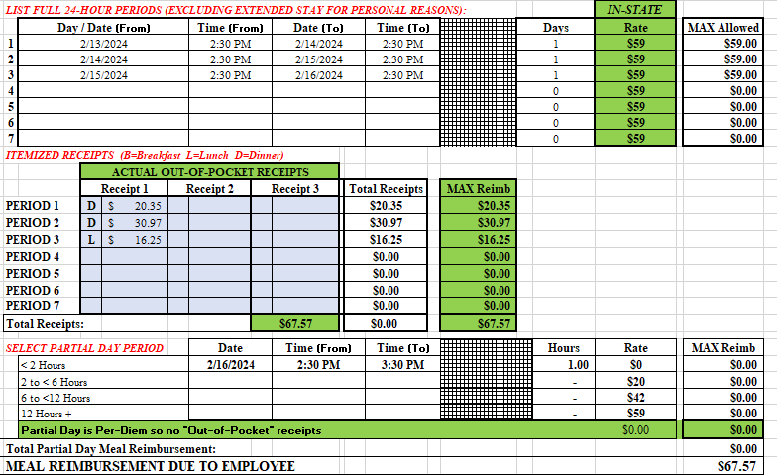

On this trip, Period 1 starts the time you leave Hatch at 2:30 on 2/13, and ends at 2:30 on 2/14. Period 2 begins at 2:30 on 2/14 and ends on 2/15 at 2:30. Period 3 begins at 2:30 on 2/15 and ends on 2/16 at 2:30.

Original receipts (itemized and receipt showing amount paid) must be attached to the travel log.

Period 1 (Dinner)

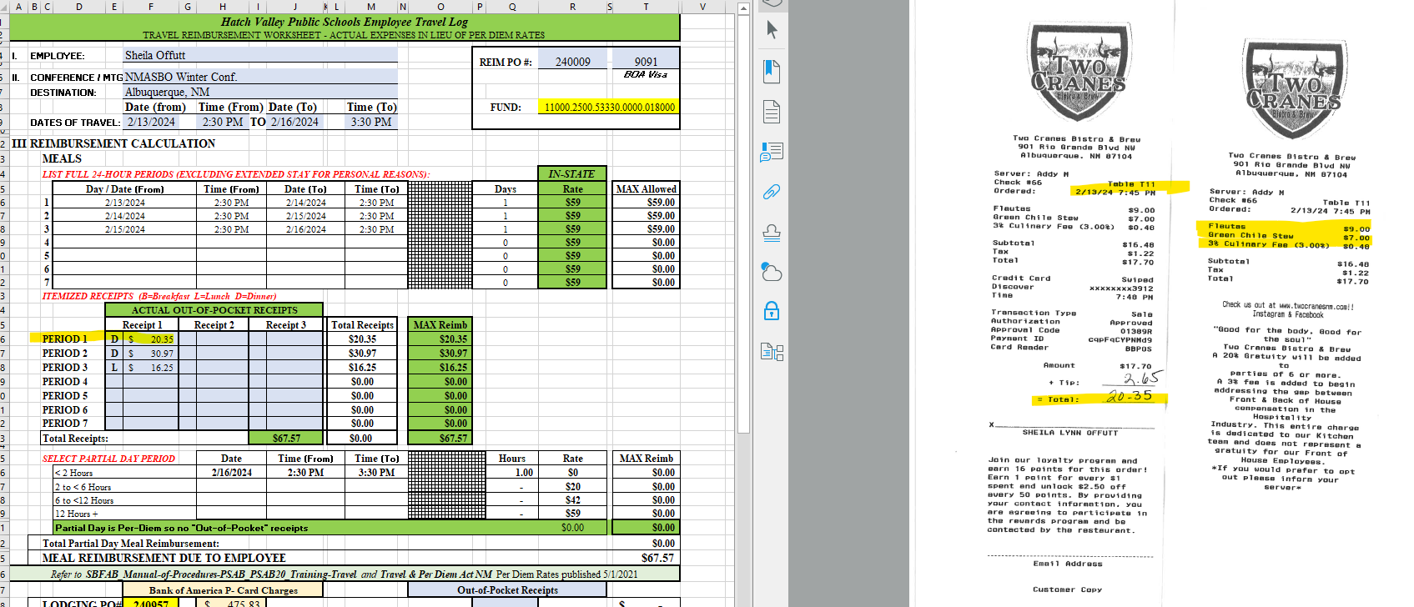



# Period 2 (Dinner)

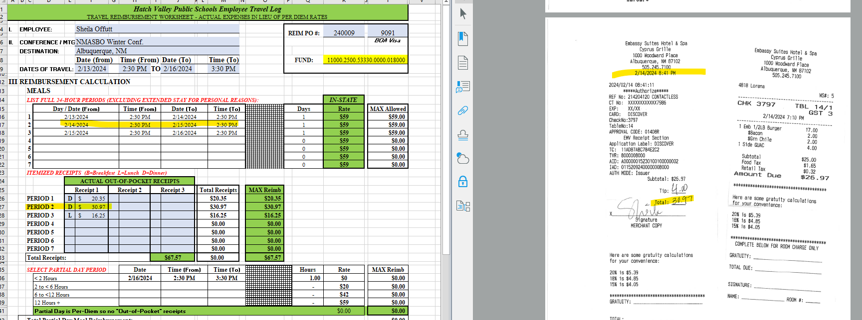

# Period 3 (Lunch)

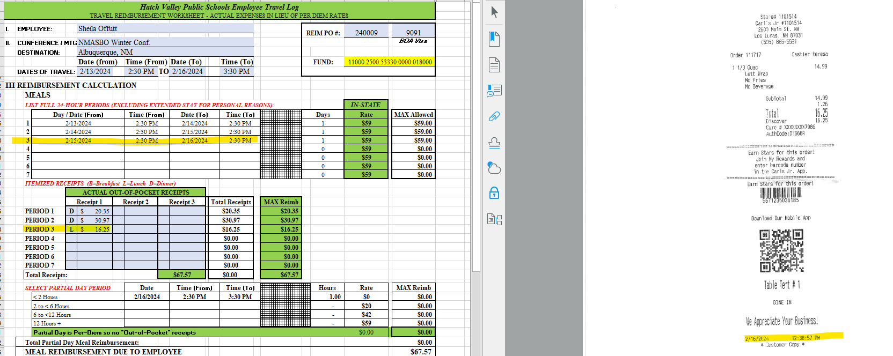

Any receipts stamped after 2:30 on 2/16 will be considered partial day and are NOT entered in Actual Out-Of-Pocket Receipts. *I did not have a reimbursement for partial day on this travel log. If I had returned home after 4:30 PM, I would have a $20 Reim.; after 8:30 PM a $42 Reim.; after

1. Enter PO number in the yellow boxes and amounts charged to school BOA card in tan boxes, when applicable and provide copies of all receipts and registration confirmation and certificates of attendance, agendas, name badges, etc. as outlined on Travel Agreement.

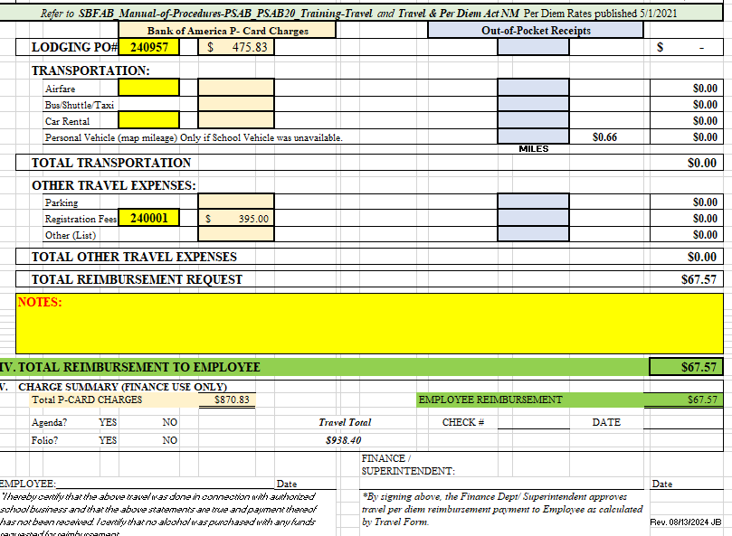

1. Print document to PDF:
   1. Click File b. Click Print c. Click arrow on right of Printer,

and select pdf or Power PDF

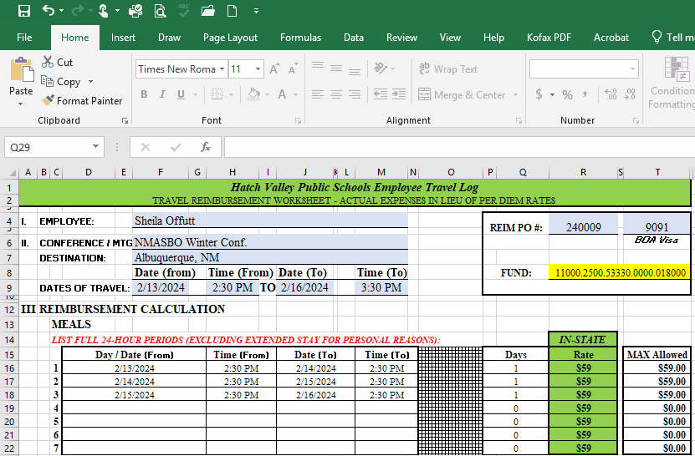 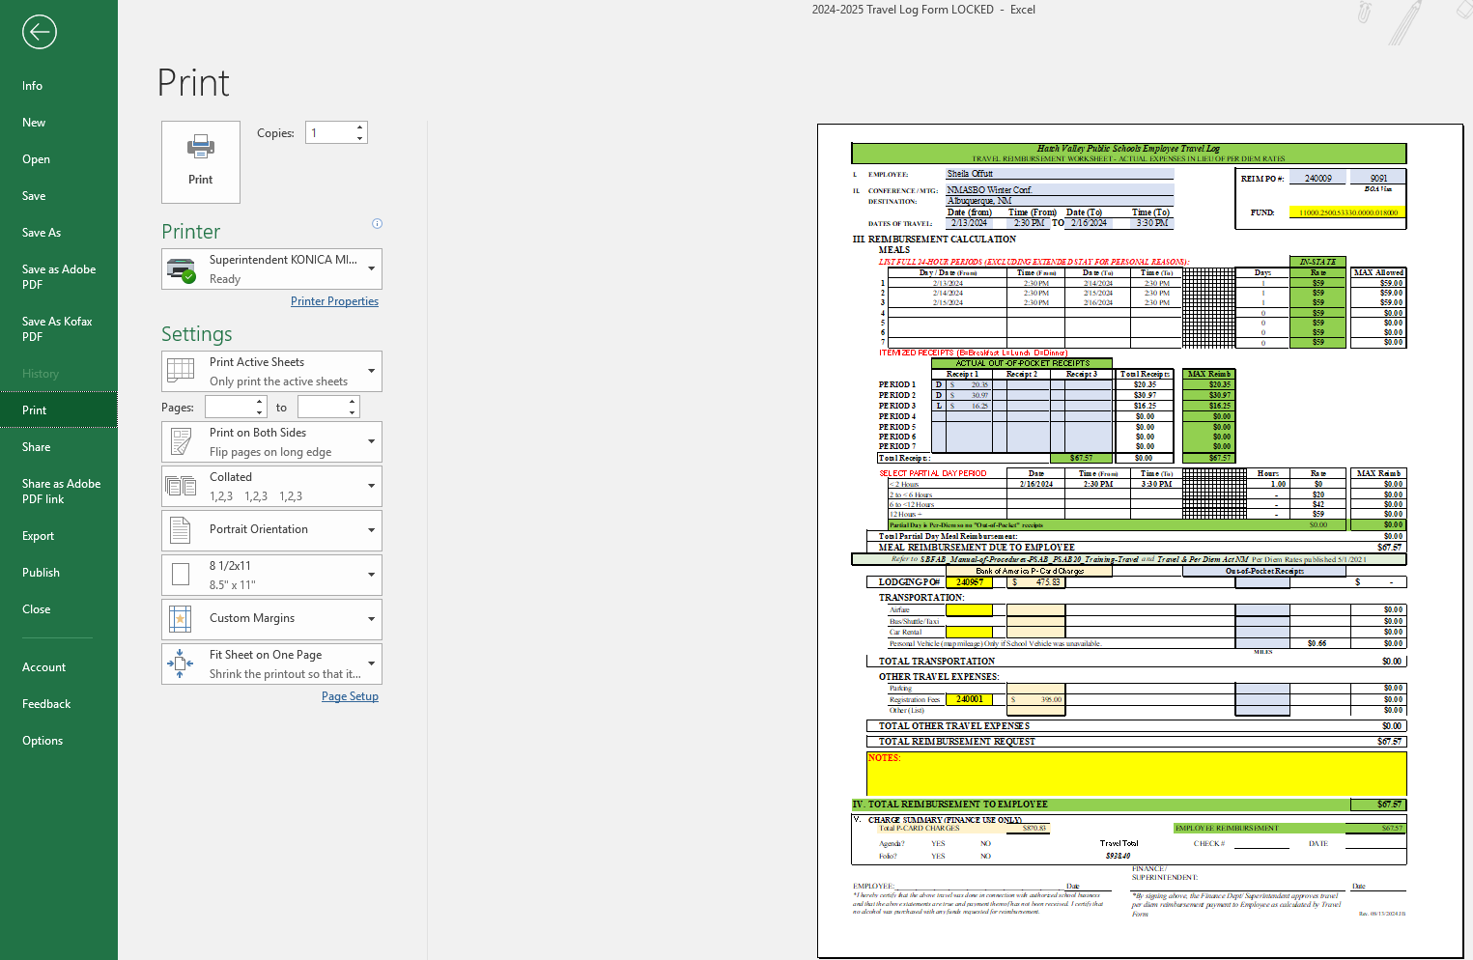 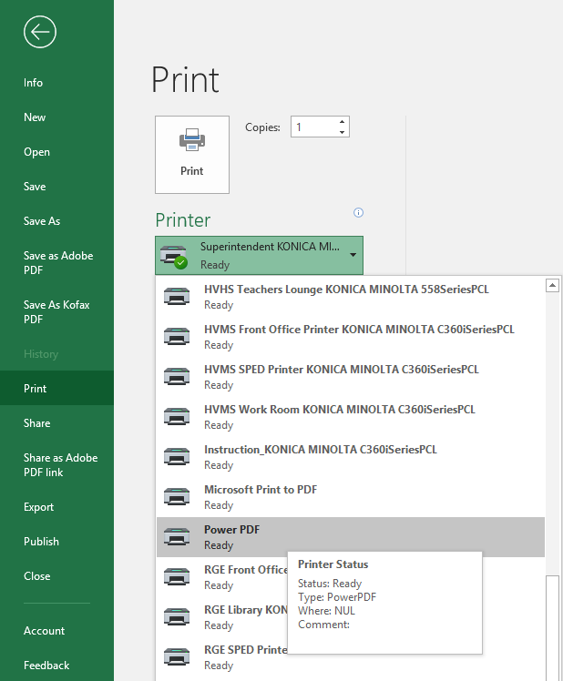

d. Click Print e. Choose file location, enter name of file, click save.

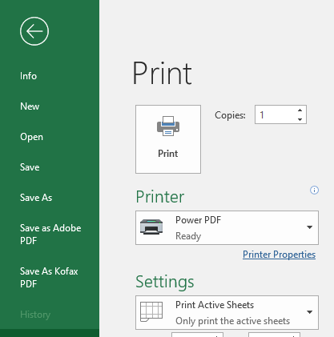 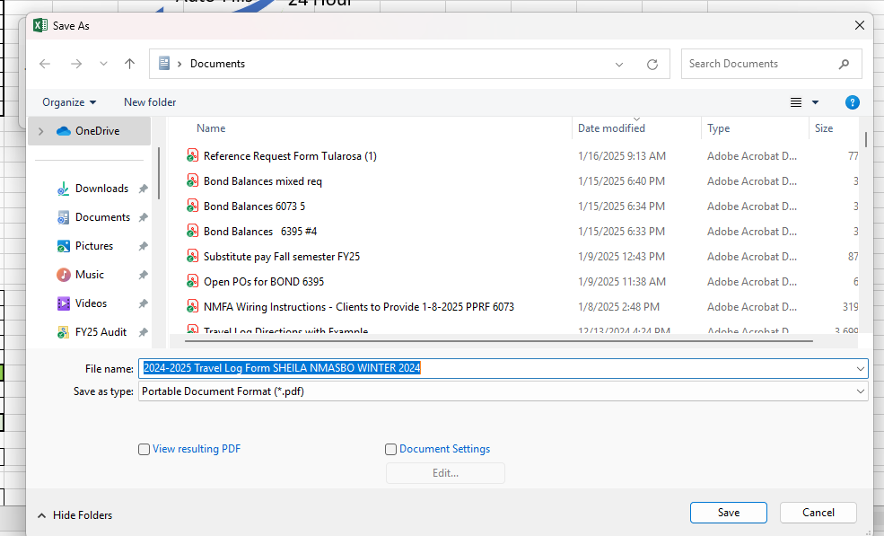

1. Sign/date via Adobe and send to Sheila Offutt for Approval via Adobe.
   1. Open file location to open your pdf in Adobe.

NOTE: You may add pages to the Travel log before sending for signatures. Steps to do this:

* + - * 1. Open Adobe File. Click Edit.
        2. Click Organize pages.
        3. In another window, open the file location (My Documents) and drag/drop the additional files such as a scanned copy of receipts, agenda, badge, hotel folio, etc.
        4. Click on the X to close the Organize pages window.
        5. Click Save.
        6. Proceed with e-signature steps below.
  1. Click e-Sign

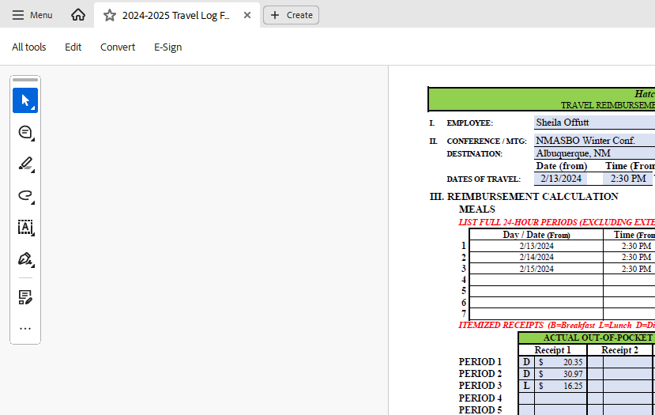

* 1. If signing for yourself, click the signature. If sending to another employee to sign, click Request e-signatures.

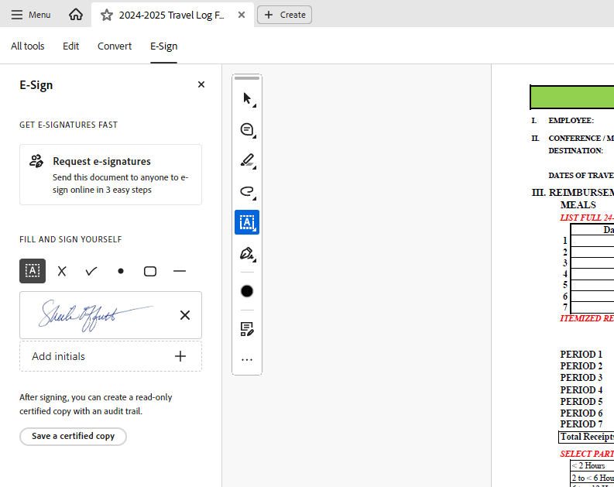

To send for signatures, click here

Click and drag to insert your own signature

* 1. Type the email addresses of the intended recipients, and enter message if needed. Click Specify where to sign

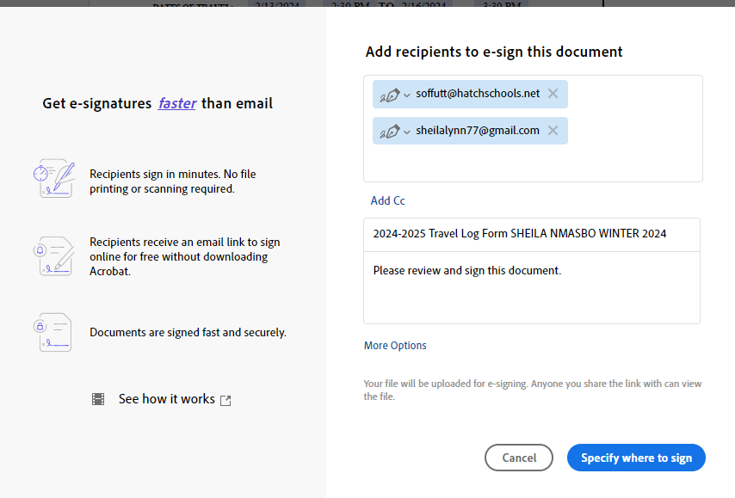

Enter addresses (using personal email for illustration purposes only)

Click to continue

* 1. Click and Drag “Signature” to the location where the signature should be entered. 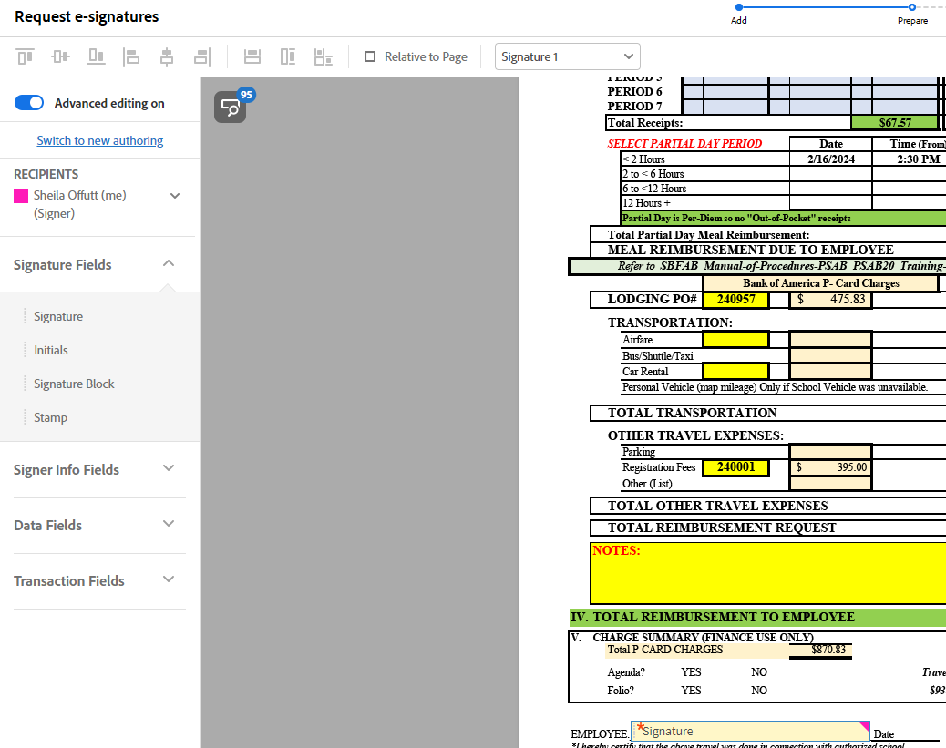
  2. Click “Signer Info Fields” and Click and Drag “Date” and any other relevant fields to the correct Location on the document.

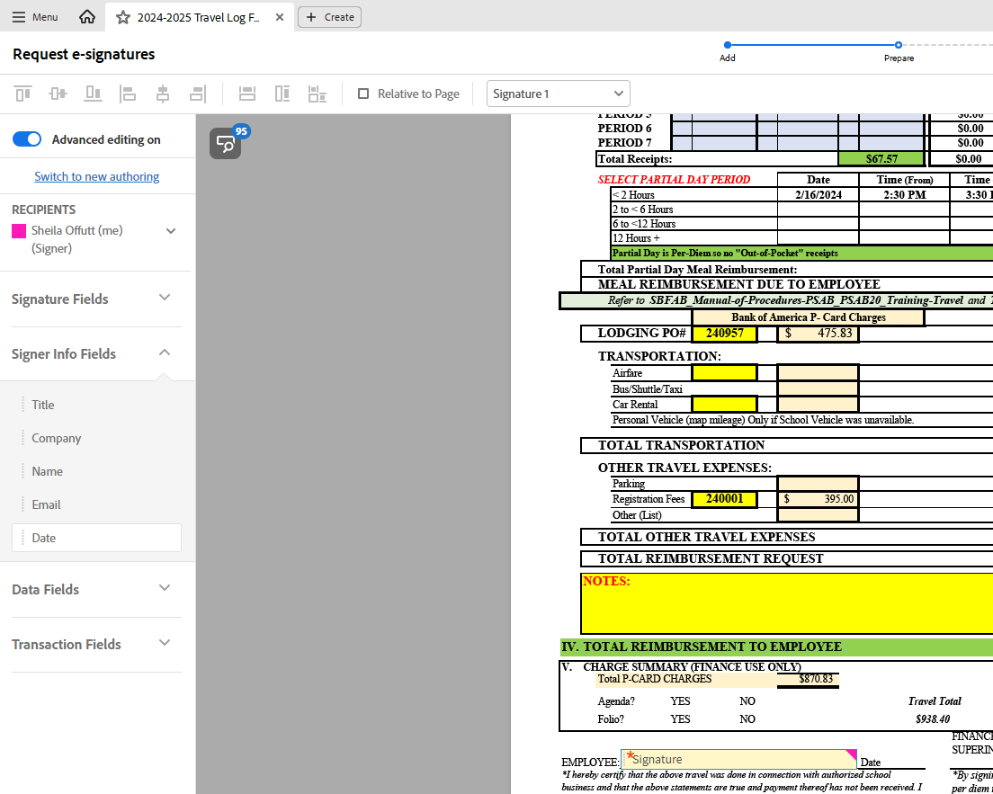

* 1. Click the drop-down button on the Recipients list and choose second (or third, etc.) recipient, and follow above steps. Click SEND (Bottom Left of screen)

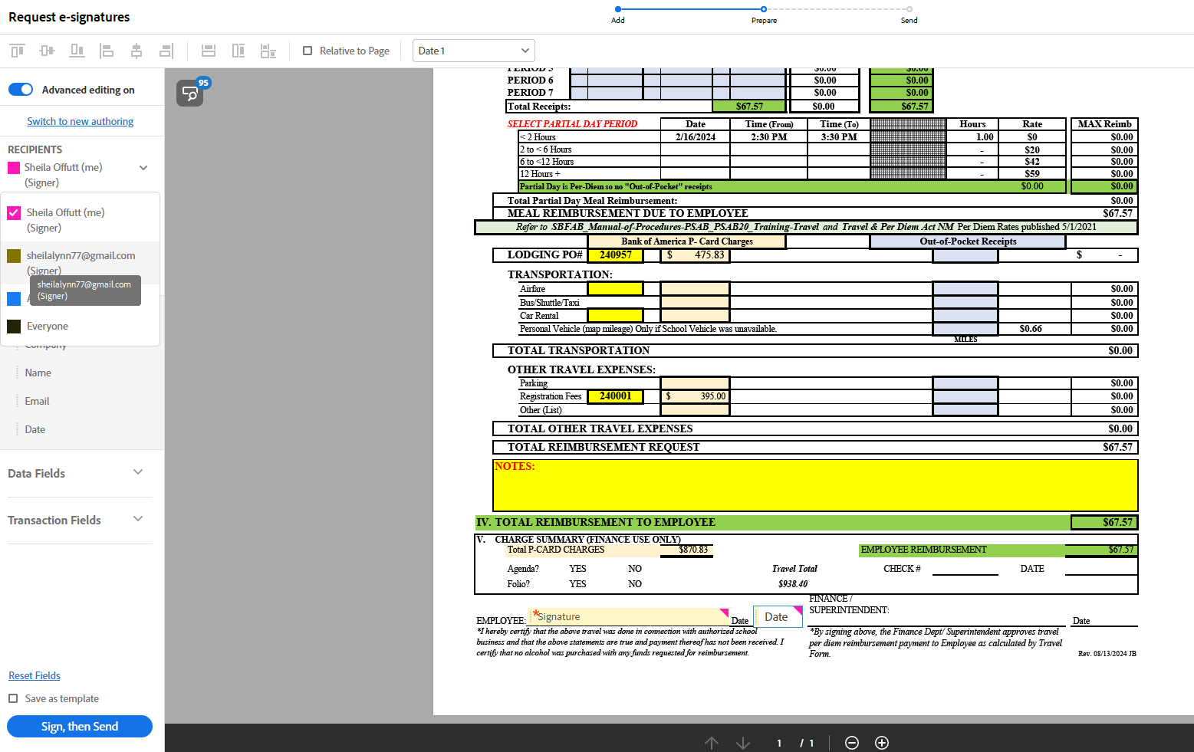

* 1. Click Close. Signers should receive an email to sign.

1. If you have not received the signed PDF back, you can log into Adobe via your Gmail account and send a reminder to the signer, or cancel if the PDF is no longer needed. Click on the file pending a signature, then additional options will appear on the right:

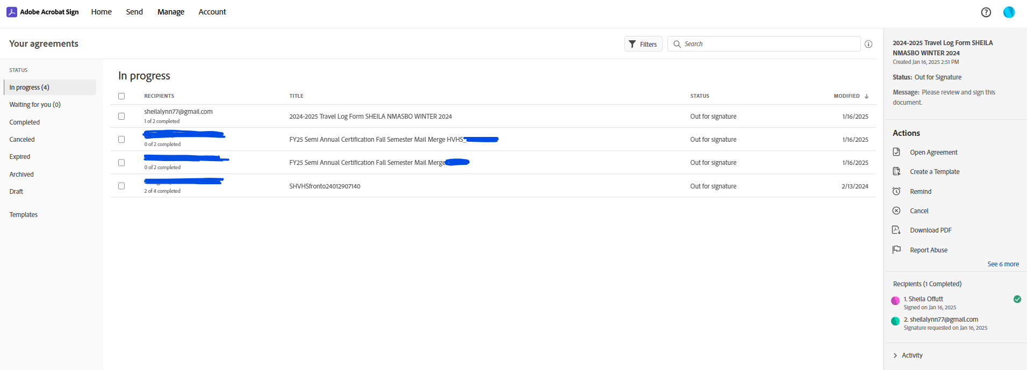

1. Submit all paperwork to Raney Weiler in AP for payment.