AP Biology

Unit 3

Student Notes

Unit 4 Student Notes

Table of Contents

- Bioenergetics—Pages 3-4
- Metabolism and Metabolic Pathways—Pages 4-6
- Thermodynamics—Pages 6-7
- ATP—Pages 7--9
- Coupling—Page 9
- Phosphorylation—Pages 9-10
- Enzymes—Pages 11-15
- Factors That Affect Enzyme Activity—Pages 12-15
- Inhibitors—Pages 13-15
- Feedback Inhibition—Pages 14-15
- Introduction to Cellular Respiration—Page 15
- Redox Reactions—Pages 16-17
- Aerobic Cellular Respiration—Pages 17-29
- Glycolysis—Pages 18-21
- The Mitochondria—Pages 21-22
- Pyruvate Conversion—Pages 23-24
- Krebs Cycle—Pages 24-25
- Electron Transport Chain—Pages 26-27
- Utilizing Proteins and Lipids as Energy Sources—Pages 28-29
- Anaerobic Cellular Respiration—Pages 29-31
- Photosynthesis—Pages 32-44
- Overview of Photosynthesis—Page 32
- Chloroplast Structure—Page 33
- Light Energy—Pages 33-35
- Absorption and Reflection of Light—Pages 35-36
- Absorption Spectrum—Page 37
- Light Dependent Reactions of Photosynthesis—Pages 37-39
- Calvin Cycle—Pages 40-41
- Fitness/Photorespiration & Adaptations for Hot/Dry Con.—Pages 41-43
- Thermoregulation—pages 44-46
Key Ideas/Enduring Understandings for this unit:
- The highly complex organization of living systems requires constant input of energy and the exchange of macromolecules.
- Naturally occurring diversity among and between components within biological systems affects interactions with the environment.
Bioenergetics Student Notes

Bioenergetics
Bioenergetics is a field of Biology that concerns energy flow through living systems. The field includes the study of the processes involved in the transferring and transforming of energy in living organisms. This includes the study of enzymatic processes, metabolic pathways, cellular respiration, and photosynthesis. The goal of bioenergetics is to describe how living organisms acquire, transfer, and transform energy in order to perform biological work.

It is important to note that while matter and energy move through an ecosystem together when they are contained within organic compounds, they follow different paths at the beginning and the end of food chains and food webs. Producers (like plants and algae) get matter from carbon dioxide, water, and minerals (from the soil). They get energy from sunlight. Heterotrophs get both matter and energy from food. All of the matter is eventually converted back into carbon dioxide, water, minerals, and some metabolic wastes, while all of the energy leaves the ecosystem as heat. This heat ultimately flows out into space. Matter cycles continuously through an ecosystem, while energy flows through the ecosystem and eventually ends up in space. The energy isn’t used up or created. It is simply transformed (from one type of energy to another type) and transferred from one place or organism to another as it moves through the ecosystem.

An extremely important idea from this unit is that “The highly complex organization of living systems requires a constant input of energy and the exchange of macromolecules.

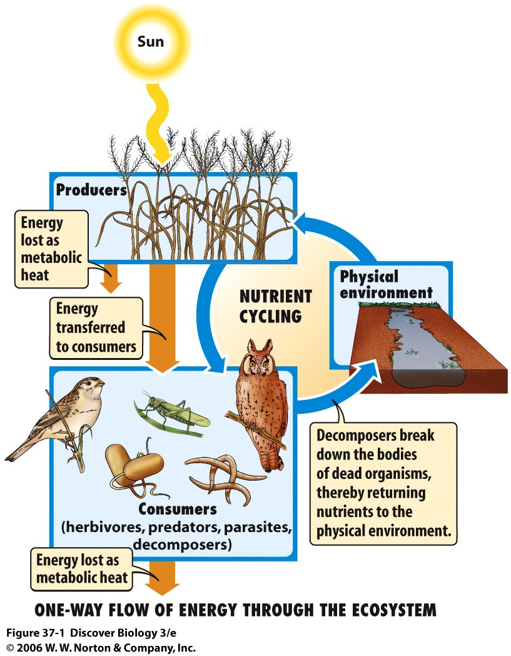

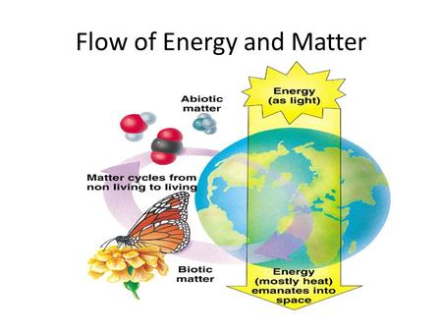
Enzymes and Energy Student Notes

Metabolism
Enzymes, Metabolism, and Energy Screencast
Metabolism--The sum of all the chemical reactions occurring in an organism. All of life’s processes occur due to chemical reactions.
Metabolism can be subdivided into two separate phases.
Catabolism – This refers to chemical reactions which break down molecules.
In many cases, catabolic reactions release the “potential” energy found in the chemical bonds between monomers.
These reactions are often exergonic reactions because they release heat energy to the environment

Anabolism –These reactions combine monomers to build polymers.
Anabolic reactions usually require an input of “Kinetic” energy to create bonds between the monomers.
Usually, anabolic reactions are endergonic reactions because they absorb energy from the environment.

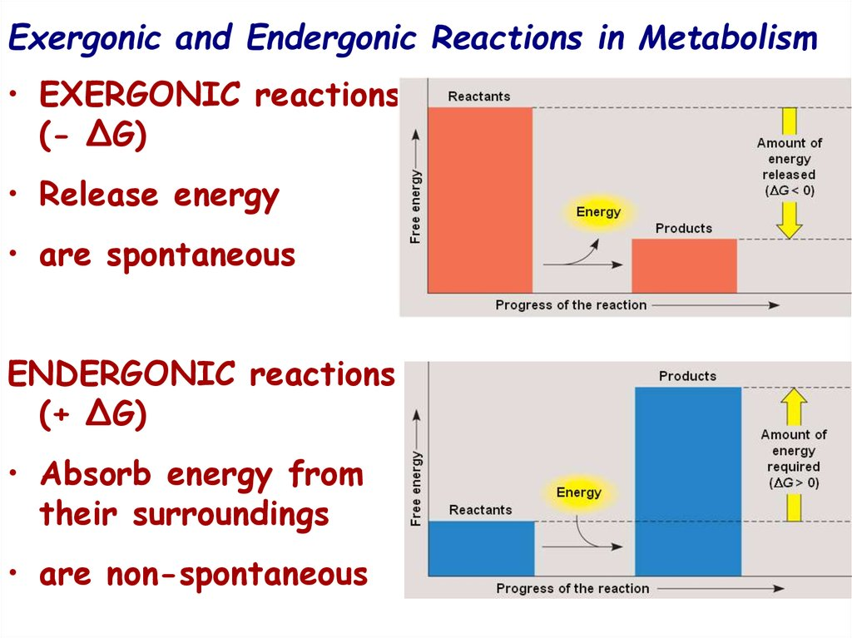

- 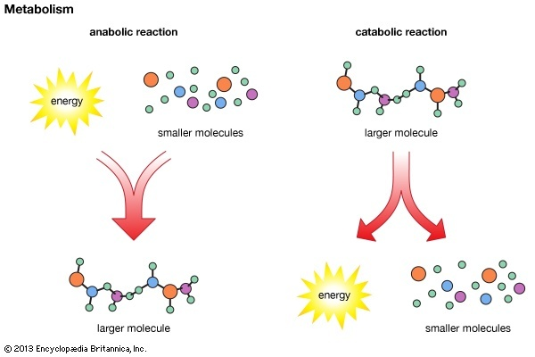

Energy (represented by “E”)—The ability to do work or make things move.

There are three main types of Energy that affect living organisms.
Kinetic Energy (represented as “KE”) - This is the energy of movement. (Usually refers to the movement of electrons or protons in Biology.)
Potential Energy (represented as “PE”) – This is energy in its stored form. (In Biology, this usually refers to the energy stored in the bonds of chemicals.)
Thermal Energy—Thermal energy is a form of kinetic energy. The movement of thermal energy is called heat. Thermal energy/heat is often released to the environment during chemical reactions.

For living organisms, the chemical energy of life is found in chemical bonds.
The processes of Cellular Respiration and Digestion are catabolic processes which release energy from biological macromolecules for use by cells.
The process of photosynthesis, an anabolic process, allows plants to store solar energy in the form of chemical energy (sugar). The process involves the bonding together of carbon atoms (from carbon dioxide) to create biological macromolecules like sugars.

Metabolic Pathways

Metabolic pathways—Everything that happens in a cell happens because of chemical reactions. Most of these processes are complicated and require lots of chemical reaction steps to take place. Metabolic pathways are enzyme-regulated sets of biochemical reactions that lead to either biosynthesis (anabolic pathways) or breakdown (catabolic pathways). Examples of metabolic pathways include glycolysis, the Krebs cycle, and the Calvin Cycle. Photosynthesis, Cellular Respiration, and Digestion might also be thought of as metabolic pathways. Each step of a metabolic pathway consists of a separate chemical reaction. Metabolic pathways consist of a sequential set of chemical reactions in which the products of one reaction are typically the reactants (substrates) for the next reaction. Each step is catalyzed by a different, specific enzyme.

Many of the major metabolic pathways such as glycolysis and Krebs cycle are conserved across most living things. This indicates that the organisms inherited the metabolic pathways from a common ancestor.

Sample Metabolic Pathway
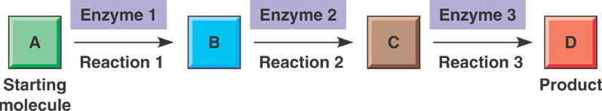

Thermodynamics

The study of Heat Energy(Thermo) and its properties (dynamics).

First Law of Thermodynamics (Also called the Law of the Conservation of Energy)
Energy cannot be created nor destroyed but can be transformed from one type of energy to another type of energy and can be transferred from one location to another location.

Second Law of Thermodynamics
Every energy transfer increases the entropy of the universe.
Entropy- a thermodynamic quantity representing the unavailability of a system's thermal energy for conversion into mechanical work; often interpreted as the degree of disorder or randomness in the system. Essentially, the Second Law of Thermodynamics says that during every energy transfer, some of the system’s energy is converted to heat. This heat is then unavailable to do useful work. Life requires a highly ordered system and
does not violate the Second Law of Thermodynamics. This means that the amount of energy input into an
organism or biological system must exceed the amount of energy lost to maintain order and power cellular
processes. The loss of order or energy flow results in the death of the organism.
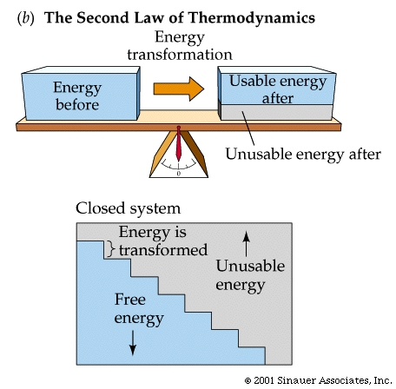

ATP

A cell can be thought of as a small, busy city. Carrier proteins move substances into and out of the cell, motor proteins carry cargo along microtubule tracks, and metabolic enzymes busily break down and build up macromolecules.
Even processes that are not energetically favorable (spontaneous or exergonic) will occur if there is energy available to power them. However, if the energy runs out, the reactions will grind to a halt, and the cell will begin to die.
Energetically unfavorable reactions are “paid for” by coupled, energetically favorable reactions that release energy. Often, the "payment" reaction involves one particular small molecule: adenosine triphosphate, or ATP.

Adenosine triphosphate, or ATP, is a small, relatively simple molecule. It can be thought of as the main energy currency of cells, much as money is the main economic currency of human societies. The energy released by the hydrolysis (breakdown) of ATP is used to power many energy-requiring cellular reactions.

Structurally, an ATP molecule is composed of a single nucleotide that bears a chain of three phosphates. At the center of the molecule lies a five-carbon sugar, ribose, which is attached to the nitrogenous base adenine and to the chain of three phosphates.
ATP is made unstable by the three adjacent negative charges in its phosphate tail, which "want" very badly to get further away from each other. The bonds between the phosphate groups are called phosphoanhydride bonds and are often referred to as “high-energy” bonds.

ATP
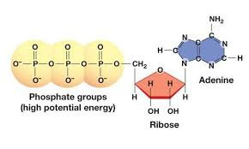

The conversion of ATP to ADP releases energy, which is used to power many metabolic processes.
All this really means is that an appreciable amount of energy is released when one of these bonds is broken in a hydrolysis (water-mediated breakdown) reaction. ATP is hydrolyzed to ADP in the following reaction:
ATP + H₂O →ADP + P_{i} + energy
Like most chemical reactions, the hydrolysis of ATP to ADP is reversible. The reverse reaction, which regenerates ATP from ADP and P, requires energy. ATP is regenerated during the process of cellular respiration. Regeneration of ATP is important because cells tend to use up (hydrolyze) ATP molecules very quickly.

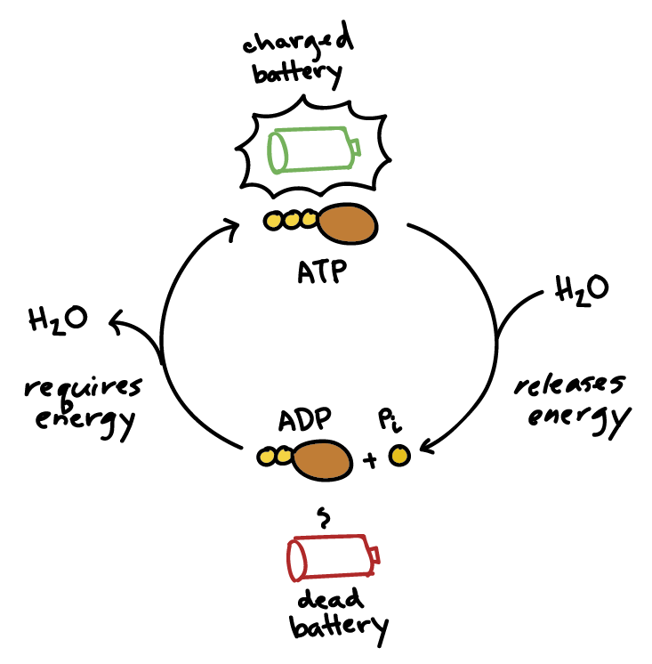

You can think of ATP and ADP as being sort of like the charged and uncharged forms of a rechargeable battery (as shown above). ATP, the charged battery, has energy that can be used to power cellular reactions. Once the energy has transferred to another molecule, the uncharged battery (ADP) must be recharged before it can again be used as a power source. The ATP regeneration reaction is just the reverse of the hydrolysis reaction.

∆G for the hydrolysis of one mole of ATP in a living cell is around -14 kcal/mol or −57 kJ/mol. Because of this value, the reaction is extremely spontaneous. This means that ATP is very reactive and is difficult for the body to store or transport. This is why plants use ATP to make glucose. Glucose and other sugars are much more storable and transportable energy molecules.

Coupling
The energy from ATP is often used to power endergonic reactions via a process known as reaction coupling. During coupling an energetically favorable/spontaneous reaction (like ATP hydrolysis) is directly linked with an energetically unfavorable (endergonic) reaction. This essentially means that a reaction that releases energy (like the hydrolysis of ATP) is often coupled with reactions that require an input of energy.
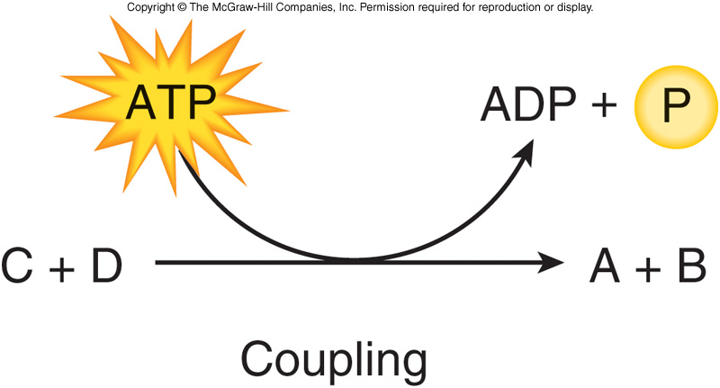

Phosphorylation

When reaction coupling involves ATP, the shared intermediate is often a phosphorylated molecule (a molecule to which one of the phosphate groups of ATP has been attached). As an example of how this works, let’s look at the formation of sucrose, or table sugar, from glucose and fructose.

The formation of sucrose requires an input of energy: its ΔG is about +27 kJ/mol. ATP hydrolysis has a ΔG around -30 kJ/mol, so it can release enough energy to “power” the synthesis of a sucrose molecule

How is the energy released in ATP hydrolysis channeled into the production of a sucrose molecule? As it turns out, there are actually two reactions that take place, not just one big reaction, and the product of the first reaction acts as a reactant for the second.
In the first reaction, a phosphate group is transferred from ATP to glucose, forming a phosphorylated glucose intermediate (glucose-P). This is an energetically favorable (energy-releasing) reaction because ATP is so unstable, i.e., really "wants" to lose its phosphate group.
In the second reaction, the glucose-P intermediate reacts with fructose to form sucrose. Because glucose-P is relatively unstable (thanks to its attached phosphate group), this reaction also releases energy and is spontaneous.

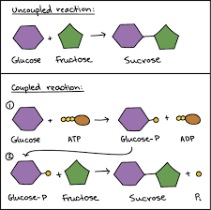

This example shows how reaction coupling involving ATP can work through phosphorylation, breaking a reaction down into two energetically favored steps connected by a phosphorylated (phosphate-bearing) intermediate. This strategy is used in many metabolic pathways in the cell, providing a way for the energy released by converting ATP to ADP to drive other reactions forward.

Protein phosphorylation is the major molecular mechanism through which protein function is regulated in response to extracellular stimuli both inside and outside the nervous system. Virtually all types of extracellular signals, including neurotransmitters, hormones, light, neurotrophic factors and cytokines, produce most of their diverse physiological effects by regulating phosphorylation of specific phosphoproteins in their target cells.

It is the job of a group of enzymes known as protein kinases to carry out the many phosphorylations that happen in a cell.

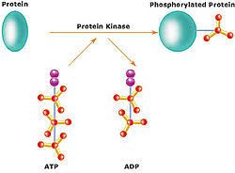

.

Enzymes

After completing this unit, students should be able to describe the properties of enzymes.
Enzymes are proteins which catalyze chemical reactions. Enzymes increase the rate of biological reactions.
They do this by lowering the activation energy required for a reaction to occur.
The substance(s) acted upon by an enzyme is the substrate.
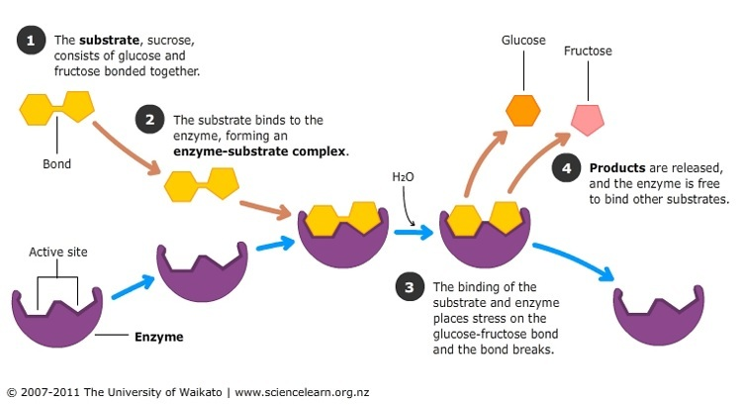

The substrate binds to an area of the enzyme known as the active site. The shape of the substrate and enzyme must be complimentary. The charges of the substrate and active site must also be compatible. This ensures that each enzyme is very specific and only catalyzes one particular reaction.
Once the substrate binds to the enzyme, the enzyme undergoes a slight change in shape (induced fit). This change in shape helps to catalyze the reaction.
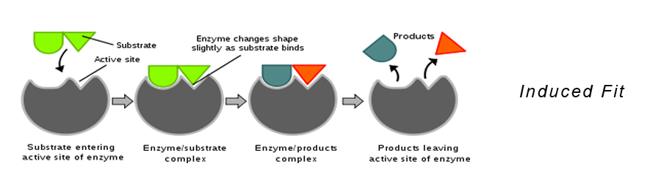

Some enzymes catalyze anabolic reactions, while others catalyze catabolic reactions.
Enzymes catalyze reactions, but aren’t themselves changed by or used up during the reactions in which they take part.
Each enzyme works best at a specific (optimal) temperature and pH. If the temperature and/or pH is moved away from the optimal conditions, the enzyme will begin to denature (change shape and lose function). This is largely because the changes in pH and increases in temperature disrupt the hydrogen bonds which help to provide and support the shape/structure of the enzyme. In most cases, denaturation is permanent although in some cases it can be reversible.
It is important to remember that pH is a measure of the hydrogen ion concentration in a solution. It can be calculated using: pH=-log[H⁺] Higher hydrogen ion concentrations [H⁺] lead to lower pH values. Lower hydrogen ion concentrations lead to higher pH values. Solutions with pH values below 7 are acidic, while those above 7 are basic.
Most human enzymes have an optimal temperature of 37 degrees Celsius and an optimal pH around 7.

Factors that can affect enzyme activity
Concentration of Enzymes and Substrates: The rate of reaction increases with increasing substrate concentration up to a point, beyond which any further increase in substrate concentration produces no significant change in reaction rate. This occurs because after a certain concentration of the substrate, all the active sites on the enzymes are full and no further reactions can occur. The rate of reaction also increases with increased enzyme concentration, up to the point at which all of the substrate is either used up or bound to an enzyme. The relative concentrations of substrates and products can also determine how efficiently an enzymatic process proceeds. When the concentration of products is high compared to the concentration of substrates, the reaction will proceed slowly. When the concentration of the substrates is high compared to the concentrations of the products, the reaction will proceed quickly.
Temperature: With an increase in temperature, enzyme activity increases because of the increase in kinetic energy of the molecules. More kinetic energy means more movement of enzymes and substrates. This means that the enzymes and substrates will bind to each other more often and more reactions will take place. There is an optimum level at which the enzymes work best. This temperature is often the normal body temperature. When the temperature increases beyond a certain limit, enzymes, which are actually made up of proteins, begin to denature and the rate of the reaction slows down.
pH: Enzymes are very sensitive to changes in pH and work in very small windows of permissible pH levels. Below or above the optimum pH level, there is a risk of the enzymes denaturing and the reaction rate slowing down.
Salinity: Enzymes are also very sensitive to salinity (salt levels). If salinity levels vary on either the high or low side of normal, enzymes may denature and reaction rates may slow.
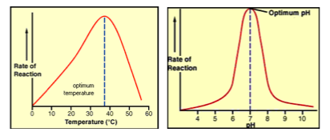

Inhibitors
Inhibitors: Certain substances can attach to and inhibit/prevent the action of a particular enzyme.

Types of Inhibitors:
Competitive Inhibitors- These molecules compete for the active site. They have a shape similar to that of the substrate. These molecules slow down the reaction rate because they prevent normal substrate binding. Some competitive inhibitors bind permanently to the enzyme and permanently deactivate it, while others bind reversibly.

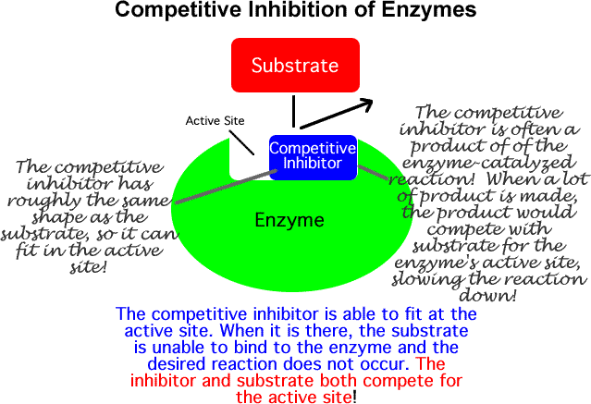
Non-competitive Inhibitors –These molecules attach somewhere other than the active site causing the shape of the active site to change so the substrate can’t fit into it. In many cases, non-competitive inhibitors bind to allosteric or feedback sites.
These molecules cause the reaction to stop completely. (These molecules may affect the enzyme permanently or maybe temporarily in the case of an Allosteric connection.)

If an inhibitor is competitive, it will decrease the reaction rate when there's not much substrate, but can be "out-competed" by lots of substrate. That is, the enzyme can still reach its maximum reaction rate given enough substrate. In that case, almost all of the active sites of almost all the enzyme molecules will be occupied by the substrate rather than the inhibitor.

If an inhibitor is noncompetitive, the enzyme-catalyzed reaction will never reach its normal maximum rate even with a lot of substrate. This is because the enzyme molecules with the noncompetitive inhibitor bound are "poisoned" and can't do their job, regardless of how much substrate is available.

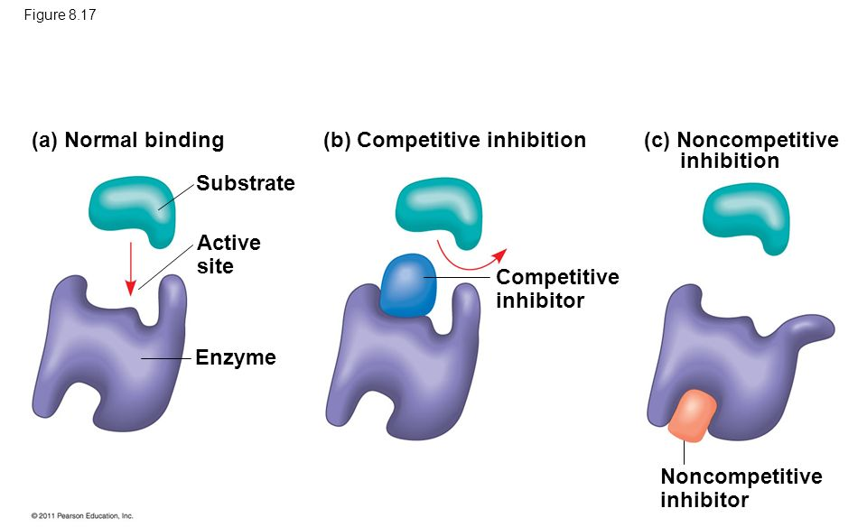

Feedback Inhibition
Feedback/Allosteric Inhibition---Temporary deactivation of an enzyme or metabolic pathway brought about by an elevation of an end product of the metabolic pathway. This is a type of noncompetitive inhibition.
Typically, the product of the pathway binds to the allosteric or feedback site on one of the early enzymes in the pathway. This inhibits the action of the enzyme. Since the products of this reaction are the reactants for the next reaction, the entire metabolic pathway is inhibited. The process is dependent on the concentration of the end product.
When the concentration of the end product is high, the pathway is inhibited. When the concentration is low, the pathway resumes its normal function and once again begins to produce the end product.
Feedback inhibition is an example of negative feedback. This process is an important way for cells to conserve resources.
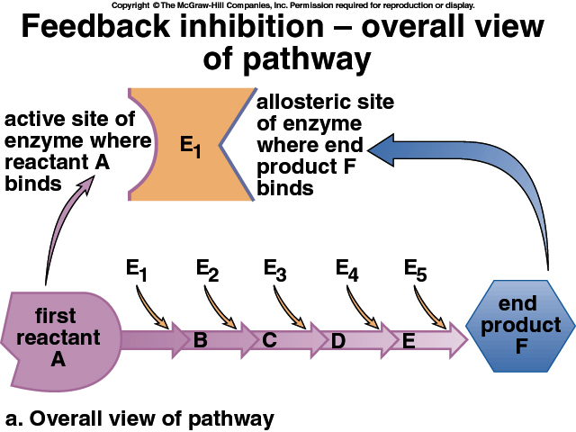

Allosteric Activators
Co-enzymes and Co-factors

These are molecules or ions that help enhance an enzyme’s ability to work.

Cofactors are inorganic metal minerals (such as Mg, Fe, and Zn) that attach to and activate specific enzymes.

Coenzymes are organic molecules (what are called “vitamins”) that attach to and activate specific enzymes.

Vitamin and mineral deficiencies are dangerous because without them the body’s enzymes don’t
function properly.

Cellular Respiration Student Notes

Introduction to Cellular Respiration

Cellular Respiration
Cellular Respiration Screencast
Cellular Respiration is the process of releasing the energy contained in organic molecules (mainly Glucose) to do work. (This is an example of catabolism.)
The process uses the energy from the organic, biological macromolecules to make ATP. ATP then serves as the energy source for most of the body’s endergonic reactions.
Cellular Respiration also releases heat (unusable energy) and free electrons. The free electrons serve as a source of energy for producing ATP.
The process of cellular respiration is a series of coordinated enzyme-catalyzed reactions that capture energy from biological macromolecules.
When O₂ is present in the cell, aerobic respiration takes place. The first stage of this process, glycolysis, occurs in the cytoplasm/cytosol. The other two stages, Krebs Cycle and the Electron Transport Chain, take place within the mitochondria. Exceptions to these statements will be discussed below.

Aerobic Cellular Respiration Chemical Equation
60₂ + C₆H₁₂O₆ → 6CO₂ + 6H₂O + Free Energy +Heat Energy
∆G = -686 kcal per mole of Glucose A negative ∆ G means Free E is available to do work. During cellular respiration the free energy is used to make ATP.

Without O₂ present in the cell, anaerobic respiration takes place. This process also involves glycolysis as its first step. This step is again carried out in the cytoplasm/cytosol. The second step of the process is called fermentation. It too occurs in the cytoplasm. Some books/questions refer to all of anaerobic respiration as fermentation. Be sure to pay attention to the context of the question when answering questions about anaerobic respiration.

The process of cellular respiration is highly conserved across all life forms on Earth. Almost all organisms, both prokaryotic and eukaryotic, carry out glycolysis in almost exactly the same way, using the same enzymes. The enzymes and chemical reactions of Krebs Cycle and the Electron Transport are also highly conserved. The process of fermentation/anaerobic cellular respiration is also highly conserved throughout most living things. This high level of conservation indicates that all living things are related and that somewhere back in evolutionary history they shared a common ancestor which did cellular respiration. The genes for the enzymes that carry out the process have been passed on to almost all life forms from that common ancestor.

Redox Reactions

During cellular respiration, glucose (or other organic molecules) is oxidized.
Oxidation—The process in which electrons and energy are removed from a molecule/atom.

Whenever one molecule/atom is oxidized, another molecule/atom must be reduced.
The process is called oxidation, because oxygen is very good at removing electrons from other atoms/molecules. Note: Not all oxidation reactions actually involve oxygen.

Reduction—The process in which electrons and energy are added to a molecule/atom.
During aerobic cellular respiration, the electrons and energy that are removed from the glucose are initially used to reduce electron carriers/coenzymes (NAD+ or FAD). Ultimately, the electrons provide the energy to produce ATP. The electrons end up combining with oxygen gas and hydrogen ions to form water. Reduction is called reduction because the addition of electrons to a molecule/atom decreases its charge.

Other terms to be aware of:

Oxidizing Agent—The atom/molecule that takes electrons away from another atom/molecule. The oxidizing agent is actually reduced during redox reactions.

Reducing Agent—The atom/molecule that donates electrons to another atom/molecule. The reducing agent is actually oxidized during redox reactions.

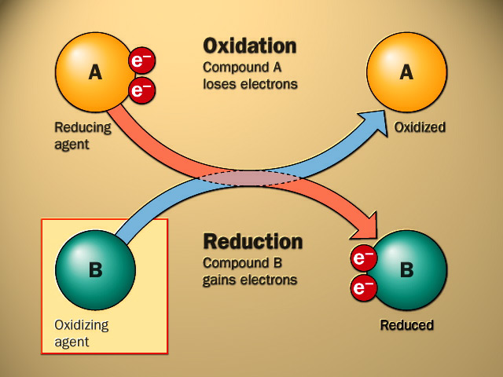

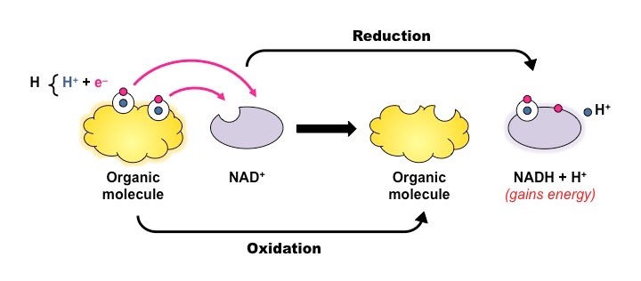
.

Use the acronym “OIL RIG” to help you remember the difference between oxidation and reduction. The acronym stands for “Oxidation is loss (of electron) Reduction is Gain (of electrons).

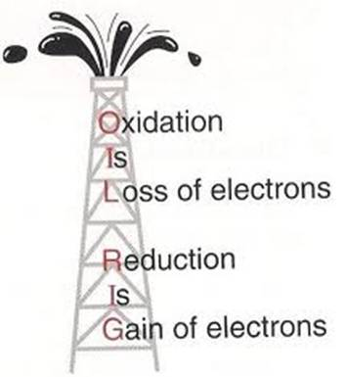

Aerobic Cellular Respiration
Aerobic Cellular Respiration is usually discussed as a Three Step Process:
Step 1: Glycolysis—During the process, Glucose is broken into 2 three carbon molecules of pyruvate or pyruvic acid. All organisms (including bacteria) can do this process since it occurs in the cytoplasm of the cell.
Step 2: Krebs Cycle—In eukaryotic cells, this stage occurs in the innermost compartment of a mitochondrion, the matrix. In aerobic prokaryotes, this stage occurs in the cytoplasm. During this stage, the pyruvate molecules that were produced during Glycolysis are oxidized. The energy and electrons from the pyruvate are used to reduce electron carriers to form the energy storage molecules NADH and FADH₂. Two molecules of ATP are formed during this stage for each glucose that entered into glycolysis.
Step 3: Electron Transport Chain—In eukaryotic cells, the electron transport chain takes place on the folds of the inner mitochondrial membrane. These folds are called cristae. In aerobic prokaryotic cells, the electron transport chain takes place on the folded inner surface of the cell membrane. During the ETC, the electron carriers (NADH and FADH₂) that were formed during glycolysis and the Krebs Cycle are oxidized. The energy from these electrons is used to create large amounts of ATP. The electrons ultimately reduce oxygen gas and form water. Oxygen gas is a required reactant for this process. The ETC and the process of chemiosmosis, which accompanies it, are sometimes referred to as oxidative phosphorylation because the electron carriers are oxidized and their energy is used to bring about the phosphorylation of ADP to form ATP.

The whole process of aerobic cellular respiration yields a Maximum of 38 ATP molecules per glucose.

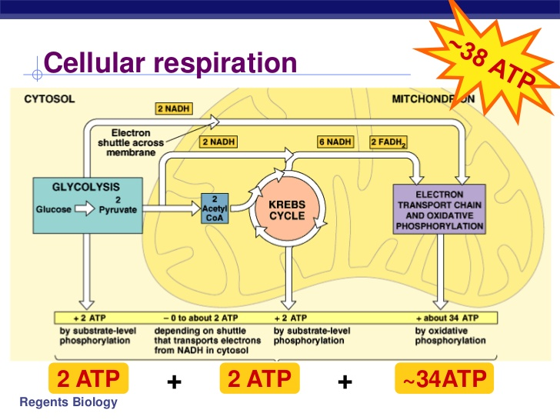

Glycolysis
Glycolysis is a highly conserved biochemical pathway that releases energy from glucose to form ATP from ADP and inorganic phosphate, NADH from NAD+, and pyruvate from the original glucose.
During Glycolysis, Glucose (C₆ H₁₂ O₆ ) is broken apart into 2 three carbon molecules of G3P. Each molecule of G3P is then oxidized to form a molecule of Pyruvate (a 3 carbon molecule with less energy than G3P).

There are two phases of Glycolysis:
1. Energy Investment Phase—During this stage 2 ATP molecules are required to act as activation energy for each glucose molecule that enters the process. The ATPs are used to phosphorylate the glucose. The phosphorylation makes the glucose unstable. This ultimately leads to the breaking of the glucose into 2 G3P molecules.

The enzyme phosphofructokinase carries out the second phosphorylation step. This enzyme has an allosteric/feedback site. ATP can bind to this allosteric site. If the cell has produced lots of ATP and the concentration of ATP is high within the cell, ATP is likely to bind to the allosteric site on phosphofructokinase. This changes the shape of the enzyme and deactivates it. Once this enzyme is deactivated, glycolysis cannot happen The deactivation is temporary. When ATP levels within the cell drop, the ATP molecule releases from the feedback/allosteric site and phosphofructokinase returns to its active form. The process described above is an example of feedback inhibition. The process helps the cell regulate when and how much cellular respiration it carries out. Since ATP is highly unstable, it doesn’t make sense for the cell to make more of the molecule than it can use within a short period of time.

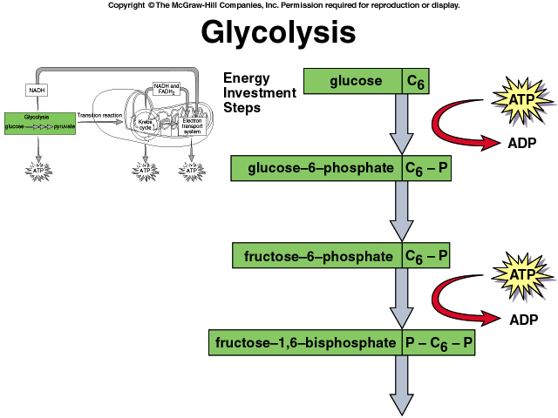
Phosphofructokinase acts here.

2. Energy Payoff or Energy Harvesting Phase—During this stage, each of the two G3P molecules formed during the energy investment phase is oxidized. The energy and electrons from the 2 G3P molecules are used to create 2 molecules of NADH and 4 ATP molecules per glucose (that initially entered glycolysis).

During Glycolysis, the ATPs are formed by a process known as substrate-level phosphorylation. In this process, phosphate groups and energy are transferred from 1,3 bisphosphoglycerate and phosphoenolpyruvate directly to ADP to make ATP.

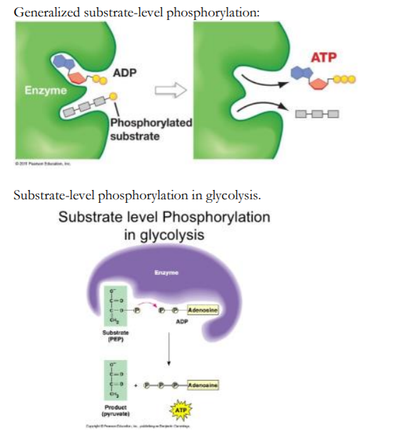

The NADH formed during this phase is formed by the oxidation of G3P and the transfer of electrons and energy to NAD+.

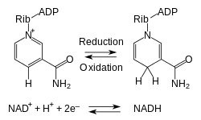

The electrons (2e-) in the equation shown above were removed from G3P.

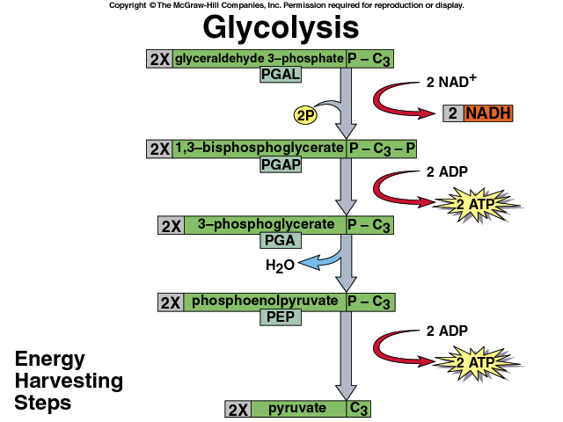
G3P

At the conclusion of glycolysis, the following products have been formed from 1 glucose molecule:
- 2 molecules of pyruvate (3 carbon molecules/essentially half of a glucose)
- 2 molecules of NADH (electron carriers/energy storage molecules)
- 2 net molecules of ATP—4 molecules of ATP are formed, but 2 are used during the energy investment stage.

Some important points to remember about Glycolysis:
A. This process occurs with or without O₂ present in the cell.
B. ALL organisms carry out glycolysis essentially the same way due to common ancestry. It always takes place in the cytoplasm.
C. When glycolysis is complete, most of the energy that was originally in the glucose molecule is now in the 2 molecules of pyruvate.

The Mitochondria
In eukaryotic cells, the Krebs Cycle and the Electron Transport Chain phases of aerobic cellular respiration take place within the mitochondria.

This organelle has its own DNA, its own bacteria-like ribosomes, its own enzymes and it can even reproduce independently via binary fission. The inner membrane of a mitochondrion is folded into structures known as cristae. The folds increase the surface area and serve as the sites for the electron transport chain.
Evolutionary Significance—Mitochondria are believed to have descended from aerobic bacteria that entered into a symbiotic relationship with larger prokaryotic cells that could provide protection in return for the ATP produced by the mitochondria. Together they would have an evolutionary advantage over other bacteria. The advantage allowed them to survive and reproduce and eventually led to the evolution of Eukaryotic cells/organelles. This idea is known as the endosymbiotic hypothesis.

The innermost compartment of a mitochondrion is called the matrix. This is the location for the Krebs Cycle in eukaryotic cells. It is important to remember that aerobic prokaryotes carry out the Krebs Cycle in the cytoplasm. If the endosymbiotic hypothesis is correct, the cytoplasm of an aerobic bacteria corresponds to the matrix of a mitochondrion (which originated from an engulfed aerobic bacterium).
In eukaryotic cells, the electron transport chain takes places on the folds of the inner mitochondrial membrane (cristae). These folds correspond to the folded surface of the cell membrane in aerobic bacteria. These cell membrane folds serve as the location of the electron transport chain in aerobic bacteria.

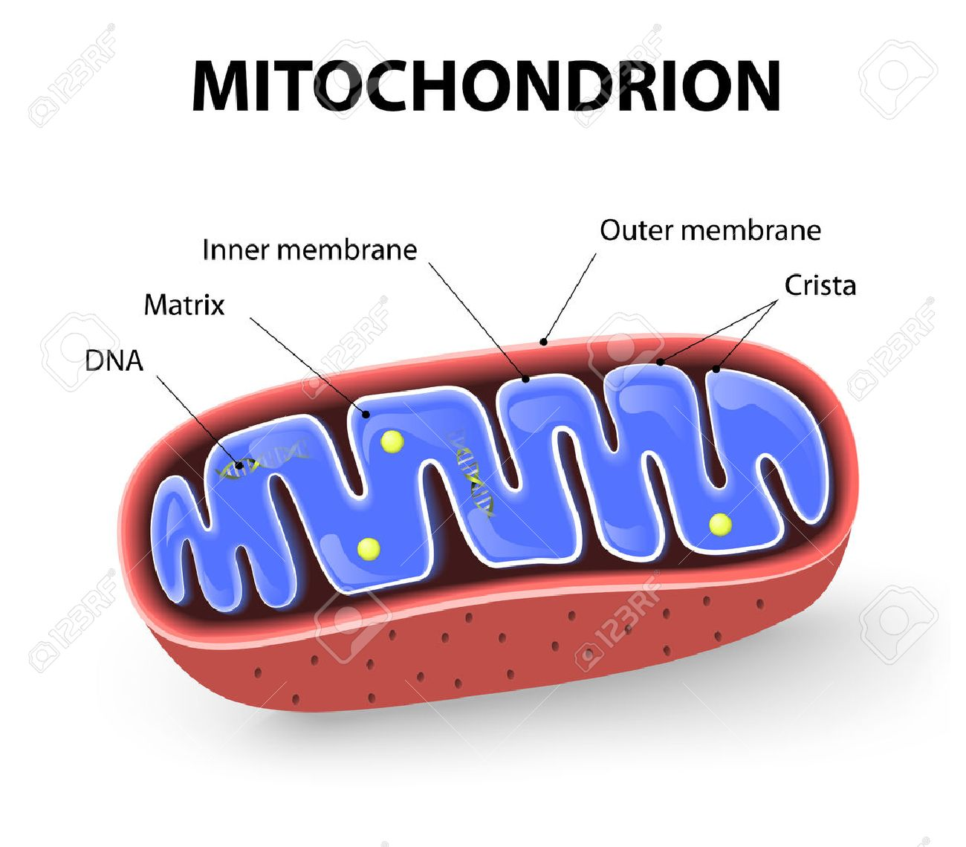

Pyruvate Conversion
If Oxygen is present within a eukaryotic cell or an aerobic bacterial cell, the cell can perform the other two parts of Aerobic Cellular Respiration – Krebs Cycle and Electron Transport Chain.
Note: The Krebs Cycle is also sometimes referred to as the citric acid cycle.

Before Krebs Cycle can start, the pyruvate (a 3 carbon molecule created during glycolysis) is transported from the cytosol to the mitochondrion where it is oxidized more. It is first converted to a 2 carbon molecule known as an acetyl group. This conversion process occurs in the mitochondria and is referred to as the Preparatory Step, the Transition Step, or the Pyruvate Conversion.

During this process, each pyruvate is oxidized. Two electrons from each pyruvate are transferred to NAD+ molecules to form two molecules of NADH. Each pyruvate releases one of its carbons as a carbon dioxide molecule. The resulting 2 carbon acetyl groups each attach to a molecule known as coenzyme A to form two molecules of Acetyl Coenyzme A. These molecules serve as the starting point for the Krebs Cycle.

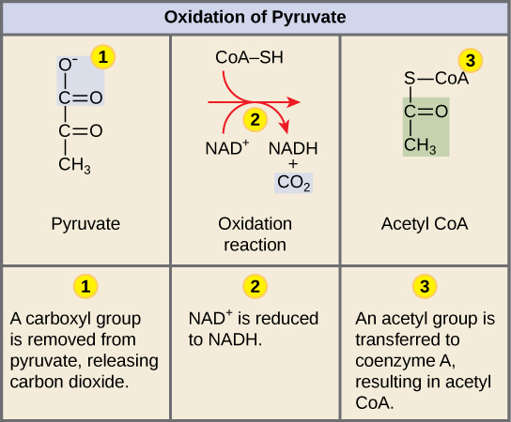

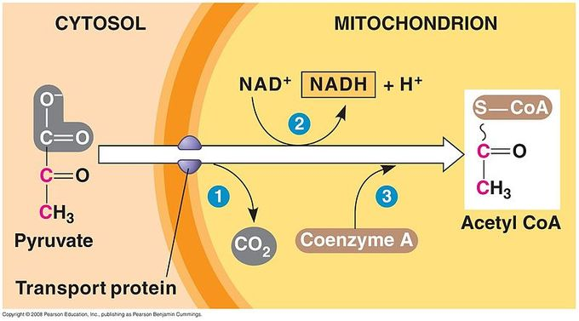

Krebs Cycle

Krebs Cycle occurs in the matrix of the mitochondria (in eukaryotic cells) and in the cytoplasm of aerobic prokaryotic cells. During Krebs cycle, the 2 Acetyl CoA molecules (the remains of the original glucose molecule from glycolysis) are oxidized. Their electrons and energy are transferred to the electron carriers/coenzymes NAD+ or FAD to make either NADH or FADH₂ . Two molecules of ATP (per glucose) are also produced via the process of substrate level phosphorylation. During the substrate level phosphorylation process, phosphate groups are transferred directly form succinyl-CoA to ADP to form ATP. By the end of Krebs Cycle, all of the carbon atoms from the original sugar are released as carbon dioxide gas.

It is important to note that you don’t need to memorize all of the complicated steps in the Krebs Cycle (see the diagram included below). The important details to remember are that:
- Acetyl Coenzyme A is oxidized. The energy that was originally contained in the Acetyl CoEnzyme A is contained mostly in the electron carriers/coenzymes (NADH or FADH₂) at the end of the process.
- By the end of the process, the carbon atoms that originally composed the glucose are all released as carbon dioxide gas. The CO₂ is released from organic intermediates that are oxidized during the Krebs Cycle.
- The two ATP molecules (per glucose) created from ADP and inorganic phosphate during Krebs Cycle are created via the process of substrate level phosphorylation.

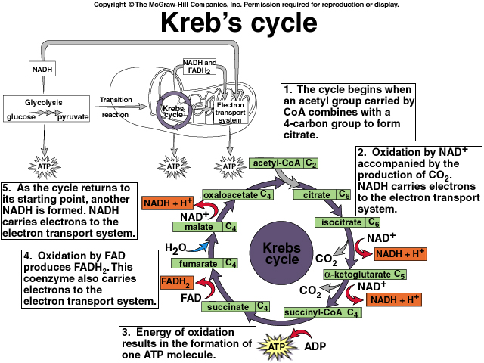

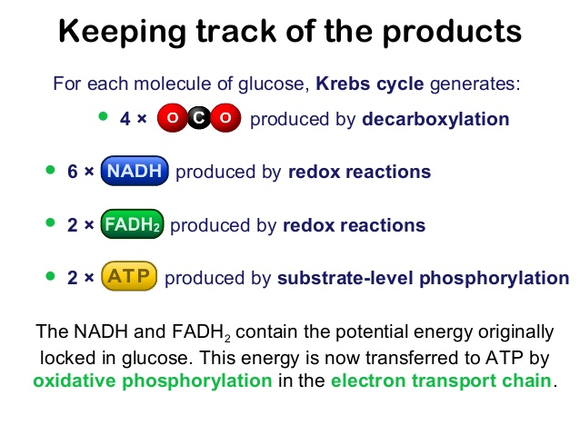

Electron Transport Chain
The Electron Transport Chain occurs on the folds (cristae) of the inner mitochondrial membrane (in eukaryotic cells) and on the folds of the cell membrane (in aerobic prokaryotic cells). The folds increase the available surface area (like the villi/microvilli in the small intestine) and allow for the production of more ATP.

The electron transport chain transfers the energy from electrons (contained in the electron carriers like NADH and FADH₂) in a series of coupled reactions that establish an electrochemical (H+) gradient across the membranes of the mitochondria (in eukaryotes) or the cell membrane (in prokaryotes).

During the Electron Transport Chain, the electron carriers formed during glycolysis and Krebs Cycle are oxidized. The energy from these molecules is used to generate large amounts of ATP.

The actual electron transport chain is composed of a group of proteins known as the cytochromes. These proteins are highly conserved in all organisms.

The process starts when NADH is oxidized by the first cytochrome in the chain (this protein is known as FMN). The 2 electrons lost from NADH pass through three proteins (proton pumps) as they move down the ETC. The electrons move from the least electronegative location (the first cytochrome/electron acceptor) toward the most electronegative location (the last cytochrome/electron acceptor). As the electrons move through the proton pumps, the energy from the electrons powers the pumping of a hydrogen ion or proton from the matrix into the intermembrane space (the space between the inner and out mitochondrial membrane). A single proton is pumped as a pair of electrons travels through each of the three proton pumps. A proton/hydrogen ion gradient is created across the inner membrane. The pumping of the protons creates an area of high proton/H+ concentration in the intermembrane space and an area of low proton/H+ concentration in the matrix. The gradient is a way to store potential energy. The bigger the gradient, the more potential energy is stored. In prokaryotes, the protons are pumped from the cytoplasm through the cell membrane and into the fluids around the cell.

An enzyme, ATP synthase, embedded in the inner membrane, has a channel that will allow protons/H+ ions to move through it. Since this is the only way back into the matrix (in eukaryotes) or prokaryotic cell (because the nonpolar nature of the inner membrane won’t allow protons to cross it), the protons/H+ ions move quickly through the ATP Synthase channel. The enzyme is able to use the kinetic energy of the moving protons/hydrogen ions to add a phosphate group to ADP to make ATP. The energy from a single proton provides the energy to create a single ATP molecule. The process of using energy from a proton/H+ ion gradient to phosphorylate ADP with an inorganic phosphate group is known as chemiosmosis. This process is responsible for the creation of most of the ATP created during both aerobic cellular respiration and photosynthesis.

Since the pair of electrons from each NADH molecule power the pumping of three protons into the intermembrane space, each NADH ultimately provides the energy to create three molecules of ATP.

FADH₂ is also oxidized during the ETC. It is oxidized at a protein (known as Q) that is located further down the electron transport chain than the protein involved in the oxidation of NADH. The pair of electrons from FADH₂ only passes through 2 proton pumps. This means that each FADH₂ molecule provides the energy to make 2 molecules of ATP.

Once the electrons reach the final cytochrome, they must be removed. If not, the last cytochrome will become negatively charged and will repel addition electrons. This would shut down the entire process of aerobic respiration.

The role of oxygen in aerobic respiration is to remove the electrons from the final cytochrome. Because of its role, oxygen is often referred to as the final/terminal electron acceptor. Oxygen is capable of this task because of its high electronegativity. Since it is more electronegative than the final cytochrome, the electrons move from the final cytochrome to oxygen. The now negatively charged oxygen, combines with hydrogen ions to form water.

The electron transport chain can produce a maximum of 34 ATP molecules per glucose that initially entered glycolysis. The process also creates water and regenerates the electron acceptors NAD+ and FAD.

The electron transport chain and chemiosmosis are collectively referred to as oxidative phosphorylation. This term is very descriptive of the processes since the electron carriers (NADH and FADH₂) are oxidized and their energy is used to phosphorylate ADP to make ATP.

Oxidative phosphorylation is an example of ENERGY COUPLING. During the process, the active transport of the hydrogen ions/protons into the intermembrane space and the subsequent movement of the protons/H+ ions through ATP synthase provide the energy to phosphorylate ADP to make ATP.

In cellular respiration, the decoupling of oxidative phosphorylation from electron transport generates heat. This heat can be used by endothermic organisms to regulate body temperature.

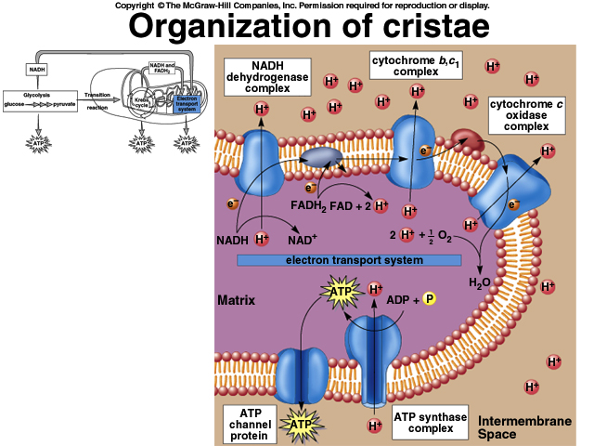

Summary of the Products of Aerobic Cellular Respiration from 1 Glucose Molecule

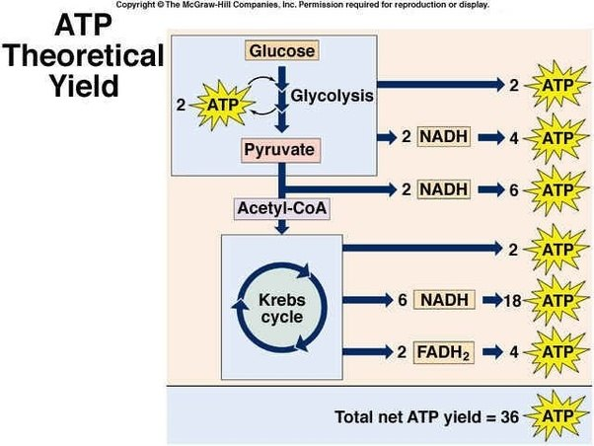

Utilizing Proteins and Lipids as Energy Sources

Although we normally think of sugars/carbohydrates as the source of energy for our bodies, proteins and lipids can also be used to fuel the body.

In order to use proteins for energy, the body must first break the proteins down into individual amino acids. The amino acids then undergo a process known as deamination. During this process, the amino group is removed from the amino acid. The remaining 2 carbon skeleton is very similar to an acetyl group. The 2 carbon group is attached to coenzyme A and enters the Krebs Cycle. From this point forward, the process works essentially the same as it did with glucose as the initial energy molecule. The removed amino group is converted to ammonia which has to be disposed of by the liver and kidneys.

In order to use lipids for energy, the fatty acid chains undergo a process known as beta oxidation in which they are essentially broken up into 2 carbon skeletons. These 2 carbon skeletons are attached to coenzyme A and enter the Krebs Cycle. From this point forward, the process works essentially the same as it did with glucose as the initial energy molecule.

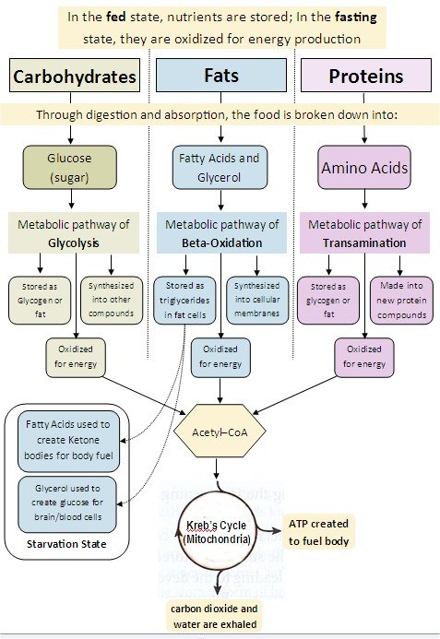

Anaerobic Cellular Respiration
If NO OXYGEN is present within the cell, the cell carries out anaerobic cellular respiration.
Some cells solely use anaerobic cellular respiration to make ATP. This typically only works in very small and relatively inactive organisms because the process of anaerobic cellular respiration is highly inefficient and does not yield very much ATP (only 2 ATPs per glucose).

Larger and more active organisms use anaerobic cellular respiration to supplement ATP production in times of low oxygen concentration. This type of situation might arise when the organism is running at full speed or exerting the muscles with full force (lifting extremely heavy weights).

The process of anaerobic respiration occurs in two phases: glycolysis and fermentation.

Glycolysis occurs just as it does during aerobic cellular respiration. Each glucose is used to produce 2 net molecules of ATP, 2 molecules of pyruvate, and 2 molecules of NADH.

When there is no oxygen present, the electron transport chain is not able to oxidize NADH back to NAD+. Since there is a limited amount of NAD+ in the cell, the cell must use an alternate method to regenerate NAD+ from NADH.

Fermentation’s only role is to free up NAD+ so that they it is available to keep glycolysis going in the absence of oxygen gas. Pyruvate, the end product of glycolysis, serves as an electron acceptor for oxidizing NADH back to NAD+, which can then be reused in glycolysis. Anaerobic cellular respiration yields only the 2 net ATP molecules produced during glycolysis.

There are many types of fermentation, but the two most commonly discussed in Biology courses are Alcoholic Fermentation and Lactic Acid Fermentation. All types of fermentation regenerate NAD+ from NADH and produce organic by-products such as alcohol or lactic acid.

Alcoholic Fermentation—During alcoholic fermentation, the pyruvate (also known as pyruvic acid) molecules from glycolysis are used to oxidize NADH and convert it back to NAD+. During the process ethanol and carbon dioxide gas are created as byproducts. Yeasts and some bacteria are capable of carrying out the process of alcoholic fermentation. Beer, wine, and some types of bread are produced using the products of alcoholic fermentation.

Alcoholic Fermentation Summary
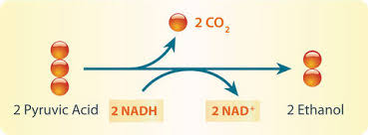

Lactic Acid fermentation—During lactic acid fermentation, the pyruvate molecules from glycolysis are used to oxidize NADH and convert it back to NAD+. During the process, lactic acid or lactate is produced as a byproduct. Most animals and some bacteria can carry out lactic acid fermentation. Animals use the process to regenerate NAD+ in the absence of oxygen. Anaerobic respiration doesn’t produce enough ATP to power the entire organism, but can be used to supplement the ATP levels in tissues (like muscle) where oxygen levels may drop quickly.

The products of bacterial lactic acid fermentation have been used by humans to create food products such as yogurt, sour cream, buttermilk, and sour dough bread.

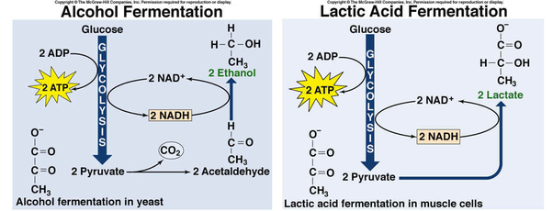

Comparison between Aerobic and Anaerobic Cellular Respiration
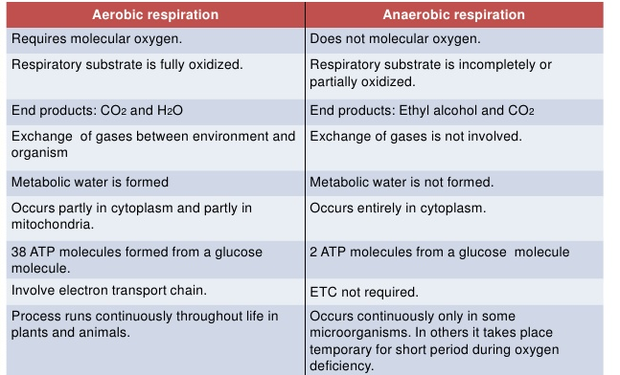

Photosynthesis Student Notes

Overview of Photosynthesis
Photosynthesis Screencast
During photosynthesis, energy is captured from the sun/light and converted to chemical energy stored in the bonds of glucose.
Plants, algae, some protists, and some bacteria (cyanobacteria) are capable of carrying out photosynthesis.
Scientists think that photosynthesis first evolved in some prokaryotes and that the photosynthesis carried out by these organisms was responsible for the production of an oxygenated atmosphere on Earth. These original prokaryotic photosynthetic pathways served as the foundation for the evolution of eukaryotic photosynthesis.
The reactants for photosynthesis include carbon dioxide (taken in from the air via the stomata), water (taken in from the ground through the roots), and light energy (absorbed by the pigment proteins in the leaves).
The overall products of photosynthesis include glucose (stored energy) and oxygen gas.
The balanced overall equation for photosynthesis may be written in either of the two ways illustrated below.
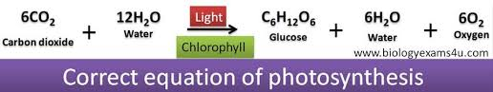
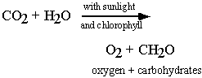

Most textbooks teach that photosynthesis occurs in a two-phase process.
Phase 1—Light Dependent Reactions—The light dependent reactions occur on the thylakoid membranes of the chloroplasts of leaf cells (in eukaryotes). In prokaryotic photosynthesizes, the light dependent reactions occur on folds of the cell membrane. The light dependent reactions involve a series of coordinated enzyme-catalyzed reaction pathways that capture energy from light. During the light dependent reactions, light energy is absorbed and used to reduce the electron acceptor NADP+ to make NADPH (a form of stored energy). NADP+ is the final/terminal electron acceptor. The light energy is also used to power the creation of a proton/H+ gradient which is used, during chemiosmosis, to create ATP (another form of stored energy). Oxygen gas is also released as a by-product of the light dependent reactions. The energy from ATP and NADPH power the production of organic molecules (like glucose) during the Calvin Cycle.
Phase 2—Calvin Cycle/Calvin-Benson Cycle/Light Independent Reactions—The Calvin Cycle occurs in the stroma of the chloroplasts in eukaryotic cells and in the cytoplasm of photosynthetic prokaryotes. During this phase, the energy from the NADPH and ATP (formed during the light dependent reactions) is used to reduce and phosphorylate carbon dioxide gas to create G3P and ultimately glucose. Glucose is an energy storage molecule that can be readily stored and/or transported to other parts of the plant like the roots and stems.

Important Terms to Know

Autotrophs – Organisms that can “produce” their own food. Most autotrophs produce food through the process of photosynthesis. There are a few organisms (mostly bacteria and archae that live around thermal vents in the oceans) that carry out a process known as chemosynthesis. Chemosynthesis is the biological conversion of one or more carbon-containing molecules (usually carbon dioxide or methane) and nutrients into organic matter using the oxidation of inorganic compounds (e.g., hydrogen gas, hydrogen sulfide, or methane) as the original source of energy.

Heterotrophs – Organisms that “consume” other organisms in order to obtain energy and nutrients.

Chlorophyll – A green light-absorbing pigment found in the chloroplasts of plants, algae, and some protists. Chlorophyll is also embedded in the cell membranes of cyanobacteria. Chlorophyll appears green because it reflects green light and absorbs red and blue light.

Chloroplast Structure

Chloroplasts are the sites of Photosynthesis in plants and algae.
Chloroplasts are a type of Plastid or pigment container.
Like mitochondria, chloroplasts have their own DNA, ribosomes, and enzymes! They can also reproduce independently of the cell in which they reside (via binary fission).
The interior of a chloroplast is composed of stacks of sack-like structures known as thylakoids. The pigment molecules needed for photosynthesis are embedded in the membranes of the thylakoids. Stacks of thylakoids are known as grana. This stack-like arrangement increases the surface area needed to carry out the light-dependent stages of photosynthesis.
The stroma is the mostly watery space in between the thylakoids and the outer membrane. The stroma serves as the site of the Calvin Cycle (the metabolic pathway in which sugar is made).
Evolutionary Significance—Chloroplasts are thought to have evolved from blue-green bacteria (cyanobacteria) that entered into a symbiotic relationship with other bacteria for protection in return for sugar production. This is the endosymbiotic hypothesis.

The Chloroplast

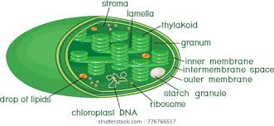

Light Energy
Sunlight is a form of high quality electromagnetic energy that can be used by some organisms to do work.

Sunlight travels in waves with different wavelengths and frequencies. Waves with different wavelengths and frequencies have different colors and different amounts of energy per photon.

A photon is the smallest discrete amount or quantum of electromagnetic radiation. It is the basic unit of all light. Think of a photon as the smallest packet of light energy that is possible. Photons are always in motion and, in a vacuum, travel at a constant speed of 3 x 10⁸ m/s (the speed of light).

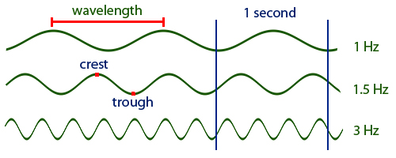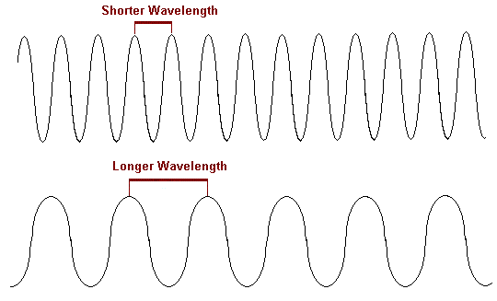

The following equation illustrates the relationship between the speed of light (c), the wavelength (λ), and the frequency (f).
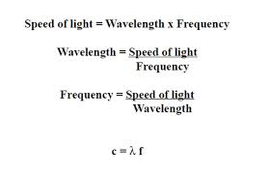
As the equation implies, wavelength and frequency are inversely proportional. Waves with a long wavelength have a lower frequency. Waves with a short wavelength have a higher frequency.

The frequency of light is directly related to the amount of energy contained per photon. A higher frequency means that each photon has a higher energy content.

The diagram included below, the electromagnetic spectrum, illustrates the relationship between frequency and wavelength for each form of electromagnetic radiation. It also indicates that of the visible forms of light, the purples and blues have the shortest wavelength, the highest frequency, and the most energy per photon, while the reds and oranges have the longest wavelength, the lowest frequency, and the least energy per photon.
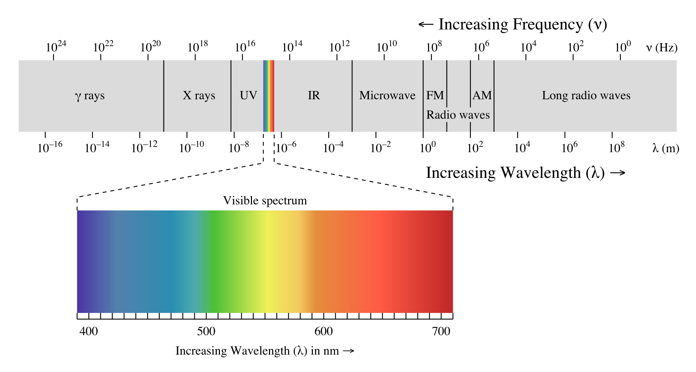

Absorption and Reflection of Light
Different types of pigment proteins appear as different colors because they absorb and reflect different wavelengths/colors of light. The absorbed light is used to provide the energy to make glucose. The reflected light is not used by the plant.
Plants contain three major groups of pigments:

A. Chlorophyll A – This is the main pigment found in all plants and algae. It is a protein which consists of a ring of carbon, nitrogen, and hydrogen atoms, connected to a central atom of magnesium. This is very similar in structure to the heme group found in hemoglobin, except that in heme the central atom is iron, whereas in chlorophyll it is magnesium. Chlorophyll A is best at absorbing blue and red wavelengths of light. Chlorophyll A reflects most green and yellow wavelengths. This is why it appears green.
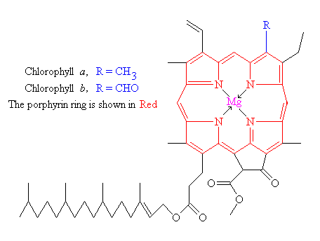

B. Chlorophyll B – Chlorophyll B is a yellowish-green pigment which acts mainly as an accessory pigment. This means that it absorbs some wavelengths of light that chlorophyll A isn’t able to absorb. Chlorophyll B then passes the absorbed energy to Chlorophyll A.

C. Carotenoids – Carotenoids are a group of yellow, orange, and red pigments which (like Chlorophyll B) act as accessory pigments.

Photosystems – Photosystems are complex arrangements of many chlorophyll A molecules with other pigments, including chlorophyll b and carotenoids. The photosystems are embedded within the thylakoid membranes of the chloroplasts. Think of a photosystem like an array of solar panels. The pigments capture energy and then funnel the energy to a pair of molecules of chlorophyll A known as the reaction center. This pair of molecules is often called the special pair. Once energy reaches the special pair, it will no longer be passed on to other pigments. Instead, the special pair can actually lose electrons when excited, passing the electrons to another molecule in the complex called the primary electron acceptor. With this transfer, the electrons will begin the journey through the electron transport chain of photosynthesis.

There are two types of photosystems in the light-dependent reactions, photosystem II (PSII) and photosystem I (PSI). PSII comes first in the path of electron flow, but it is named PSII because it was discovered after PSI. The chlorophyll A special pairs of the two photosystems absorb different wavelengths of light. The PSII special pair absorbs best at 680 nm, while the PSI special pair absorbs best at 700 nm. Because of this, the special pairs are called P680 and P700, respectively. Note that both wavelengths, 680 nm and 700 nm, are in the orange to red color range. Most chlorophyll molecules actually absorb blue wavelengths better than orange and red wavelengths. The P680 and P700 numbers refer to the maximum absorption for the entire photosystem rather than for the actual reaction center chlorophyll molecules.

Photosystems I and II are connected by the transfer of high energy electrons through the electron transport chain.

Absorption Spectrum
The set of wavelengths absorbed by a pigment is its absorption spectrum. In the diagram below, you can see the absorption spectra of three key pigments in photosynthesis: chlorophyll a, chlorophyll b, and β-carotene. The set of wavelengths that a pigment doesn't absorb are reflected, and the reflected light is what we see as color. For instance, plants appear green to us because they contain many chlorophyll a and b molecules, which reflect green light.

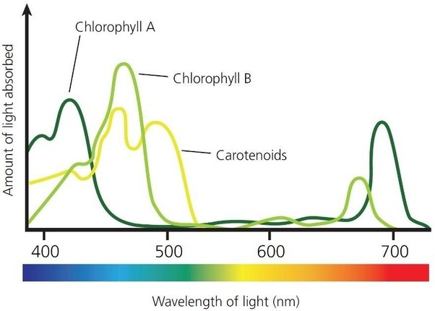

Light Dependent Reactions of Photosynthesis
This process occurs on the thylakoid membranes of the chloroplasts located in leaf cells. During the process, light energy is absorbed and used to produce the energy storage molecules ATP and NADPH. Oxygen gas is generated as a by-product of the process.

The light dependent reactions occur in two different ways in most photosynthesizers, non-cyclic photophosphorylation and cyclic photophosphorylation. These processes occur simultaneously across the thousands of photosystems on each thylakoid membrane.

Non-cyclic photophosphorylation (also known as non-cyclic electron flow) – During this process, both photosystems absorb light energy. The absorbed light energy is funneled to the reaction center of each photosystem. This absorbed energy boosts electrons in photosystems I and II to higher energy levels. Eventually, so much energy is absorbed that it causes the reaction centers to be oxidized. A pair of electrons is released from the reaction center of each photosystem. The electrons from Photosystem II travel through a cytochrome complex (ETC) and are eventually used to reduce Photosystem I’s reaction center. As the electrons move across the ETC, their energy is used to power the active transport of hydrogen ions/protons from the stroma into the thylakoid. This process begins the build-up of a hydrogen ion/proton/electrochemical gradient much like the one that occurs during the ETC stage of cellular respiration. During this process (in photosynthesis) an area of high H+ concentration is established inside the thylakoid and an area of low H+ concentration is established in the surrounding stroma. This process/gradient stores potential energy within the thylakoid. This energy will eventually be used to manufacture ATP.

The electrons that leave Photosystem I also travel through an ETC. These electrons are ultimately used to reduce NADP+ to form NADPH. NADP+ is an electron carrier, much like the NAD+ that functions during cellular respiration. Think of NADP+ as a “dead battery” and NADPH as a “charged battery”. The electrons and energy from Photosystem I “charge” this molecular battery. The energy stored in NADPH will be used to make glucose during the Calvin Cycle.
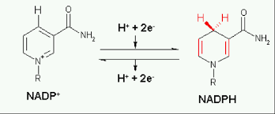

The hydrogen ions within the thylakoid eventually rush out (into the stroma) via a channel within the ATP synthase enzyme. The enzyme is able to harness the kinetic energy of the moving hydrogen ions/protons to phosphorylate ADP to make ATP. This process of using energy from a proton/H+ ion gradient to phosphorylate ADP is known as chemiosmosis. The energy from the ATP will be used during the Calvin Cycle to make glucose.

One other product is formed during non-cyclic photophosphorylation. That product is oxygen gas.
After Photosystem II is oxidized, it acquires a positive charge. The Photosystem then splits water molecules, through a process called photolysis, in order to acquire electrons to replace those lost during the oxidation. The remains of the split water molecules are hydrogen ions, which contribute to the H+ gradient in the thylakoid, and oxygen gas. This process is the source of all of Earth’s oxygen gas. All of Earth’s oxygen gas was originally part of water molecules. Plants release some of the oxygen gas into the atmosphere. It is important to note that plants do use some oxygen gas to perform aerobic cellular respiration.

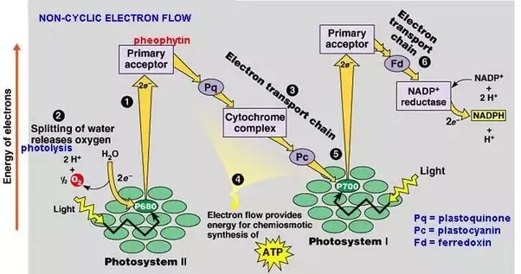

To summarize, non-cyclic photophosphorylation produces three main products NADPH and ATP, energy storage molecules which will be used during the Calvin Cycle to produce glucose, and oxygen gas. The name non-cycle photophosphorylation is very descriptive of the process. During the process, electrons move across the thylakoid membrane in a linear/noncyclic pattern. Essentially, the electrons move from water to Photosystem II to the ETC to Photosystem I to the ETC to NADP+ to make NADPH. The phosphorylation portion of the name refers to the part of the process in which energy from the movement of hydrogen ions is used to add a phosphate group to ADP to make ATP.

Cyclic photophosphorylation or cyclic electron flow – This process occurs simultaneously with noncyclic photophosphorylation. Cyclic photophosphorylation involves only Photosystem I. During this process, photosystem I’s pigment proteins absorb light energy and funnel it to the reaction center. The absorbed energy eventually causes the reaction center to be oxidized. The ejected pair of electrons move through a different ETC network than the one used during the noncyclic version of the process. As the electrons move through this ETC, their energy is used to power the active transport of hydrogen ions/protons from the stroma into the thylakoid. This again builds up a hydrogen ion gradient. The hydrogen ions eventually move through the channel within the ATP synthase and exit the thylakoid. The kinetic energy of the moving ions is used to phosphorylate ADP to make ATP.

The only product of cyclic photophosphorylation is ATP. No oxygen gas or NADPH are produced. The name of the process is again very descriptive of what occurs during the process. The cyclic portion of the name refers to the fact that the ejected electrons from Photosystem I move through a circular arrangement of cytochromes and ultimately end up reducing the reaction center that they were ejected from. The phosphorylation portion of the name refers to the part of the process in which energy from the movement of hydrogen ions is used to add a phosphate group to ADP to make ATP.

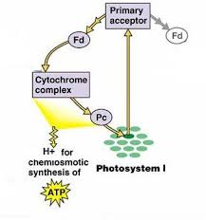

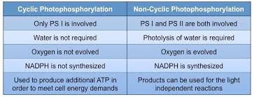

Calvin Cycle/Light Independent Reactions of Photosynthesis

The light dependent reactions of photosynthesis use the energy from the sun to create the energy storage molecules NADPH and ATP. These molecules are very chemically reactive and can’t be efficiently stored or transported. Since almost all photosynthesis occurs in the leaf, the plant needs to be able to store and transport energy to the stem and roots. In order to do this, the plant must transfer the energy from NADPH and ATP to carbon dioxide in order to form a more stable and transportable energy storage molecule, glucose. This is the purpose of the Calvin Cycle.
The Calvin Cycle occurs in the stroma of the chloroplast (in eukaryotic cells) and in the cytoplasm of photosynthetic prokaryotes. The Calvin Cycle occurs in three main phases:

Phase 1—Carbon Fixation—During this phase, a carbon dioxide molecule is attached to a 5-carbon chain known as ribulose bisphosphate by an enzyme known as Rubisco or RuBP Carboxylase. This forms an unstable 6 carbon compound that quickly breaks into two 3 carbon chains that are referred to as phosphoglycerate or PGA molecules. Think of a PGA molecule as ½ of a glucose molecule, but without the stored energy.
Phase 2—Reduction—During this phase, the PGA molecules formed during Phase 1 are energized using the energy storage molecules which were manufactured during the light dependent stage of photosynthesis. First, phosphate groups/energy from ATP molecules are transferred to the PGA molecules. Next. the PGA molecules are reduced using electrons and energy from NADPH. The product of this process is a highly energized 3 carbon compound known as Gyceraldehyde-3-Phosphate or G3P. Two G3P molecules can be combined to form glucose. G3P can also be used to synthesize starch, cellulose, and other organic molecules needed by the plant.
Note: The Calvin Cycle diagram included below depicts the Calvin Cycle as it occurs for every 3 carbon dioxide molecules that are fixed. The fixation of 3 carbon dioxide molecules results in the creation of 6 molecules of G3P. Only one of the six G3Ps are used to create glucose or other organic molecules. The other 5 are used to carry out Phase 3 of the Calvin Cycle.
Phase 3—Regeneration of the Carbon Dioxide Acceptor/Ribulose Bisphosphate—During this phase, the remaining 5 G3P molecules are phosphorylated again (using ATP from the light dependent reactions) to regenerate ribulose bisphosphate. This ensures that the cell doesn’t run out of ribulose bisphosphate so that the Calvin Cycle can continue.

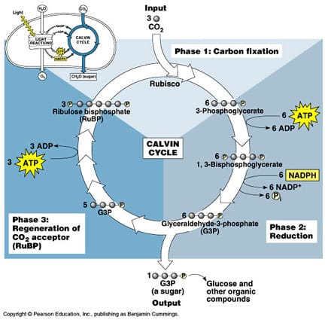

To summarize, during the Calvin Cycle the energy from the energy storage molecules (manufactured during the light dependent stage of photosynthesis) is added to carbon dioxide to form G3P and ultimately glucose and other organic molecules. This is necessary because ATP and NADPH are chemically reactive and difficult to store and transport. On the other hand, glucose and other sugars are stable and highly transportable and storable.
Fitness
Although many of the biochemical metabolic pathways of life are conserved through almost all life forms, small amounts of variation at the molecular level can provide organisms with the ability to respond to a variety of different environmental stimuli. This variation in the number and types of molecules within cells provides organisms a greater ability to survive and/or reproduce in different environments. For example: plants found in different environments have slightly different collections of photosynthetic pigments that all them to exploit the wavelengths of light that are available in their specific environments. Deep water plants must use different pigments than land plants because the water only allows certain wavelengths of light to penetrate (mostly blues and greens). That is why many aquatic plants often appear red or orange. They are absorbing blue and green wavelengths. The description of C3, C4, and CAM plants included below provides another illustrative example of the importance of variation to fitness and evolution.

Photorespiration and Adaptations for Dealing with Hot and Dry Conditions
The carbon-fixing enzyme, Rubisco or RuBP Carboxylase, has an evolutionary flaw. It is capable of attaching both carbon dioxide and oxygen gas to ribulose bisphosphate. The attachment of carbon dioxide ultimately leads to the creation of G3P and glucose, while the attachment of oxygen yields no glucose and actually requires the cell to use energy to rid itself of the products of oxygen fixation. The process of fixing oxygen instead of carbon dioxide and the resulting dramatic decrease in photosynthetic efficiency is known as photorespiration.

When the environment is not too hot and there is plenty of water available in the soil, photorespiration isn’t a huge problem. When the environment is very hot and dry, plants are forced to close their stomata to conserve water. When the stomates are closed, the concentration of oxygen gas in the leaf rapidly increases, while the concentration of carbon dioxide rapidly decreases. Under these conditions, much more oxygen is fixed than carbon dioxide. This dramatically decreases the photosynthetic efficiency of the plant and if the conditions persist for long periods of time, the plant may die or be forced to enter a dormant state.

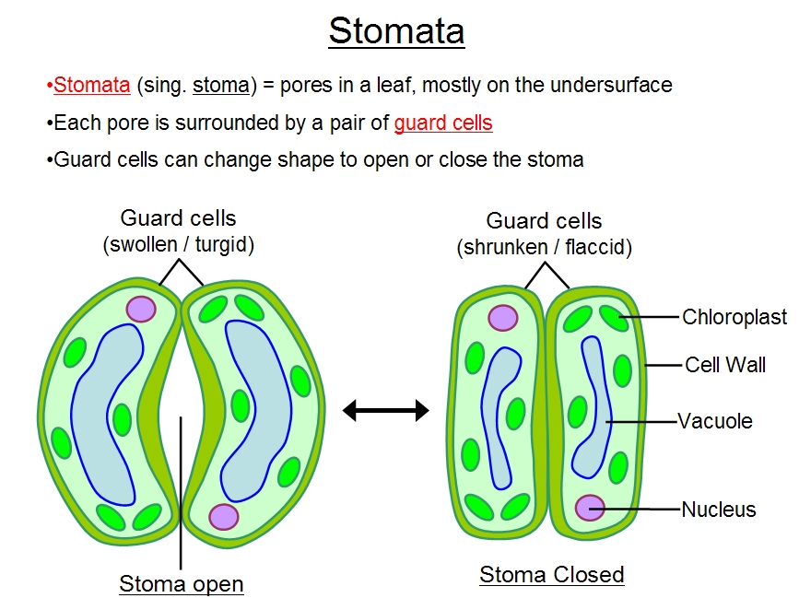
C3 Plants—Most plants are classified as C3 plants. They perform the Calvin Cycle as described above. These plants are the most efficient of all plants as long as the environment is not too hot or dry, but have an issue with photorespiration in hot and dry climates. If C3 plants close their stomates to conserve water, they begin to carry out a large amount of photorespiration very quickly.

C4 plants—C4 plants, like corn and cotton, have adaptations that allow them to avoid photorespiration in hot and dry climates. In the mesophyll of the leaf, C4 plants have a carbon-fixing enzyme known as PEP Carboxylase. This enzyme has no attraction for oxygen gas. Once PEP fixes the carbon dioxide, the fixed carbon is transported into a small, enclosed chamber known as the bundle sheath. Once there, the carbon dioxide is released and fixed again by Rubisco. In C4 plants, the initial carbon fixation step and the Calvin Cycle are said to be spatially separated because they occur in different locations. Since the bundle sheath is small, and there is a constant supply of carbon dioxide, carbon dioxide concentrations are high and Rubisco works without fixing oxygen. These adaptations allow C4 plants to close their stomates for extended periods of time and continue to do photosynthesis without photorespiration. When CO₂ levels drop below a critical level the stomates can be opened for a short period in order to replenish the needed CO_{2.} This allows the plants to continue to make sugar while also conserving water. It is important to note that C4 plants perform the Calvin Cycle in exactly the same way as C3 plants; C4 plants just have an extra carbon-fixation step that occurs before the Calvin Cycle.

CAM Plants—CAM plants, like the cactus, are highly adapted to life in hot and dry environments. Like the C4 plants, these plants possess PEP carboxylase. An additional adaptation of CAM Plants is that they only open their stomata at night when the environment is cool. During the night, PEP carboxylase fixes carbon and stores it as malate. Once the sun comes up, the stomata close (so that the plants don’t lose water through transpiration). During the day, the malate breaks down and releases a constant supply of Carbon Dioxide so that Rubisco and the Calvin Cycle can function without a high degree of photorespiration. In CAM plants, carbon fixation and the Calvin Cycle are said to be temporally separated because they occur at different times. CAM plants are the plant group that is best adapted to hot and dry conditions.

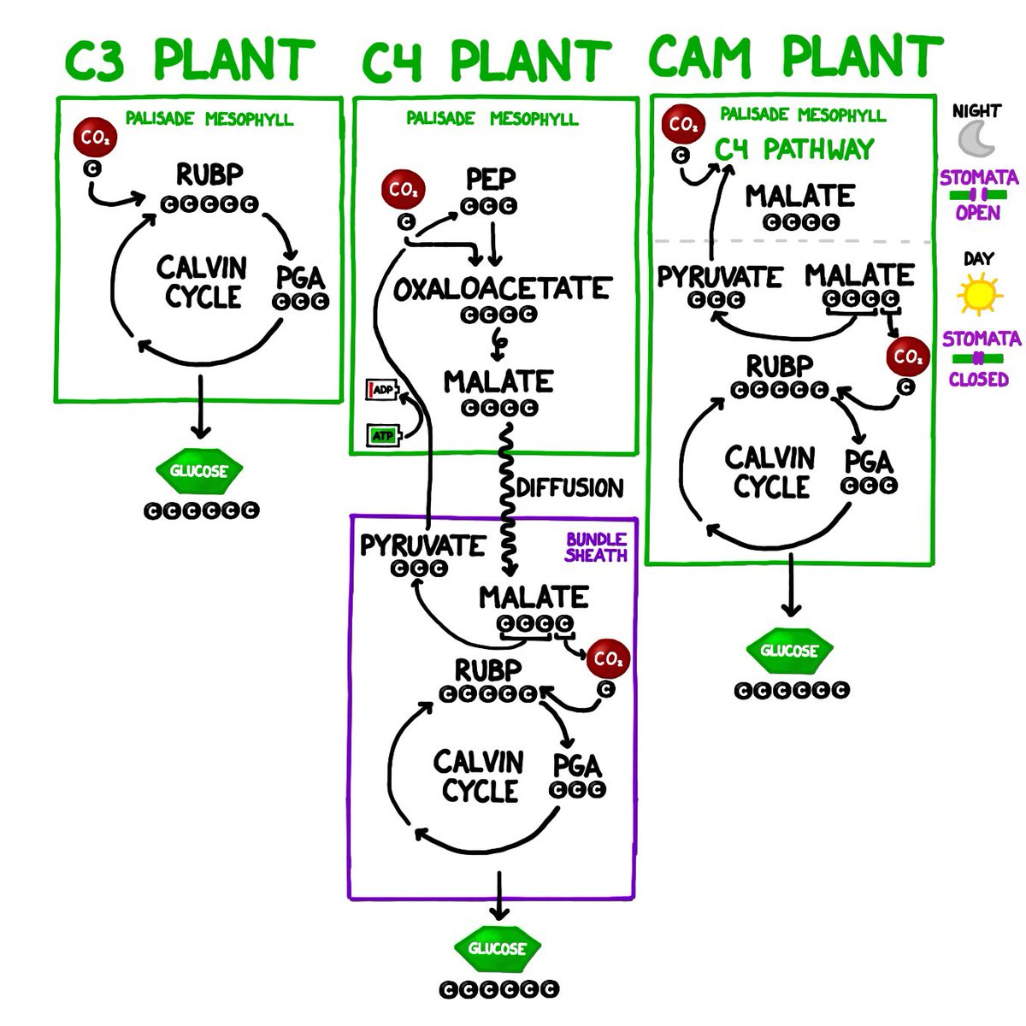

Thermoregulation
Thermoregulation Screencast

Ectotherms—Organisms whose body temperatures vary greatly with the external environment. These organisms are often also referred to as “cold-blooded” or “thermoconformers”.
As the external temperature drops, the body temperature of these organisms drops. This causes a decrease in metabolic activity.
As the external temperature rises, the body temperature of these organisms increases. This causes an increase in metabolic activity.
Examples of ectotherms include: most fish, reptiles, amphibians, and insects.
An advantage of being an ectotherm is that organisms don’t use energy (ATP) to produce heat and regulate the body temperature. This means that ectotherms don’t need to eat as much as endotherms.
A disadvantage of being an ectotherm is that ectotherms can’t normally live in places where it gets too hot or too cold. If they do live in these environments, their activity is limited to only certain parts of the day or seasons of the year.
Endotherms-- Organisms who maintain their body at a metabolically favorable, nearly constant temperature, largely by the use of heat set free by internal bodily functions. These organisms don’t rely purely on ambient heat for thermoregulation. The internally generated heat is mainly an incidental product of the animal's routine metabolism, but under conditions of excessive cold or low activity an endotherm might apply special mechanisms adapted specifically to heat production. These organisms are also known as “warm-blooded” and also as “thermoregulators”.
Changes in the external temperature have little effect on the internal temperature of an endotherm.
If the external temperature drops, an endotherm will either generate or trap excess body heat so that it maintains a constant internal temperature. Possible mechanisms include: shivering, increasing the rate of metabolism/cellular respiration, vasoconstriction of blood vessels located near the skin.
If the external temperature rises, an endotherm will release excess body heat to the environment. Possible mechanisms include: sweating (evaporative cooling), panting, vasodilation of blood vessels located near the skin, and/or decreasing the metabolic rate.
Endotherms typically use negative feedback loops, like the one included below, to regulate their internal temperature.
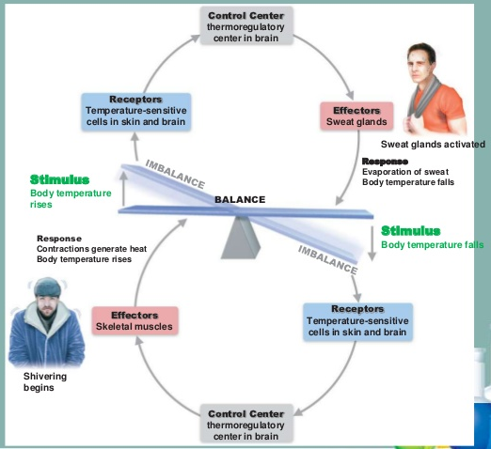
Examples of endotherms include birds, mammals, and a few species of fish.
An advantage of being an endotherm is that the internal temperature of the organisms is independent of the external, environmental temperature. This allows endotherms to live in almost all habitats on Earth.
A disadvantage of being an endotherm is that in order to maintain a constant internal temperature, an organism must use a lot energy. This requires endotherms to eat on a regular basis.

Metabolic Rates—Comparison
- In general, endotherms have higher metabolic rates than ectotherms.
- As the external temperature drops, the metabolic rate of an ectotherm will also drop. The metabolic rate of an endotherm will either be unaffected or it might rise slightly.
- As the internal temperature increases, the metabolic rate of an ectotherm will rise quickly. The metabolic rate of an endotherm will be largely unaffected, but may drop slightly.
- The metabolic rates of endotherms per kilogram tends to decrease dramatically with increased body mass.
- This is largely due to the fact that as body size increases, the surface area to volume ratio decreases. This means that larger endotherms are more efficient at keeping in heat and therefore don’t lose as much heat to the environment. Small endotherms have a high surface area to volume ratio, lose lots of heat to the environment, and must use high metabolic rates to replace this lost heat (so that they can maintain a constant internal temperature).



