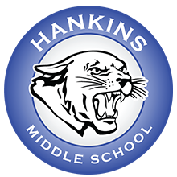
Hankins 2022-2023 School Supply List
- Bookbag (mesh only)
- 1 TI 30XIIS calculator
- 1 box of tissues
- 1 roll of paper towels
- 1 container of wipes
- 1 hand sanitizer
- 1 box Ziplock gallon bags
- 1 box Ziplock quart bags

All other school supplies will be provided by the school.

