Tucker Elementary School
Student Handbook
2024-2025
1300 Tucker Road
Perry, Georgia 31069
(478)988-6278
Mrs. Eddie Williams
Principal
Dr. Meredith Fletcher
Assistant Principal for Instruction
Mrs. Yolanda Felder
Assistant Principal for Discipline
Mrs. Lora Ostrat
Counselor/504 Coordinator

Dr. Mark Scott, Superintendent
Houston County Board of Education
P.O. Box 1850, 110 Main Street
Perry, Georgia 31069
(478) 988-6200
www.hcbe.net

Welcome back Tucker Tigers! I know the 2023/2024 School Year will be the best year ever!
Mission: To develop compassionate, confident, lifelong learners
Vision: To provide a safe environment that engages all students, staff, and community
Values:
Kindness – We care about the feelings of others & show compassion for others.
Respect – We treat others as we would want to be treated.
Excellence – We strive to be the best we can be. ( Nothing but the BEST)
Focus – We focus on reading & computing on grade level.
Proven Instruction – We teach & learn based on evidence
Procedures & Information:
Arrival & Dismissal, Visitor & Checkout
- School begins at 8:30.
- Students need to be in their classroom by 8:25.
Announcements and Pledge start at 8:25,
- instruction begins at 8:30.
- All students report to the lunchroom between 7:45-8:05,
- Students are dismissed to their classrooms at 8:05.
For safety reasons:
• Do not drop your student off before 7:45 as there is no one assigned to
watch them.
- Doors do not open until 7:45.
• Do not drop them off after 8:30.
- If you arrive late, you must park your car in the front parking lot, walk them in and check them in.
- Do not drop them at the front entrance of the school and allow them to walk in by
themselves. They must be accompanied by an adult.
After School Program-
Students enrolled in our After School Program are dismissed from the classroom
and report to the Lunchroom for a snack.
Parents may sign up students by contacting Ramona Johnson at 478-210-8099 or contacting the front office at 478-988-6278. Mrs. Newberry is the coordinator.

Students have an opportunity to work on homework with the support of our After
School Program Teachers, go outside to the playground (weather permitting)
and spend time using technology. They are picked up and signed out from the
front entrance of the school.
Bus Riders-
- Buses drop off on the front hall in the morning,
- Students report to the lunchroom from 7:45-8:05.
- Breakfast is available for bus students from 7:45-8:25 or until the last bus arrives.
- Breakfast carts are located on the front hall. If students choose, they may have breakfast on the go (bagged breakfast) to eat in the lunchroom or take with them to the classroom.

If your child is a Bus Rider, there is an APP to help you track the location of their bus.
- Download Here Comes the Bus App or visit www.herecomesthebus.com online.
- Click the “Sign Up” button.
- Enter the Houston County code 29158. Students who receive special education transportation use code 29157.
- Click “Next” followed by “Confirm.”
- Complete the “User Profile” box.
- Under “My Students,” click “Add.” Enter your child’s last name and student ID number
- Once you confirm your information, you’re ready to begin customizing your settings.
Car Rider Line
- The Car Rider Line moves extremely fast when we all work together.
- Please remember to have your car rider number in your car and visible.
- If you do not have your number in the car, we must call the front office, get the number, and do an ID check.
This is a safety procedure and even though it is frustrating at times, it is necessary to keep our students safe.
However, this takes time and holds the rest of the line up from moving forward.
Checking in & checking out students:
- Students must be checked in and out by an adult.
- Please remember to bring your ID in as we check it against IC permitted pick up list.
- For safety reasons, there will NOT be any early dismissals after 3:00 p.m. except for emergencies or doctor’s appointments.
- Documentation of the appointment needs to be provided no later than the following day.
- If you need to check your child out of school for any reason, you will need to do it before 3:00p.m.

Transportation Changes

- Our front office staff is incredibly busy during dismissal.
- To avoid any confusion, missed buses, and safety issues, we cannot change transportation for your child after 3:00 p.m.
- Also, please do not send a change of dismissal through Class Dojo as teachers do not always get to check that until after school.
- These procedures are put into place for the safety of your children and to make
dismissal run more smoothly.
- If you need to change dismissal, please make sure to call the office before 3:00 p.m
Communication
- Class DOJO – This app helps the school inform you of school events and information as well as being a way to communicate with the teacher on an individual basis.
- Thursday Folders – This folder goes home every Thursday with your student. IT holds your students’ work, forms you may need to fill out, and general information.
- Social Media – We also use social media as one form of communication so please follow us on Facebook and our website.
Discipline
At Tucker we are kind and respectful.
We use Positive Behavior Intervention System (PBIS) as our school-wide discipline plan.
As a PBIS school, we address behavior by teaching the desired behavior, giving positive reminders, reteaching desired behavior, and rewarding desired behavior.
PBIS MATRIX
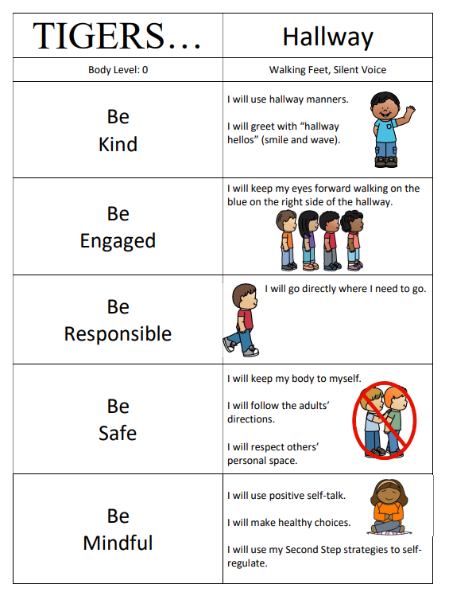
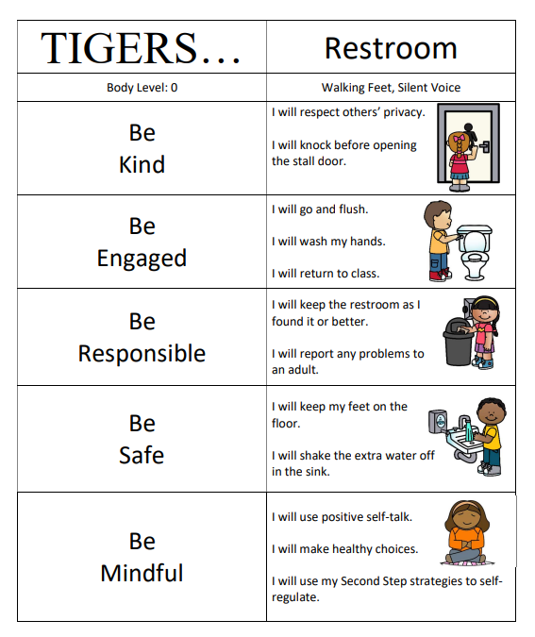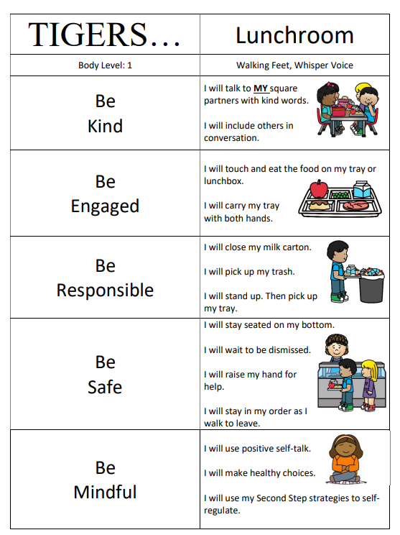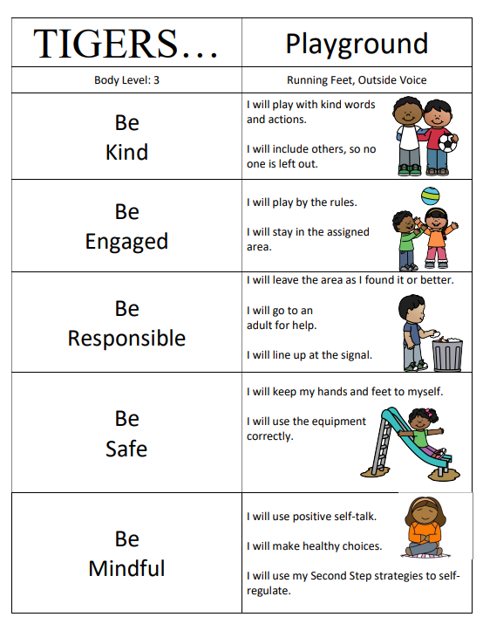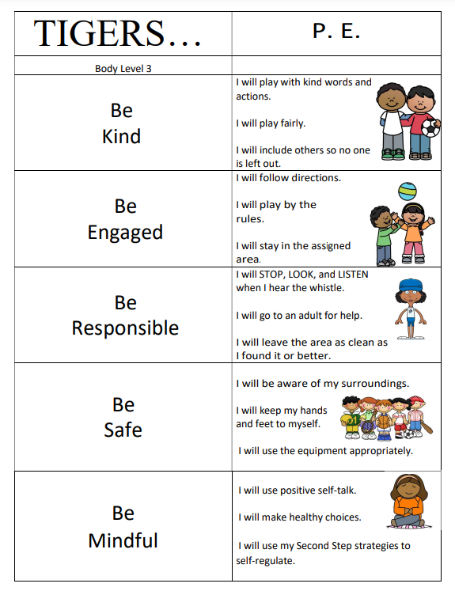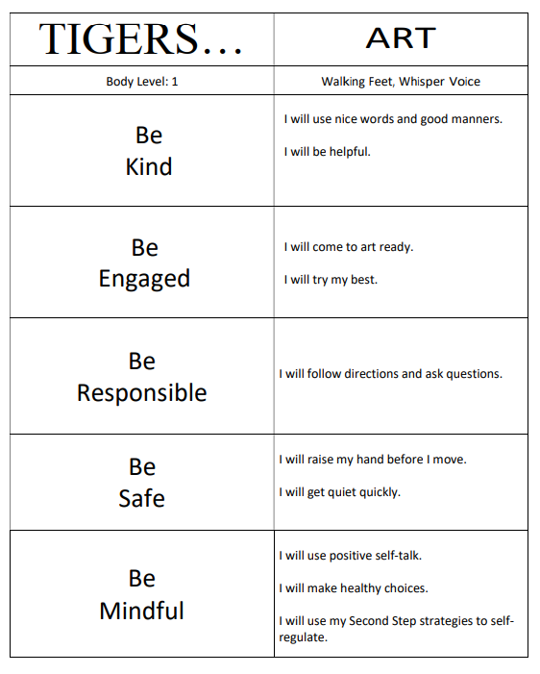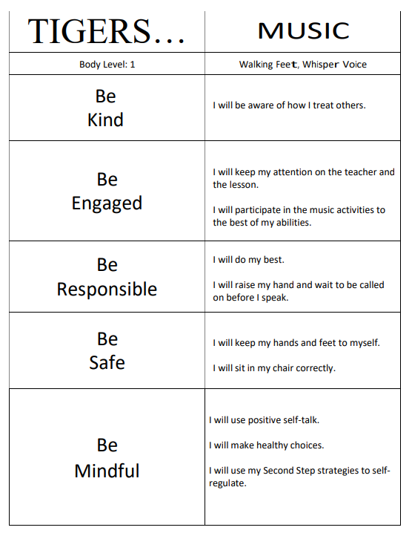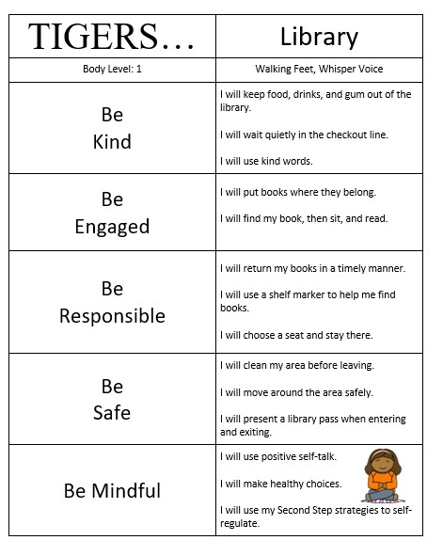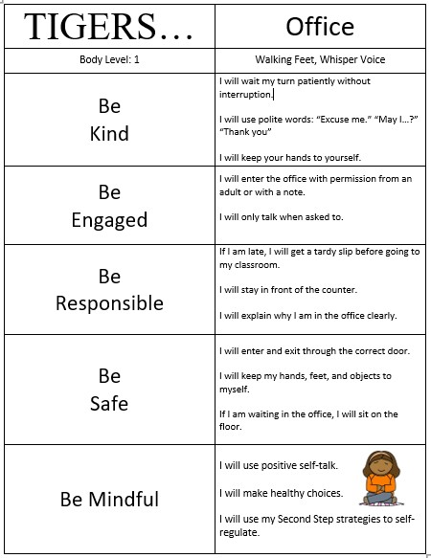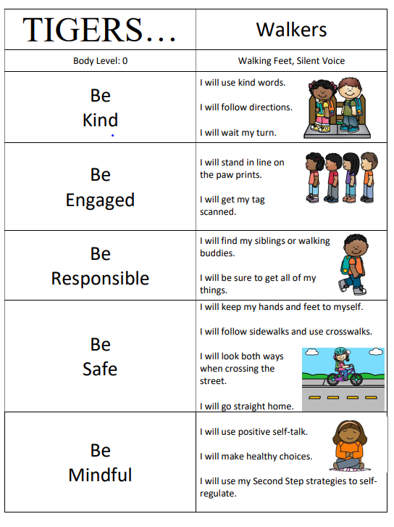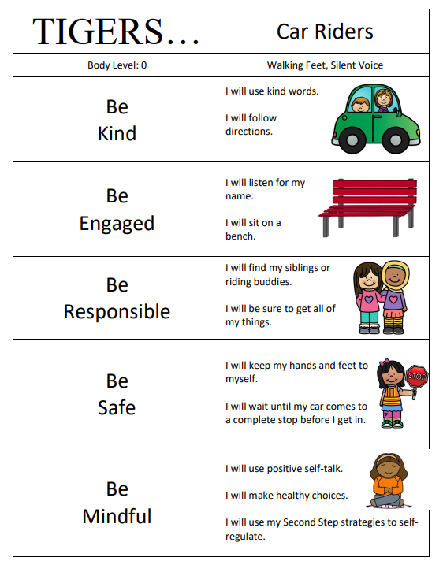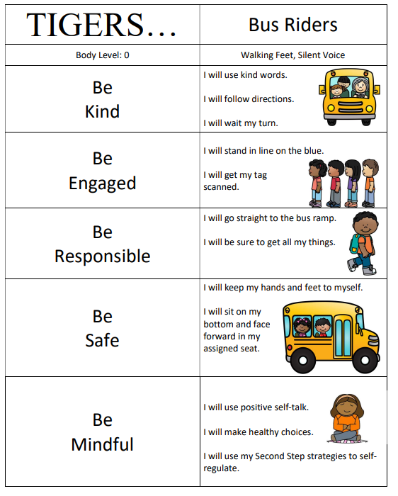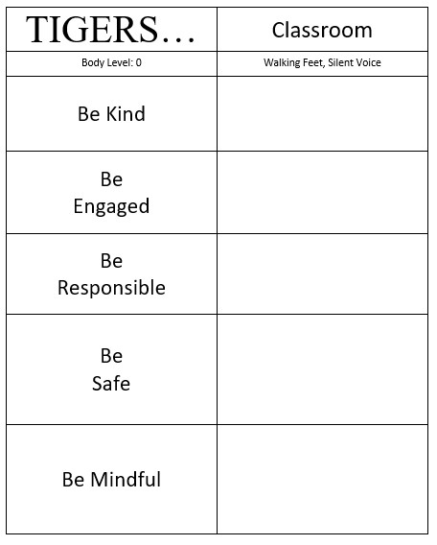
Clubs and Organizations
Paw Squad | 2nd-5th | Shain | Sept 23 | Every other Monday | Gym/Nipper's room | 4:00-4:45pm | foster confidence, teamwork and creativity | $50
Cooking Club | 2nd and 3rd | Seabolt | Sept 24 | last Tuesday of each month | Seabolt's room | 4:00-4:45pm | learn basic kitchen safety, promote healthy eating habits with teamwork | $40
Early Act | 4th and 5th | Whiddon | Sept 10 | every other Tuesday morning | Whiddon's room | 7:45am - 8:30 |  | $0
Chorus | 4th and 5th | Holcombe | Sept 3 | Thursdays | Music room | 3:45-4:45 | learn higher level singing techniques and use them in public performances both at the school and throughout the middle ga area | $20
Art | 4th and 5th | L Harrison |  | 1st and 3rd Tuesday | Art room | 4:00-5:00 | explore different art mediums and personal expression in art | $25
STEM/LEGO | 3rd - 5th | Owen | Sept 24 | last Tuesday of each month | Mrs. Bersey's room | 4:00-4:45 | explore project-based learning activities in science, technology, engineering, and mathematics | $20
Leading Ladies | 3rd - 5th | Witmer | Sept 6 | Every other Friday | Witmer's room | 4:00-5:00 |  | $0

Volunteering
In order to volunteer, one must have a background check completed and on file with the school. Please reach out to our Family Engagement Liaison at 478-988-6278. You can also reach out to our PTO President, Dalas Wright at 229-402-9113 for more volunteer information.
We need your signature on Required Documents:
Required Documents
Parent signature pages for the School Handbook, Technology agreement and various other parent signature pages can be found in Infinite Campus (IC). These documents are required by the school district and must be signed off through infinite campus. Please have all documents signed off by October 4th.
TECHNOLOGY –
The purpose of informational technology is to facilitate communications in support of research and education. Use by any student or staff member must be in support of and consistent with the educational objectives of the Houston County School District. Downloading of non-instructional materials from the Internet is unacceptable. Students must receive permission from a teacher or designated personnel prior to accessing the Internet or any other specific file or application. Students should not have “free time” on computers. If they are not completing an assignment you gave them, computers should not be in use.
Student Personal tables and/or laptops are not permitted on campus. All student cellphones should be collected at the start of the day and returned to students at the end of the day. You should have a designated location for these items. Students are not to have access to these devices at their desks during the instructional day. They are not to be on these devices during arrival, dismissal, or on the bus. Students should not access their devices at all while on campus or school property.
Also, when student computers are not in use, they should not be on their desks. Have a designated location to keep student computers when not in use that is not in or beside student desks. This will help to keep students focused on the learning tasks at hand.
When students are on their computers, let’s be sure that we can answer the question: What are they there for? Let’s be sure that the computer is the best way for students to engage in the learning at hand. If students are simply doing a digital worksheet, we need to rethink our plan. Engagement, rigor, and students having an opportunity to productively struggle with and connect to the content need to be at the forefront of our instructional planning, not easy access.

