Math Review Week # 29 Name__________________
Day 1

1. Write the missing number: 8 + _____ = 10
- Put an X on all the largest number: 51 16 29

- Jenny has 3 s. She popped 2 s. How many s are left? = ____

Mental Math ______________________
_________________________________________
_________________________________________

Math Review Week # 29 Name__________________
Day 2

1. Add: + = ________

- Trace the numbers: 17 16 15 14 13 12

3. Write the number that comes before 10:____

Mental Math ______________________

Math Review Week # 29 Name__________________
Day 3

1. Circle the object that is most like a triangle:
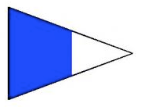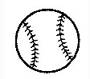
2. What is the name of this shape?_______

- Put an X on the smallest number: 51 16 29

Mental Math ______________________
_________________________________________
_________________________________________
Math Review Week # 29 Name__________________
Day 4

- Write the missing number: 7 + _____ = 10

2. Add: + = ________
3. What is the name of this shape?_______

Mental Math _______________________________

Math Review Week # 30 Name__________________
Day 1
- Add the dominos: 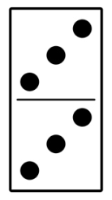 + 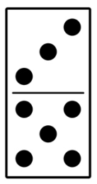 = ______

- Trace these numbers: 87 88 89 90 91
- Tim has 7 s. He ate 3 s. How many s are left? = ____

Mental Math ______________________
_________________________________________
_________________________________________
Math Review Week # 30 Name__________________
Day 2

1. Subtract 6 - 2 = _______

2. Write the missing number: _____ + 3 = 9

3. Draw a circle:

Mental Math ______________________

Math Review Week # 30 Name__________________
Day 3

1. How many vertices?_____ How many sides?_____

2. Count backwards: 10, 9, 8, ___, ___, ___, ___, ___

- Draw the addition sentence: 2 + 4 = 6

Mental Math ______________________
_________________________________________
_________________________________________
Math Review Week # 30 Name__________________
Day 4
1. Draw the addition sentence: 5 + 1 + 6

2. Subtract 7 - 3 =______
3. What is the name of this shape?_______

Mental Math ______________________

Math Review Week # 31 Name__________________
Day 1
- Add the dominos: 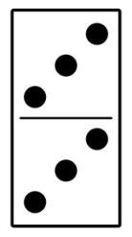 + 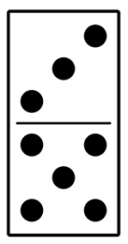 = ______

- Trace these numbers: 87 88 89 90 91
- Fred has 4 s. He got 2 mores. How many s does he have in all? + = ___

Mental Math ______________________
_________________________________________
_________________________________________
Math Review Week # 31 Name__________________
Day 2

1. Subtract 4 - 2 =________

- Color all the rectangles:

3. Circle the largest number: 94 19 71

Mental Math ______________________
Math Review Week # 31 Name__________________
Day 3

1. Color the shapes with 4 vertices:

2. Circle the smallest number: 84 19 41

- Color the coin that is worth more:

Mental Math ______________________
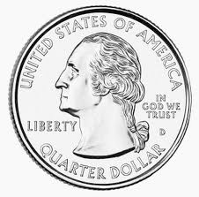
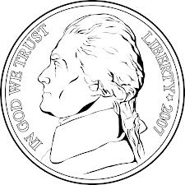
_________________________________________
_________________________________________
Math Review Week # 31 Name__________________
Day 4
1.Color the nickels: 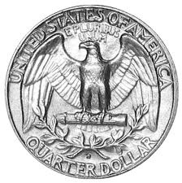
- Add: + = ________
- Show 7:00 on the clock: 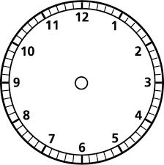

Mental Math ______________________

Math Review Week # 32 Name__________________
Day 1
- Subtract the dominos: - = ______

- Trace these numbers: 93 94 95 96 97
- Pam ate 1 . She ate 6 mores. How many s did she eat in all? + = ___

Mental Math ______________________
_________________________________________
_________________________________________
Math Review Week # 32 Name__________________
Day 2
1. Circle the picture that is the shortest: 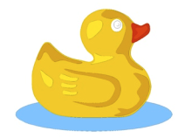
7

2. Which numbers make 7?

3. Count backwards: 20, ___, 18, 17, ___, 15, ___, 13

Mental Math ______________________
Math Review Week # 32 Name__________________
Day 3

1. Color the square:

2. Count forwards: 47, 48, 49, ___, ___, ___, 53
12

- What numbers make 12?

Mental Math ______________________
_________________________________________

_________________________________________

Math Review Week # 32 Name__________________
Day 4
- Make a model of the number 14:

- What shape is this?_________
3. Circle the object that is the lightest:

Mental Math ______________________
Math Review Week # 33 Name__________________
Day 1
- Make a model of 15:

- Trace these numbers: 95 96 97 98 99
- Circle the object that is the longest:
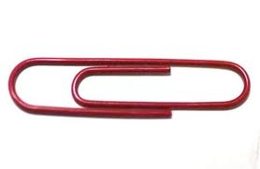

Mental Math ______________________
_________________________________________
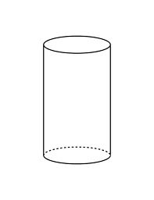
_________________________________________
Math Review Week # 33 Name__________________
Day 2

1. Add: + = ________

2. What is the missing number: 9 + _____ = 10

- Is this shape 2D or 3D? 2D 3D

Mental Math ______________________

Math Review Week # 33 Name__________________
Day 3

1. Make a model of 34:

2. Count forwards: 87, 88, 89, ___, ___, ___, ___

- What is the missing number: _____ + 6 = 10

Mental Math ______________________
_________________________________________
_________________________________________
Math Review Week # 33 Name__________________
Day 4
1. Solve: 7 - 2 = _____ 4 - 1 = _____ 5 - 3 = ____
- Which is longer?
3. Bon had 4 s. He ate 2 s. How many s does he have left? = ____

Mental Math ______________________

Math Review Week # 34 Name__________________
Day 1
- Draw a model of 23:

- Trace these numbers: 18 17 16 15 14 13
- Color the shape with the most sides:
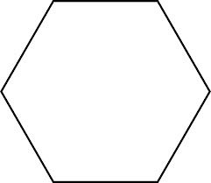

Mental Math ______________________
_________________________________________
_________________________________________
Math Review Week # 34 Name__________________
Day 2

1. Add: + = ________

- Draw a model of 18:

3. Finish the AB pattern: ___ ___ ___

Mental Math ______________________

Math Review Week # 34 Name__________________
Day 3

1. Solve: 6 - 1 = _____ 4 - 4 = _____ 8 - 4 = ____

2. Which shape does not belong?

3. Compare the circles using <, >, =:
_____
Mental Math ______________________
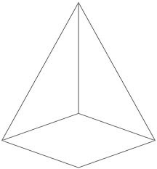
_________________________________________
_________________________________________
Math Review Week # 34 Name__________________
Day 4
- Draw a model of 31:

- Is this shape 2D or 3D? 2D 3D

- If today is Saturday, what was yesterday?
Sunday Friday

Mental Math ______________________

Math Review Week # 35 Name__________________
Day 1
- 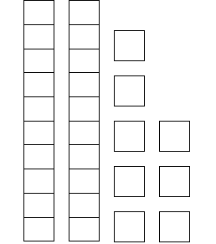 Circle the number: 18 37 28

- Complete the addition sentence: ___ + ___ = 5
- Compare kids the using <, >, =:
_____
Mental Math ______________________
_________________________________________
_________________________________________
Math Review Week # 35 Name__________________
Day 2

1. Subtract 6 - 3 =______

- Solve: 5 + _____ = 8
3. Which is heavier?

Mental Math ______________________

Math Review Week # 35 Name__________________
Day 3

1. If this month is May, what will next month be?
June December
2. Complete the addition sentence: ___ + ___ = 3

3. Draw a model of 42:

Mental Math ______________________
_________________________________________
_________________________________________
Math Review Week # 35 Name__________________
Day 4

- Solve: ____ + ____ = 8
- 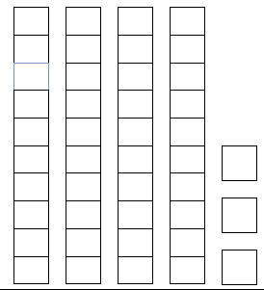 Circle the number: 43 18 34

- If today is Saturday, what will tomorrow be?
Sunday Friday

Mental Math ______________________
Math Review Week # 36 Name__________________
Day 1
- 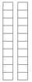 Circle the number: 18 20 10
- Is a cylinder a 2D shape or a 3D shape?_____

- Compare fish the using <, >, =:
_____

Mental Math ______________________
_________________________________________
_________________________________________
Math Review Week # 36 Name__________________
Day 2

1. Subtract 4 - 3 = ______

- Circle the group that has the least amount:

3. Complete the addition sentence: ___ + ___ = 10

Mental Math ______________________

Math Review Week # 36 Name__________________
Day 3

1. Which shape does not belong?
2. Write a 72 in the square:

3. Show 4 o’clock on the clock:

Mental Math ______________________
_________________________________________
_________________________________________
Math Review Week # 36 Name__________________
Day 4
- Circle the coin name: 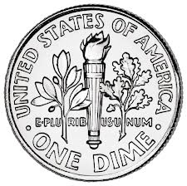 nickel dime

2.Circle the group that has the most:
- Color all the 2D shapes: 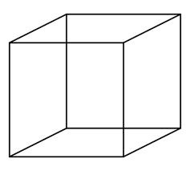 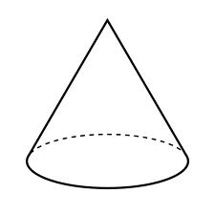

Mental Math ______________________
Math Review Week # 37 Name__________________
Day 1
- Circle the number: 18 20 40

- Finish the ABB pattern: X O O X O O ___ ___ ___

- Put an X on the largest number: 91 86 99

Mental Math ______________________
_________________________________________
_________________________________________
Math Review Week # 37 Name__________________
Day 2

1. Add: + = ________

- There were 5 in the pond. 3 more were born. How many s are there now?
+ = ____

3. Count forwards: 85, 86, 87, ___, ___, ___, ___

Mental Math ______________________

Math Review Week # 37 Name__________________
Day 3

1. Trace the numbers: 60 61 62 63 64
2. Circle the object that is most like a triangle:
3. Show 6 o’clock on the clock:

Mental Math ______________________
_________________________________________
_________________________________________
Math Review Week # 37 Name__________________
Day 4
- Color the dimes: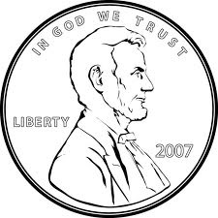

2. Add: + = ________

- What is the name of this shape?__________

Mental Math ______________________

