

Student/Parent Handbook
2026-2027

*Taylor County Primary is a school-wide Title I school, and as such, ensures that all students receive educational services based on their identified needs.

Taylor County School District 2026-2027 School Calendar

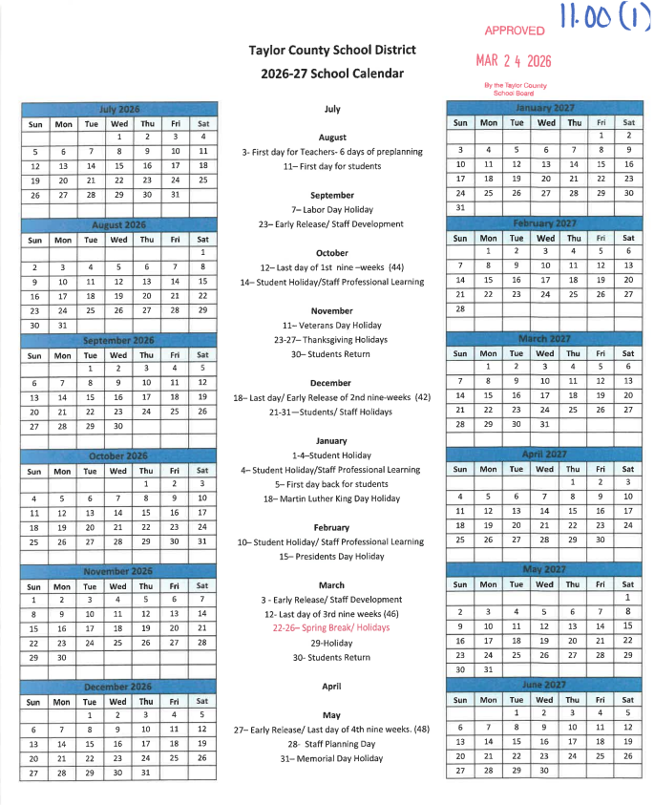



The Foundation for a Bright Future!

TCPS Mission Statement
Taylor County Primary School’s mission is to equip our students with foundational skills that will allow them to develop academically, socially, and physically.

TCPS Vision Statement
Taylor County Primary School’s vision is to commit to preparing students to achieve academic success and to reach their full potential as productive citizens.

ATTENDANCE
Taylor County School Board ATTENDANCE REGULATIONS
The Legislature finds that poor academic performance is associated with nonattendance and that school districts must take an active role in promoting and enforcing attendance as a means of improving student performance. The Legislature finds that early intervention in school attendance is the most effective way of producing good attendance habits that will lead to the improvement of student learning and achievement.
Attendance procedures shall be carried out in accordance with Taylor County School Board Rule 5.02, Florida Statute 1003.26, and the Code of Student Conduct and Attendance Policies.
- According to FS 1003.26, any student between the ages of 6 and 16 is within compulsory school attendance age requiring regular school attendance. Parents of a child within the compulsory school attendance age shall be responsible for such child’s attendance as required by FS 1003.26. It is understood that ALL students will be subject to the stipulations within this attendance policy. Attendance is required of all students for at least 180 days of instruction or the equivalent as provided by law, except for absences which are excused or as otherwise provided by law.
- Attendance is defined as the actual presence of a student at school or away from school on a school day engaged in an educational activity that constitutes a part of the school-approved instructional pupil program.
Absence is defined as the nonattendance of a student on days that school is scheduled to be in session. Any tardy/absence of 10 minutes or more from a class will result in an absence from that class. Absences may be defined as excused or unexcused in accordance with local policy.
Excused Absences
In compliance with Florida School Laws, the Taylor County School Board recognizes excused absences as those resulting the following:
- • Absence resulting from sickness, injury or other insurmountable conditions or participation in an approved academic program or class
- • Participation in the observance of a religious holiday or in religious instruction
- • Death in the immediate family of the student (immediate family is defined as parents, siblings, grandparents, aunts, and uncles, and in some cases, other persons in the household)
• Pre-excused doctor, dentist appointments, or educational/field trips
• Insurmountable weather conditions.
A student who misses one (1) or more periods during the school day must, within two (2) school days, bring a note from a parent or guardian stating the reasons for that absence. Excused absences are described above. Students returning to school after an excused absence shall have a period equal to the number of days excused or a minimum of five (5) days, whichever is greater, to make up missed work. It is the student’s responsibility to plan with their teachers to complete missed work. If reasonable doubt exists regarding a sickness or injury, the principal is authorized to require a statement from an accepted medical authority. Failure to comply with this requirement shall result in the absence being unexcused.
If a student fails to bring a note within two (2) school days after being absent, or if the reason is not a valid one, the student will receive an unexcused absence for the days/classes missed and the following rules will be in effect: Students with unexcused absences and determined to be truant or skipping are subject to disciplinary action.
Monitoring of Absences
As outlined in FS 1003.26, upon each unexcused absence, or absence for which the reason is unknown the school principal, or his or her designee, shall contact the student’s parent to determine the reason for the absence. If the absence is an excused absence, the school board shall provide opportunities for the student to make up assigned work and not receive an academic penalty unless the work is not made up within a reasonable time.
If a student has had at least five unexcused absences, or absences for which the reasons are unknown, within a calendar month or 10 unexcused absences, or absences for which the reasons are unknown, within a 90-calendar day period, the student’s primary teacher shall report to the school principal or his/her designee that the student may be exhibiting a pattern of nonattendance. *Parents may submit 3 notes per semester for excused absences. (All doctors' notes will be honored as excused absences).
During each semester of the school year, the following actions will take place: The student’s primary teacher(s) will make documented attempts at parent contact, once the student has been identified with five unexcused absences within a 30-calendar day period a Level 1 Truancy letter will be mailed home at this time. The school principal or designee will make documented attempts at parent contact once the student has been identified with ten unexcused absences within a 90-calendar day period. A Level 2 Truancy letter will be mailed home at this time and a meeting with the Intervention Assistance Team will take place with designated team members, the parents/guardians, and the student present.
The school principal or designee will mail a Level 3 Truancy letter to the parent/guardian of any student identified with 15 unexcused absences within a 90-calendar day period. This student will be referred to the district level Intervention Services Department.
Exceptions to the Attendance Policy
- Chronic or extended illness (must have a doctor’s verification). Students suffering chronic illnesses –i.e. Asthma, Diabetes, etc.—must submit to the principal at the beginning of the school year, a doctor’s verification of the condition
- A note from the hospital, and/or physician must verify hospitalization
- Death in the immediate family requiring extended absence (parents/guardian written verification needed)
- Court subpoena (copy of court paperwork for verification)

Preschool Attendance
Your child is expected to attend school on a daily basis. You are paying for excellent care and the only way we can provide it is if your child attends the center daily. If you are set on a part time rate, the same rules apply. VPK hours are from 8:00 a.m. – 11:00 a.m.
- Your child must be in school by 7:55am to be included in the count for breakfast.
2. Your child must be in attendance at, or before, 8:30 a.m. to be considered present for the day. If you arrive after the designated time your child will not be accepted for the day.
Note: If your child is tardy for an excused reason (dr. visit, etc.) please bring your excuse from the doctor so that he or she may be accepted for the program day.
- If you keep your child at home for any reason, please be sure and contact the center as soon as possible. When the child returns proper documentation from the doctor/hospital must be turned in to the front office.
**Please Note: Your tuition payment will remain the same regardless of absences for your child to receive care without interruption. Parents/ guardians are responsible for paying any difference between the full time rate and the part time rate as listed on the approved School Readiness rate certificate. Payments are due one week in advance based on the provider’s tuition schedule. Timely payments help ensure your child’s enrollment remains active, and services continue without interruption.
4. Children that miss more than 3 days per month will be in jeopardy of losing their slot in VPK and/or School Readiness.
5. Parent must sign child in and out every day and sign the monthly verification of attendance form.

BULLYING
TCSD STUDENT BULLYING AND HARASSMENT POLICY
The Taylor County School System is committed to a safe and civil educational environment for all students, employees, volunteers, and patrons, free from harassment, intimidation, or bullying. "Harassment, intimidation, or bullying" means any intentional written, verbal, or physical act, including but not limited to one shown to be motivated by any characteristic in RCW 9A.36080(3), (race, color, religion, ancestry, national origin, gender, sexual orientation, or mental or physical disability), or other distinguishing characteristics, when the intentional written, verbal, or physical act:
- Physically harms a student or damages the student's property; or
- Has the effect of substantially interfering with a student's education; or
- Is so severe, persistent, or pervasive that it creates an intimidating or threatening educational environment; or
- Has the effect of substantially disrupting the orderly operation of the school.

Bullying may involve but is not limited to: Teasing, Social Exclusion, Threat, Intimidation, Stalking, Physical Violence, Theft, Sexual, religious, or racial harassment, Public Humiliation, Destruction of Property

Cyber stalking as defined in s. 784.048(1)(d), F.S., means to engage in a course of conduct to communicate, or to cause to be communicated, words, images, or language by or using electronic mail or electronic communication, directed at a specific person, causing substantial emotional distress to that person, and serving no legitimate purpose. Nothing in this section requires the affected student to possess a characteristic that is a basis for harassment, intimidation, or bullying. "Other distinguishing characteristics" can include but are not limited to physical appearance, clothing or other apparel, socioeconomic status, gender identity, and marital status. Harassment, intimidation, or bullying can take many forms including slurs, rumors, jokes, innuendos, demeaning comments, drawings, cartoons, pranks, gestures, physical attacks, threats, or other written, oral, or physical actions. "Intentional acts" refers to the individual's choice to engage in the act rather than the ultimate impact of the action(s).

This policy is not intended to prohibit expression of religious, philosophical, or political views, provided that the expression does not substantially disrupt the educational environment. Other inappropriate behaviors that do not rise to the level of harassment, intimidation, or bullying may still be prohibited by other district policies or building, classroom, or program rules.

This policy is a component of the district's responsibility to create and maintain a safe, civil, respectful, and inclusive learning community and is to be implemented in conjunction with comprehensive training of staff and volunteers, including the education of students in partnership with families and the community. The policy is to be implemented in conjunction with the School Improvement Plan and the Code of Student Conduct that includes prevention, intervention, crisis response, recovery, and annual review. Employees are expected to support the dignity and safety of all members of the school community.

Depending upon the frequency and severity of the conduct, intervention, counseling, correction, discipline, and/or referral to law enforcement will be used to remediate the impact on the victim and the educational environment and change the behavior of the perpetrator. This includes appropriate intervention, restoration of a positive educational environment, and support for victims and others impacted by the violation. False reports or retaliation for harassment, intimidation, or bullying also constitute violations of this policy.

The Superintendent shall develop procedures for the implementation of this policy, as well as guidelines for the prompt investigation of a report of bullying or harassment. These procedures are to be implemented in full and shall represent the guidelines, actions, and responsibilities of all Taylor County School District employees, as well as our students, parents, and the community.

STATUTORY AUTHORITY: 1001.41, 1001.42, F.S
LAWS IMPLEMENTED: 1001.31, 1001.372(1), 1001.363, 1001.395,
1001.41, 1001.43, 1003.02, F.S.
TAYLOR COUNTY

CAFETERIA/LUNCH
The Taylor County School District has received a grant enabling all students to eat breakfast and lunch free of charge. This is for every child regardless of their economic status. Food and drinks should only be brought for lunch or snack and should be packed away in a lunch box that is not accessed during instructional time.
To check out the monthly menus visit http://www.taylor.k12.fl.us/shared.content/lunch.menus/ on the district website.

All students have a right to an enjoyable lunchtime. Students are expected to follow these rules so that the cafeteria is a place where all feel welcome to have a pleasant meal:
- Enter in a quiet and orderly manner.
- Stay in a line until seated.
- Use inside voices with other students at your table.
- Stay seated at your assigned table.
- Raise your hand if you need something.
- Take no food or drink from the cafeteria.
- Do not share food that has already been opened with others.
- Use good table manners.
- Help others remember the cafeteria rules.

CLINIC PROCEDURES
Our school is proud of the clinic and health services offered to our students. These are the required procedures of the clinic:
- All students must have an Emergency Contact form on file. This will allow the nurse to notify the appropriate people in case of an emergency. It will also list those persons that the parent/guardian has given permission to take that student off campus if ill. Parents will be required to provide any changes in home or business telephone numbers to the school nurse as soon as possible.
- Written parental consent on a Taylor County School Board form is required before any medication can be administered. This school and district will not be held responsible for the effects of dispersing medication. NO STUDENT WILL BE GIVEN ANY MEDICATION WITHOUT A MEDICAL CONSENT FORM. Parents are provided with this form on the first day of school. Additional copies may be obtained in the clinic.
- Parents are responsible for providing necessary medications in its original container and bringing it into the clinic. Students are not allowed to bring any type of medication to the school. For prescription medications, the bottle must have a legible pharmacy label with the student’s name, dose, frequency, and the name of the medication must be present.
- Students are not permitted to carry medications of any kind in their pockets, purses, lunchboxes, etc. during school hours and on the school campus. All medications are to be checked in with the school nurse in the clinic when brought to school. Inhalers are permitted only if the school nurse is notified and provided with required documentation from the child’s physician.
- No medication will be dispensed at school unless these requirements are met.
- The school cannot be held liable for civil damages as a result of administering such medications.
- Students with fevers are required to stay home.
- If a student becomes too sick to stay in class, or is seriously injured, he/she will report to the clinic with a pass from his/her classroom teacher. The school nurse will notify the student’s parent/guardian so the student can be picked up from school by their parent/guardian.
- Students may not go to the clinic between classes or at break time. They must report to their next class and receive a pass from that teacher to go to the clinic.
Accidents - Any accident occurring on campus or during school hours must be reported immediately to the teacher so that the proper accident reports can be completed, and the student can receive the first aid necessary. If a student has school accident insurance, medical attention should be received within 30 days following the accident to receive benefits. Claim forms are available in the front office.
Head Lice - In accordance with Florida State Statutes and Taylor County School District Policy, students who have evidence of head lice shall not be permitted to attend class until presenting a current written notice from a doctor declaring the child to be free from head lice or being cleared by the clinic staff. Students with head lice are also prohibited from riding Taylor County School buses, so arrangements must be made for infected students to be picked up. Parents/guardians are strongly urged to obtain valuable information from the school clinic staff on the proper prevention, detection, and treatment of head lice. Students will not be marked present until they have been cleared by the nurse and are attending class.
COMMUNICATION
Conference: Our teachers will make every effort to contact each parent during the first two weeks of school. The following guidelines ensure successful parent-teacher conferences:
- Every conference must be pre-arranged so parents and teachers can bring all pertinent materials to the conference.
- “Drop-in” conferences during the school day are NOT permitted. A scheduled conference between parents and teachers will allow you the benefit of having your teacher’s undivided attention regarding your child and will be much more effective.
- If parents or teachers want the principal, assistant principal, dean, or academic coach to participate in the conference, the teacher or parent should notify staff members in advance.
FOCUS Parent Portal: The FOCUS parent portal gives access to current information about your child’s data, attendance, discipline records, and your child's latest grades. Information, along with messages of school or class information will be secure web-based communication. Visit: https://focus.taylor.k12.fl.us/focus
Home Folder: Each Wednesday, teachers will send communication folders home with students to give to their parents. These folders will contain important feedback on assignments, tests, and other pertinent information about the student’s progress and/or general school information. Parents are to review information, sign the folder, and return the empty folder with the child the next day so it can be used week after week during the school year.
Phone /Phone Messages: Our schools use FOCUS automated phone calling system to notify parents about attendance and other school information. To stay informed of events and emergency situations, please make sure to keep your phone number and address updated by contacting the front office with any changes.
Every classroom is equipped with telephone service. However, students will not be allowed to place calls by themselves. If a call is warranted, the teacher or school staff member will place the call and allow the student to talk to their parent/guardian. Telephone calls to the classroom are not permitted during instructional day. If there is an emergency, please call the TCPS front office and a staff member will assist you.
CURRICULUM
TCPS follows rigorous standards-based curriculum programs designed to improve and maintain students’ reading and math abilities. Students are assigned to flexible reading and math groups for instruction at the appropriate levels. Each classroom will also utilize learning centers to differentiate instruction for all students.

CUSTODY OF CHILDREN
School personnel are required by law to release children to either of their parents unless the school has on file a copy of a court order stating that one parent has been granted custody of the child.

DAILY SCHEDULE
Supervision of Students Begins | 7:30 am
Breakfast | 7:30am -7:50 am
Instruction Begins | 7:55 am
Lunch Blocks | 10:45am-11:20 am - Kindergarten  11:20-11:50 am Preschool and VPK  11:55- 12:30 – Second Grade  12:30-1:05pm – First Grade
Preschool Nap Time | 12:30pm-2:00pm
Dismissal | 2:30pm
Students are expected to arrive at school before the instructional day begins. Drop off begins at 7:30 AM and ends at 7:50 AM. Students not arriving at school on time MUST report to the office, a parent/guardian MUST walk the student into the building to sign them in for the day. Students who have an excessive number of tardy days will be turned over to TCSD for truancy purposes.

DISCIPLINE
Student Code of Conduct – can be found by visiting the link below, or on the district website. https://content.myconnectsuite.com/api/documents/1611cea49c49464895e4f527295fccc4.pdf
NOTE: The principal has the final authority for determining consequence once a discipline referral is submitted.

PRESCHOOL REMOVAL POLICY

There are reasons we must remove a child from our program either on a short term or permanent basis. We want you to know that we will do everything possible to work with the family of the child(ren) to prevent this policy from being enforced. The following are reasons we may have to expel or suspend a child from this center:
IMMEDIATE CAUSES FOR REMOVAL
- The child is at risk of causing serious injury to other children or him/herself
- Parent threatens physical or intimidating actions towards any staff member
- Parents exhibit verbal abuse to a staff member in front of enrolled children.
PARENTAL ACTIONS FOR CHILD’S REMOVAL
- Failure to pay/habitual lateness in payments
- Failure to complete required forms including the child’s physical/immunization records
- Habitual tardiness when dropping off your child.
- Habitual tardiness when picking up your child.
- Attendance of student.
- Verbal abuse to staff
CHILD’S ACTIONS FOR REMOVAL
- Failure of child to adjust after a reasonable amount of time
- Uncontrollable tantrums/angry outbursts
- Ongoing physical or verbal abuse to staff or other children
- Excessive biting (multiple occurrences by the child in the same day/week)
Prior to removal, a parent/guardian will be called, and correspondence will be sent home indicating what the problem is, and every effort will be made by both school staff and the parent to correct the problem. If, after one or two weeks, depending on the risk to other children’s welfare or safety, behavior does not improve, and the school finds that they can no longer accommodate the child, the parent/guardian will be asked to remove him/her. The parent/guardian will be given a minimum of one week’s notification to find another center to provide care for this child.

DISTRICT POLICIES
Please visit Taylor County District website at www.taylor.k12.fl.us to see policies on:
- Statement of Non-Discrimination
- Equity Statement
- Maintenance of Student Records
- Location & Availability Student Educational Records
- Who Has Access to Student Records
- What Information is in a Student’s Record
- Notification of Rights Under FERPA
- Authority to Remove Disruptive Students
- Alcohol, Mood-Modifying, or Controlled Substance on Board Property
- Student’s Use and Possession of Tobacco and Tobacco Products
- Dangerous Weapons in School
- Parental Notification of School Health Services
- AIDS Policy Statement
- Sexual Harassment Statement
- Gun-Free Schools Act

DRESS CODE
Dress Code Policy – can be found on page 16 of the Student Code of Conduct. https://content.myconnectsuite.com/api/documents/1611cea49c49464895e4f527295fccc4.pdf
NOTE: The principal has the final authority for determining dress code violations.

ELECTRONIC DEVICES
In the best interest of all, students should leave electronic devices at home. If a parent feels it is necessary for their child to have a cell phone at school, the following rule applies cell phones must always remain off and out of sight during school hours. If a student violates this policy the cell phone will be confiscated, and a parent will have to come to the school to pick up the phone. The discipline matrix will be followed for non-compliance. The school will not take responsibility for any electronic devices that are lost or damaged.

ENRICHMENT WHEEL CLASSES

Media- Our media center supports the academic curriculum of the school. Library Media programs provide a welcoming, resource-rich environment that supports multiple literacies, cultivates a culture of inquiry and literacy appreciation, and encourages the independent, ethical exploration of information and ideas. Students also have opportunities to check out books and participate in the Accelerated Reader (AR) program.
Physical Education - Structured fun activities, led by our highly qualified staff, are designed to make children aware of the importance of physical fitness. Our PE curriculum includes health education and a character education component as well as physical activities designed to teach the foundational skills of physical education. Students are encouraged to wear closed toed, well-fitting shoes on their PE days.
Music- Music education plays a crucial role in the holistic development of primary age students, offering benefits that extend far beyond musical proficiency. Engaging in musical activities stimulates brain development, leading to improvements in cognitive skills like memory, attention span, and language processing. Music also fosters emotional intelligence by providing an outlet for self-expression and helping children understand and manage their feelings.

FAMILY ENGAGEMENT NIGHT
As a Title I school-wide project, we will sponsor Family Engagement activities for you and your family. Our school will also be offering several meeting nights during the school year. Please consult your school newsletter, school Facebook page, and FOCUS for more detailed information about each planned activity. We look forward to your participation.
FIELD TRIPS
Field trips are a part of our schools’ programs of activities; therefore, the same Code of Conduct required at school will be enforced during these functions. Only students who demonstrate appropriate behavior prior to the trip will be allowed to attend. Bus rules are to be observed on such trips as well. Parents will receive information regarding field trips in advance and we encourage parents, if space is available, to accompany their children on field trips. Parents may sign their child out during the trip or at the end, for their child to ride home with them, but all students are to ride to the event on the school bus as they are participating in a school-sponsored event. Some field trips are extracurricular and voluntary with parents funding the cost of their child’s participation in the trip. Other field trips are curricular activities with every child participating in the field trip at no cost to the parents. A signed and notarized Field Trip Permission Form is required for any student going on any field trip or off-campus event.
* Field Trip behavior expectations will be made clear prior to expectation period beginning.
GRADING POLICY
In accordance with the legislative ruling, the following grading procedure applies at TCPS:
Letter Grade | Percent | Definition
A | 90-100 | Outstanding Progress
B | 80-89 | On Grade Level
C | 70-79 | Average Progress
D | 60-69 | Lowest Acceptable Progress
F | 0-59 | Failure
Additional Grades (Conduct and Enrichment Wheel Courses) |  | Definition
S |  | Satisfactory
N |  | Needs Improvement
U |  | Unsatisfactory
I |  | Incomplete
NG |  | No Grade

Grading Protocols for Grades K-5: See Pupil Progression plan at www.taylor.k12.fl.us
Report cards will be issued to your student on the school board approved calendar days shown on the District Calendar which can be accessed at www.taylor.k12.fl.us or the front of this handbook.

HOMEWORK
Homework builds study skills, teaches responsibility, and reinforces daily assignments. Homework is provided for extra practice and will not affect a student’s grade. Homework details will be provided by your child’s teacher.

INSURANCE
Our schools and the Taylor County School District make available a school insurance plan for students. Participation in the school insurance plan is optional. The school district does not profit from your child’s participation in this plan, nor do we control the process by which claims are handled. Parents who wish to participate in the Supplemental Insurance Program must complete and return the Insurance Registration Form as directed. The program has a time limit for participation. The website for this insurance is: www.schoolinsuranceagency.com.

LOST & FOUND
We would like to encourage students and parents/guardians to make sure all articles are properly labeled with the student’s name, especially coats and jackets. All unlabeled items found at TCPS will be placed in the lost and found area in the cafeteria. Unclaimed items are donated at the end of each 9 weeks.

PARENT INVOLVEMENT & VOLUNTEERS
We enjoy and appreciate the support and involvement of families and friends. The TCPS Parent Teacher Association is open to all school employees, parents, grandparents, neighbors, and friends that help with fund-raisers, field trips, family night activities, recognition programs, teacher appreciation activities and a variety of other projects.
Serving on a School Advisory Council (SAC) is another opportunity for parents to become involved. By state mandate, our membership must consist of at least 51% non-school-based personnel. Parents, business, and community leaders must make up this percent and must maintain a racial/ethnic balance percentagewise, based on the student population at the school. We also strive to balance the membership according to the socio-economic status of our students. The parents at large will be given the opportunity to vote after school begins. In accordance with the Florida Sunshine laws, our SAC meetings are always open to the public. All parents and other stakeholders are invited to attend these meetings.
Volunteering in the classroom is another opportunity for parents to become involved in the school. Our staff will help to make your participation at the school a most enjoyable and productive experience. All volunteers will need to complete and return our Volunteer Survey and application and provide a copy of drivers’ licenses then return it to the school so we may get you started. The school district will put into operation programs, activities, and procedures for the involvement of parents in all its schools with Title 1, Part A programs, consistent with section 1118 of the Elementary and Secondary Education Act (ESEA). Those programs, activities and procedures will be planned and operated with meaningful consultation with parents of participating children. To view the policy in full please check the Taylor County Website at:
http://www.taylor.k12.fl.us/parents/taylor.county.title.i.parental.involvement.policy.pdf

Parties/ Celebrations
On occasion classroom will have parties for holidays or activities. Teachers will contact parents via Focus, or a note, with information regarding classroom parties or celebrations.
Birthdays- parents are allowed to drop off cupcakes or treats for their child’s birthday in the front office. The teacher can choose to have those passed out during lunch, or during recess. Please notify your child’s teacher through Focus, in advance, if you would like to drop off treats for your student.
PROMOTION
Students are expected to make significant academic progress during the school year. Our academic curriculum is aligned to Florida’s B.E.S.T. Standards. These identify the subject area skills to be mastered. A pacing guide can be accessed on the district website. Promotion for students in grades K-5 will be based on proficient achievement in classroom work as evidenced by the report card grade and acceptable levels of performance on state assessments.
Please view our Progression Plan at https://content.myconnectsuite.com/api/documents/28bd56f240d0450f9a4f6534c7c4446e.pdf
REASONABLE ACCOMODATION PROVIDED
Individuals with a disability needing reasonable accommodations to participate in and enjoy the benefits of services, programs, and activities of the School Board are required to notify the administrator at the school/center at which the event or service is offered, in advance, to request reasonable accommodation. To assist parents in making informed decisions regarding their child’s education, please refer them to the Taylor County School District website www.taylor.k12.fl.us/parents/Exceptional Student Education section (under information for parents) for placement, least restrictive environment, diploma options, FSA Waiver Options and a list of contact organizations. Teachers are responsible for reading all students’ IEPs in their class within the first 2 weeks of school.

REGISTRATION
All registration procedures and forms must be completed before a student attends school. An orientation is scheduled prior to the start of the school year to provide parents time to complete the registration forms. Any changes occurring during the school year of your phone numbers or address need to be reported to the office to ensure that communication between school and home is not interrupted. You may send a note with your child or call the front office if information changes are needed.
Immunization records are required for registration packets to be deemed as complete. Students must have the immunizations required by the Florida Department of Health or the proper documentation that excuses them from receiving the immunizations.

RESTROOMS
Restroom facilities are available to students in each classroom. Each classroom teacher will develop his or her own policy regarding the method of use, it is our policy that any child will be allowed to use the restroom as needed within reason. Should your child have a medical condition or physical challenge which requires further restroom consideration, please advise the principal, clinic staff, and classroom teachers in writing.
SAFETY
Safety drills (fire and lockdown) will be conducted throughout the year to ensure the safety and protection of students and staff. Tornado drills will be conducted as needed.
HB 1421 provide provisions for school safety drills including but not limited to active shooter drills, fire drills, school lockdown drills, and tornado drills with the assistance of the appropriate county law enforcement offices.
SIGN-OUT POLICY
Early sign outs are strongly discouraged. When a student is signed out early, valuable teaching opportunities are lost, students are responsible for any missed work. Please make every effort to leave your child in school until school dismissal time. However, if your child is sick (excused by clinic), or your child has a doctor/dentist appointment then a parent/guardian or someone that has written authorization must sign out the student to leave campus in the front office. This will be UNEXCUSED until a note from appointment is returned. Please be prepared to present a photo ID and your child’s Security Code. The receptionist will call the student to meet you in the reception area. Teachers are directed not to release students from class without a call or notification from the reception area. For the safety of all students, parents/guardians will wait in the reception area for their child. TCPS WILL NOT ACCEPT SIGN OUTS OR AFTER 1:45pm, DUE TO END OF DAY PROCEDURES, please make arrangements prior to this time.
SOCIAL MEDIA
You can follow Taylor County Primary School on Facebook at:
https://www.facebook.com/TaylorCountyPrimarySchool

The Taylor County School Board has a YouTube page which is located at: https://www.youtube.com/channel/UCQGw6YQ2f1XUp2kRmHYXB7A
The Taylor County School District’s Facebook and YouTube accounts are meant to be another source of information to the community, as well as a place for the district to engage with its stakeholders. We welcome the opportunity to hear from you and encourage your participation.
At the same time, we would like to establish some rules for engagement. We expect that the people who use our pages exercise civility and common sense when posting comments to our pages. Please remember that your comments can be viewed by many people in our community and are in the public domain. While the district does not want to limit the opinions or comments of its community members, certain types of comments will not be tolerated. We reserve the right to delete posts that:
- Are vulgar or profane
- Contain personal attacks or accusations
- Could be offensive to or target specific ethnic or racial groups
- Incite violence
- Encourage others to break the law
- Could be considered campaigning for a political office
- Easily identify students and/or staff in defamatory, abusive, or generally negative terms
- Promote services or products
- Are rude or ridicule the opinions of others
Thank you for observing the rules of engagement and we welcome your participation and feedback. If you have any questions or concerns about our Facebook page, please email, or call the school.
SOS (Serve our School) Club
Taylor county Primary School’s SOS (Serve Our School) Club is a positive behavior group that provides an opportunity for students to learn about community service and to build leadership skills. To be eligible, students must be practicing consistent responsible behaviors in all areas at school. Their teachers recommend them for the opportunity, and with parent permission the students are assigned age-appropriate jobs around the school. These jobs do not interrupt academic time. The jobs include being a teacher aid, helping in the lunchroom at breakfast, making deliveries, escorting students to class, and sidewalk safety. They also get to help with various activities or events during the school year.

TRANSPORTATION
K-2nd grade students transported by parents or guardians in vehicles must be dropped off and picked up in the area located on the west side of our school building. We ask that you remain in your vehicle; please pull all the way forward and use the entire sidewalk to drop off your child. Preschool and VPK students can be walked to the blue double doors to the right of our main entrance, during drop off times, K-5th grade students who have preschool siblings may be walked to the doors as well. For safety, parents are NOT allowed to walk their child to class. Students are also not allowed to walk up from the parking lot unattended.
Buses will drop students off and pick students up in the bus loop on the east side of the school building, at no time should parents/ vehicles be in the bus loop. Teachers will bring students to the loading area during dismissal.
To ensure safe and efficient transportation for all students, Taylor County School District will assign each student to one bus route and one designated pick-up/drop-off location.

Transportation Changes
Because many buses are operating at full capacity, the district is unable to accommodate frequent or last-minute transportation changes. Parents and guardians are responsible for coordinating transportation between residences when needed.

Approved Schedule-Based Arrangements
Preplanned and necessary schedule-based transportation arrangements, such as custody schedules or consistent alternative schedules, will continue to be allowed when approved in advance.
- Written documentation must be submitted to the school 72 hours in advance.
- The arrangement must be approved by school administration and the transportation director.

Same-Day Pick-Up Requests
If your child needs to be picked up instead of riding the bus on a given day, please contact the school directly at (850) 838-2506, before 1:00 p.m.
Emergencies
We do understand emergencies arise. If you have an emergency, contact the school (850) 838-2506, and school administration will work with the transportation department to allow for the change.
We appreciate your understanding and cooperation as we work to maintain a safe, efficient, and consistent transportation system for all students.
WITHDRAWALS
The parents/guardians must request a withdrawal form from the front office on the last day of attendance. Books are to be returned to individual teachers. The withdrawal form must be signed by the student’s teachers and the media specialist, and then returned to the front office. Student records will be forwarded to the student’s new school upon official written request from the new school.

The School Board of Taylor County, Florida does not discriminate in admission or access to, or treatment or employment in, its programs and activities on the basis of race, color, religion, age, sex, national origin, marital status, disability, genetic information, sexual orientation, gender identity or expression, or any other reason prohibited by law, regarding nondiscrimination. See 34 C.F.R.100.6(d); 34 C.F.R. 106.9; 34 C.F.R. 110.25. In addition, the School Board provides equal access to the Boy Scouts of America and other designated youth groups. This holds true for all students who are interested in participating in educational programs and/or extracurricular school activities. See 34 C.F.R. 108.9. Disabled individuals needing reasonable accommodations to participate in and enjoy the benefits of services, programs, and activities of the School Board are required in advance to notify the administrator at the school/center at which the event or service is offered to request reasonable accommodations. The lack of English language skills will not be a barrier to any opportunity or event associated with Taylor County Schools. Questions, complaints, or requests for additional information regarding discrimination or harassment may be sent to: Kiki Bell- Director of Personnel and Title IX Coordinator, 318 N. Clark St. Perry, Fl. 32347: 850-838-2500/ kiki.bell@taylor.k12. fl.us or Supervisor of ESE and Student Services and Section 504 Coordinator, 318 N. Clark St. Perry, Fl. 32347: 850-838-250

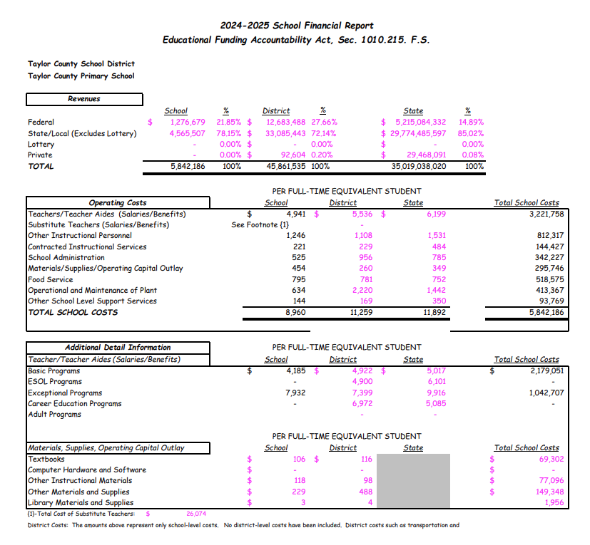
LCOHOL/DRUG AND VIOLENCE PREVENTION
RESOURCES AND REFERRALS

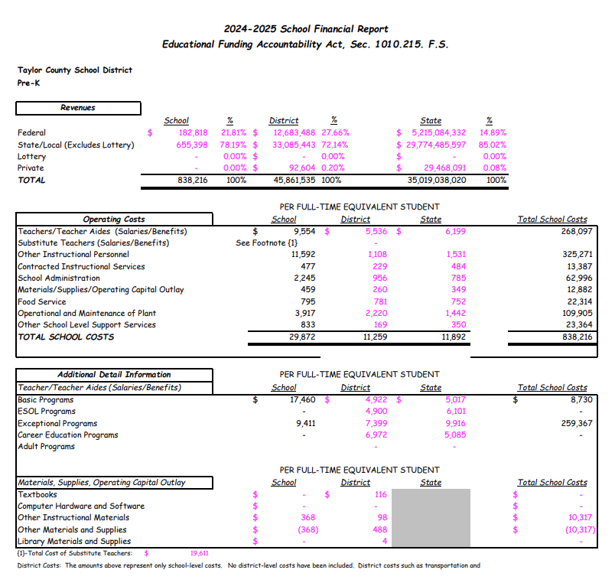

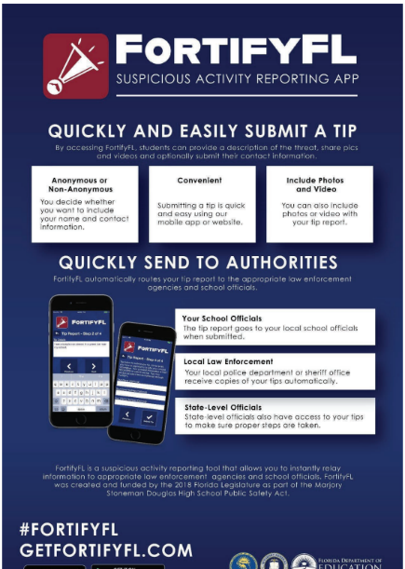
IMPORTANT LINKS and PHONE NUMBERS
The Family and School Partnership for Student Achievement Act
http://infor.fldoe.org/docushare/Get/Document-7577/dps-2016-06.pdf

Monthly Florida Standards Updates
http://infor.fldoe.org/docushare/Get/Document-7578/dps-2016-27.pdf

Taylor County Homeless Information
http://www.taylor.k12.fl.us/Student and Families; Homeless Education www.taylor.k12.fl.us

Emergency Response Taylor County Sheriff’s Office Refuge House Hotline
911 Non-Emergency, 584-4225 584-8808

Domestic Violence Hotline City of Perry Police Department of Children and Families
1-800-500-1119 Non-Emergency, 584-5121 584-3444

Alcoholics Anonymous Department of Juvenile Justice National Runaway Switchboard
584-2554 838-3660 1-800-621-4000

Apalachee Center Alcohol Hotline Information and Referral
584-5613 1-800-252-6465

Drug Education Resource Coordinator Greenleaf Center Twelve Oaks Alcohol & Drug Recovery
TCSD 850-838500 1-800-247-2747 1-800-622-1255

Routing Service for Drug & Alcohol Focus on Recovery Helpline Tallahassee Counseling & Referral
Abuse 1-800-622-1255 1-850-224-6333
1-800-662-4357

Hotline for Abuse, Neglect & Exploitation Florida Abuse Registry Hotline Turn About, Inc.
Of Children, Adults, Elderly 1-800-283-2600 1-850-671-1920
1-800-962-2873

Florida Alcohol and Drug Abuse Al-Anon/Alateen
Association 1-850-222-2294
1-850-878-2196

