Wyoming Area School District

Regular Meeting of the Wyoming Area Board of Education

252 Memorial Street, Exeter, Pennsylvania, 18643

Tuesday, March 26, 2024, 7:00 p.m.

AGENDA

Pledge of Allegiance

Roll Call

Communications Report

Approval of Minutes: Regular Meeting of February 27, 2024

Superintendent’s Report

Solicitor’s Report

Student Representative’s Report

Treasurer’s Report

New Business

Finance Report

Education Report

Activities Report

Building Report

Policy Report

Bids Report

Police Report

Open Discussion

Adjournment



Wyoming Area School District

Regular Meeting of the Wyoming Area Board of Education

252 Memorial Street, Exeter, Pennsylvania, 18643

Tuesday, March 26, 2024, 7:00 p.m.

Communications Report

1. Luzerne Intermediate Unit #18 submitting their regular meeting minutes of January 24, 2024.

2. West Side Career and Technology Center Joint Operating Committee submitting their minutes of January 22, 2024.

3. Sheri Slusser, Wyoming Area Girls Softball Parents Association, requesting permission to hold fundraisers.

4. Karen Donati, Wyoming Area Baseball Parents Association, requesting permission to hold a fundraiser.

5. Sharon Yates, Senior Project Manager of A.D. Marble, on behalf of PennDOT, requesting permission to rent the Secondary Center auditorium for a public open house to discuss the Pittston/West Pittston bridge.

6. Employee #20567, Cleaner, submitting their letter of resignation.

7. Employee #20228, Teacher, submitting their letter of resignation.

8. Wyoming Area Kindergarten/Primary Center PTO requesting permission to hold fundraisers.

Summary of Applications Received

School Psychologist – 2

Cafeteria – 6

Teacher of Visually Impaired - 4

***WYOMING AREA SCHOOL DISTRICT***

***REGULAR MEETING OF THE BOARD OF EDUCATION***

***TUESDAY, MARCH 26, 2024***

***SUPERINTENDENT’S REPORT***

1. **Thank you to our Wyoming Area Baseball Team who read to our kindergarten students for Read Across America week.**



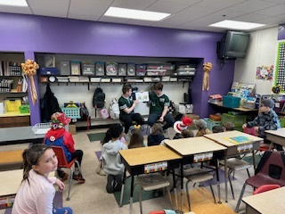

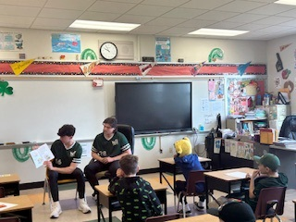

1. **The Primary Center celebrated Read Across America in honor of Dr. Seuss’s birthday. Classrooms were visited by the baseball team and the Drama Club. Community members such as firefighters, police officers, business owners, doctors, lawyers, and politicians visited. Our guests read stories to students and discussed their careers. Throughout the week students showed their Spirit by dressing up each day reflecting stories from Dr. Seuss, such as wear your favorite hat/headband (Cat in the Hat) and crazy socks (Fox in Socks). Students ended the week by eating cake during lunch. Happy birthday Dr. Seuss.**





1. **The Science Olympiad team competed in the Regional Science Olympiad Competition at Penn State Wilkes Barre on Wednesday, March 6th.    
   Congratulations to the following students who earned medals in their events:**

**Astronomy - Loc Bui-Pham and Bella Vogel**

**Chemistry Lab - Drew Dixon and Cadance Cable**

**Codebusters - Kayden Dructor, Chris Fath, Justin Zhou**

**Detector Building - Drew Dixon and Mario Belza**

**Forensics - Cadance Cable and Hannah Stoss**

**Forestry - Hannah Stoss and Brady Kearns**

**Optics - Justin Zhou and Drew Dixon**

**The team also competed in an invitational competition at North Pocono High School in January.  Head Coach is Molly Kearns**

**Assistant Coaches are Nancy Roman and Gordon Williams**

**Teachers Clarise Bandru, Damien Rutkoski, and Alan Hanczyk also assisted in preparing students.**

1. **March marks the one year anniversary of our Satellite Children’s Produce Market at the Exeter Township Borough Building. During that year, the Satellite site has served 1728 people by providing access to groceries. I would like to thank the Exeter Township Board of Supervisors, the Harding Recreation Committee and the Becker Family for their dedication and support of this endeavor. The Children’s Produce Market is held monthly and serves any school age child and their family that resides in the district.**
2. **The Wyoming Area Intermediate Center physical education classes recently**

**participated in a March Madness Free Throw competition. During the week of March 11th–15th, students from Mr. Argo and Mrs. Lombardo’s 4th, 5th, and 6th grade classes had the opportunity to shoot 10 free throws during their PE class to determine the top girl and boy shooters for each class. On March 20th, the top shooters from each homeroom competed for the overall winner of each grade. The winners are as follows:**

**Girl winners: Payson Galvin (4th grade), Ella Tigue (5th grade), and Janessa Barber (6th grade).**

**Boy winners: Tyler Lucas (4th grade), Austin Mucha (5th grade), and**

**Kashius Warren (6th grade)**

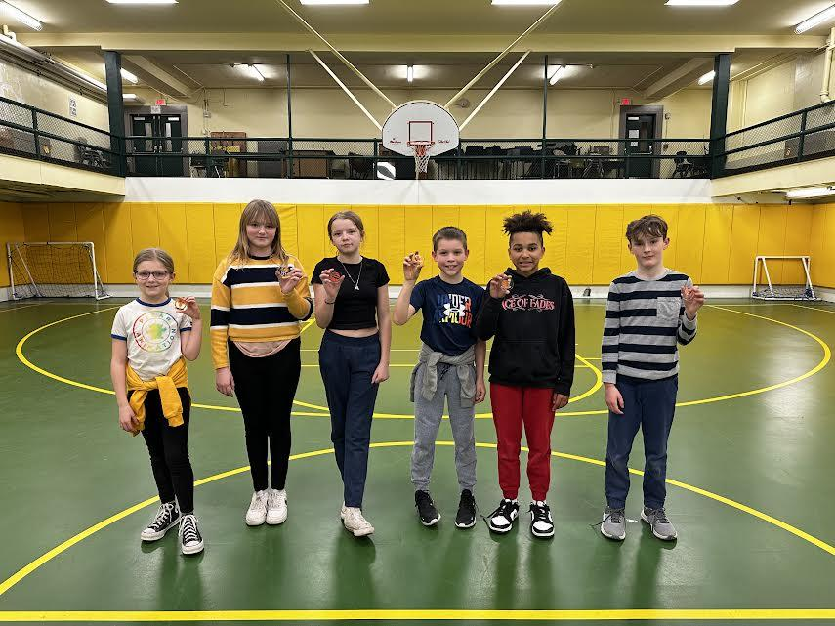

1. **Our annual Climate Survey is posted on our website. Parents and community members are encouraged to submit responses. Students will be taking the survey over the next several weeks.**
2. **WINTER SPORTS - END OF YEAR SUMMARY**
   1. **Wrestling *-* our team record was 5-13 with 7 losses by 6 points or less. We finished with 2 District Champs - Connor Novakowski at 121# and Nate Obrzut at HWT. 1 -5th place finisher Michael Appel at 114#. Nate Obrzut finished 5th and Connor Novakowski finished 6th at Regionals. Nate’s record was 33-9 and Connors was 28-14. Chase Wilhelm was 12-10, Ben Gravine at 16-17, Michael Appel at 14-17, Shane Emsley at 7-13, Johnny Stone at 5-4 and Caden Reynolds at 9-10.**
   2. **Swimming -The Wyoming Area Swim Team more than doubled the size of its team from the previous season.  The girls’ team had a winning record of 6-5 with Ameriana Walker and Ava Menditto leading the Warriors in points.  Ameriana placed 7th in 100 backstroke, and Ava 12th in the 100 butterfly at districts. Macy Waters, a senior, placed 6th in the district diving competition.  The girls 400 free relay team of Bree Harry, Emma Kratz, Walker, and Menditto finished 7th.  The boy’s team was led by Jonathan Cortez and Sonny Sabatini. Cortez, Sabatini, along with John Getzie and William Vanauken finished 8th in the 400 free relay at the district meet.  The Warrior captains were seniors Samara Campenni, Macy Waters, Karamia Marranca, and John Getzie.**
   3. **Boys Basketball -The boy’s basketball team had a very successful season. The team finished with an overall record of 17-9, defeating Berwick in the first round of district playoffs before ending its season with a loss to Scranton Prep in the District 2 AAAA Semifinals. This season, our team became the first team from WVC Division 2 to defeat Holy Redeemer, beating them 74-68 in triple overtime. The team eventually finished tied with Redeemer, losing to them in a WVC league championship playoff game. Many players from the boy’s basketball team received well-deserving accolades upon completion of the regular season.**

**Dane Schutter became the 11th player in school history to achieve the 1,000 point milestone, finishing his career with over 1,300 total points. He was named WVC Division 2 Most Valuable Player.**

**Brady Noone was selected to the WVC Division 2 Second Team All Stars.**

**Tyler Sciandra and Matt Rusinchak were both voted to represent Wyoming Area in the George Moses Senior All Star Game on April 5.**

**Coach Macario was voted WVC Division 2 Coach of the Year, and he will also be coaching our seniors in their senior all- star game.**

* 1. **The Lady Warriors Basketball team embarked on a rebuilding season during the 2023-2024 season. The younger players gained a tremendous amount of experience this season. Players at the Varsity, JV and Junior High levels all had the opportunities to show their tenacious play. Our future looks very bright. Highlights of this season include: Morgan Slusser was invited to play in the Dr. George Moses Senior All Star Game; Addison Gaylor (9th) finished in Top Ten WVC Division 2 for 3 Pointers with 17; Anny Sterba (9th) finished in Top Ten WVC Division 2 in Free Throw Percentage with 52.3%. The team did make the playoffs but lost in the quarterfinals round to Berwick.**
  2. **Winter Track – The team mostly focused on getting in quality conditioning and mileage as a group to prepare for the outdoor season. We traveled to Susquehanna University and Clarks Summit University for two indoor meets to assess training progress, where the kids turned in some solid performances in the 800m and mile.**

Wyoming Area School District

Regular Meeting of the Wyoming Area Board of Education

252 Memorial Street, Exeter, Pennsylvania, 18643

Tuesday, March 26, 2024, 7:00 p.m.

Treasurer’s Report

First National General Fund 5,590,366.24

Community Bank

First National Payroll Account 6,485.32

Community Bank

First National Cafeteria Account 170,316.68

Community Bank

First National Student Activities Account 152,242.20

Community Bank

First National Athletic Fund Account 16,104.01

Community Bank

First National Purchasing Account 500.00

Community Bank

Pennsylvania Local General Fund Account 142,222.23

Government Investment Trust

First National Series 2022 GON Account 7,905.37

Community Bank

First National Money Market Account 6,148,983.90

Community Bank

Wyoming Area School District

Regular Meeting of the Wyoming Area Board of Education

252 Memorial Street, Exeter, Pennsylvania, 18643

Tuesday, March 26, 2024, 7:00 p.m.

Finance Report

1. Received the following checks:

Berkheimer Income Tax

Earned Income Tax 469,165.50

Local Services Tax 4,376.27

Per Capita Tax 604.00

Delinquent Per Capita 1,654.02 Total: 475,799.79

State & Federal Subsidy Payments

Social Security 182,247.12

Title II – Improving Teacher Quality 30,135.00

PCCD Safety & Mental Health Grant 12,740.34

Basic Education Funding 1,361,886.00

ARP ESSER III 181,814.08

ARP ESSER 7% 7,065.51

Total: 1,775,888.05

Local Realty Transfer Tax

Luzerne County 17,444.12

Wyoming County 288.69

Total: 17,732.81

2. Approve the March payment of $94,926.95 to the Luzerne Intermediate Unit in accordance with the terms of the approved contract for Special Education Services and other related services for the 2023-2024 school year.

3. Approve the March payment of $4,958.33 to the Luzerne Intermediate Unit for the Lighthouse Academy Dual Diagnosis Services for 2023-2024 school year.

4. Approve to ratify the March payment of $69,097.00 to the West Side Career & Technology Center for the 2023-2024 school year.

5. Approve engineering services and environmental consultation services pending approval by the school solicitor and business manager.

Wyoming Area School District

Regular Meeting of the Wyoming Area Board of Education

252 Memorial Street, Exeter, Pennsylvania, 18643

Tuesday, March 26, 2024, 7:00 p.m.

Finance Report

6. Approve the Settlement Agreement for student #3002923 pending approval by the school solicitor.

7. Approve Resolution____- 2024 granting the request of Wyoming Avenue Development Group, LLC for the LERTA tax abatement on the subject properties identified as approximately 16 acres, along Wyoming Avenue, Exeter Borough identified by Luzerne County Parcel Id Numbers 16-E11SW1-002-01A-000; 16-E11-00A-21A-000; 16-E10-00A-12A-000; 16-E10-A-12B-000. **(See proposed resolution on the Wyoming Area website)**

**(8.) Approve motion to authorize the development of a strategic planning services agreement between the Wyoming Area School District and CM3 Business Solutions, Inc., subject to final approval of the Board and School Solicitor.**

**(9.) Approve Appendix II – Authorized Official Resolution for a Public School Facility Improvement Grant.**

**(10.) Approve the appointment of Bob Dellarte of Golden Photo Studio to be named the Official Yearbook Photography Studio for the 2024-2025 school year.**

**(11.) Approve the general ledger account:**

**Bill Listing: March 2024 1,067,814.47**

**Prepaids: February 2024 221,231.25 1,289,045.72**

**Cafeteria Account: 109,153.68**

**Athletic Account: 5,781.00 114,934.68**

**Total: 1,403,980.40**

Motion by ______________, second by ______________, to accept the finance report.

Roll Call:

Wyoming Area School District

Regular Meeting of the Wyoming Area Board of Education

252 Memorial Street, Exeter, Pennsylvania, 18643

Tuesday, March 26, 2024, 7:00 p.m.

Education Report

1. Reporting as per Federal Regulations Requirement that the District’s Federal Programs (Title I, Title II, Title III and Title IV) have been planned for the 2023-2024 school year. Anyone desiring information regarding these programs, contact Dr. Jon Pollard, Superintendent, at the District’s Business Office.

2. Approve the agreement regarding waiver of expulsion hearing and free appropriate public education stipulation for student #148310 pending approval by the school solicitor.

3. Approve the step placement of the following temporary professional employees:

Kayla Taddei Bachelors Step 4 $41,483.00

Holly McBroom Bachelors Step 4 $41,483.00

4. Approve the revised professional substitute list for the 2023-2024 school year.

5. Accept, with regret, employee #20228, Teacher, submitting their letter of resignation.

**(6.) Approve the appointment of ______________ as School Psychologist.**

**(7.) Approve the appointment of ______________ as Teacher for the Visually Impaired.**

Motion by ________________, second by ______________, to accept the education report.

Roll Call:

Wyoming Area School District

Regular Meeting of the Wyoming Area Board of Education

252 Memorial Street, Exeter, Pennsylvania, 18643

Tuesday, March 26, 2024, 7:00 p.m.

Activities Report

1. Approve the request of Sheri Slusser, Wyoming Area Girls Softball Parents Association, to hold the following fundraisers:

* Gerrity’s Bagging – 4/1/24
* American Grille Night Out – 4/17/24 & 4/18/24
* Mother’s Day Purse Raffle – 4/22/24

2. Approve the request of Karen Donati, Wyoming Area Baseball Parents Association, to hold an American Grille fundraiser on May 1, 2024.

3. Approve the request of the Wyoming Area Kindergarten/Primary Center PTO to hold a Community Dine Out Night fundraiser at Booyah and Donato’s Pizza on April 14th, April 15th and April 16, 2024.

**(4.) Approve the appointment of Nicholas Sciandra as Assistant Jr. High Trach & Field Coach for the 2023-2024 spring sports season.**

**(5.) Approve the appointment of Jason Gaylord as a volunteer coach for Varsity Softball for the 2023-2024 spring sports season.**

Motion by _________________, second by _____________, to accept the activities report.

Roll Call:

Wyoming Area School District

Regular Meeting of the Wyoming Area Board of Education

252 Memorial Street, Exeter, Pennsylvania, 18643

Tuesday, March 26, 2024, 7:00 p.m.

Building Report

1. Approve the request of Sharon Yates, Senior Project Manager, A.D. Marble, on behalf of PennDOT to rent the Secondary Center auditorium for a public open house regarding the Pittston/West Pittston bridge on Wednesday, May 8, 2024, 3:00 p.m. to 9:00 p.m., pending approval by the building principal. **PennDOT may also be charged for security and custodian.**

2. Accept, with regret, employee #20567, Cleaner, submitting their letter of resignation retroactive to March 1, 2024.

**(3.) Approve the appointment of ______________ as 5.75 hour cafeteria employee.**

**(4.) Approve the appointment of ______________as 4 hour cafeteria employee.**

**(5.) Approve the appointment of ______________as 4 hour cafeteria employee.**

**(6.) Approve the agreement between Wyoming Area Education Support Professionals and Wyoming Area School District to allow any member of the support staff to voluntarily donate one sick leave day during the 2023-2024 school year to employee #20377.**

Motion by _____________, second by _____________, to accept the building report.

Roll Call:

Wyoming Area School District

Regular Meeting of the Wyoming Area Board of Education

252 Memorial Street, Exeter, Pennsylvania, 18643

Tuesday, March 26, 2024, 7:00 p.m.

Policy Report

1. Approve the first reading of revised policies:

Policy #626.1: Travel Reimbursement – Federal Programs

Policy #903: Public Comment in Board Meetings

Policy #254 Attachment- Compact Rules

Motion by _______________, second by ________________, to accept the policy report.

Roll Call:

Wyoming Area School District

Regular Meeting of the Wyoming Area Board of Education

252 Memorial Street, Exeter, Pennsylvania, 18643

Tuesday, March 26, 2024, 7:00 p.m.

Bids Report

The bids for purchase and removal of certain pieces of district property were advertised on the following dates:

Citizen’s Voice/Times Leader/Website

Sunday, March 3, 2024

Sunday, March 10, 2024

Sunday, March 17, 2024

The bids were received and opened on Friday, March 22, 2024, at 10:00 a.m.

The following items were put out for bid:

* 28 Epson Projectors
* 1 Cross Country 18 Ft. Trailer
* 1 12 Ft. Trailer
* 1 Snow Plow (Plow Only)
* 4 Snow Blowers (Troy Bilt – Parts Only)

(Successful Bidder)

Dave Veneziano Yellow Cross Country MFG Trailer $607.00

Bellefonte, PA. Small Black Trailer 207.00

Total: 814.00

Motion by ___________, second by _____________, to ratify the bids report.

Roll Call:

Wyoming Area School District

Regular Meeting of the Wyoming Area Board of Education

252 Memorial Street, Exeter, Pennsylvania, 18643

Tuesday, March 26, 2024, 7:00 p.m.

Police Report

Wyoming Area Police Department

Monthly Report for February 2024

Total Calls for Service

CODE COUNT

1430 Criminal Mischief – Public Buildings 1

1532 Weapons – Possession – Knife 1

1810 Drug Violations 1

2400 Disorderly Conduct 2

2450 Harassment 3

2601 Use of Tobacco in Schools 2

2690 All Other Offenses - Reports 2

3840 Fire Alarm 1

3900 Traffic & Parking Problems 1

4020 Suspicious Vehicle 1

4028 Non-Criminal – Other Investigations 1

5004 Lost & Found – Found Articles 1

7504 Assist Other Agencies – Other Police 2

9997 Child Custody 1

S2S Safe-2-Say Reports 8

TRUA Compulsory School Attendance 16

________

Total 44