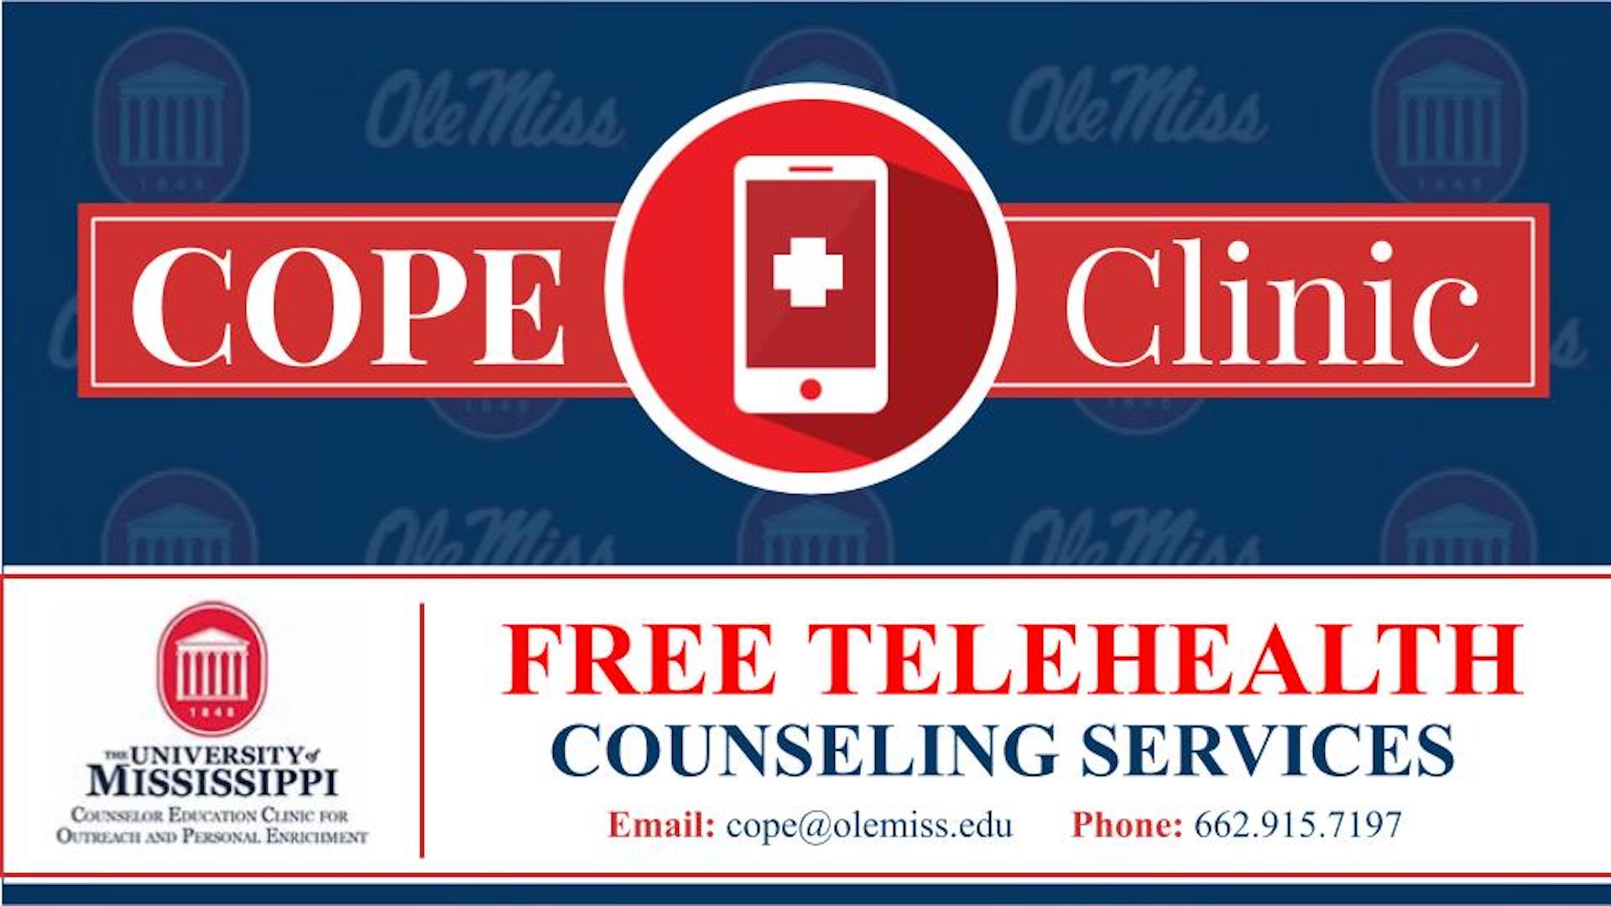

Free mental health counseling is being offered through the Clinic for Outreach and Personal Enrichment (COPE). Outreach efforts are being geared towards K-12 teachers and staff due to the unique stressors you all are faced with during this pandemic. We are offering free Telemental Health Counseling to all Mississippi residents, with the sessions taking place on Zoom. Please feel free to reach out by phone or e-mail to set up confidential counseling services.

