**State of Alabama Research Paper Links:**

**National Geographic Kids**

[**https://kids.nationalgeographic.com/geography/states/article/alabama**](https://kids.nationalgeographic.com/geography/states/article/alabama)

**Britannica Kids**

[**https://kids.britannica.com/kids/article/Alabama/345451**](https://kids.britannica.com/kids/article/Alabama/345451)

**Ducksters**

[**https://www.ducksters.com/geography/state.php?State=Alabama**](https://www.ducksters.com/geography/state.php?State=Alabama)

**Montgomery, AL Population (2023)**

195,287

Attractions



# **USS ALABAMA Battleship Memorial Park**

At Mobile’s USS ALABAMA Battleship Memorial Park, you don’t have to look very far to find heroes. From the Battleship USS ALABAMA to the Submarine USS DRUM and over 30 aircraft, the spirit of military pride is alive and well. Aboard the battleship you will be able to explore 12 decks. Among those, you can climb inside gun turrets, get locked in the Brig, man a 12mm gun and much more. Also at the park, you will be able to go below and explore inside the oldest Submarine on display, Submarine USS DRUM. In the Medal of Honor Aircraft Pavilion as well as in the park, you will be able to view many rare and historic aircraft. A few in our collection include: A-12 Blackbird Spy Plane, OS2U Kingfisher, F-86L Sabre Jet, B-52 Bomber, just to name a few. While in the pavilion, don’t forget to take a ride on the Flight Simulator and experience flight without ever leaving the ground. It’s an unforgettable experience for the entire family. All tours are self guided. Allow approx. 2.5 hours.

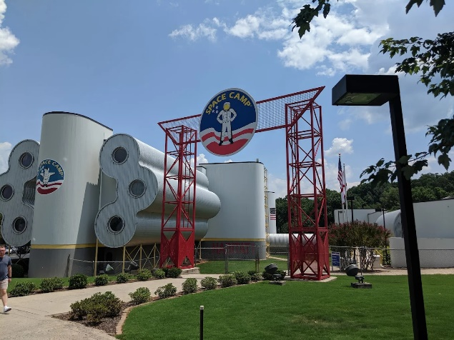 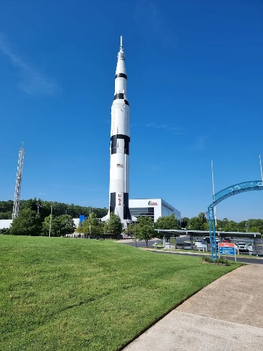

**U.S. Space and Rocket Center**

Home to Space Camp, Aviation Challenge, Space Camp Robotics, U.S. Cyber Camp and NASA's Official Visitor Information Center for Marshall Space Flight Center; The U.S. Space & Rocket Center is recognized as one of the most comprehensive U.S. manned space flight hardware museums in the world.

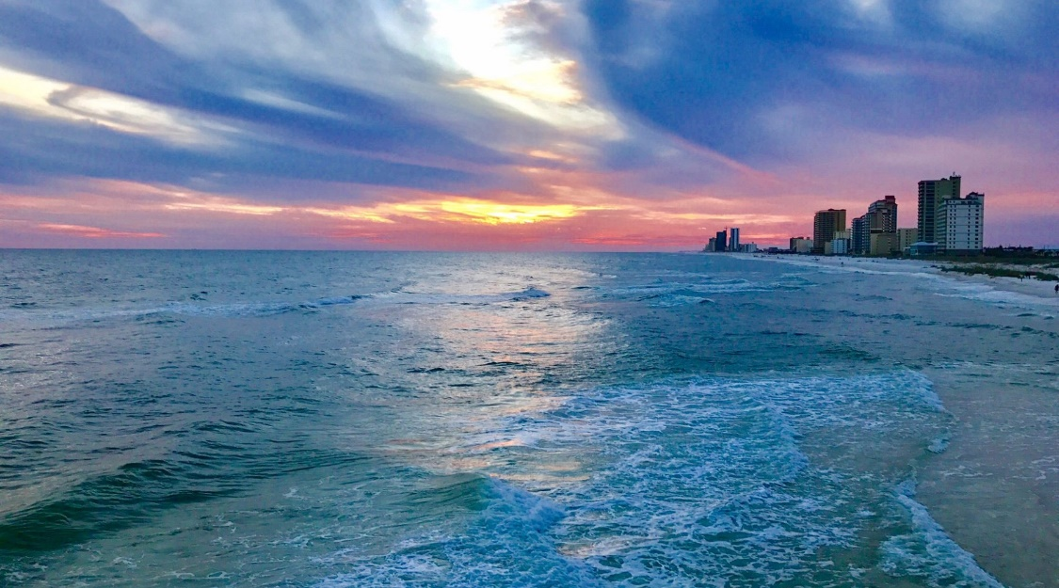

**Alabama Gulf State Park**

Gulf State Park's two miles of beaches greet you with plenty of white sun-kissed sand, surging surf, seagulls and sea shells, but there is more than sand and surf to sink your toes into. Inside Gulf State Park there is a brand new Gulf Front lodge and Conference Center, beach pavilion, National Geographic Unique Lodges of the World Cottages, tennis courts, camp sites, 28 miles of paved/enhance trails and a fishing pier that is 20-feet wide and extends 1,512 feet into the Gulf. This and much more make Gulf State Park the perfect in-state vacation or out-of-state adventure.

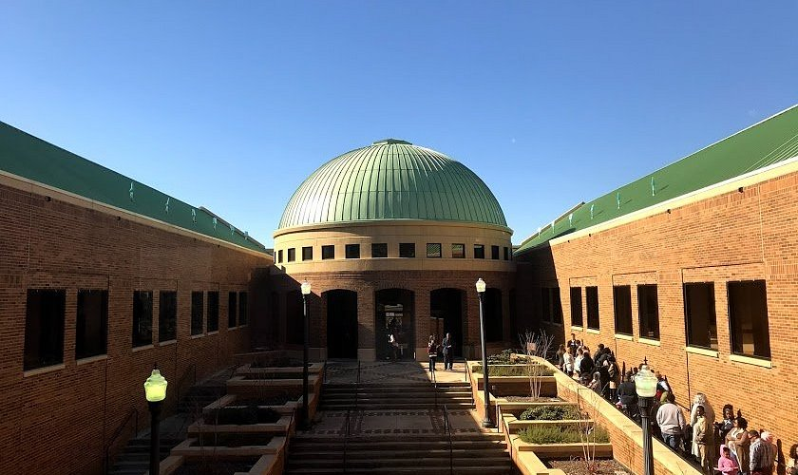

**Birmingham Civil Rights Institute**

This historic museum traces the journey of the civil rights advocates of the 1950s and 60s, who changed the course of American history. The struggle for equality for Black Americans is chronicled here, from the Jim Crow laws in the 1800s to the freedom rides, sit-ins and demonstrations of the 1960s.