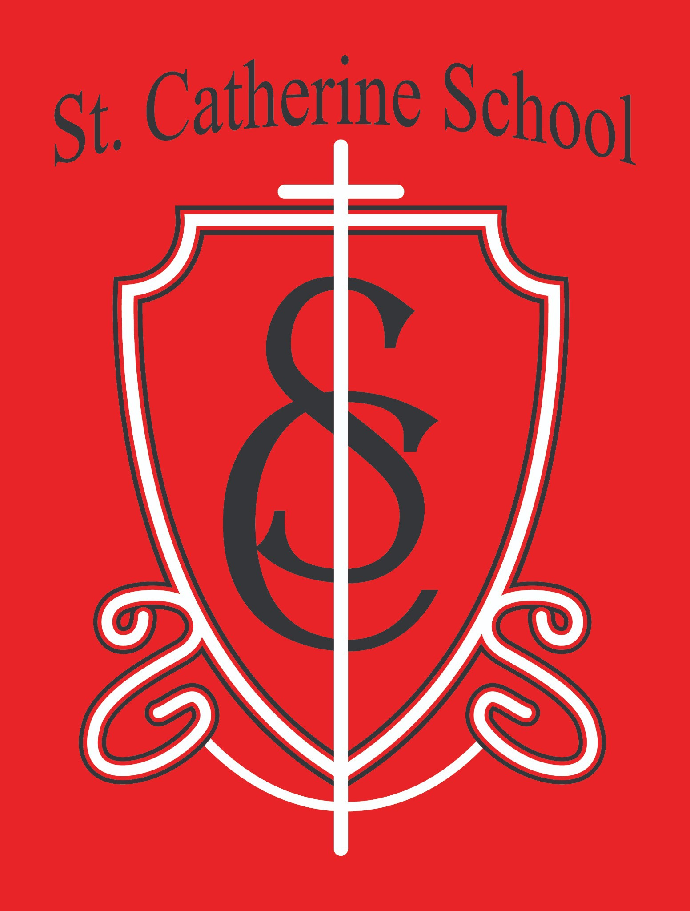
2026 Round-Up FB Cover photo.jpg

St. Catherine School Weekly Newsletter (Week of February 2nd - 6th)
https://www.stcatherine.k12.nd.us/parents

Principal's Message
Kindergarten Round-Up – February 27
Kindergarten Round-Up will be held on Thursday, February 27, from 8:45–10:00 AM.
Families with a child who will be kindergarten-age are encouraged to attend. Please RSVP by calling the school office if you have a child who will be eligible for kindergarten.
Children who turn 5 prior to August 1, 2026, are eligible to enroll in kindergarten. Some children with summer birthdays may benefit from an additional year of Pre-K. As always, families are encouraged to choose what is best for their child.
Kindergarten Round-Up is an opportunity to hear from current and former parents, school administration, and the classroom teacher about how a small, Catholic school can serve your family and your child.

I have attached some graphics related to the kindergarten round-up. Please share on social media and with anyone who might have a Kindergarten-age child entering school this next year.

Reminders
It is a busy season of winter activities. Students are tired, and we are seeing some typical winter “doldrums.” Please continue to reinforce consistent bedtimes (when possible), good meals, and regular routines.
- No School on Friday, February 13, and Monday, February 16. Enjoy the long weekend!
Intent to Attend forms are due February 12. These forms help us plan staffing and classroom assignments for the upcoming school year.
Tuition was adjusted last school year and will remain the same for the 2026–2027 school year.
Thank you to the parents for their strong attendance, communication, and partnership during the conferences.

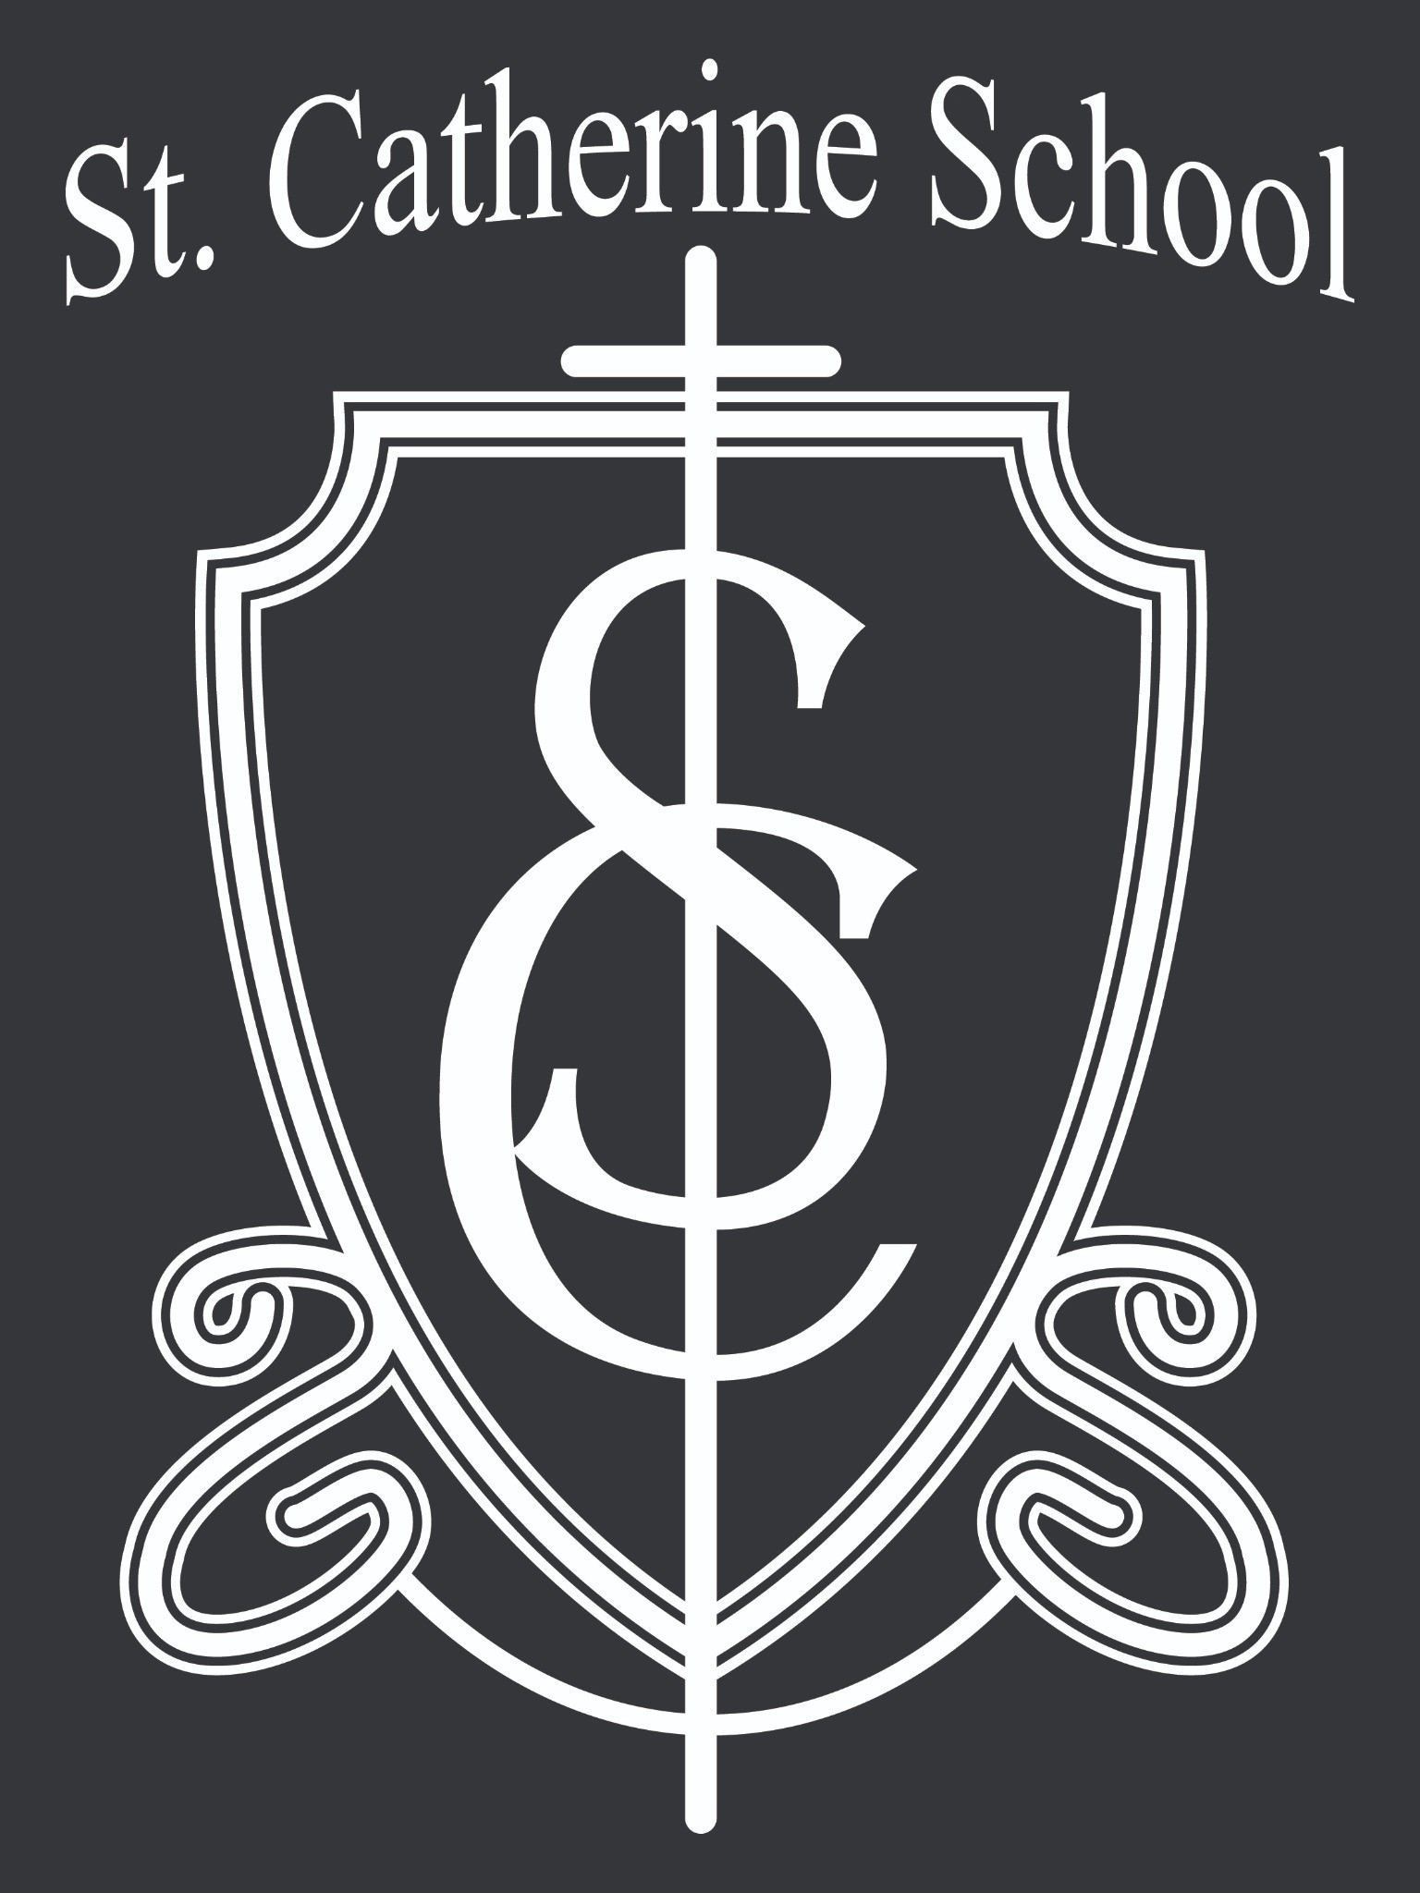St. Catherine Spotlight
- Congratulations to Hatley Thoreson and Peter Hellinga for representing St. Catherine School at the Barnes County Spelling Bee. While they did not advance to the state spelling bee, we are very proud of their hard work and willingness to represent our school.
- We are incredibly thankful for the strong parent involvement during Catholic Schools Week. From special events to quiet moments of presence, we were reminded that it is often the ordinary togetherness that makes our school community so special. Thank you to each family who continues to choose St. Catherine School. We work hard each day to honor that partnership with parents.

Stay Connected with St. Catherine School
📍 Address: 540 3rd Ave. NE, Valley City, ND 58072
Email: nicholas.lee1@k12.nd.us
📧
Phone: 1-701-845-1453

📞
Website: www.stcatherine.k12.nd.us

🌐
📘 Follow Us on Facebook: St. Catherine School on Facebook

“Inspiring excellence through faith, learning, and service.”

