
Chicken Wrap
Chicken Spaghetti
Roll/Carrots
Fruit/Milk/Salad

MENU IS SUBJECT TO CHANGE
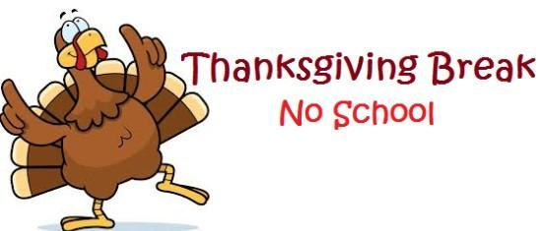
Turkey Sandwich
Corndog
Chips/Corn
Fruit/Salad/Milk

Lunchable
Crispito
Chili Beans
Fruit/Salad/Milk

Chicken Wrap
Eggs/Grits/Toast
Sausage/Hashbrown
Fruit/Salad/Milk


Lunchable
Chick. Quesadilla
Rice/Refried Beans
Fruit/Milk/Salad

Turkey Sandwich
Cheeseburger
Fries
Fruit/Milk/Salad

Soybutter Sandwich
Mozzarella Sticks
Marinara Sauce
Mixed Vegetables
Fruit/Milk/Salad

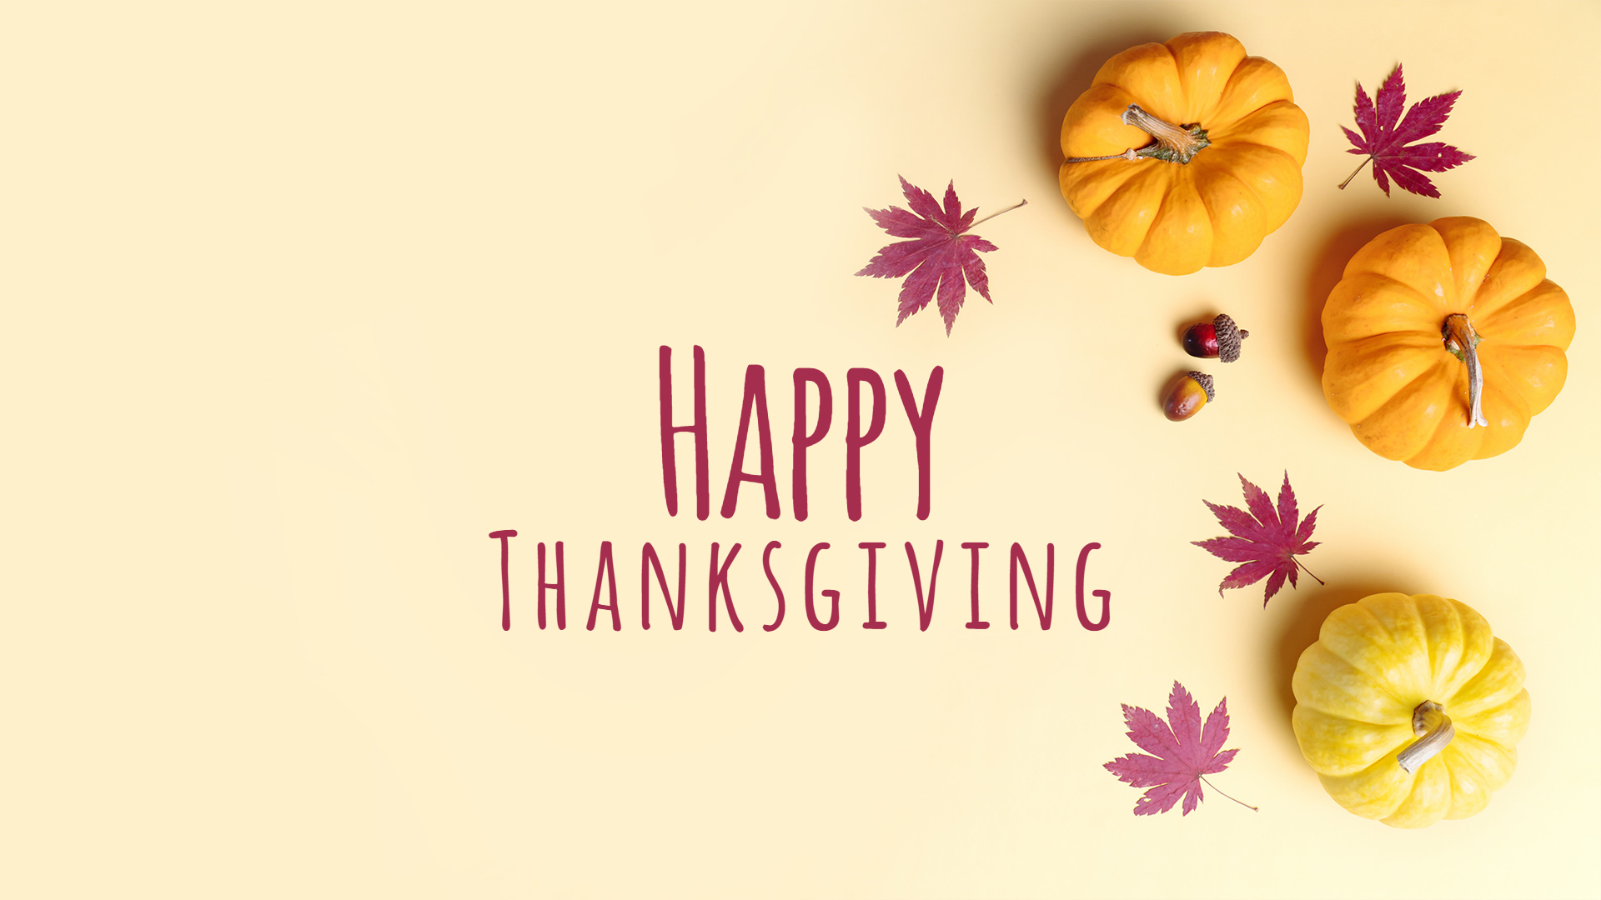
Grilled Cheese
Turkey/Gravy/Dressing
Green Beans/Peach Cobbler
Cranberry Sauce/Roll
Fruit/Milk/Salad
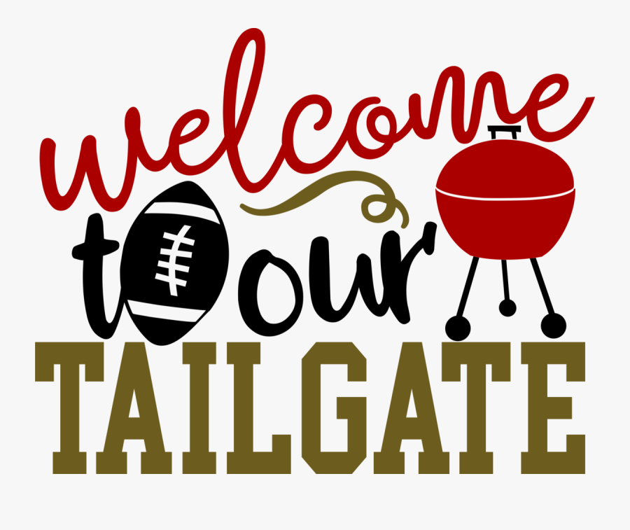
Hotdogs/Chips
Carrot Sticks/Fruit
Milk/Cookie

Turkey Sandwich
Chicken Sandwich
Chips/Corn
Fruit/Salad/Milk

Chicken Wrap
Chicken Nuggets
Fries
Fruit/Milk/Salad

Grilled Cheese
Spaghetti/Roll
Green Beans
Fruit/Milk/Salad

Soybutter Sandwich
Pizza
Broccoli
Fruit/Milk/Salad

Lunchable
Tacos
Salsa/Sour Cream
Buttered Corn
Fruit/Milk/Salsa

Turkey Sandwich
Hotdog/Chips
Baked Beans
Fruit/Milk/Salad

