2022-23 Announcers

Daily Bulletin
Wednesday
November 16, 2022
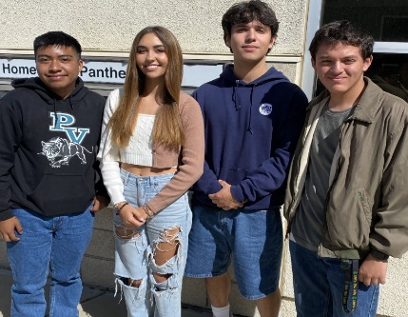

SCHOOL ACTIVITIES

CLUB INFORMATION

Looking for community service and volunteer opportunities? The ASTRA club will be meeting this Thursday at lunch in Mr. Dickinsons room 334. We will be going over new events, The Festival of Trees and more! Bring a friend, new members are always welcome. (Dickinson 11/15-17)

The Glow Jesus Club is a safe place for you to experience faith and seek God. Come just as you are to room 607 today at Lunch. Every Wednesday at Lunch the Glow Jesus club meets in room 607. (Dearborn 11/15-16)

Students, have you ever imagined being on a stage interacting with musicians and other singers, while at the same time transforming songs and your voice to another level? Consider signing up for Jazz Choir and Concert Choir this Spring. Stop by room 201 at lunch for more details. (Hernandez 11/15-16)

ASL club meets today in room 303. New members are always welcome to come learn sign language, play games and have fun! We are taking our yearbook picture this week, so don't miss it! (Price 11/15-16)

The NAMI Club is meeting today in room 211 during lunch. We will be taking our club photo for the yearbook! (Avrit 11/16)

Attention FFA members: Are you interested in showing an animal at the Santa Barbara County Fair this year? Bring your parent or guardian to our required livestock meeting tonight at 6PM in the cafeteria. Ask your ag teacher if you have any questions! (Bray 11/16)

FCA - Fellowship of Christian Athletes meets Thursdays in room 607. Come for pizza and to learn more about the Christian faith ... FCA - Fellowship of Christian Athletes every Thursday in room 607. (Dearborn 11/16-17)

The Inclusion Clubs invites you to our "Club-giving" where we shall continue our Thanksgiving festivities and share food with one another. Come by room 355 during lunch on Thursday during lunch. See you there! (Marino 11/16-11/17)

COLLEGE AND CAREER

TECHNOLOGY INFO
SPORTS NEWS

WEEK IN SPORTS

Team Start

“Good luck to all our Teams”

OTHER

