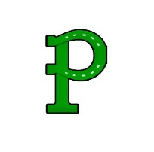

Choice at least 3 food groups.

Take at least ½ cup fruit and/or vegetable.

Cereals Offered Daily:

Trix

Apple Cinnamon Cheerios

Lucky Charms

Breakfast Kits Offered Daily:

Fudge Pop tart

Strawberry Pop tart

Cocoa Puff Bar

**MENU SUBJECT TO CHANGE WITHOUT NOTICE DUE TO PRODUCT AVALIABILITY**

Meal Prices

2nd Breakfast - $2.00 Adult Breakfast - $3.00

Milk (2nd) - $.50

Bottled Water (Large) - $.50

Bottled Water (Small) - $.30

**A copy of the menu with the nutritional and allergy information is available at:**

**https://www.schoolcafe.com/PortageASD**

The 5 food groups to a school breakfast are:

Meat/Meat Alternative

Grain

Fruit

Vegetable

Milk

Chocolate Chip Crumb Cake or

Mini Strawberry Filled Bagel

Assortment of Fruit

100% Juice

Choice of Milk

No School

No School/

Thanksgiving

Break

No School

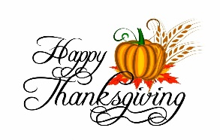

French Toast Squares or

Mini Strawberry Filled Bagel

Assortment of Fruit

100% Juice

Choice of Milk

Omelet w/Toast or

Mini Strawberry Filled Bagel

Assortment of Fruit

100% Juice

Choice of Milk

Breakfast Pizza or

Mini Strawberry Filled Bagel

Assortment of Fruit

100% Juice

Choice of Milk

Donut or

Mini Strawberry Filled Bagel

Assortment of Fruit

100% Juice

Choice of Milk

Chocolate Chip Crumb Cake or

Mini Strawberry Filled Bagel

Assortment of Fruit

100% Juice

Choice of Milk

Mini Pancakes or

Mini Strawberry Filled Bagel

Assortment of Fruit

100% Juice

Choice of Milk

Egg, Sausage, & Cheese Muffin or

Mini Strawberry Filled Bagel

Assortment of Fruit

100% Juice

Choice of Milk

No School



Raspberry Turnover or

Mini Strawberry Filled Bagel

Assortment of Fruit

100% Juice

Choice of Milk

French Toast Squares or

Mini Strawberry Filled Bagel

Assortment of Fruit

100% Juice

Choice of Milk

Omelet w/Toast or

Mini Strawberry Filled Bagel

Assortment of Fruit

100% Juice

Choice of Milk

Breakfast Pizza or

Mini Strawberry Filled Bagel

Assortment of Fruit

100% Juice

Choice of Milk

Donut or

Mini Strawberry Filled Bagel

Assortment of Fruit

100% Juice

Choice of Milk

**NOVEMBER 2022**

Portage Area Elementary School

Breakfast Pizza or

Mini Strawberry Filled Bagel

Assortment of Fruit

100% Juice

Choice of Milk

Egg, Sausage, & Cheese Muffin or

Mini Strawberry Filled Bagel

Assortment of Fruit

100% Juice

Choice of Milk

Mini Pancakes or

Mini Strawberry Filled Bagel

Assortment of Fruit

100% Juice

Choice of Milk

No School

Parent/Teacher

Conferences

No School

Parent/Teacher

Conferences