Dear Parents and Guardians,
Dawson Springs Independent Schools and the Kentucky Department of Education (KDE) value your input and want to hear about your experience as a parent or guardian of a child with an Individual Education Program (IEP). The information you offer will give the KDE and Dawson Springs Independent Schools valuable data on how to improve parent and family engagement.
To collect your input, we ask that you complete a brief survey about how the school supported parent or guardian engagement to improve services and results for your child during the current school year. Specifically, we want to hear about how your child’s school involves you in the special education process. The survey is available in English, Spanish, Arabic, Somali, Swahili and Amish. All responses are anonymous and cannot be traced back to you or your child.
The online survey can be completed in three ways:
- Go to www.kypso.org and select “Click here to access the 2023 Parent Survey.”
- Scan the code below into your smartphone or mobile device. Some smartphones will open the survey link automatically when you open your camera, others may need a QR code scanner app. If you do not have access to a computer or smartphone, you may contact your child’s school to request a printed copy and a confidential envelope.
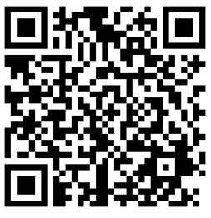
- If using a printed copy, the sealed envelope can be returned to your child’s special education case manager, and they will ensure it is sent to the appropriate location. You may also mail the completed survey to the address below:
Human Development Institute
c/o Tony LoBianco
1525 Bull Lea Rd. Suite 160
Lexington, KY 40511

Only one parent or guardian per student should complete this survey. However, if you have more than one child with an IEP, please complete the survey for each of your children.
Survey results will be carefully studied by the KDE and the Human Development Institute (HDI) at the University of Kentucky (UK) and reported to the Office of Special Education Programs (OSEP). The results will help us further understand what supports parents and districts may need to ensure meaningful parent and family engagement in special education.
The deadline for completing this important survey is June 30, 2023. If you have any questions or need assistance, please contact Kristin Merrill/270-797-3811/ Kristin.merrill@dawsonsprings.kyschools.us.
Thank you for your help.
Kristin Merrill
Kristin Merrill
Director of District-wide Programs

