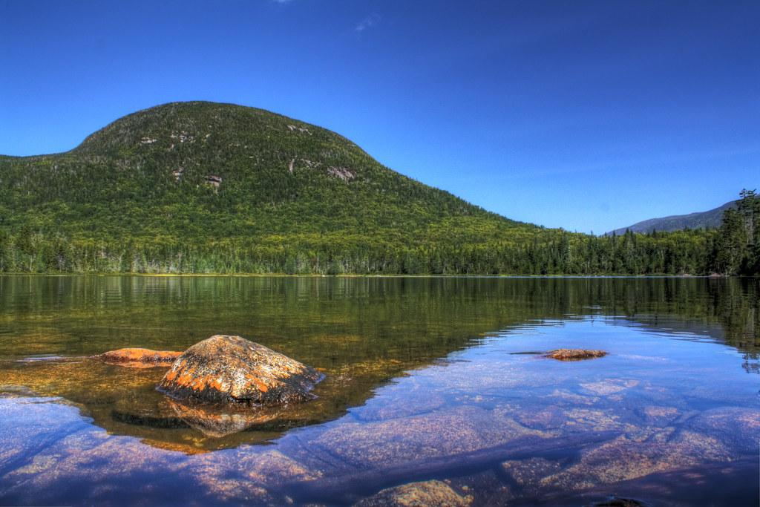
SAU 7

August 2021
Superintendent
School Board Report

Dr. Debra Taylor

What a beautiful summer!

Our year-round staff is busy preparing for school to resume on August 30, 2021. Our leadership team participated in a two-day retreat on July 7 and 8 and have been meeting weekly ever since to continue our preparations for the start of the upcoming school year.

Planning for the start of the school year has been our primary work this summer. The NH Department of Health and Human Services recently announced that they will be providing general guidelines to schools concerning COVID - 19. Our team is in the process of preparing an updated reopening plan which will be presented for board approval at the upcoming SAU #7 Board Meeting on August 12 at 6:00 pm at the Columbia Town Hall.

A second focus of our SAU 7 Meeting will be planning. I will present a summary of the progress to our SAU 7 Strategic Plan and we will engage in discussion about prioritizing focus areas for the coming school year. This plan was enacted in 2018 after significant board and school community input is in effect until 2023. In advance of our SAU 7 meeting, I will send you documentation of the plan, progress toward goals, and recommendations for our collective focus in 21-22. I look forward to your feedback and direction on the next steps as we continue to work together to improve education for all students in SAU 7 now and in the future.

We are continuing our hiring process for teachers and support staff in each of our schools. This fall we will welcome:

Colebrook Pittsburg Stewartstown
Cloutier, Tia – Teacher Hall, Melissa – Teacher Gourlay, Alexandra – Teacher
Dagesse, Jessica – Admin. Support Wood, Emily – Teacher Humphrey, Stephanie – Principal
Desmond, Michelle – Teacher Wood, Kaitlin – Para
Desmond, William – Teacher
Frizzell, Jennifer – Teacher
Griffin, Elizabeth – Teacher

Colebrook (cont.)
Harvey, Lauren – Teacher
Klee, Jessica – Teacher
Lopes, Nicholas – Para
Neary, Scott – Teacher
Noyes, Mariah – Teacher
Pariseau, Nicole – Para
Sanchez-Roosa, Nicolas – Teacher
Tallmage, William – Teacher
Uran, Lori – Para
Wowaka, Nikkole - Teacher

Celebrating the Beauty of our North Country Summer...

Down the Lanes of August

DOWN the lanes of August-and the bees upon the wing,
All the world's in color now, and all the songbirds sing;
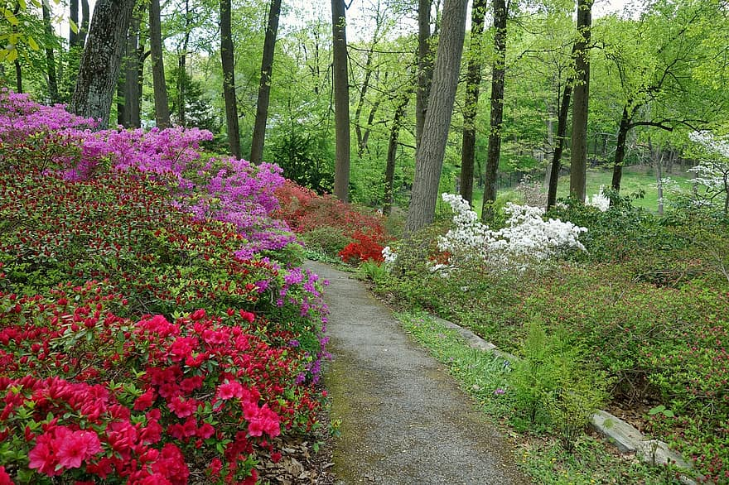
Never reds will redder be, more golden be the gold,
Down the lanes of August, and the summer getting old.

Mother Nature's brushes now with paints are dripping wet,
Gorgeous is her canvas with the tints we can't forget;
Here's a yellow wheat field-purple asters there,
Riotous the colors that she's splashing everywhere.

Red the cheeks of apples and pink the peaches' bloom,
Redolent the breezes with the sweetness of perfume;
Everything is beauty crowned by skies of clearest blue,
Mother Earth is at her best once more for me and you.

Down the lanes of August with her blossoms at our feet,
Rich with gold and scarlet, dripping wet with honey sweet.
Rich or poor, no matter, here are splendors spread
Down the lanes of August, for all who wish to tread.

Edgar Albert Guest

