**CNP is an equal opportunity employer.**

**Cold Plate Options Offered Daily: Bento Box, Sandwich Bags, Wrap Boxes and Chef Salad.**

**Menu is subject to change at any time.**

**Cheeseburger**

**Smoked Pork Sandwich**

**Coleslaw**

**Corn Nuggets**

**Fruit of the Day**

**Cheeseburger**

**Mozzarella Sticks**

**Marinara**

**Green Beans**

**Fruit of the Day**

**Dill Chicken Sandwich**

**Pollo Locco**

**Chili Beans**

**Corn**

**Fruit of the day**

**Fruit, Milk, and Salad Bar**

**Offered Daily.**

**Spicy Chicken Sandwich**

**Pancakes**

**Eggs/ Sausage**

**Hashbrown**

**Fruit of the Day**

**Pizza Crunchers**

**Turkey Melt**

**Green Beans**

**Fruit of the Day**

**Cheeseburger**

**Hot Honey Chicken Sandwich**

**Curly Fries/ Sweet Potato Fries**

**Fruit of the Day**

**Steak Fingers**

**Roasted Chicken**

**Baby Potatoes**

**Succotash/ Roll**

**Fruit of the Day**

**Dill Chicken Sandwich**

**Walking Tacos**

**Mexican Corn**

**Fruit of the Day**

**Spicy Chicken Sandwich**

**Chicken Philly Hoagie**

**Chili Beans**

**Fruit of the Day**

**Sausage Pizza**

**Loaded Hot Dogs**

**Baked Beans**

**Fruit of the Day**

**Chicken Tenders**

**Chicken Spaghetti**

**Green Beans**

**Texas Toast**

**Fruit of the Day**

**Dill Chicken Sandwich**

**Fajita Nachos**

**Taco Beans**

**Fruit of the Day**

**Spicy Chicken Sandwich**

**Chicken Bacon Ranch**

**Fries**

**Corn/ Muffin**

**Fruit of the Day**

**SEPTEMBER 2025**

**Prattville High School**

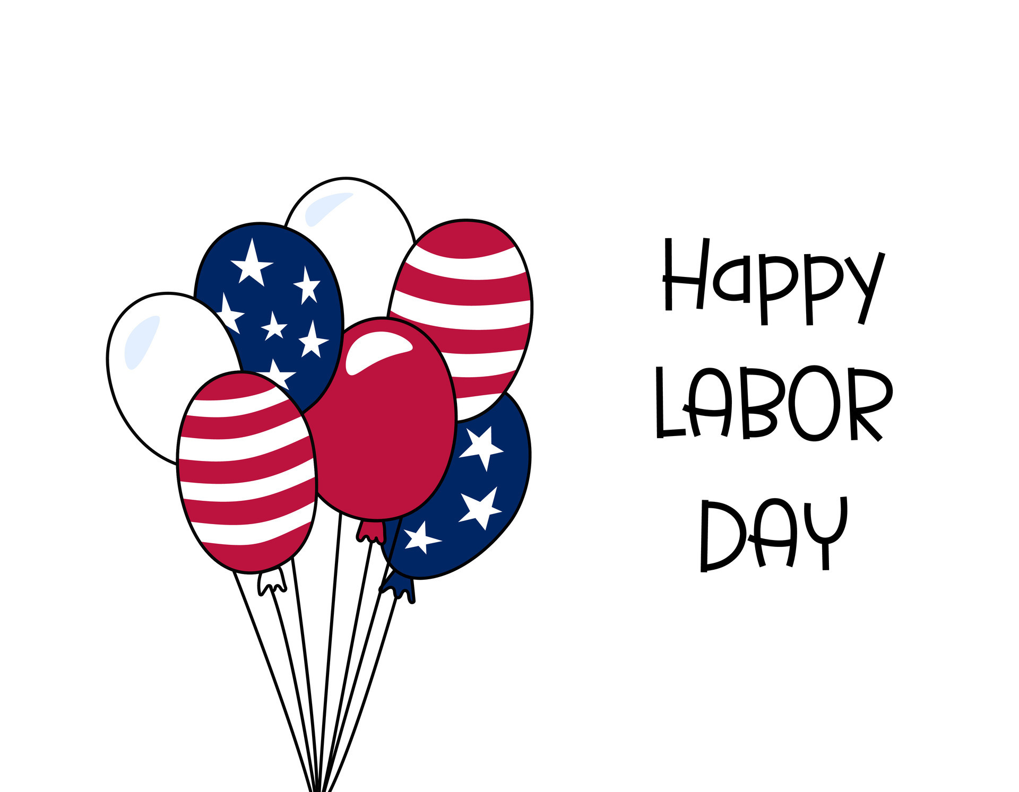

**Chicken Tenders**

**Breaded Steak**

**Mash Potatoes Gravy**

**Green Peas /Texas Toast**

**Roll/ Fruit of the Day**

**Pepperoni Pizza**

**Chili Cheese Corndog**

**Hashbrown**

**Mixed Vegetables**

**Fruit of the Day**

**Spicy Chicken Sandwich**

**General TSO**

**Chicken Bowl**

**Stir Fry**

**Fruit of the Day**

**Dill Chicken Sandwich**

**Buffalo Chicken Dip**

**Tostitos/ Celery/ Corn**

**Fruit of the Day**

**Chicken Tenders**

**Meatball Subs**

**Green Beans**

**Sun Chips**

**Fruit of the Day**

**Cheeseburger**

**BBQ Chicken Sandwich**

**Sweet Potatoes/ Chips**

**Fruit of the Day**

**Pepperoni French Bread Pizza**

**Conecuh Dogs**

**Glazed Carrots**

**Dill Chicken Sandwich**

**Teriyaki Chicken Fried Rice Bowl/ Broccoli**

**Fruit of the Day**