**Agenda – Regular Board Meeting**



**Florence County School District Five Board of Trustees**

**District Office – 156 East Marion Street**

**Monday, August 23, 2021, 7:00 p.m.**

1. **Call to Order, Welcome, and Pledge of Allegiance**

**2. Approval of Agenda**

**3. Confirmation of Notice to Media**

**4. Public Forum**

**5. Consent Agenda**

**A**. Minutes – June 28, 2021 and July 12, 2021 – pp. 1-3

**B**. Monthly Financial Statements – June and July 2021 – pp. 4-7

**6. Special Presentation –** Presentation of Adult Education Diplomas

**7. Regular Agenda**

**A. Staff Report Updates:**

1. JES – Mrs. Mirandi Squires

2. JMS – Mr. Brian Goins

3. JHS – Mr. Sam Tuten

**B. Superintendent’s Report**

1. Trustee Election (November 2, 2021)

2. Operational Updates

3. Instructional Updates

4. Legislative Updates

5. Recognitions

**8. For Action Agenda**

**A**. Request(s) for Student Release from Florence Five

**B**. Textbook Adoptions – Mrs. Beth Snowden – p. 8

**C**. First Reading of Policy IKAA (Tests and Examinations) – p. 9

**D**. Board Member Resignation – p. 10

**9. Executive Session Agenda**

**A.** Personnel for Hire and Resignations

**10. Reconvene in Open Session with Action if Necessary from Executive Session**

**11. Adjournment**

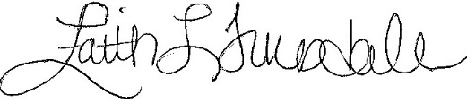 __________________________

Faith L. Truesdale, Vice Chair

Board of Trustees

*The Morning News/NPO*

*WMBF-TV*

*WPDE-TV*

*WBTW News*

*www.fsd5.org*