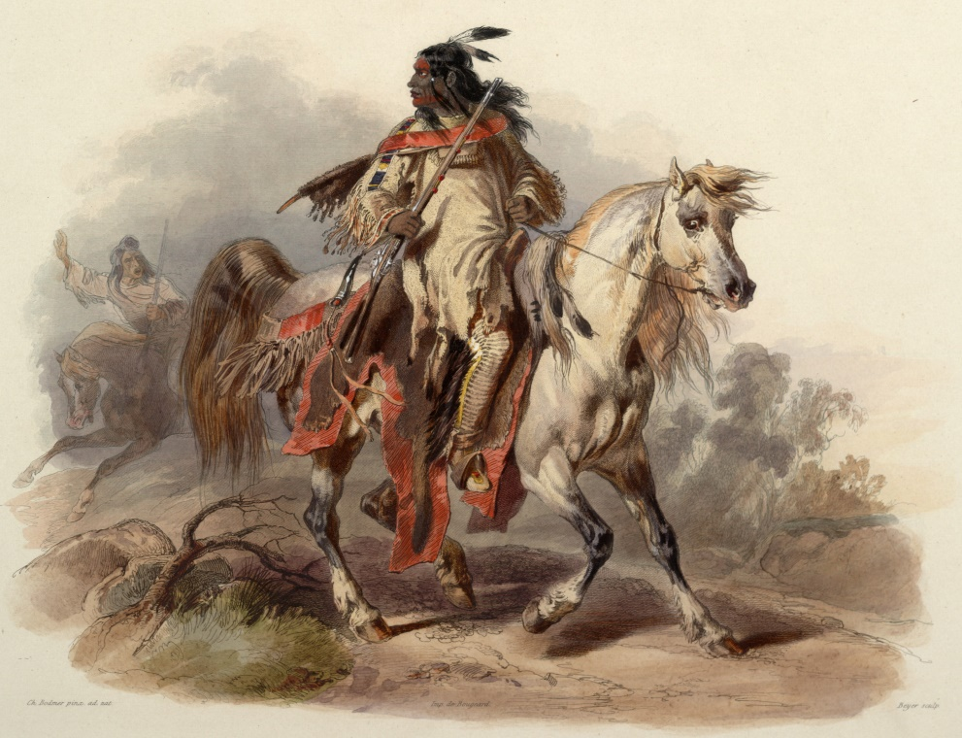
Reading News
Mrs. Williams’ Second Grade
November 3, 2025

Reading: The Cheyenne People

Word Study: spell words that drop silent e before adding the –ed –ing endings

Vocabulary:
separated – caused to move or be apart
language – a way of communicating that may be spoken, written, or that may use hand signs and gestures
popular – liked, admired, or enjoyed by many people, or by a person or group of people
ceremony – a special procedure that we do for a reason
community – a group of people who have particular characteristics in common

