




Governiing Board Nov. 2nd Meetiing Summary & Other Important Informatiion
Governiing Board Meetiing Summary
The November 2, 2021 Governing Board Meeting was held with topics including the Superintendent’s Report and a Student Learning Update presentation by our Elementary School Leadership Team. In addition, there were many comments received and read from the in-person and virtual call to the public. There were no action items appearing on the agenda.Reports to the BoardStudent Board Member, Lilyana Brummitt presented theStudent Board Report, which focused on activities at Tanque Verde High School and Agua Caliente Elementary School.Dr. Scott Hagerman presented information on the Aggregate Expenditure Limits, the ADE Aggregate Expenditure Report, and high school student club and sports end of season successes which are included in the Board Acknowledgments.Informatiion and Diiscussiion ItemsElementary principals, Chris Rietz and Emma Batty, provided an update on the enVision Math Implementationfor the elementary schools.40 Under 40 Award Wiinner!We are excited to announceEmma Batty, Principal of Tanque Verde Elementary School, is one of an elite group of forty Tucson young professionals selected for the prestigious 2021 40 Under 40 Award! Mrs. Batty will be honored at the 40 Under 40 Awards Breakfast on December 7, 2021.More information is availablehere.



eligible, get a booster.
Addiitiionall Important Informatiion
Piima County Heallth Department Recommends Cllosure of Agua Calliiente Ellementary Schooll Untiill November 15thTanque Verde Unified School District’s Agua Caliente Elementary School has been closed for 10 days through the recommendation of the Pima CountyHealth Department, due to the number of confirmed COVID-19 cases and the percentage of students absent at the school over the past two days. Three classrooms had already been closed prior to the school closure. Students will be able to access their learning virtually during the closure. The order is in effect until November 15, 2021.Agua Caliente Elementary School (ACES) is currently the only TVUSD school under the Pima County Closure Order. Detailed information was sent to ACES staff/families about the closure yesterday afternoon. An InTouch Emergency Telephone Notification was also made to ACES families.Parents/ACES staff will continue to receive email communication from the school with important updates and information. A Chromebook drive-thru pick-up was held at ACES to assist families with devices for remote learning. The Grab and Go Pick Up Meal Service continues to be available to ALL children at Tanque Verde High School.The Tanque Verde Unified School District Governing Board, in a letter to the TVUSD Community dated October 22, 2021, had previously noted the increasing numbers of cases in the district’s schools and asked for continued cooperation with the schools’ COVID-19 Mitigation Protocols. They implored everyone “to work together with kindness and respect.” At the November 2nd Board Meeting, there was a board request made to add a future action item on the implementation of a mask mandate. A Special Board Meeting may be scheduled, or it may be addressed at the next regular board meeting on November 17th.ACES information from PCHD:Unvaccinated individuals should quarantine for a period of 10 full days. Vaccinated individuals, if asymptomatic, do not need to quarantine but should test for COVID-19 from Saturday, Nov. 6, to Monday, Nov. 8.If an individual tests positive for COVID-19, they should contact the school, wait for the quarantine period to end, and then get the vaccine, or if they are

If an individual in quarantine (unvaccinated) has anegative test result, they can get the vaccine without delay.

Current Ages 5-11 vaccineinformation is available as of Wednesday, November 3rd. CVS and Walgreens are scheduling now for first shots starting Sunday 11/7. Pima County will start scheduling soon. Tanque Verde Pediatrics will have a shot clinic on November 13-14.

Message from the TVUSD Food Serviice Department

Grab & Go pick-up meal service:

Grab & Go pick-up time is Monday through Friday 9 a.m.-10 a.m. at Tanque Verde High School.
Children do not have to be enrolled in TVUSD to receive free meals and parents/guardians are allowed to pick-up meals without the children being present. All children on campus will be offered a free breakfast and free lunch.

TVUSD Food Service will serve meals on days of student instruction,on-line and/or on campus. There will be no meals served on school holidays. Please visit the website below for information on free meals for children on days we will not be operating.

https://www.azhealthzone.org/summerfood#summer-lunch-buddies

Annuall Test of the Emergency Notiifiicatiion System

Dear TVUSD Parents/Guardians,

We will be conducting a test of the Tanque Verde Unified School District Emergency Telephone Notification System the week of November 15 - 19, 2021.

Please make any needed updates to your emergency contact informationbefore the test dates noted below, to ensure an accurate system test. Thank you!

EMERGENCY TELEPHONE NOTIIFIICATIION SYSTEM TEST SCHEDULE::

TUESDAY,, NOV.. 16TH - AGUA CALIIENTE ELEMENTARY SCHOOL

TUESDAY,, NOV.. 16TH - TANQUE VERDE ELEMENTARY SCHOOL

WEDNESDAY,, NOV.. 17TH - EMIILY GRAY JR.. HIIGH SCHOOL

THURSDAY,, NOV.. 18TH - TANQUE VERDE HIIGH SCHOOL

Important Dates & Informatiion

November 9 Special Governing Board Meeting - Virtual November 11 Veterans Day - No School
November 16-18 Emergency Notification System Tests November 17 Interim Grading Day, K-8 Early Release November 17 Regular Governing Board Meeting November 24-26 Thanksgiving Holiday - No School

November Events Calendar

Nerdy Derby POSTPONED!!

In light of the recent closure of Agua Caliente Elementary School, TVF has decided to postpone the Nerdy Derby. A new date will be scheduled for after the holiday season, and will be announced as soon as possible. Thank you for your understanding. TVF Board

Next Governiing Board Meetiing Date:

The next Regular Meeting of the TVUSD Governing Board will be held on *Wednesday, November 17th.

*A special board meeting may be called in advance of the Regular Meeting to address the Safe Return to In-Person Learning Plan and Facemasks.

Board Meeting Agendas and Minutes

TVUSD Board Meeting Livestream Link

Student, Staff & Communiity Acknowlledgements

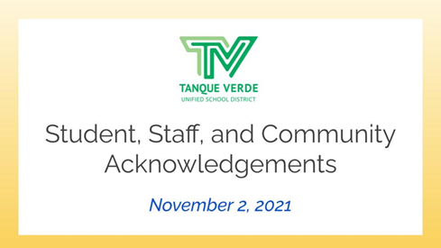
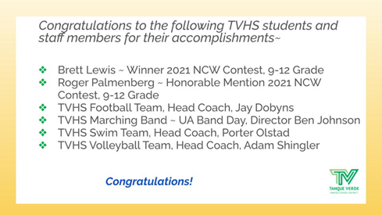
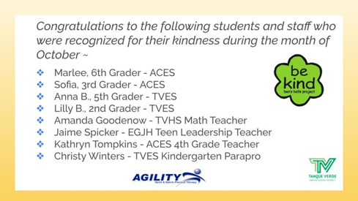

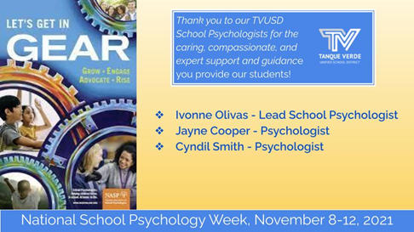
Connect wiith us
Visit our website

