APRIL 2022 | APRIL 2025 |  | WCSD FRESH fRUIT & Vegetable Program
 | MONDAY | TUESDAY |  | WEDNESDAY | THURSDAY | FRIDAY
 |  | 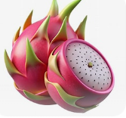  Sweet Dragon Fruits |  |  | 3  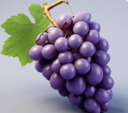  Delicious Grapes | 4    Carrot Slices
 | 7  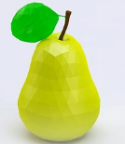  Sweet Pears | 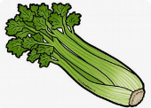  Crunchy Celery Sticks |  |  | 10  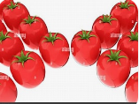  Grape Tomatoes Farm | 11  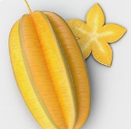  Gorgeous Star Fruits
1 | 14  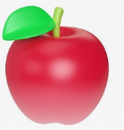  Fresh Red Apples | 15  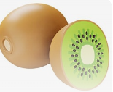  Sweet Kiwi Slices |  |  | 17    Pre-Orange Slices | 18  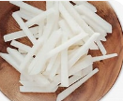  Jicama Sticks
 | SPRING BREAK
 | 28  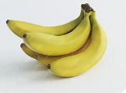  Bananas | 29  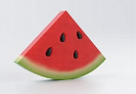  Watermelon Slices

