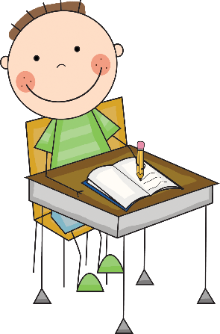

Ms. Bechtold and Ms. Schmidt’s
Classroom Management Plan

Classroom management is the process that teachers use to create and maintain a positive and productive learning environment by managing student behaviors.

Classroom Expectations: Students should be
- Responsible
- Respectful
- Safe

Conduct and Responsibility Log
When these expectations are not met, the student will sign the Conduct and Responsibility Log, noting the behavior code. Behavior codes are a more specific variation of our classroom expectations to help parents and students better understand why the log was signed. There will be weekly consequences for signing the log. These consequences are listed below. Parents, this is our way of communicating with you on a weekly basis. Conduct grades will be noted in weekly folders and should be signed by the parent.

Behavior Codes
- Not following teacher directions
- Not following classroom procedures
- Class disruption (Talking, Making Noises, Etc.)
- Off task
- Not completing and returning homework
- Not returning weekly folder by 3rd day
- Disrespectful
- Not following school expectations outside of classroom
- Talking during silent lunch
- Other misbehaviors

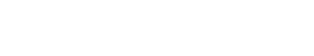
CONSEQUENCES:
 |  | WEEKLY GRADE
0 signs | Super job! | S+
1 sign | Warning | S
2 signs | Miss half of Fun Friday | S-
3 signs | Miss all of Fun Friday | N
4 signs | Note sent /Call Parent | N-
5 signs | Parent/Teacher Conference | U

S = Satisfactory N = Needs Improvement U = Unsatisfactory

Rewards
ClassDojo points will be awarded for positive student behavior. Students will earn an individual reward based on their Dojo points. Additional rewards may include verbal praise, stickers, positive notes home, class game, free time, Fun Friday, etc.

We hope this classroom management plan will ensure a positive, safe, and productive environment for the school year.

Thank you,
Ms. Bechtold and Ms. Schmidt

