Parent Schoology Directions
(seeing your students’ grades)

- Have your student sit next to you and pull up their grades by clicking the Grades tab in Schoology.
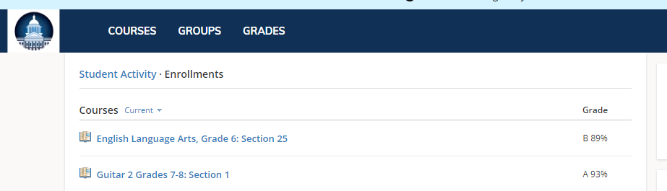
- Click Grade Report.
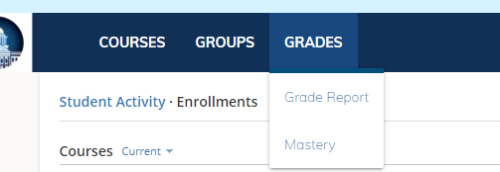
- Click each class and see the individually graded assignments and the overall average for the quarter.
