$2,000 SCHOLARSHIP FOR GRADUATING SENIORS

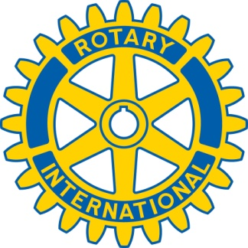

2025 WARNER ROBINS ROTARY CLUB SCHOLARSHIPS

APPLICATION DEADLINE: January 31, 2025

The Rotary Club of Warner Robins will award a $2,000.00 scholarship to two 2025 graduates from Warner Robins. Students from each of the following high schools may apply: Warner Robins, Northside, Houston County and Veterans. The selection will be competitive. Recipients of the scholarship should be aware that funds will be mailed directly to the college or university and not provided directly to the student.

ELIGIBILITY REQUIREMENTS:

1. You must be a student in good standing who will graduate in 2025 from one of the participating schools.
2. You must have plans to go on to post-secondary education.
3. You must submit a letter of recommendation written by a teacher, school administrator or counselor.

APPLICATION CHECKLIST (ITEMS WHICH MUST BE SUBMITTED):

1. 2025 WARNER ROBINS ROTARY CLUB SCHOLARSHIP APPLICATION FORM
2. A typed document, not more than two pages in length, which summarizes your academic accomplishments, extracurricular activities, community activities, plans for post-secondary education and any other relevant factors that might support your selection.
3. A 500-word essay on the topic of “Service Above Self,” the Rotary International motto.
4. A signed letter of recommendation from a teacher, administrator or counselor.

Mail your complete, original hard copy application package to the address below. In order to be considered, application packages must contain all items on the checklist above and must be postmarked no later than Friday, January 31, 2025. E-mail or electronic submissions will not be accepted.

Rotary Club of Warner Robins

Attn: Scholarship Committee

P.O. Box 1082

Warner Robins, GA 31099

For more information, contact Michael P. Chaloult, Jr. @ [chaloult@spdesigngrp.com](mailto:chaloult@spdesigngrp.com)