St. Edward Catholic School
Fr. Todd Petersen, Pastor * Jaci Garvey, Principal
210 W. 4th Street * Minneota, Minnesota 56264
Phone:(507) 872-6391 * Fax: (507) 872-5263
Email: jgarvey@stedscatholicschool.com
Website: www.stedscatholicschool.com

February 24, 2022

Primetime will be held on Friday, February 25th from 3-6 pm for the 3rd-6th grades. Please turn-in your permission slips for this event.

On Sunday, Feb. 27th from 5 – 7 pm we will be holding a round table type informational event for all families wanting more information about St. Edward School. Please reach out to friends and family to invite them to this event. Families with children of all ages are encouraged to attend.
Monday, February 28th will be the last turn in day for the Catholic United Financial Raffle. At this point, Trudy has collected over $5,000.00. If you still have tickets that you are unable to sell, please return them to the office so we can try to sell them.
The Schoenstatt Girls Group will meet on Monday, February 28th at 3 pm. Snacks will be provided. All girls are invited to attend. If your daughter will be attending, please let Trudy know.
Our next school Mass is Wednesday, March 2nd at 10:30 am. This is Ash Wednesday and the staff will be leading us. Come and celebrate the Mass with us.
The end of the 3rd quarter is Friday, March 11th. We will have an early dismissal at 12:00 pm; this is a correction from last week’s parent letter. We will also have an early dismissal on Monday, March 14th at 1:10 pm.
Report cards will go home on Thursday, March 17th.
As field trip season is right around the corner, please keep in mind that in order to be a chaperone, you must be VIRTUS trained. This is for the safety of all involved. To be qualified as a VIRTUS trained volunteer, you must attend one three hour in person session. Each year thereafter you will be asked to complete a short (less than 30 minutes) training on-line.

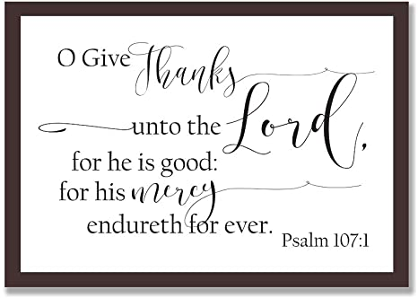
There is a VIRTUS Training Session on Thursday, March 3, 2022, from 6:00–9:00 p.m. at Cathedral High School in New Ulm. Please register online through the diocesan website at https://www.dnu.org/safeenvironment/ . If you have any questions, please contact Caren at 507-872-6346.

May God Bless,

Mrs. Garvey

