THE INDIAN ACADEMY
Parent & Student Handbook
2026–2027 School Year
Southern Local School District


Table of Contents
1. Welcome
2. Mission and Vision
3. Enrollment
4. Withdrawal
5. Student Expectations
6. Parent Expectations
7. Attendance and Educational Engagement
8. Academic Progress
9. Grading, Promotion, and Graduation
10. Academic Integrity and AI
11. Technology and Acceptable Use
12. Communication Expectations
13. Student Support Services
14. Bullying, Harassment, and Cyberbullying
15. School Safety
16. Discipline, Suspension, and Expulsion
17. State Testing
18. Extracurricular Activities
19. Student & Parent Commitment Agreement

Table of Contents
1. Welcome
2. Mission and Vision
3. Enrollment
4. Withdrawal
5. Student Expectations
6. Parent Expectations
7. Attendance and Educational Engagement
8. Academic Progress
9. Grading, Promotion, and Graduation
10. Academic Integrity and AI
11. Technology and Acceptable Use
12. Communication Expectations
13. Student Support Services
14. Bullying, Harassment, and Cyberbullying
15. School Safety
16. Discipline, Suspension, and Expulsion
17. State Testing
18. Extracurricular Activities
19. Student & Parent Commitment Agreement

Welcome
The Indian Academy is Southern Local School District's online learning program. Students receive a flexible educational experience while maintaining the same academic expectations required of all Southern Local students. Success requires consistent participation, communication, responsibility, and partnership between students, families, and school staff.

Mission and Vision
Mission: The Indian Academy empowers students to achieve academic success through flexible, personalized learning experiences that foster responsibility, integrity, engagement, and lifelong learning.
Vision: The Indian Academy provides innovative learning opportunities that prepare every student for college, career, military service, and responsible citizenship.

Enrollment
Students must complete district registration requirements, enrollment documentation, orientation requirements, and technology agreements. Enrollment is subject to district approval and compliance with district policies. Students and parents are expected to review this handbook before enrollment is finalized.

Withdrawal
Students withdrawing from The Indian Academy must notify administration, complete withdrawal paperwork, return all district-issued equipment, and resolve outstanding obligations. District property remains the property of Southern Local School District.

Student Expectations
Students are expected to:
• Participate regularly in coursework.
• Complete assignments on time.
• Maintain academic integrity.
• Attend required meetings and testing sessions.
• Communicate respectfully with staff and peers.
• Seek help when needed.
• Follow district policies and technology expectations

Parent Expectations
Parents and guardians are expected to:
• Monitor student progress.
• Support regular educational engagement.
• Maintain current contact information.
• Review school communications.
• Participate in conferences and intervention meetings.
• Encourage academic success and responsible technology use.

Attendance and Educational Engagement
Under Ohio law, parents, guardians, and custodians share responsibility for ensuring that students of compulsory school age participate in educational activities and comply with attendance requirements. Attendance is measured through documented educational engagement rather than physical presence.
Weekly Attendance Period:
The instructional week begins Sunday at 12:00 a.m. and ends Saturday at 11:59 p.m. Educational activities completed during this period apply toward that week's participation expectations.

Educational Opportunity Requirement:
Students are expected to participate in at least 910 hours of educational opportunities during the school year. Educational opportunities may include coursework, assessments, instructional activities, teacher communication, intervention sessions, approved learning activities or attendance at assemblies at the school building. Over 172 school days, this equals an average of 5 hours and 20 minutes per day. This means students should get 26 hours and 40 minutes of educational time per week.
Examples of Educational Engagement:
• Completing assignments
• Taking quizzes and tests
• Participating in teacher-directed instruction
• Communicating with teachers
• Attending required meetings
• Completing state assessments
• Demonstrating measurable academic progress
Logging into a platform without meaningful participation may not constitute attendance.
Attendance Interventions:
Students demonstrating limited engagement may be subject to parent contact, conferences, intervention plans, progress monitoring, attendance meetings, and other actions authorized by Ohio law and district policy.
Extended Non-Engagement:
Students who fail to participate for extended periods will be referred for attendance interventions and other actions permitted by law. Families should communicate immediately when circumstances interfere with participation.

Habitual Truancy and Attendance Intervention
The Indian Academy complies with all Ohio attendance laws, including House Bill 410 (HB 410) and subsequent revisions to Ohio attendance requirements.
Although students participate in an online learning environment, attendance requirements established by Ohio law continue to apply. Student educational engagement is monitored throughout the school year to ensure compliance with state attendance requirements and to support student success.
A student may be considered habitually truant when the student accumulates:
- 30 or more consecutive hours of unexcused absence;
- 42 or more hours of unexcused absence within one school month; or
- 72 or more hours of unexcused absence within one school year.

Because The Indian Academy is an online educational program, attendance is measured through educational engagement and participation. Failure to complete assignments, demonstrate academic progress, communicate with teachers, attend required meetings, participate in required assessments, or otherwise engage in educational activities may result in missed educational opportunity hours and attendance interventions in accordance with district policy and Ohio law. Within seven school days after a student is determined to be habitually truant, the district may assign the student to an Attendance Intervention Team as required by Ohio law. The team will develop an Attendance Intervention Plan designed to improve participation and educational engagement.

Parent Notification
When attendance concerns are identified, school personnel may contact parents or guardians through:
- Telephone calls
- Email communications
- Written notices
- Conferences
- Other forms of communication deemed appropriate by the district
The purpose of these contacts is to identify barriers to participation and provide support before attendance concerns become chronic.

Attendance Intervention Process
When attendance thresholds established by Ohio law are reached, The Indian Academy may initiate an attendance intervention process.
The attendance intervention process may include:
- Review of attendance and educational engagement records.
- Communication with the student and parent/guardian.
- Identification of barriers affecting participation.
- Scheduling of an Attendance Intervention Meeting.
- Development of an Attendance Intervention Plan.
- Ongoing monitoring and follow-up.

Attendance Intervention Team
When required by law or district policy, an Attendance Intervention Team may be established.
The team may include:
- School administrators
- Teachers
- School counselors
- Attendance personnel
- Parents/guardians
- The student, when appropriate
- Other individuals designated by the district

Attendance Intervention Plan
Attendance Intervention Plans may include:
- Weekly participation goals
- Academic recovery expectations
- Communication requirements
- Parent monitoring expectations
- Counseling or support services
- Check-in meetings
- Progress-monitoring procedures
Students and families are expected to actively participate in implementing attendance intervention plans.

Continued Attendance Concerns
Students who continue to demonstrate excessive absences or educational non-engagement after interventions have been implemented may be subject to additional actions authorized under Ohio law.
These actions may include:
- Referrals to attendance personnel
- Referrals to community support agencies
- Juvenile court referrals when required by law
- Additional attendance interventions
- Administrative review of continued enrollment within The Indian Academy in the subsequent school year.
Parents and guardians should understand that school attendance is a legal responsibility under Ohio law. The Indian Academy will make every reasonable effort to support students and families through communication, intervention plans, and available resources. When attendance concerns continue despite these efforts, the district may be required to initiate additional actions permitted under Ohio law, including referrals to attendance personnel, community agencies, or juvenile court. Early communication and cooperation with school staff can help prevent attendance concerns from reaching this level.
The Indian Academy will make every reasonable effort to support students and families before more serious interventions become necessary.

Importance of Communication:
Parents and guardians should immediately communicate with school personnel whenever illness, family emergencies, technology issues, housing instability, medical conditions, or other circumstances interfere with a student's ability to participate.
Early communication allows school staff to provide support and connect families with available resources before attendance concerns escalate.

Academic Progress
Students are expected to make satisfactory progress in every course. Virtual Learning Academy classes will be labeled as A1, A2, B3, B4. All A1 classes must be completed by the end of the first 9 weeks, A2 classes by the end of the 2nd 9 weeks, B3 classes by the end of the 3rd 9 weeks, and B4 classes by the end of the 4th 9 weeks. Alternative curriculum being utilized may be labeled differently, but will also need to be completed on a 9 weeks basis. Guidance on this will be communicated to students and parents/guardians based on curriculum.
Failure to complete required coursework by designated deadlines may negatively impact course grades and may result in a zero for missing assignments in accordance with district grading practices. Students who fall behind may be required to attend tutoring, intervention meetings, complete recovery plans, or participate in additional supports. Progress is monitored regularly by staff.

Grading, Promotion, and Graduation
District grading scale:
90–100 A
80–89 B
70–79 C
60–69 D
Below 60 F
Students must earn required state and local credits and satisfy all graduation pathway requirements established by Ohio law and Southern Local School District. Promotion and retention decisions are made according to district policy.

Graduation Honors
The Indian Academy recognizes students who demonstrate outstanding academic achievement through the following graduation honors, based on their final cumulative weighted grade point average (GPA):

- Summa Cum Laude – 4.00 and above
- Magna Cum Laude – 3.75 to 3.99
- Cum Laude – 3.50 to 3.74
Graduation honors are determined using a student's final cumulative weighted GPA after all graduation requirements have been successfully completed.

Academic Integrity and AI
Academic honesty is expected at all times.
Examples of academic dishonesty include:
• Plagiarism
• Cheating
• Unauthorized collaboration
• Using another student's account
• Falsifying information
• Misrepresenting AI-generated work as original work
AI tools may be used only when permitted by the teacher. Students may use AI for brainstorming, study support, and concept review when authorized. Students may not submit AI-generated content as their own work.

Technology and Acceptable Use
District-issued technology remains district property. Students are responsible for protecting equipment, maintaining account security, and complying with district acceptable use policies.
Students may not:
• Share passwords
• Access inappropriate content
• Attempt to bypass security measures
• Install unauthorized software
• Damage district equipment
Violations may result in disciplinary consequences and loss of technology privileges.

Communication Expectations
Students should review communications regularly and respond to teachers and staff in a timely manner. Parents are encouraged to maintain regular communication with school personnel regarding academic progress and concerns.

Student Support Services
Students have access to:
• School counseling
• Academic intervention services
• Special education services
• Section 504 accommodations
• College and career planning
• Social-emotional support
• Graduation planning assistance

Bullying, Harassment, and Cyberbullying
Bullying, harassment, intimidation, discrimination, retaliation, and cyberbullying are prohibited. Reports should be made immediately to a teacher, counselor, principal, or administrator. All reports will be investigated according to district policy.

School Safety
Students and families should report threats, self-harm concerns, weapons, suspicious behavior, bullying, or other safety concerns. Student safety is a shared responsibility.
Discipline, Suspension, and Expulsion
Students remain subject to Southern Local School District discipline policies. Suspension and expulsion procedures will follow Ohio law and district due process requirements. Serious misconduct may result in removal from the program.

State Testing
Participation in required state assessments is a condition of enrollment. Students are expected to attend testing sessions, complete assessments, and participate in required testing-related activities. Students who miss required testing sessions may be required to participate in make-up testing opportunities scheduled by the district.

Extracurricular Activities
Students may be eligible to participate in extracurricular activities, athletics, and school-sponsored events at Southern Local High School in accordance with district eligibility requirements and Ohio High School Athletic Association rules where applicable.

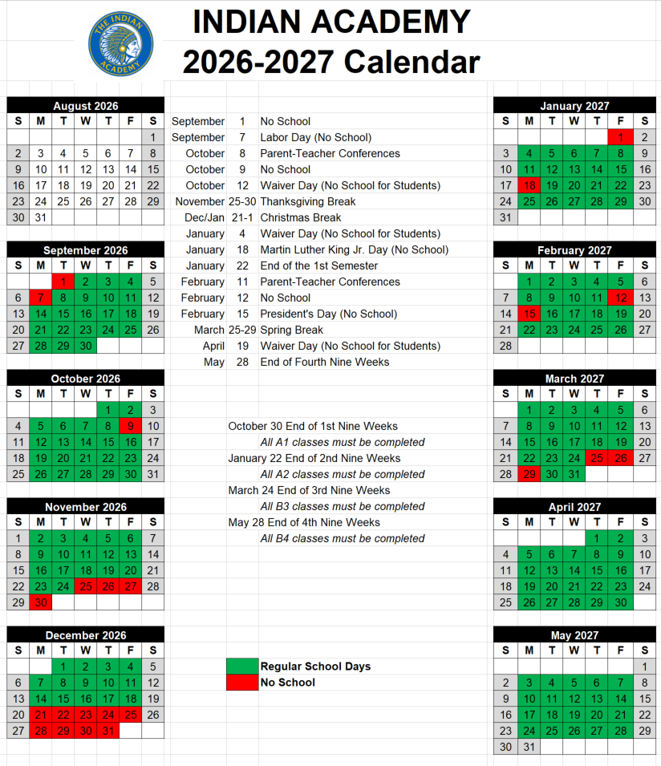

Snow Days and Delays:
Because The Indian Academy operates online, snow days, calamity days, weather closures, and two-hour delays do not automatically excuse students from participation requirements. Unless specifically communicated otherwise by the district, students are expected to continue coursework and educational engagement.

Student & Parent Commitment Agreement
We acknowledge receipt of The Indian Academy Parent & Student Handbook.*
We understand:
• Attendance and educational engagement expectations
• The 910-hour educational opportunity requirement
• The Sunday through Saturday attendance week
• Academic integrity requirements
• Technology expectations
• State testing requirements
• Graduation requirements

*Acknowledgement of receipt is made during the Final Forms enrollment process.

