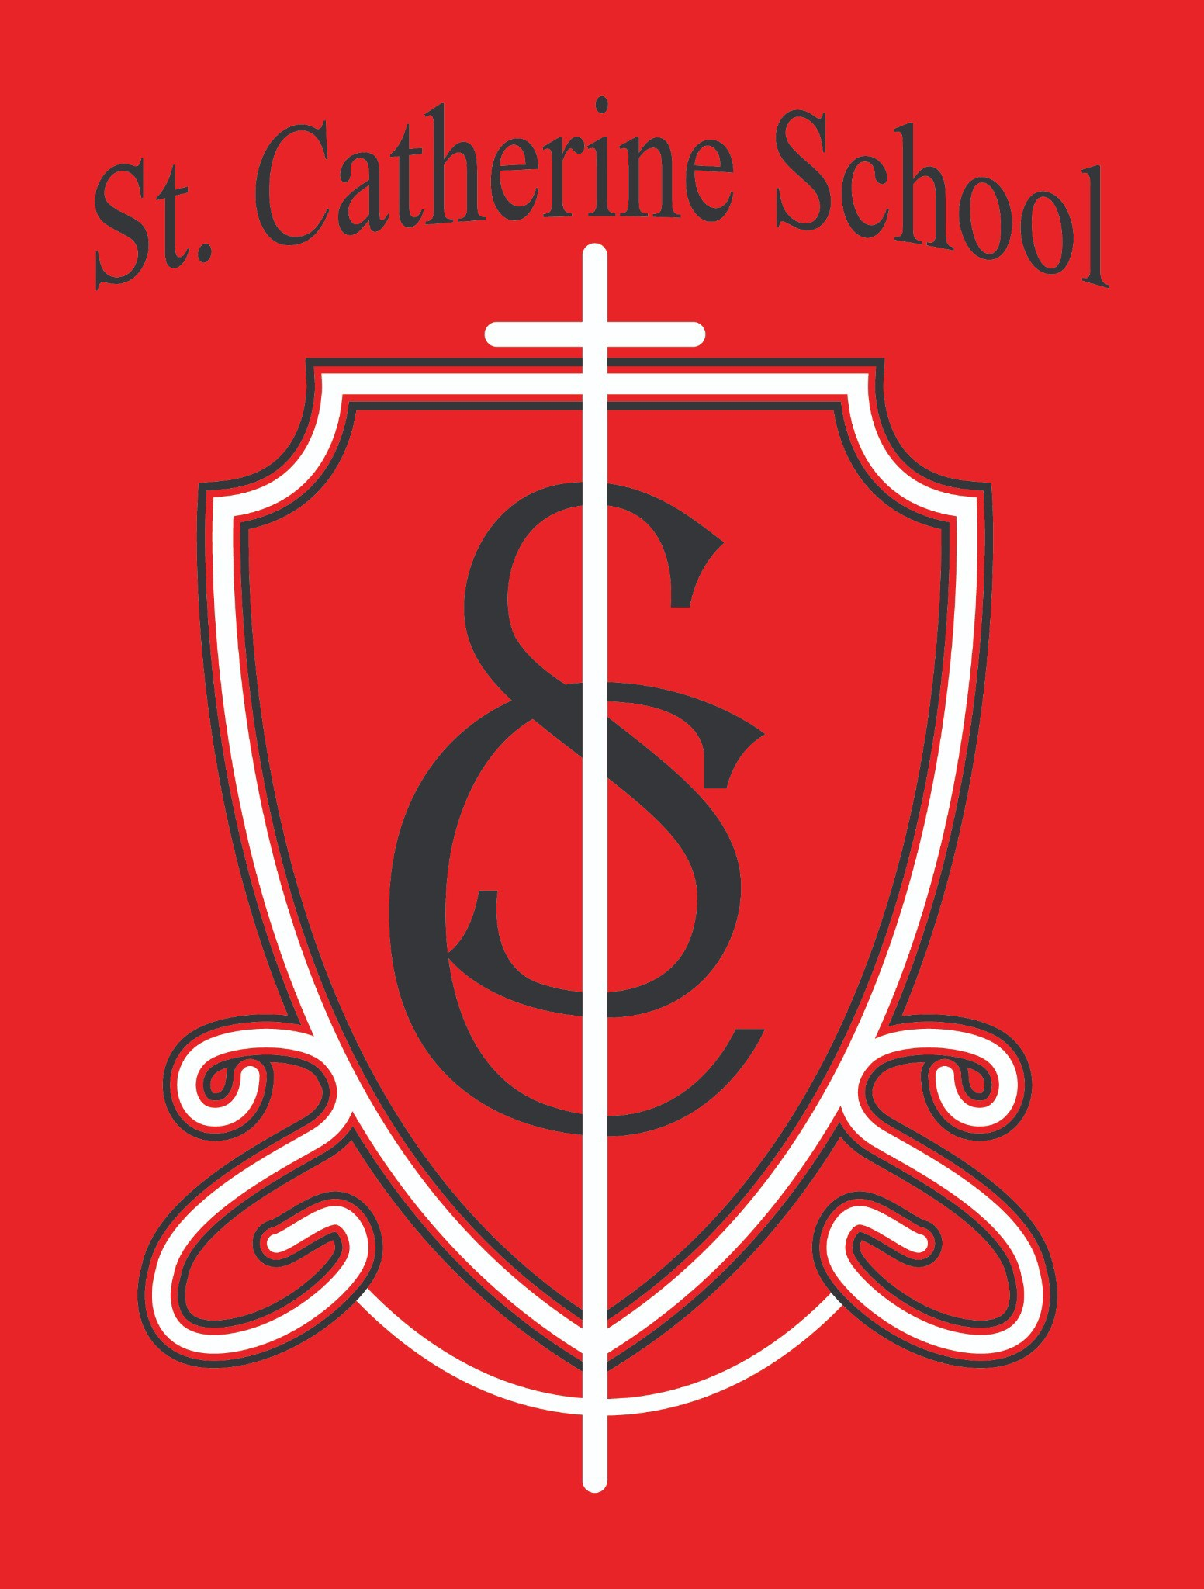

St. Catherine School Weekly Newsletter (Week of September 15-19th)
https://www.stcatherine.k12.nd.us/parents

Principal's Message
Dear St. Catherine Families,
I hope you are doing well. As we move deeper into the school year, the “newness” of school is starting to wear off. That’s a regular part of the transition back into routines. Not every day is going to be your child’s “best day ever,” and I know that can be hard to hear—especially when your child comes home saying they got in trouble or didn’t like something.
Please know that growth often comes through the boundaries we set and the perseverance we encourage. Reading isn’t always fun—especially when it’s hard. Math can be frustrating. But when your child gets to algebra in high school or chooses a future path that uses those skills, you’ll be thankful they pushed through. Perseverance is a tough virtue to grow in, but it’s one of the most important.
Some children struggle more with academics or transitions than others. You know your child. Trust your instincts about when they are truly struggling versus just having a rough day.
Communicate with your child’s teachers, and we will work together through anything that comes up.
As always, thank you for being part of the St. Catherine School family. We are so grateful for your trust in our mission.
In Christ,

Nick Lee

Reminders
Book Fair is Coming Soon!
We’ve moved our St. Catherine School Book Fair to the fall this year! It will begin in October— just in time for early Christmas shopping or refreshing your home libraries. Keep an eye out for more information.

Fall Benchmark Testing
Our MAP and STAR testing windows are opening soon. These assessments help us understand your child’s progress and how we can support them best. Please ensure your child is well-rested, has had breakfast, and is dressed comfortably for the school day.

Illness Guidelines
We’ve already seen some seasonal illness going around. Please keep your child home if they’re sick. If your child comes to the office not feeling well, we’ll check their temperature and use our judgment—and often call you to help make the best decision.

Fall Savings at Little Saints Childcare
Enroll by October 31 and receive your first two weeks FREE—a savings of nearly $400!
➤ Click here to take the next step
Large family discounts are also available—costs are capped at $1,700/month if you have 3 or more children enrolled.

Looking Ahead: No School
Please note that there is no school on October 16–17 due to Diocesan in-service and fall break.

Homecoming Thank You!
A big thank you to all the parents who helped make our Homecoming Parade a fun (and slightly soggy) success! Thank you to those who volunteered a trailer, drove, walked with students, decorated, and donated candy. A special thanks to the Hi-Liner Pride shirt sponsors—our students loved them! Also, thank you to the Homecoming royalty who visited our school and played with students. It was a wonderful week!

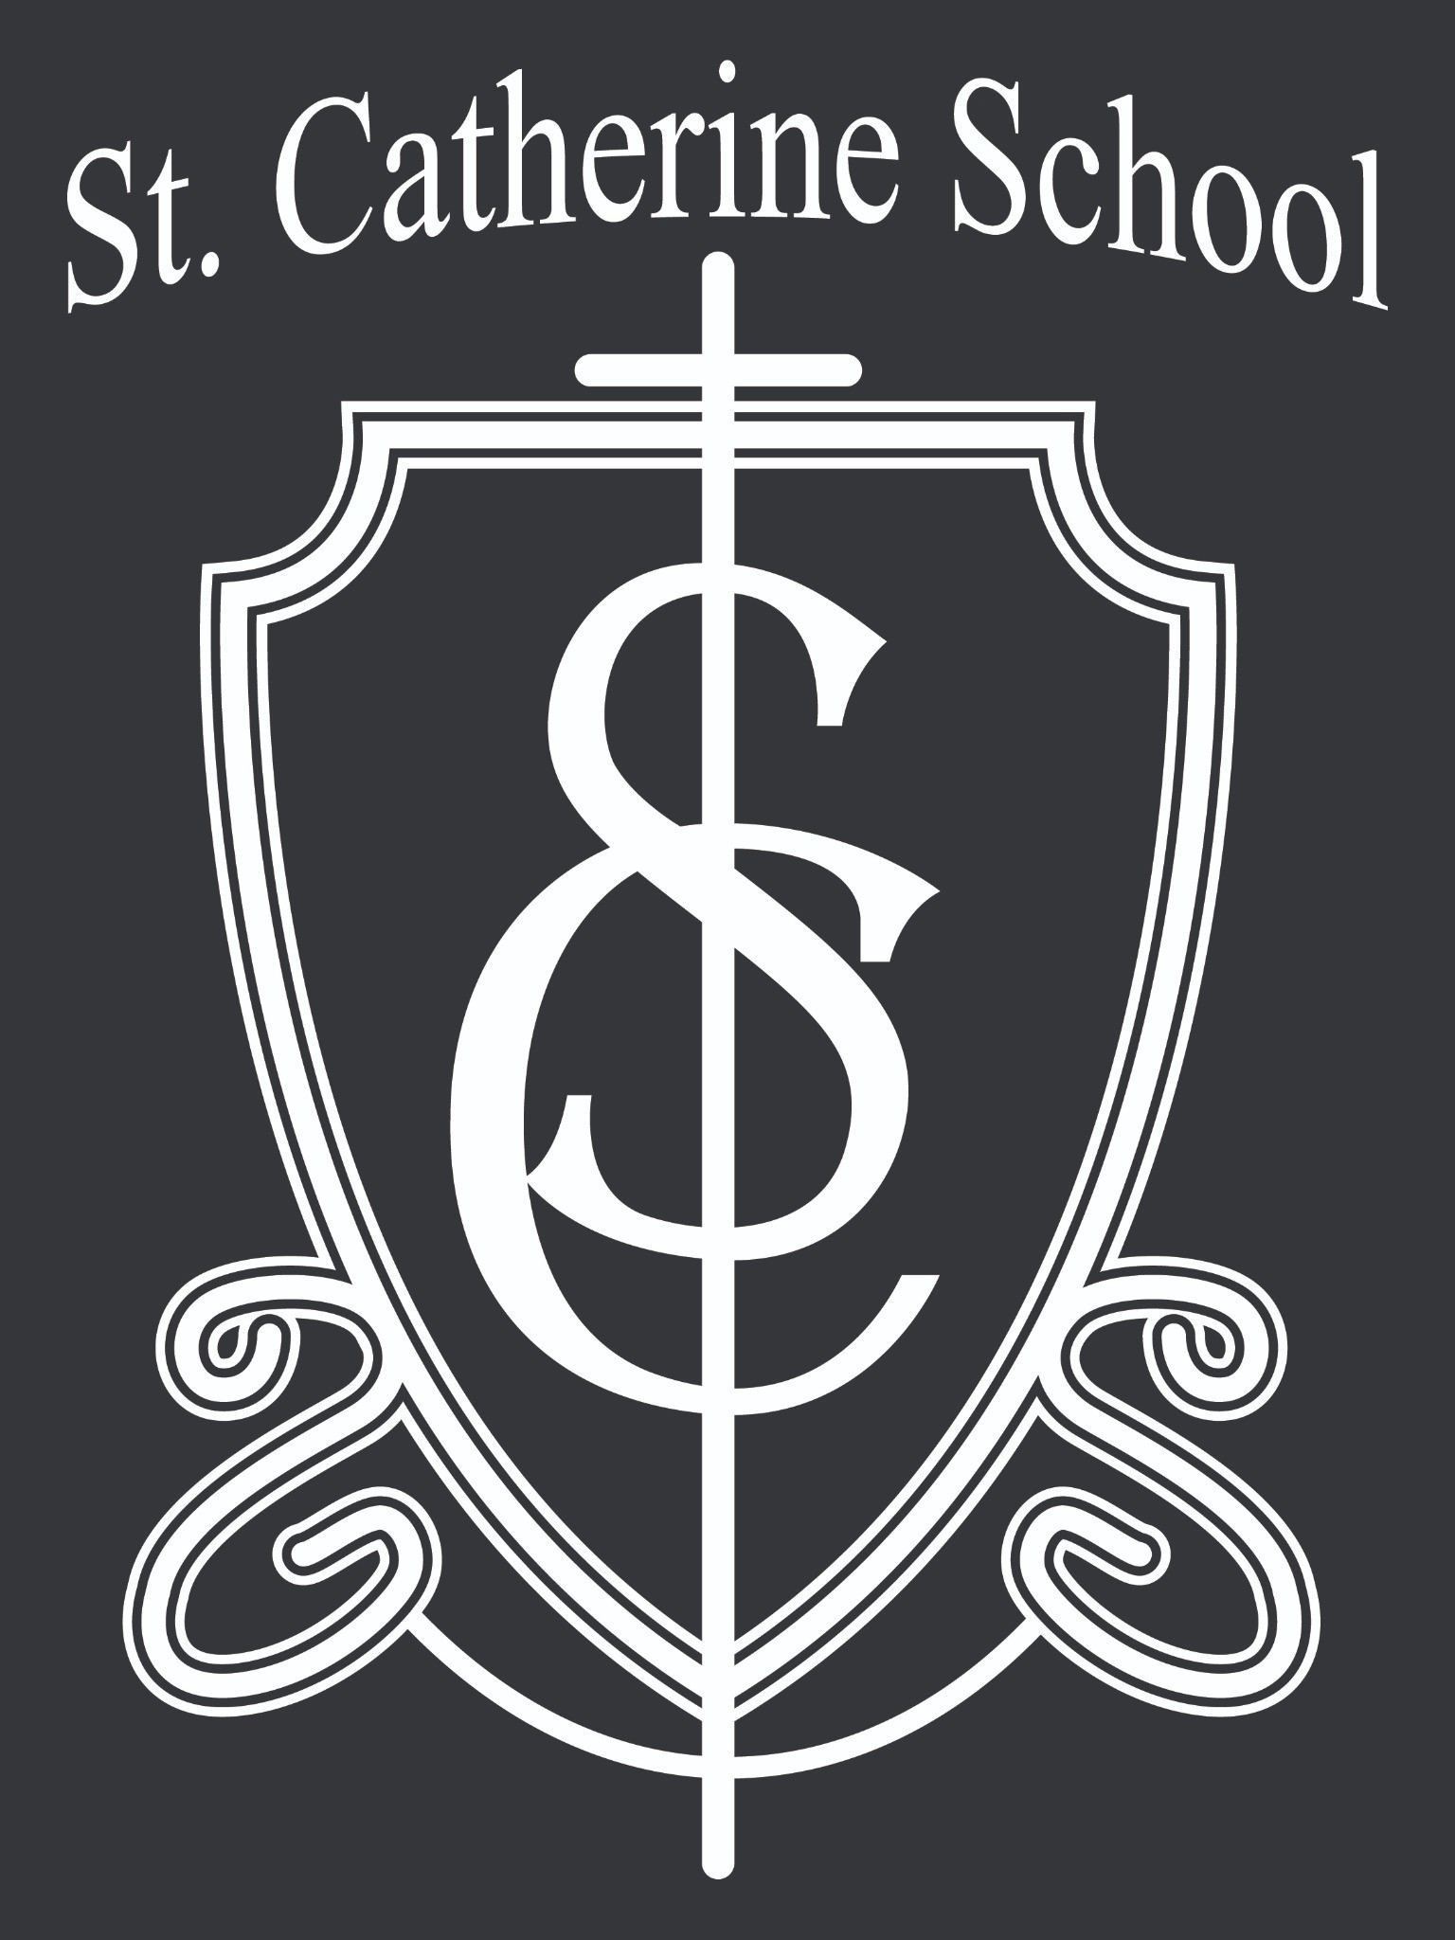St. Catherine Spotlight
A 5th grader offered to help a childcare teacher who had her hands full—such a great example of leadership and kindness!
A Circle of Friends (COF) student recognized me at the parade and gave me a hug. We love our partnership with COF and are grateful to build Christian education together in Valley City.
Time in the music classrooms this week reminded me just how blessed we are. While we look forward to Ms. Busch’s return, we are so thankful for Mrs. and Mr. Kjelland, who are sharing their musical talents and joy with our students.

Stay Connected with St. Catherine School
📍 Address: 540 3rd Ave. NE, Valley City, ND 58072
Email: nicholas.lee1@k12.nd.us
📧
Phone: 1-701-845-1453

📞
Website: www.stcatherine.k12.nd.us

🌐
📘 Follow Us on Facebook: St. Catherine School on Facebook

“Inspiring excellence through faith, learning, and service.”

