

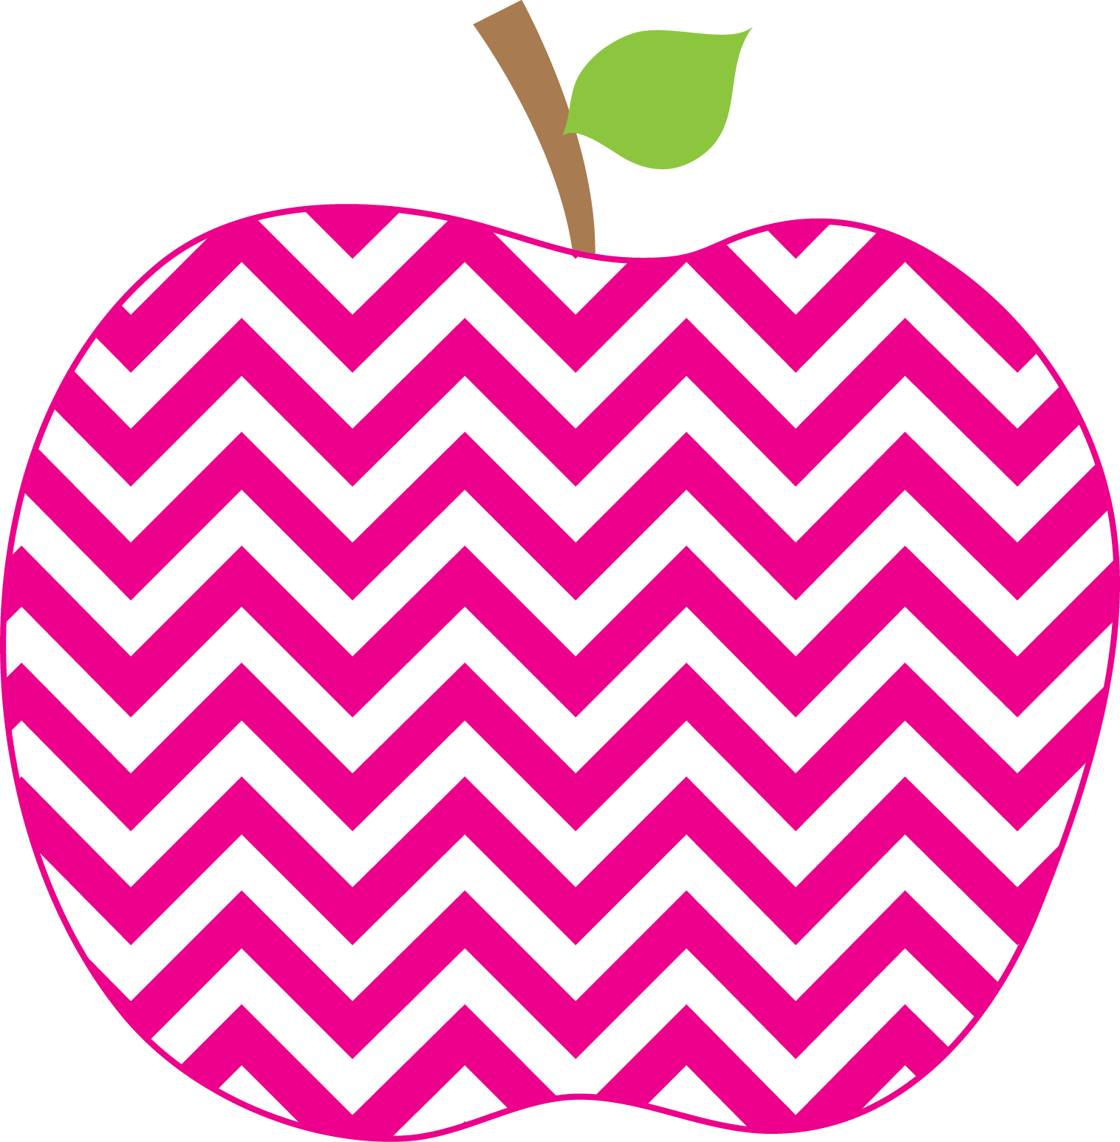



E. Robinson Weekly
Ms. E

October 21, 2024

Reading:
Phonics Skills:
*R-Controlled Vowel /er/ spelled er, ir, ur
*Final Blend -ng spelled ng

High-Frequency Words:
girl, her, with, any, from, where
like, water, but, do, long, my, no

Grammar Skill: Exclamatory Sentences

RED Words:
her any
Math:
*Counting On and Doubles

Social Studies/Science- Farm Unit continued…

**Please remember to send your child’s library book and binder to school each day.

This Week’s Focus:

Star Apple of the Week:
Kylie Davis
* * Please make sure to check the APPLE Binder each day for homework and sign the daily behavior sheet located in the back.

Tuesday, October 22nd Field Trip Money Due

October 28th-Nov. 1st Red Ribbon Week

Tuesday, October 29th Field Trip to
Penton Farms

Friday, November 1st Fall Fun Day

Reminders:
Important Dates:

