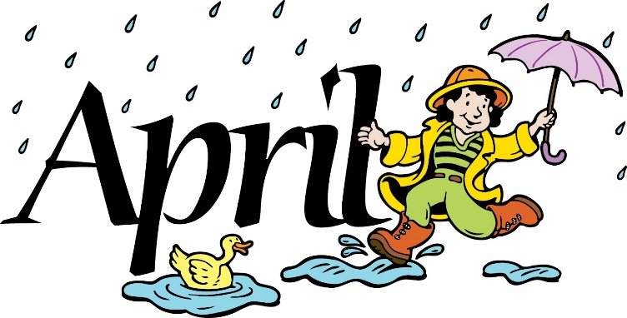
Mrs. Way’s Class News
Week of April 22, 2024
*Luray Caverns Field Trip – Fri., May 3rd. More info. will be sent home about this closer to the time.
*Interim reports were sent home on Fri., Apr. 19th. Please sign and return.

Math – Measure length in inches and centimeters

Science – animal life cycles (frog, butterfly)

