**2024-2025 Travel Estimate Form Directions**

1. Download the Estimated Travel Form and Open using EXCEL ONLY. Google Sheets does not work.
2. Only complete YELLOW boxes. All other cells are locked to protect calculation accuracy.
3. Enter employee name
4. Enter Location
5. Enter name of conference/meeting
6. Enter name of destination
7. Enter the FUND code received from Business/SPED Office
8. Enter one-way mileage (see bottom of travel estimate spreadsheet).

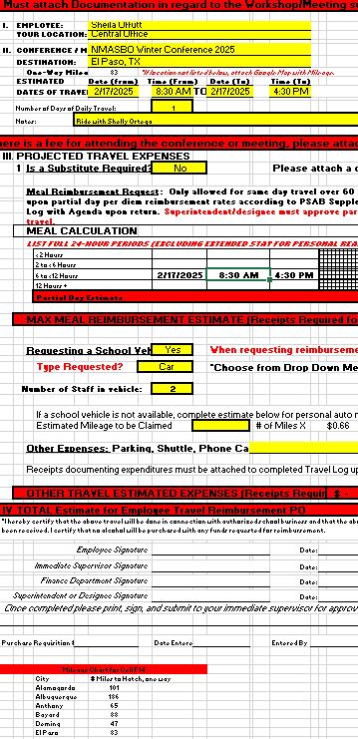

If the travel is more than 60 miles away from Hatch, NM, a partial day reimbursement will populate.

Enter GoogleMaps mileage if City not listed below.

1. Enter dates and estimated time of departure/arrival. This must be entered in the following format: 1:00 PM (with a space after the minute, before the AM/PM). If this is entered incorrectly, you will see an error.

# Incorrect Time Format:

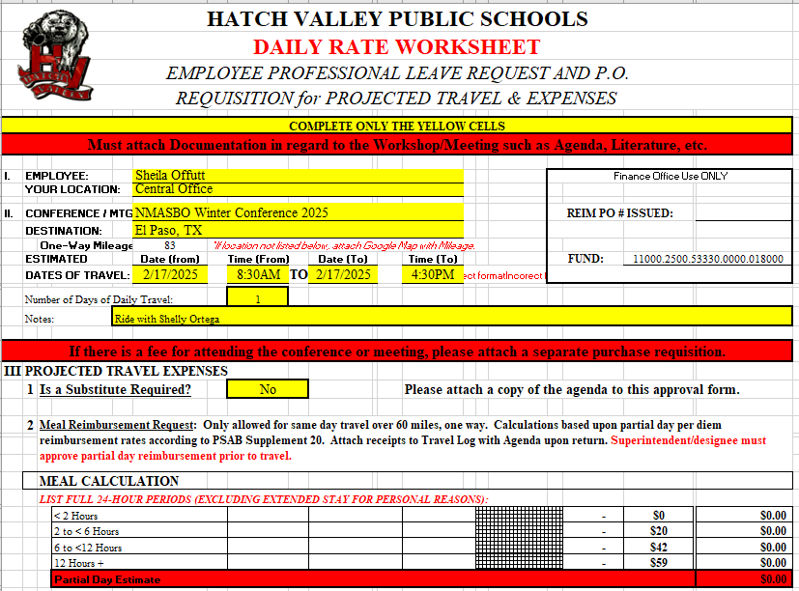

2 times entered incorrectly result in incorrect format error note.

Partial Day reimbursement will not populate

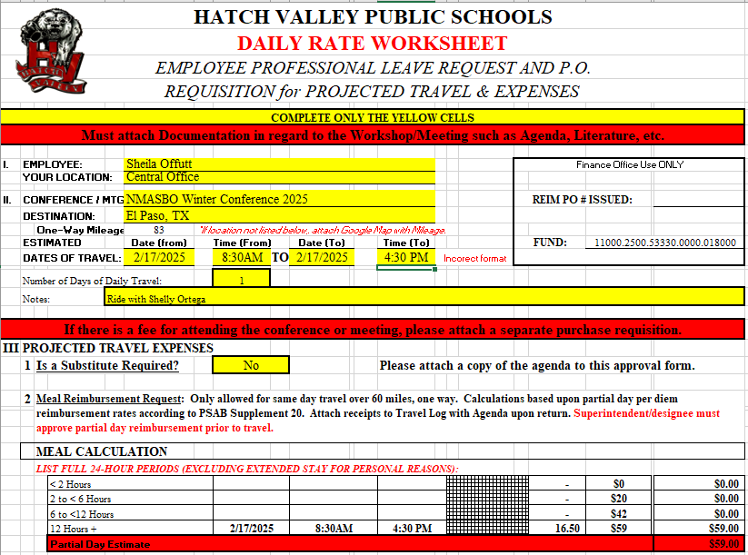

Daily reimbursement period is incorrect (8:30 AM to 4:30 PM is not more than 12 hours.)

1 time entered incorrectly result in incorrect format error note.

# Correct Time Format:

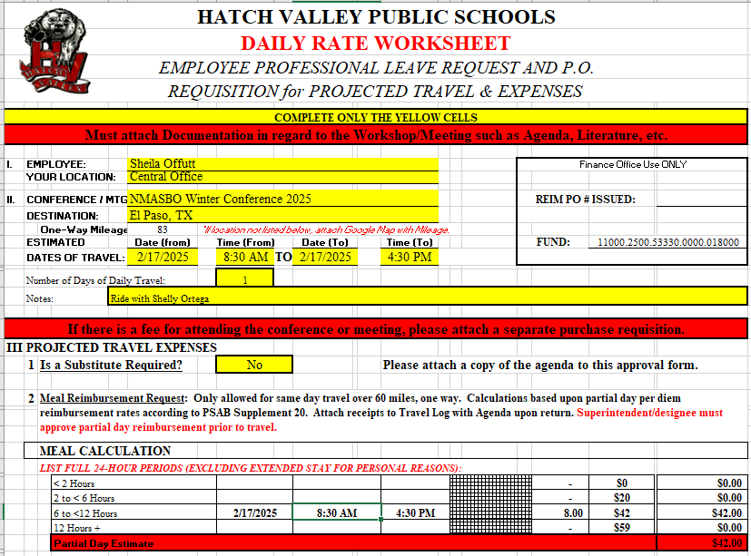

The error is gone!

Daily reimbursement period and estimate are now correct!

1. Enter number of days (1 for a one-day trip; 2 or more if you are traveling back and forth to a meeting/conference multiple days).

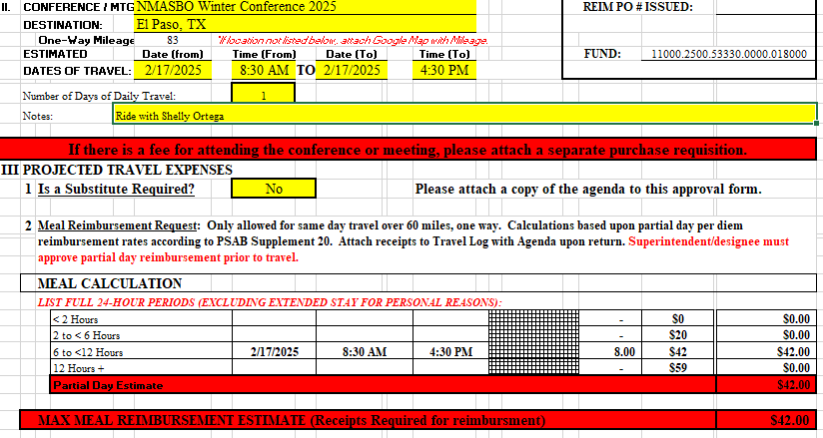

1 day travel more than 60 miles calculates $42 Reim.

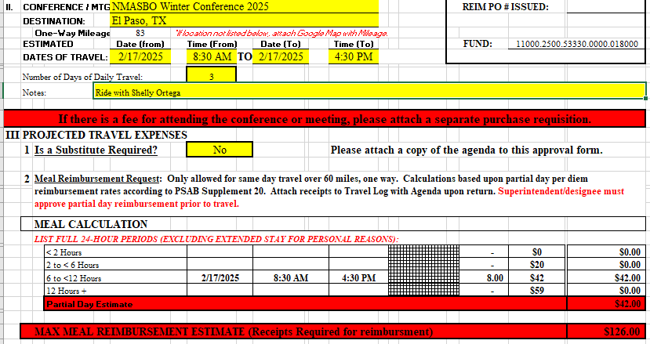

3 day travel more than 60 miles calculates $126 Reim. (3x$42=$126)

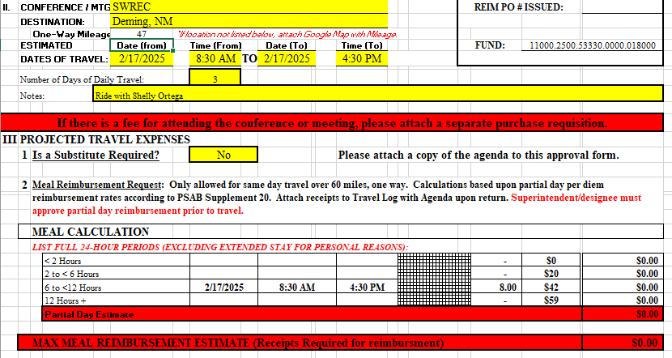

3 day travel less than 60 miles calculates $0 Reim.

1. Enter Notes regarding travel, including staff traveling with you, especially if traveling multiple days to the same location.
2. Use the drop-down menu to select whether or not a substitute is required for your absence.
3. Use the drop-down menu to select whether or not you will be requesting a school car.
4. Choose appropriate vehicle in the drop-down menu.

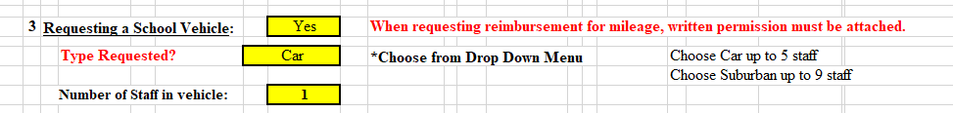

1. Enter a description and estimate of any other estimated travel expenses.



1. Total calculates and should be used to create meal reimbursement PO to employee



1. If Registration will be incurred, fill out Section V and attach backup documentation (quotes/flyer for conference). Registration PO should be created directly to the company/vendor if possible but may use Bank of America if company will not take POs (create PO to Bank of America).

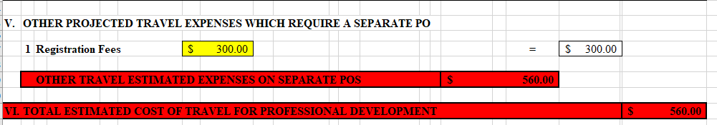

1. Section VI calculates the total estimated cost of your trip

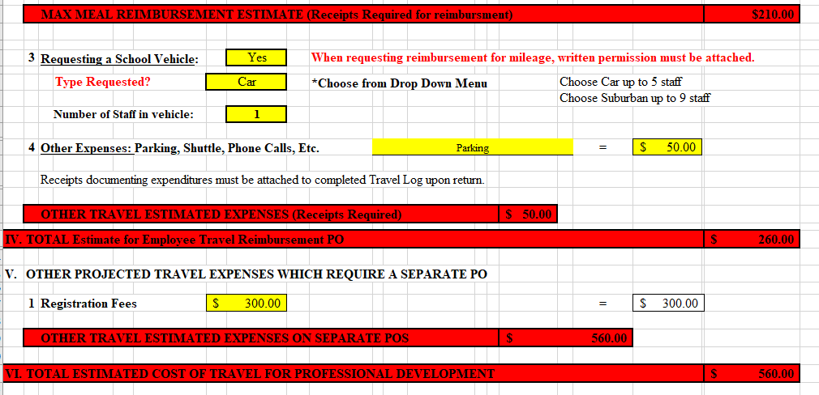

1. Enter the name of the Funding Source (Bottom Right)
2. Print and sign and submit to your supervisor for approval, or sign and send for approval via Adobe, following the following steps. The steps can be followed for any document.
3. Print document to PDF:
   1. Click File b. Click Print c. Click arrow on right of Printer,

and select pdf or Power PDF

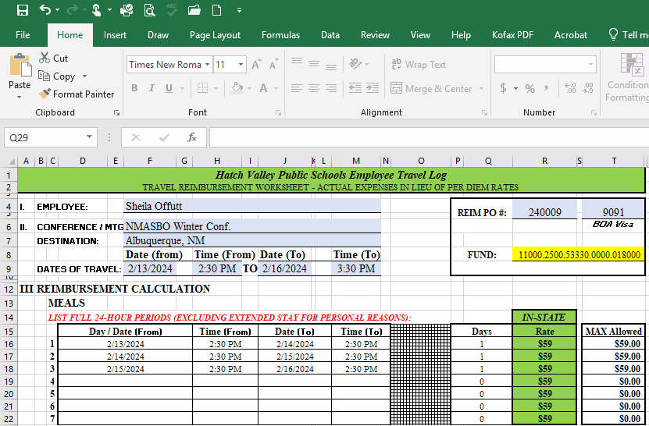 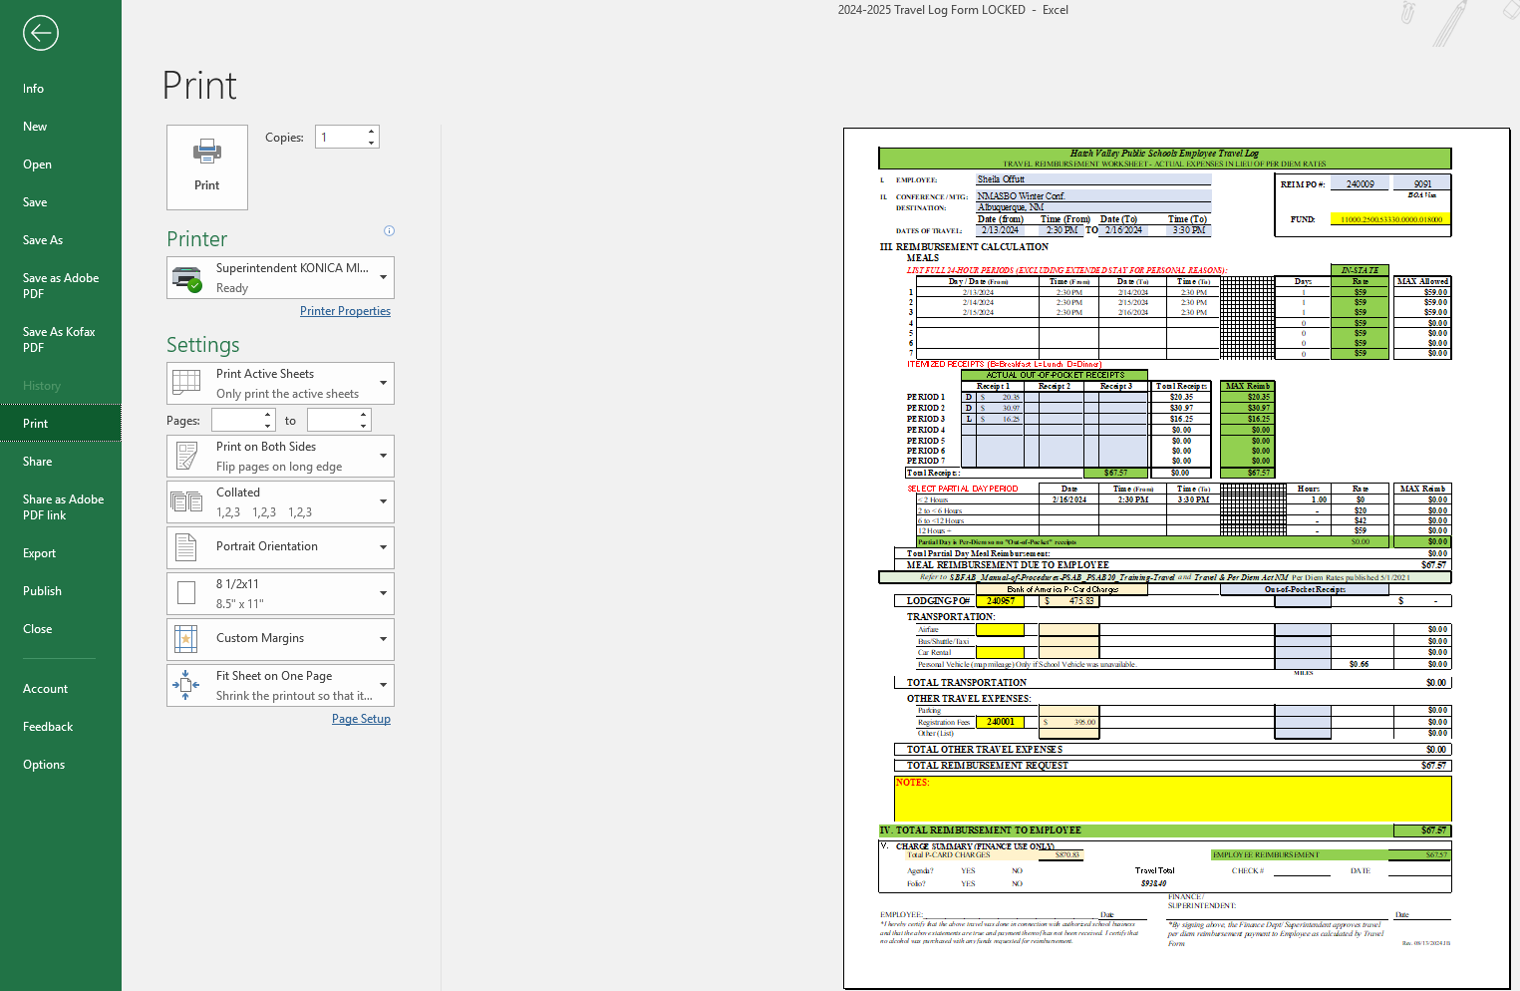 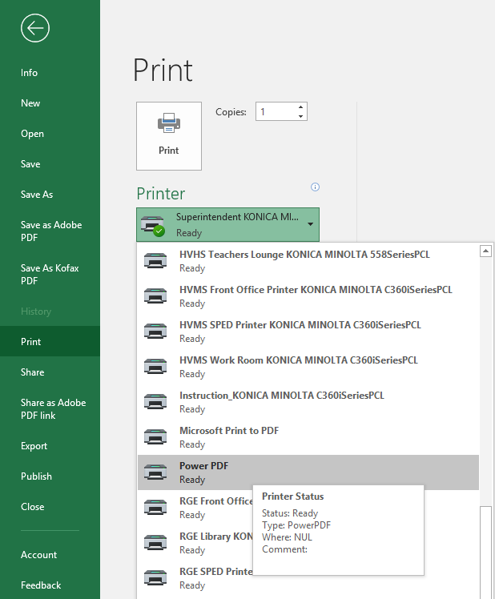

d. Click Print e. Choose file location, enter name of file, click save.

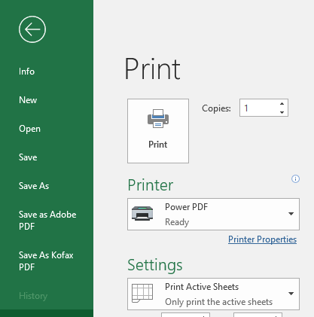 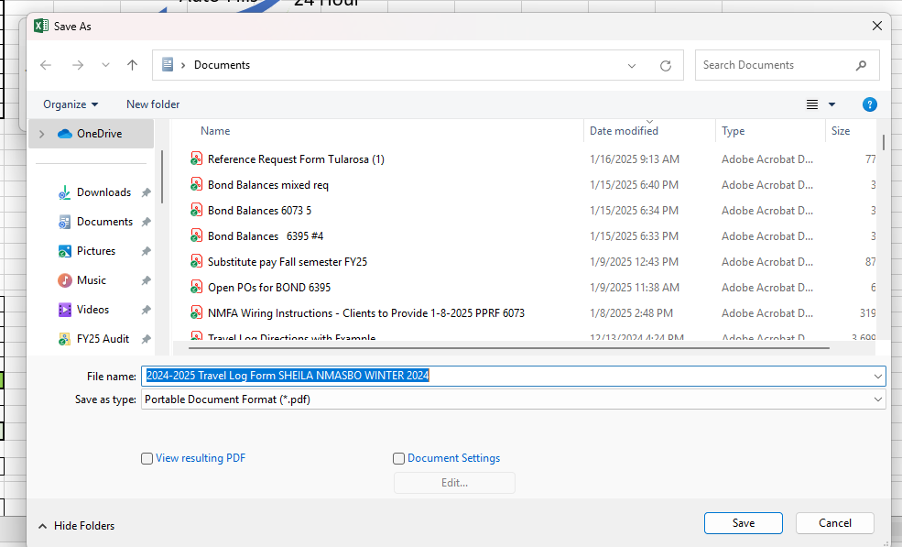

1. Sign/date via Adobe and send to your supervisor, Sheila Offutt and Mr. Michael Chavez for approval via Adobe.
   1. Open file location to open your pdf in Adobe.

NOTE: You may add pages to the Travel log before sending for signatures. Steps to do this:

* + - * 1. Open Adobe File. Click Edit.
        2. Click Organize pages.
        3. In another window, open the file location (My Documents) and drag/drop the additional files such as a scanned copy of receipts, agenda, badge, hotel folio, etc.
        4. Click on the X to close the Organize pages window.
        5. Click Save.
        6. Proceed with e-signature steps below.
  1. Click e-Sign (Example included is of a Travel Log, but steps are the same for all documents.)

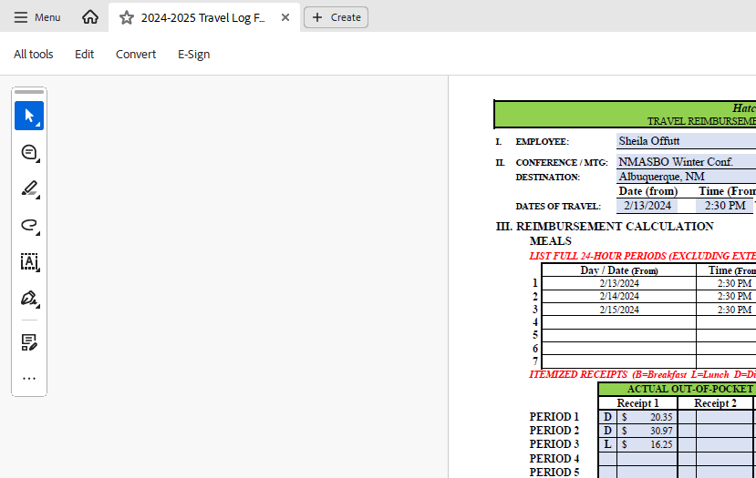

* 1. If signing for yourself, click the signature. If sending to another employee to sign, click Request e-signatures.

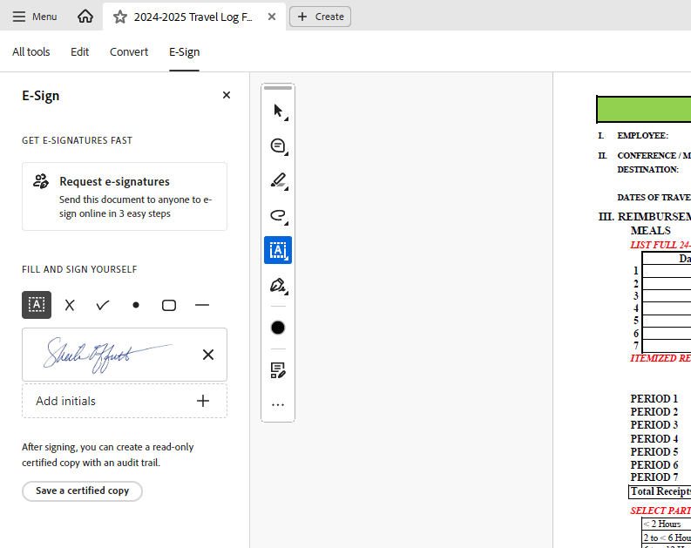

To send for signatures, click here

Click and drag to insert your own signature

* 1. Type the email addresses of the intended recipients, and enter message if needed. Click Specify where to sign

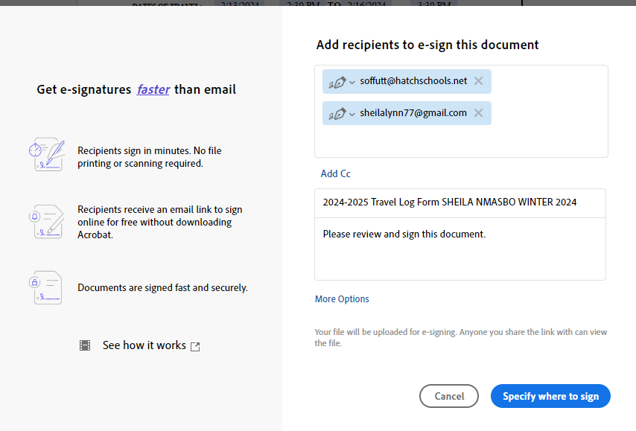

Enter addresses (using personal email for illustration purposes only)

Click to continue

* 1. Click and Drag “Signature” to the location where the signature should be entered. 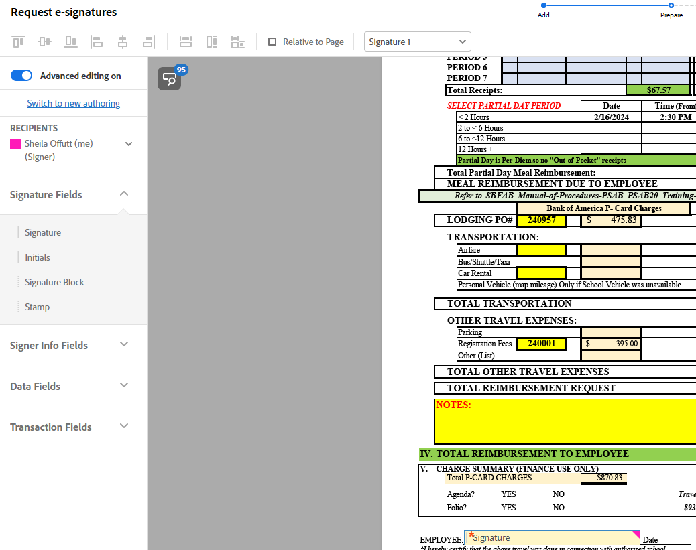
  2. Click “Signer Info Fields” and Click and Drag “Date” and any other relevant fields to the correct Location on the document.

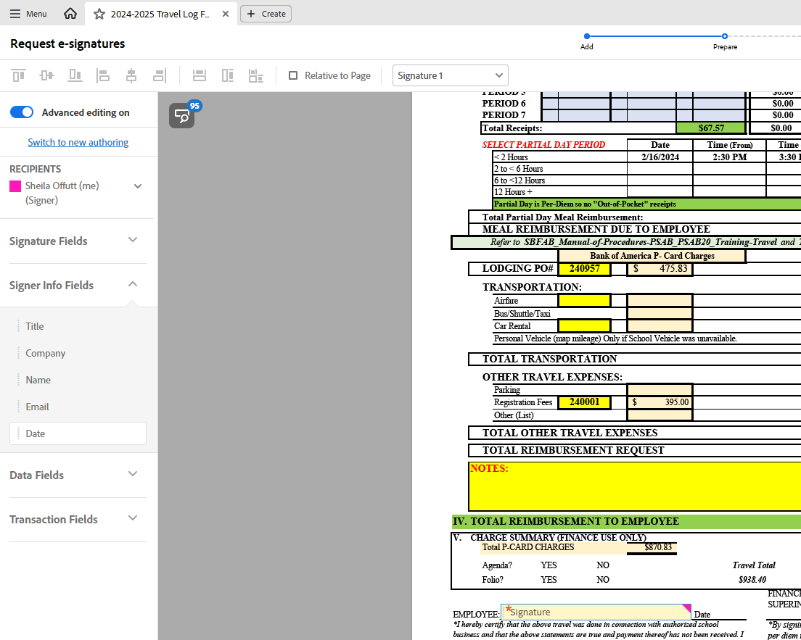

* 1. Click the drop-down button on the Recipients list and choose second (or third, etc.) recipient, and follow above steps. Click SEND (Bottom Left of screen)

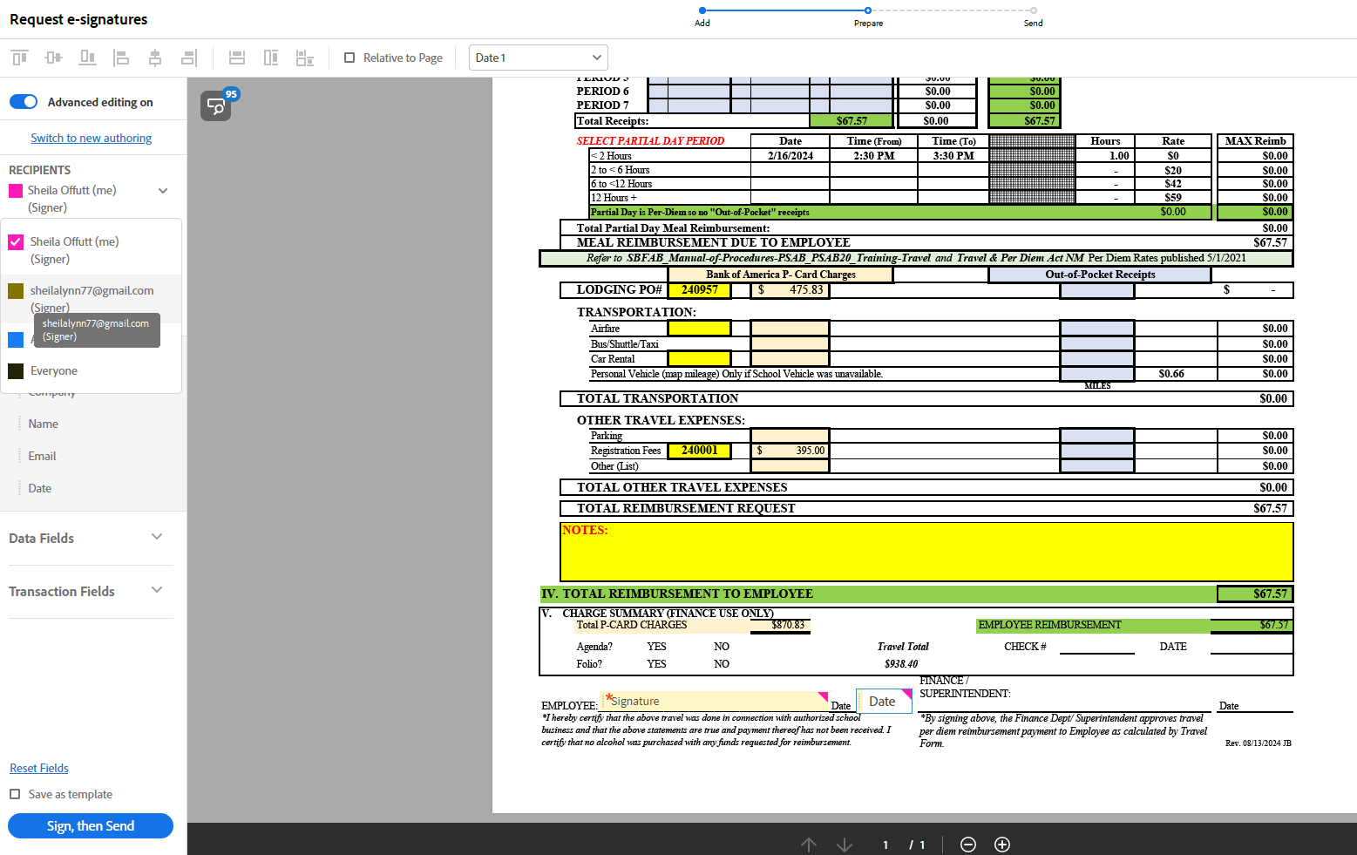

* 1. Click Close. Signers should receive an email to sign.

1. If you have not received the signed PDF back, you can log into Adobe via your Gmail account and send a reminder to the signer, or cancel if the PDF is no longer needed. Click on the file pending a signature, then additional options will appear on the right:

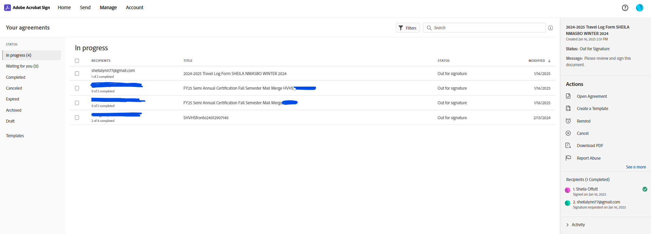

1. Submit all paperwork to Raney Weiler in AP for payment.