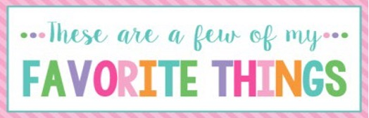

Name: | Jenny Solomon | T-Shirt Size: | M
Birthday: | 02-13 | Monogram: | JSL
Favorite Color: | pink | Favorite Flower: | potted plants
Favorite Scent: | vanilla | Favorite Candy: | Reese’s
Favorite Drink: | Sour loaded tea | Favorite Food: | Mexican
Favorite Snack: | Trail mix | Favorite Fruit: | watermelon
Favorite Restaurant: | Buon Cibo | Favorite Fast Food: | Zaxby’s
Favorite Places to Shop: |  | Amazon
Favorite Bath & Body Works Scent:
Things I Collect: |  | Fun resin earrings
Favorite Author/Book Series for Personal Reading: |  | Lysa Terkeurst
Wish List for Classroom: |  | Kinetic sand

